City of Los Angeles

A COMPREHENSIVE TECHNOLOGY SOLUTION FOR DEVELOPMENT SERVICES (BuildLA)

RFP No. 2013BLA001R

September 10, 2014

Volume I: Technical Proposal

Final Proposal Response

Original

Proposal Expiration Date: 120 Days from Date of Submission

Submitted by:

Charlie Bunten

Senior Director, Contract Services

UST Global Inc

20 Enterprise, 4th Floor

Aliso Viejo, CA 92656

charlie.bunten@ust-global.com

Cell: 714-745-0154

Fax: 949-274-4458

*NOTICE: ‘The data on the pages of this proposal identified by an asterisk (*) or marked along the margin with a vertical line, contain information which are trade secrets and/or whose disclosure would cause substantial injury to the Proposer’s competitive position. The Proposer requests that such data be used only for the evaluation of its proposal, but understands that disclosure will be limited to the extent that the City determines is required under federal, state, and local law.’*

# Cover Letter

September 10, 2014

City of Los Angeles, Department of Building and Safety

General Analysis and Budget Services Section

201 North Figueroa Street, Suite 960

Los Angeles, CA 90012-4869

**Attention:** Mr. Zachary De Corse, Contract Administrator

**Subject:** City of Los Angeles BuildLA Request for Proposals (RFP) 2013BLA001R

Dear Mr. De Corse:

UST Global Inc (UST Global), a local California-based company is pleased to respond to the above RFP with our Comprehensive Technology Solution for Development Services (BuildLA) for the City of Los Angeles. Our proposal offers the City the following unique advantages:

* A world class Integrated solution proven across many local US Government clients and meeting all the core requirements of the RFP
* A proven team with deep experience in designing, developing, testing, and implementing comprehensive integrated permitting and land use management solutions, thus enabling a risk adverse execution.
* Key personnel who bring immediate and relevant expertise, including the skills, qualifications, education, and experience required for their designated positions.
* A prime contractor as the systems integrator that has designed and delivered hundreds of successful information technology (IT) and web portal solutions across multiple Fortune 500 clients, meeting the specific needs of our clients.

Just as the City is moving from a City-centric approach for planning and permitting to a customer-centric business model, UST Global is a client-centric focused company. This client-centric focus forms the basis for how we, as a company, operate and serve our clients, and is line with our philosophy of **“fewer CLIENTS, more ATTENTION”**. Commitment to long-term client success empowers every associate to provide value and flexibility beyond the contract. Headquartered in California with offices in Los Angeles, we are known for our ability to deliver innovative, cost effective solutions to Government partners and our Fortune 500 / Global 1000 clientele. We firmly believe that our solution coupled with our commitment and financial stability can deliver this project beyond the expectations of the City and make the program a success.

Our **Head of Public Sector Giri Rajaiah** and I are authorized to represent UST Global regarding all matters related to the proposal and any contract subsequently awarded. He can be reached at **703-867**-**3640** or via email at giritharan.rajaiah@ust-global.com. Our address is below. I am the individual authorized to bind UST Global to all commitments made in the proposal. We look forward to working with the City on this critical initiative.

Yours Respectfully,

Charlie Bunten

Senior Director, Contract Services

UST Global Inc

20 Enterprise, 4th Floor

Aliso Viejo, CA 92656

charlie.bunten@ust-global.com

Cell: 714-745-0154 Fax: 949-274-4458

Contents

Cover Letter 1

Executive Overview 3

1 Proposed Solution Requirements (RFP 3.1) 20

1.1 Functional Requirements (RFP 3.1.2.2) 20

1.1.1 Functional Requirements Response Matrix (RFP 3.1.2.2 20

1.2 Technical Requirements (RFP 3.1.2.3) 21

1.3 Proposer Experience (RFP 3.1.3) 21

1.3.1 Minimum Qualifications Response Matrix (RFP 3.1.3.1) 21

1.3.2 Experience Reference Form (RFP 3.1.3.1) 23

1.3.3 Team UST Solution Providers for BuildLA (RFP 3.1.3.1) 23

1.3.4 Staff Qualifications (RFP 3.1.3.2) 24

1.4 Solution Response (RFP 3.1.4) 73

1.4.1 Functional Solution Narrative (RFP 3.1.4.1) 73

1.4.2 Technical Solution (RFP 3.1.4.2) 116

1.4.3 Implementation Approach (RFP 3.1.4.3) 145

1.4.4 Hosting, Operational Maintenance and Support Approach (RFP 3.1.4.4) 200

# Executive Overview

Los Angeles is rethinking public service, engaging citizens, and redefining the standard for permitting and land use management, and transforming government. We not only recognize your vision, we share your passion for constituent-centric, participatory government. This passion is reflected in the team we have proposed, the solutions and methodology we will utilize, and in the user experience we are bringing.

*The City’s vision to enhance the citizen experience with a service- based approach is fundamentally different. BuildLA will transform citizen productivity, interactions, and their perception of City government.*

Team UST also brings a fundamentally different approach to the BuildLA project. Our focus is a revolutionary, not evolutionary, change in constituent interactions with the City portal and City staff collaborations on constituent services. Team UST will deliver the ultimate user experience to the City of Los Angeles – creating software that people want to use and changing the way your citizens and staff interact.

**Introducing Team UST: The Right Partner for BuildLA**

Achieving the ambitious vision that the City has established will require a closely integrated team of permitting and land use experts, design experts focused on user experience, and solutions that have been proven at complex city governments across the United States. Team UST brings these capabilities with the proven team of **UST Global, IBM, Infor, Avolve, TruePoint Solutions, and Excelerate Consulting**.

The team selected by the City needs an outstanding prime contractor who will serve as its partner throughout the lifetime of this initiative. The ideal prime contractor would have the following attributes:

* Long-term proven track record of successfully leading large-scale public sector technology projects. This project would overwhelm the capabilities of any team lead by a firm that was not highly experienced at dealing with projects of this scale and complexity.
* Substantial, permanent, long-term presence in Southern California with a local senior executive team, management team, and local senior technical resources. Our CEO and senior executives are headquartered in Southern California. This project cannot be successfully completed by out-of-town “travelling consultants”.
* A history of being a trusted partner with all our clients. We are certainly ready to have this same trusted partner relationship with the City of Los Angeles. It would be a significant mistake for the City to select as the prime contractor a firm with a history of adversarial and litigious relationships with its clients.
* The ability to partner with premier subcontractors with proven expertise in land use and permitting systems. Bringing the premier solution providers, who have partnered on many major city land use and permitting systems, reduces the level of risk to the City.

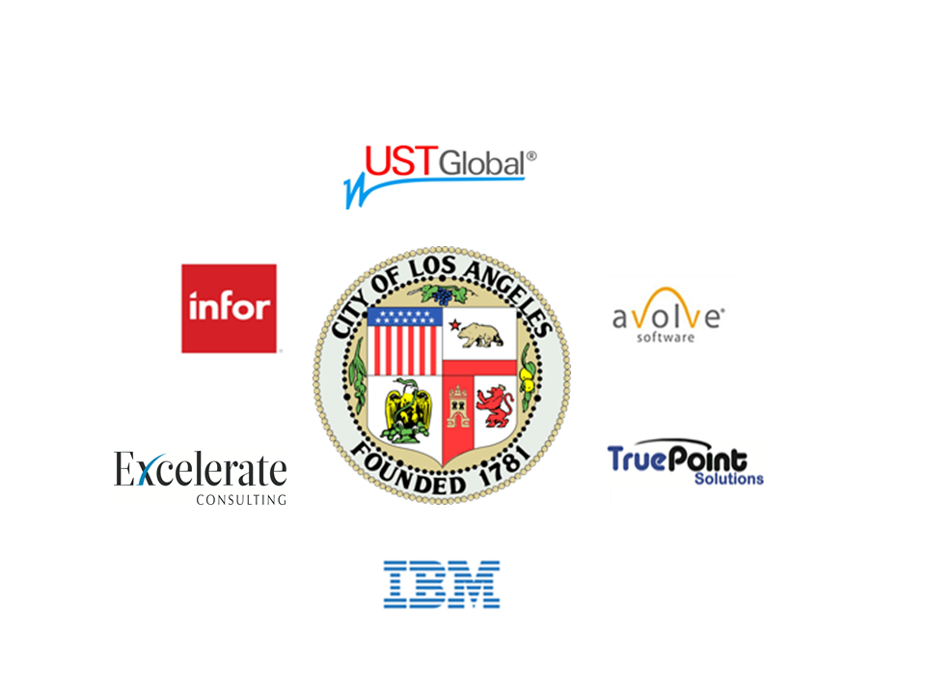

Team UST brings a complete solution plus the expertise and best practices from decades of experience delivering land permitting portal projects.



*Founded in 1999, UST Global has a 14 year history of delivering peak performance to our clients by offering a full range of project management and systems integration tailored to the unique needs of each industry.*

UST Global and our partners (Team UST) have successfully executed similar permitting and portal application projects across the United States. Headquartered in Aliso Viejo, CA, we bring our local team of 500 California-based employees backed by 11,000 employees across four continents to BuildLA. Our company is part of the Comcraft Group, a $6 billion group with operations in more than 50 countries. UST Global has 14 years of experience as a leader in end-to-end information technology (IT) services and solutions.

The following key points summarize what makes UST Global a preferred partner for the City’s objectives for BuildLA:

**Understanding of BuildLA:** UST Global has been involved in and has successfully executed similar web application implementation projects for our Fortune 500 clients, including H&R Block, KPMG, Wells Fargo, Disney, Warner Brothers, Sony Pictures, WellPoint, Costco, Dell, HEB, and Walmart. UST Global will leverage “lessons learned” from our experiences to execute this project successfully. Our partners bring expertise gained from implementing multiple large municipal government permitting projects across the county. For example, the City of Portland recently selected Infor’s CDR and Avolve’s ProjectDox after an extensive evaluation and demonstration process similar to the process undertaken by the City of Los Angeles. Our partner Avolve had a successful ProjectDox ePlan pilot with the City before this RFP was initiated and we can use that experience in this project going forward.

**We are partnering with best of breed application providers** for Permitting and Land Use Management solutions. Used by more than 100 municipalities nationwide, Infor Public Sector CDR enables governments and municipalities to operate efficiently and transparently while reducing cost and increasing citizen satisfaction. Avolve’s ProjectDox ePlan review software helps government personnel cut through information silos, share that information productively, provides better services and do more with less. IBM is a leading provider of Smarter Cities solutions including the proposed IOC platform, a smarter cities solution that allows the City to implement a targeted solution for permitting and licensing while establishing a foundation that will accelerate other city use cases in areas such as transportation management, public safety, and more. These solutions help save citizen’s time and money while providing a solid return on investment to the jurisdiction and the taxpayer alike. Quality control and assurance is built into our processes: We adopt Six Sigma practices for developing our client-facing processes. Our centers in India are International Standards Organization (ISO) 27001 certified and we were assessed People Capability Maturity Model (PCMM) level 5 in 2004.

UST Global brings proven project management expertise and innovation to every project:

The following key points summarize what makes UST Global a preferred partner for the City’s objectives for BuildLA:

* Year-on-Year customer retention successes: Our greatest achievement is our customer retention. More than 95% of our revenues come from existing customers.
* Ease of doing business, speed to market: We enable our associates to be proactive, responsive and flexible in our approach to business, and working with clients to tailor business operations to our clients’ specific needs
* [](http://www.google.com/url?sa=i&source=images&cd=&cad=rja&docid=0vpNRrGVUzZ8HM&tbnid=LqKQgLMWoMCs9M:&ved=0CAgQjRwwAA&url=http://www.businessworld.ie/&ei=B7hdUq2GBNO1kQeStYHwAg&psig=AFQjCNHihnviO9tjRilNIw32LzQ-f6_0oA&ust=1381960071217898)Client Innovation: UST Global is a leader in effectively brining innovation to our client engagements. We are committed to helping the City to achieve its business objectives by leveraging the latest in technology and innovation. We were awarded Business World’s “International Business Award for Innovation – 2012” for our outstanding capabilities in this area (http://finance.yahoo.com/news/ust-global-honored-innovation-businessworld-133000649.html).
* Executive Focus: We will endeavor to develop a deep long term partnership with City by having focused senior executive oversight and management. There is an excellent fit between the City and our team members in terms of business needs and company culture, and look forward to building this partnership together.
* Proven Solution and Approaches: We are proposing proven solutions and approaches for every element of the project, thereby reducing the City’s implementation risk s and ensuring delivery of a complete BuildLA project.
* Delivery capability: UST Global will establish a set quality guarantee requirement for any member being included in the project delivery team. We will deploy a team of highly experienced, skilled and qualified resources for this engagement to meet the City’s goals, objectives and requirements. UST Global has a dedicated IBM Smarter Cities Solution practice.
* Client intimacy model: Our business has been built around ‘Client Intimacy’ and a business philosophy of “fewer CLIENTS more ATTENTION”. With our focus on client share, and not market share, clients continually rate us ahead of others in attributes such as Speed of Response, Flexibility, Creativity and Innovation, Commitment-Beyond-Contract, and Investment in Clients. The City will experience this first hand in every interaction with our associates.
* Expertise with IBM Technologies: With a dedicated IBM Smarter Cities practice and as a premier IBM partner, we are able to architect, design, and implement in accordance with IBM best practices. This is critical since BuildLA will be a core application for the City of Los Angeles for a very long time.
* Commitment and Financial Stability: We firmly believe that our solution coupled with our commitment and financial stability can deliver this project beyond the expectations of the City and make the BuildLA project a success.



The IBM Intelligent Operations Center (IOC) Platform and WebSphere Portal integrates with Infor’s CDR and Avolve’s ProjectDox and is built on the IBM Intelligent Operations Center. This solution is based on technology built by IBM Research, validated by other cities, and extended to accommodate the City’s requirements and information systems. It augments Infor’s capabilities to include Cross Agency Coordination, Decision Support, Citizen Services and Performance Management.

***Ranked as the No. 1 company for leaders, No. 2 largest U.S. firm in terms of number of employees and No. 1 green company worldwide.***

The combined capabilities of our solution allow the City of Los Angeles to benefit by:

* Detecting and mitigating issues and conflicts;
* Facilitating stronger and more effective coordination between agencies;
* Shortening permitting cycle times; and
* Improving citizen satisfaction with city services.

IBM’s Intelligent Operations Center (IOC) platform is the foundation for IBM’s “Smarter Cities” solutions. It provides an extensible platform for cross domain growth as well as a number of out of the box capabilities including key performance indicator monitoring, team and agency collaboration tools, workflow automation and operational and executive dashboards. Additionally, the IOC includes data integration capabilities that allow the processing and management of diverse datasets including City infrastructure data.

IBM’s IOC leverages IBM Research’s thought leadership and previous technical investments designed to improve cross agency collaboration in contexts like permitting. These investments resulted in technology that can be used to quickly and easily establish patterns, understand the impact of, and assess relationship and provide detailed geospatial information. Such technology is useful within the contexts of special events, for example, in order to understand what possible conflicts and issues there might be when planning for a parade in a particular section of the city.

IBM is well-positioned to address city management needs. IBM’s approach to improving city operations is based on insights that are drawn from thousands of client implementations worldwide. By working with inspiring leaders to solve difficult challenges, IBM has developed repeatable, proven practices that can be applied to cities of all sizes. Those practices are combined with expertise in advanced analytics, data integration, cloud deployment options and IBM Smarter Cities software solutions to truly transform city operations.



Citywide Optimization

What sets IBM’s Intelligent Operations citywide optimization apart from other solutions is the ability to sift through the ever increasing amount of information, make sense of it, and take appropriate response.

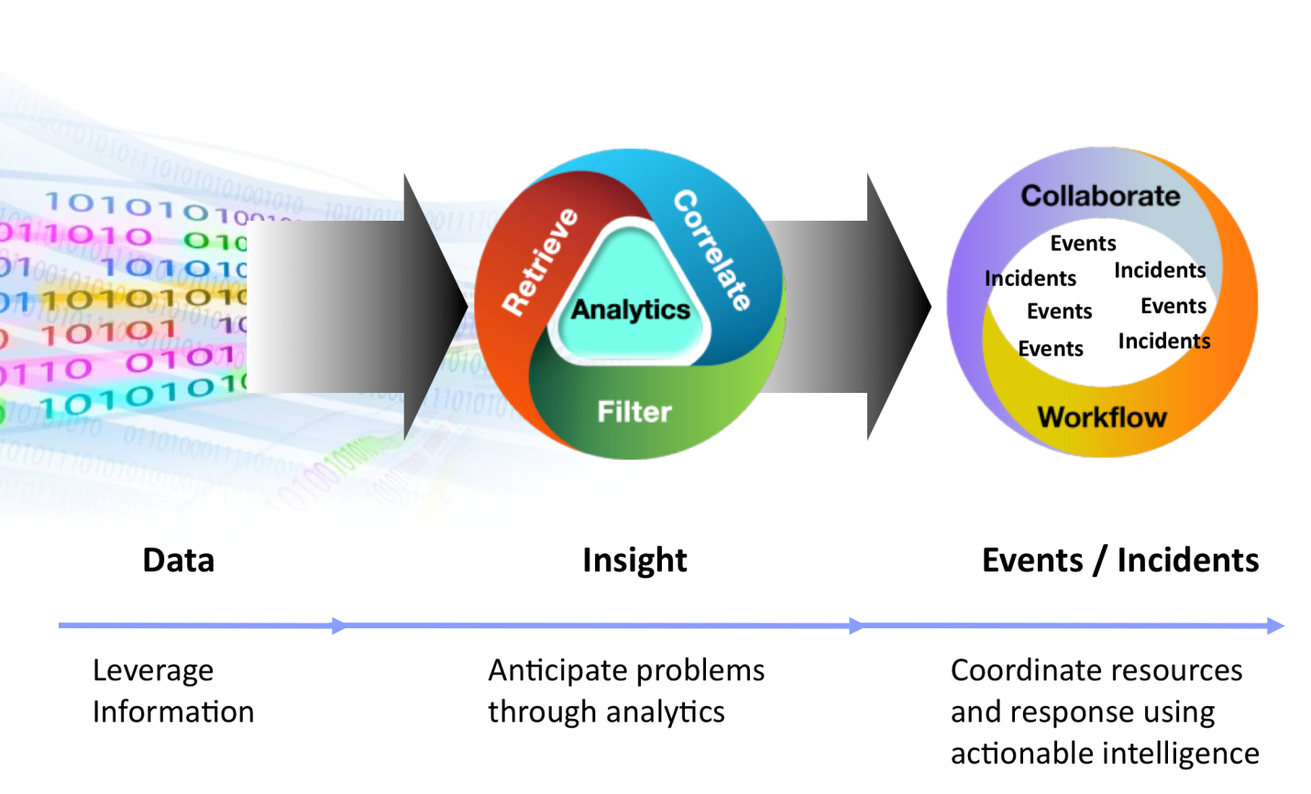

The BuildLA RFP identifies the pains of the growing veracity and velocity of information across departments, partners, and citizens. Stated vision includes desire for cross department workflow capabilities, location awareness, and reporting ranging from city leaders to supervisors. IBM’s complex event processing and correlation capability enables goals to be met by ‘listening’ to existing and new information streams to determine workflow statuses, service level agreement tracking, and automated response and escalation in near real-time providing the level of service citizens are just now starting to expect.

IBM Intelligent Operations for citywide operations improves operational outcomes by enabling smaller, more granular, course corrections holistically at the city wide level with ease and elegance not possible with workflow or BPM systems.

The operational efficiency chart below depicts various city wide sources which can include social media, internal systems, external systems, government alerts, and electronic sensor information as an input.

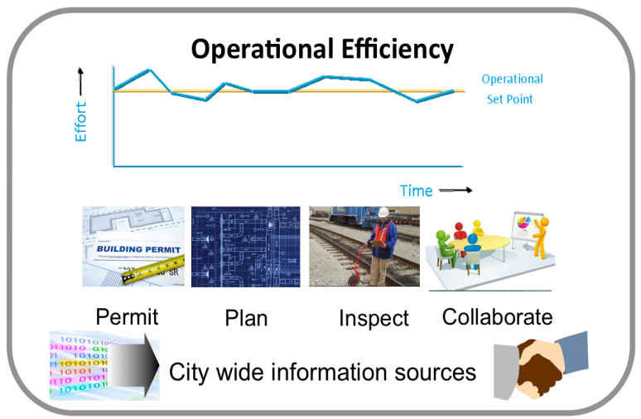As information is available to IBM Intelligent Operations for city wide operations complex event processing enables up to the moment correlation that automatically extracts important events out of all what going on, and where, across the city improving accuracy and city worker productivity.

City wide service level agreement dashboard, historical reports, and alert notifications ensure city supervisors, managers, and city executives have up to the moment awareness of what’s going on across city departments.

Automated actions can include alert notification and escalation, system to system directives, and invoking of standard operating procedures, all without requiring modification to existing system processes or workflow. This results in an elegant information based intelligent systematic approach that enables future inclusion of expert systems, such as IBM’s Watson, to continually increase speed and efficiency of operational efficiency though reason, prediction, and continual system based learning.

Infor products mark the debut of an entirely new category of business software, conceived from today’s flexible open standards and delivered through an agile, unbreakable architecture that gives customers the speed, freedom, and power they’ve always wanted— but couldn’t get until now. With the Infor suite, we’re reimagining business software to change the way work is done in the industries we serve.

***Infor is the world’s third-largest supplier of enterprise applications and services, helping more than 70,000 large and mid-size organizations improve operations with software solutions that change the way you work.***

We’re building industry suites that deliver maximum value quickly, with features tailored to the specific needs of each industry. By creating revolutionary lightweight middleware technology, and new ways to implement and integrate business software, Infor helps cities leap over traditional application boundaries to improve performance and streamline workflow.

Infor Public Sector software is designed specifically to meet the needs of state and local governments, and municipal authorities. Our portfolio of local government software solutions, which leverage more than 30 years of Infor expertise in the public sector, are being used by more than **1,000 local and state governments**, and municipal authorities worldwide to successfully address their information technology challenges. Infor Public Sector software combines functional capabilities specially designed for a government business processes and several strategic Infor enterprise solutions to create a single platform for the optimization of assets and delivery of high-quality, day-to-day government services.

Infor combines focused, hands-on industry experience with global breadth to help cities deal with today’s challenges and prepare for tomorrow’s opportunities. We offer deep industry-specific applications and suites that are engineered for speed and use groundbreaking technology to deliver a rich user experience. Our applications also feature flexible deployment options that allow customers to run their businesses in the cloud, on- premise, or both.



**Infor is a leading provider of automated Permit, Licensing, Code Enforcement, and Customer Service applications in the United States, processing more than 1,000,000 permit applications, licenses, and inspection requests every year.**

Infor has more than 29 years of experience in providing government agencies with software solutions to meet their regulatory and citizen demands. Infor Public Sector Community Development & Regulation (CDR) software is successfully implemented in other large, complex agencies in the cities of New York, Chicago, Vancouver, Seattle, and Boston.

Infor offers customers the benefits of a global company with local presence and experience.

* 2.8 Billion Annual Revenue
* 70,000 Customers
* 168 Direct Offices
* Implementation and Support Capabilities in over 194 Countries
* 12,400 Worldwide Employees



***Avolve Software is the market leader for ePlan submission, review, and tracking solutions.***

Cities, Counties, States, and Universities of all sizes across the U.S. work with Avolve Software using the ProjectDox ePlan solution as a comprehensive system for digital plan submittal, plan review business process management, and plan file management and storage. Avolve/ProjectDox is known for its customer support as well as its comprehensive product capabilities, flexibility, scalability and ease of use.

The Avolve Professional Services team has logged tens of thousands of man hours working with many different government departments to design and implement custom processes and enable data interoperability between disparate systems. We have amassed unparalleled experience and are completely dedicated to continuing to deliver the de-facto ePlan standard for state and local government.

An independent review conducted on behalf of the nation’s fourth largest city confirms our expertise when in summarizing its findings regarding ePlan offerings it says the following:

***“Avolve expressed a clear understanding of the City’s business processes and challenges and demonstrated a proven product solution to address their needs”.***

Perhaps the best example of the dynamic way that ProjectDox ePlan can change a city’s environment and enhance services is by a recent case study completed on one of Avolve’s customers, Salt Lake City, Utah:

**The Situation**

The economic recession slowed construction and business development in Salt Lake City, Utah, as it did in much of the United States. City officials could, however reluctantly, accept that. What they couldn’t accept was the possibility that they were making matters worse for themselves, their taxpayers, and the developers and investors who were considering projects in their city—and that they might be losing major businesses to other locales.

**The Solution**

Salt Lake City adopted ProjectDox® as their solution for a highly secure, online site for engineering plans/drawings and document sharing. The site provides change notification, threaded discussions, change history tracking, and markup collaboration for electronic design and construction plan submission. Avolve worked with the city and the permitting software provider to create a seamless integration and automated workflow process. “The fact that we save our customers the time and trouble of multiple trips to our office is a huge benefit for them,” says Nole Walkingshaw, Planning Program Supervisor for Salt Lake City. “The contractors or developers can sit in their offices, and upload their documents to us with a few clicks on the computer. And they have one place to go when they want to review their submissions and our comments and reports on them. It’s revolutionary for a city to conduct its permit process this way. We have customers telling us all the time, ‘Are you sure I don’t need to bring something down to your office?’ “What we’re getting with the ProjectDox solution isn’t just the latest and greatest technology**,”** says Kent Overly, Technology Consultant for Salt Lake City. ***“It’s the latest and greatest technology applied directly to the business pains we felt as a city government trying to provide the best possible service to our customers.”***



TruePoint Solutions is a California Certified Small Business Enterprise with extensive Infor/Hansen Experience.

* California Certified Small Business Enterprise (SBE) with products and services entirely focused on local government
* Over 450 years of public sector IT experience, with 150+ years of that experience with the Infor/Hansen product.
* Delivery team is comprised of Implementation Specialists whose experiences with Land Management/Permitting solutions are unparalleled
* Proven record of successful land development permitting projects over the last two decades.



Excelerate Consulting is a California Certified Minority Business Enterprise and Women’s Business Enterprise Los Angeles-based firm.

* Certified Minority Business Enterprise (MBE) and Women’s Business Enterprise (WBE) firm based in the City of Los Angeles
* Extensive vertical experience in designing, developing and implementing permits and planning systems in large scale enterprise environment in the public sector
* Led the design and development of Automated Permits and Planning System (APPS) in use today in Orange County
* Extensive experience in Community Development Regulations (CDR) workflow design and implementation

**The Right People for BuildLA**

Bringing premier companies together only benefits the City of Los Angeles if they are able to dedicate their top talent to this initiative. A project of the size and complexity of BuildLA requires the “A Team” of staff with the right backgrounds and a proven track record of success. All of our proposed staff members have deep experience in their respective domains.

Our proposed **Program Manager**, Syamlal Nair, certified project management professional (PMP), will be responsible for overseeing and ensuring the success of the project. Syamlal has significant experience in the management of large fixed price systems integration projects involving a variety of methodologies, technologies and architectures.

**Our Project Manager**, Dr. Patricia Dues, is a certified PMP and has a doctorate in Management in Organizational Leadership with a focus on Information Systems and Technology (DMIST). She has extensive experience on large complex projects that require engagement of diverse stakeholders from across the organization. Patricia has over 15 years’ experience in city government technology and leading the design and implementation of land use management and permitting systems.

**Our Technical Lead**, Steve Alexander, will provide leadership for our Technical Team, and he brings over fifteen years of experience implementing the Infor CDR and Avolve ProjectDox solutions for major cities across the country.

**Our Functional Lead** is Paula Whittemore-Montoya, who brings 17 years’ experience in large-scale project implementations for land permitting solutions in multiple cities and counties in California and other states.

**Our Transition Deployment Lead**, Douglas Witherspoon, will manage all aspects of BuildLA project implementation, and brings over 20 years of experience in land use and permitting, and large enterprise technology solution deployment.

Our **Training Lead**, Nicole Thorne, has 11 years of experience implementing the Infor and Avolve solutions and has provided training to agencies throughout North America.

Team UST’s core team has a combined 78 years of experience with business license and permitting systems. Their expertise and experience, along with that of the other team members, ensures the City will benefit from several large, successful license and permitting system implementations. Team UST’s commitment to our clients’ needs has allowed us to build long-term, trusting and loyal relationships. Lessons learned from previous projects of the same size and scope will be crucial for successfully completing the BuildLA project. People are the key to our success and yours, and we are confident that our experienced team will deliver for you. We propose the right people for the project.

**The Right Solution for BuildLA**

Team UST’s BuildLA solution does not merely meet your minimum requirements. We will revolutionize constituent interactions with the City portal and City staff collaboration on constituent services. Our solution foundation is a world class, user experience focused portal for citizens/customers and the robust Team UST for City staff.

The Team UST BuildLA solution supports a full array of permitting, planning, licensing and code enforcement needs encompassing all those listed in the RFP and more. Our BuildLA solution is a completely configurable application that allows agencies to tightly map their business rules to the workflow engine. The system can be configured to incorporate policies and procedures from regulations and statutes into the workflow engine without custom programming. Even after formal implementation, the system’s flexible tools will allow the City to easily configure the application to meet changing and regulation.

The BuildLA solution provides the backbone for City process innovation, but the best innovations come from cross-department interactions. We need to connect people and data to drive transformation. IBM’s Connections Suite, which is part of our solution, allows community configurable activities such crowdsourcing, forums, activities, Wikis, schedules, and file sharing (including version control). Connections will power this cross-department collaboration by providing a social networking engine to directly connect City staff to the right internal experts, Infor CDR transactions, and process data to transform government.



**Seamless Integration**

To complement Infor CDR, our solution includes Avolve’s ProjectDox for industry-leading electronic plan review, editing, and collaboration. Proven, seamless integration with Avolve’s ProjectDox eliminates the need for reviewers to go into multiple systems to do their job. They can review, mark up plans, and communicate with applicants all through ProjectDox while other City staff can view the progress and communications purely in Infor CDR.

ProjectDox works hand-in-hand with Infor CDR, providing additional paperless workflow and review functionality. ProjectDox provides a robust document management capability and eliminates the massive amounts of paper around plan review and approval. ProjectDox provides the ability to upload building plans without printing, saving money on printing fees. ProjectDox functions as a document management solution that can replace multiple, expensive products. Unlike other solutions, ProjectDox provides side-by-side and overlay comparison views that can easily show the difference between plans and changes over time.

Our solution includes integration with IBM’s Smarter Cities workflow analytics capabilities. Smarter Cities brings truly cutting edge analytics offering City staff views into disruptions in the workflows and potential bottlenecks with workloads.

In architecting our proposed solution, Team UST used its in-depth understanding of the needs of the City and used the following criteria in determining the optimal solution for the new BuildLA:

* **Citizen Customer Experience**: Team UST will deliver the ultimate user experience to the City of Los Angeles - creating software constituents and employees want to use. We are not giving an existing solution a facelift; we are delivering a foundation for participatory and open government as well as knocking down internal silos to facilitate innovation.
* **Collaboration**: Macro-workflows cannot depend purely on automation; people still need to interact to provide the best customer experience. People and groups who may not know each other still need to work together. Infor Ming.le and IBM Connections will revolutionize how people from different departments work together using social collaboration to redefine workflow.
* **Performance**: any of the technical decisions made in the design of this architecture were driven by strict response time requirements for user interactions. We have architected our system so that it provides the truly responsive performance that your stakeholders require.
* **Availability**: We recognize the mission-critical nature of this application and have architected it to provide an availability of 99.9% up-time. This adds significant additional costs in server hardware and associated software licensing, but we understand that BuildLA MUST be a system that is always there when your constituents and employees need it!
* **Scalability**: Our experience with Los Angeles public sector systems informs us that the BuildLA application will likely be in use in the City for decades. As such, we have architected our solution to provide the maximum possible levels of scalability. All sub-systems can either be scaled up or out to accommodate an increase in the number of users of the system or an increase in the number of transactions.
* **Security**:We understand the critical need to protect the BuildLA system from malicious, fraudulent and illegal tampering. To this end state-of-the art security technology has been used throughout the system.

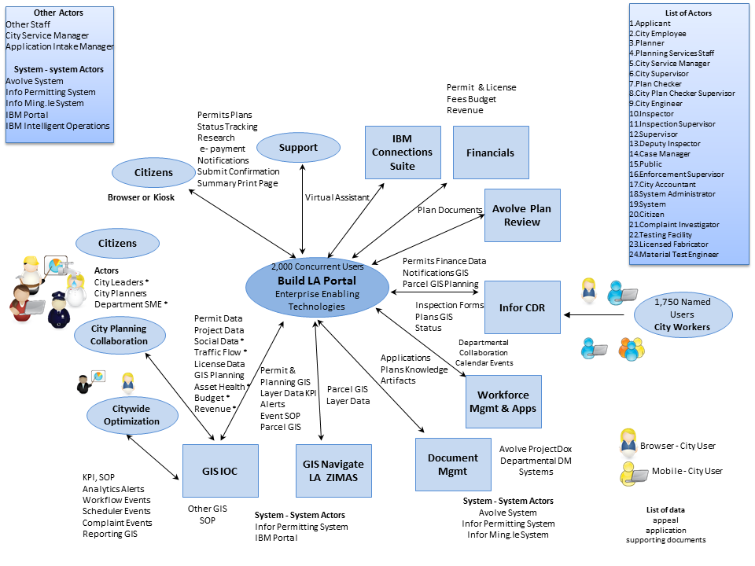

Proposed BuildLA Conceptual Architecture.

Solution Highlights

* A sophisticated Public Portal using IBM’s Intelligent City Planning and Operations IOC Platform and WebSphere Portal tailored to the needs of the City of Los Angeles
* Sophisticated workflow management capabilities built into the BuildLA database
* Industry-leading Electronic Plan Review software from Avolve’s ProjectDox solution

A Flexible Solution with the Ability to Expand to Meet the City’s Needs

The Team UST Permitting and Workflow Management (PWM) Solution incorporates all of the City of Los Angeles’ Portal, Workflow Management and Electronic Document Review requirements as specified in the BuildLA RFP as illustrated in our proposed BuildLA Conceptual Architecture above.

The PWM solution is built on the IBM Intelligent City Planning and Operations IOC Platform and WebSphere Portal integrated with Infor’s Community Development & Regulation (CDR) and Avolve Software’s ProjectDox (electronic plan review) applications.

Our solution will meet the City’s vision of providing end-to-end services that allow customers, homeowners and developers to interact with the Department of Buildings & Safety, Department of City Planning, Department of Public Works, Department of Transportation, Fire Department, Department of Water & Power, Housing Department, Office of Finance and Department of Recreation & Parks.

**The Right Approach for Build LA**

With Team UST’s deep understanding of the City of Los Angeles, large-scale systems integration projects, and the permitting and licensing domain, we are uniquely qualified to fully understand the size, scope and magnitude of the BuildLA project. We understand the complexities and risks inherent with a project of this size and understand what it takes to develop a plan and approach that will deliver the BuildLA system on time, within budget and with lower risk.

Beyond the 14 year proven track record with Global 1000 clients, UST Global has extensive experience in designing and implementing business solutions and the software that supports them. We have evolved a set of standard methods and practices over the 14 years of our continuous operation that are time tested through practice and regularly updated with industry standard practices and techniques.

Team UST has successfully delivered hundreds of information technology projects using best practices for project management and commercial product integration. We follow a strict set of project management guidelines to confirm that UST Global, together with the client management team is working collaboratively to manage and deliver solutions on time and effectively. UST Global is proposing a phased implementation approach that delivers quick “wins” to the City while minimizing risks inherent in the implementation of a significant undertaking like BuildLA. After a rigorous requirements confirmation phase, we will systematically implement core capabilities for each of the functional areas identified in the RFP. UST Global believes this approach mitigates the project risks associated with a major system replacement project.

Our project management approach and methodology is based on the generally accepted principles and standards developed by the Project Management Institute (PMI), and the Project Management Body of Knowledge (PMBOK). Our guidelines extend the PMBOK framework including detailed task guidelines, task specific tools and techniques, and UST Global Project Management templates.

The methodology is specifically designed to actively engage the City’s subject matter experts (SMEs) in applying the leading practices built into Infor CDR to the City’s business rules. Our iterative approach utilizes prototypes early in the requirements gathering stage to visually demonstrate how the business requirements and rules gathered from the SMEs are translated into a functioning system. Our process incorporates the following high-level principals:

* Early engagement of stakeholders and users
* Iterative configuration that includes specifications, configuration, and testing for a sub-set of permit/ case types
* Focus on user and technical training
* Knowledge transfer to client staff

Team UST has developed a detailed Work Plan based on the information and requirements provided in the RFP. However, at the outset of this project, the Project Manager will work collaboratively with the City’s project manager and other stakeholders to complete a Project Management Plan and a refined Project Work Plan. The Plan will be used throughout the project to control the scope, schedule, and quality of the project objectives. In addition to adhering to rigorous project management disciplines, Team UST’s approach also includes the following system implementation disciplines that we find critical to a project’s success:

* Stakeholder Identification and Expectation Management: Stakeholders will be identified early in the project so their expectations can be documented and managed.
* Progress Monitoring and Reporting: Clear status/ progress reporting processes will be utilized to note and address early indications of variances.
* Issue Management: The Project Manager will institute a formal and rigorous process for the identification, documentation, and management of issues on the project.
* Issue Escalation: Issues that are not resolved within the project team according to Team UST’s issue management process will be escalated according to a pre-defined set of rules
* Change Control: Change control is an integrated process used to manage and document change to deliverables, specifications, and/or project plans.
* Risk Management: The Project Manager will ensure that risks are identified and appropriate risk management plans are put in place to react to them.

**An Ideal Partnership for BuildLA**

The BuildLA project represents the culmination of nearly a decade of planning and developing a vision for the future of permitting and land use management in Los Angeles.

We believe that the BuildLA project will set the standard across the Country. Team UST shares your vision and passion for constituent-centric, participatory government. This passion is reflected in the team we have proposed, the solutions and methodology we will utilize, and in the user experience we are bringing.

Team UST will deliver the ultimate user experience to the City of Los Angeles—creating software that people want to use and changing the way your citizens and staff interact. Our team is committed to BuildLA’s success and to delivering the best possible solution, reflecting the quality of our people, processes, unmatched technology, and relevant experience.

Together, the City of Los Angeles and Team UST can drive operational efficiencies, reduce costs, increase revenues, and improve customer satisfaction through the collaborative environment embedded throughout our solution.

Our record of consistent high performance, customer satisfaction, and timely implementation is also unequaled and is demonstrated in part by our client retention rate of 95% over the past 14 years. We have met all our start-up dates; met or exceeded all our contract obligations; and established positive, lasting working relationships with our clients. In all our contracts, we have worked to reduce our clients’ costs while improving service quality. The City’s success is our success, and we stand confident, capable, and ready to deliver the high-quality services and solution required by the City for BuildLA.



# Proposed Solution Requirements (RFP 3.1)

## Functional Requirements (RFP 3.1.2.2)

We understand that the City of Los Angeles is looking for innovative ways to streamline and improve enterprise-wide permitting by creating better collaboration and information sharing between the Building and Safety, City Planning, Public Works and other key areas of City Management.

Team UST is recommending a BuildLA solution that will offer Cross Agency Coordination, Decision Support, Citizen Services and Performance Management capabilities designed to address the business challenges identified in the BuildLA RFP. Team UST’s BuildLA solution incorporates all of the City of Los Angeles’ Portal, Workflow Management and Electronic Document Review requirements as specified in the BuildLA RFP. The BuildLA solution is built on a combination of IBM’s Intelligent City Planning and Operations, Infor’s Public Sector suite of applications, and Avolve Software’s ProjectDox application to meet the City of LA’s vision of providing end-to-end services that allow customers, homeowners and developers to interact with the Department of Buildings & Safety, Department of City Planning, Department of Public Works, Department of Transportation, Fire Department, Department of Water & Power, Housing Department, Office of Finance and Department of Recreation & Parks. This advanced software solution has been designed specifically to streamline City processes and better manage complex community development and regulatory processes.

Our BuildLA solution uses a common platform with the fusion of data from different and separate sources to improve communication and collaboration across departments, with vendors, and with the public. Infrastructure planners can efficiently create more accurate infrastructure plans. Permit managers can make quicker and more accurate decisions about permit applications. Analysts and investigators can collaborate to find and remediate unlicensed businesses. And City executives and managers can use the solution to encourage collaboration and to oversee activities that span multiple departments. This will facilitate the integration of city data for a holistic view of permit activity and more timely and accurate responses to requesters. It will also allow them to analyze past and present permit applications, traffic assessments, and crime patterns, as well as provide greater understanding regarding patterns to constantly improve the quality of decisions being made. Of equal importance, our solution will help the City of Los Angeles successfully identify areas of lost or missed revenue, thereby increasing income. City agencies will be able to analyze data from a variety of sources, such as city permits, taxes and business records, to identify unlicensed businesses or fraudulent business practices.

Figure 1.1-1 summarizes how the Team UST BuildLA solution meets the functional requirements. Please refer to *Section 1.5.1* of this Proposal (Functional Solution Narrative) and the attached document *Appendix C.1* for a more detailed response.

|  |  |  |  |
| --- | --- | --- | --- |
| Functional Requirements | | | |
| Portal | **✓** | Mobile | **✓** |
| Intake | **✓** | Issuance | **✓** |
| Entitlement | **✓** | Enforcement | **✓** |
| Application Processing | **✓** | Licensing | **✓** |
| Plan Review | **✓** | Other | **✓** |
| Inspection | **✓** | Universal Project ID | **✓** |

Figure .1-1: Our Solution Meets All Functional Requirements.

### Functional Requirements Response Matrix (RFP 3.1.2.2

Please see the attached document *Appendix C.1,* Functional Requirements Response Matrix in *Section 5* of this volume.

## Technical Requirements (RFP 3.1.2.3)

Please see the attached document *Appendix C.2,* Technical Requirements Response Matrix in *Section 6* of this volume.

## Proposer Experience (RFP 3.1.3)

### Minimum Qualifications Response Matrix (RFP 3.1.3.1)

*Appendix E.1*, Minimum Qualifications Response Matrix is included below.

Appendix E.1 – Minimum Qualifications Response Matrix

| **Proposal Item** | **Vendor Agrees to Meet?** | | **Reference to Proposal Response Section** |
| --- | --- | --- | --- |
| **Minimum Proposer Qualification Requirement 1:** The Proposer must supply two (2) references that verify that the Proposer (Prime Contractor or Subcontractor) has designed, developed, tested, and successfully implemented **a complete, integrated permitting and land use management solution including workflow** within the last five (5) years for a paying customer external to the Proposer's organization. | **YES** | **NO** | **Section 1.4.1.2** |
| **Minimum Proposer Qualification Requirement 2:** The Proposer must supply two (2) references that verify that the Proposer (Prime Contractor or Subcontractor) has designed, developed, tested, and successfully implemented a **complete, integrated electronic plan review solution** within the last five (5) years for a paying customer external to the Proposer's organization. | **YES** | **NO** | **Section 1.4.1.3** |
| **Minimum Proposer Qualification Requirement 3:**  **Option A:** The Proposer must supply one (1) reference that verifies that the Proposer (Prime Contractor) has designed, developed, tested, and successfully implemented a **solution of similar size, scope, and complexity to the BuildLA Project** within the last five (5) years with a contract value over $5 million in one-time total project costs for a paying customer external to the Proposer's organization. | **YES** | **NO** |  |
| **OR** | | |  |
| **Option B:** The Proposer must supply one (1) reference that verifies that the Proposer (Prime Contractor or Subcontractor) has designed, developed, tested, and successfully implemented a **complete, integrated portal solution for permitting and land use management** within the last five (5) years for a paying customer external to the Proposer's organization. | **YES** | **NO** | **Section 1.4.1.1** |

* **Proposers must satisfy Requirement 1, Requirement 2 and at least one (1) of the Optional Requirements (Option A or Option B) under Requirement 3.**

**Failure to respond with Response Code “Y” to any of the minimum mandatory requirements may result in the Proposal being rejected.**

* **For each project reference, the Proposer must complete a Proposer Experience Reference Form** **(Appendix E.2, Proposer Experience Reference Form). Proposer must clearly indicate on this form which Requirement number the reference satisfies (e.g., 1, 2, 3A or 3B) and whether the reference is for the Proposer or a selected subcontractor.**

### Experience Reference Form (RFP 3.1.3.1)

Please see the attached documents *Appendix E2* in sealed packages from the referring customer organizations. *Figure 1.3.2-1* shows the referring customers and reference requirements satisfied for each of the completed references.

|  |  |  |  |
| --- | --- | --- | --- |
| **Name of Customer Organization** | **Reference Requirement(s) Satisfied** | **Prime or Subcontractor Reference** | **Name of Subcontractor** |
| City of Las Vegas, Nevada | 1 and 3B | Subcontractor | Infor Public Sector, Inc. |
| City of Boston, Massachusetts | 1 and 3B | Subcontractor | Infor Public Sector, Inc. |
| City of Buffalo, New York | 1 | Subcontractor | Infor Public Sector, Inc. |
| City of Las Vegas, Nevada | 2 | Subcontractor | Avolve Software Corporation |
| City of Boston, Massachusetts | 2 | Subcontractor | Avolve Software Corporation |
| Salt Lake City, Utah | 2 | Subcontractor | Avolve Software Corporation |

Figure 1.3.2-1: Summary of Proposer Experience Reference Forms Submitted.

### Team UST Solution Providers for BuildLA (RFP 3.1.3.1)

The City of Los Angeles has made it clear in their RFP that they are looking for a customized solution tailored to the unique BuildLA requirements. Achieving the ambitious vision that the City has established will require a closely integrated team of permitting and land use experts, design experts focused on user experience, and solutions that have been proven at complex city governments across the United States.

Team UST brings these capabilities with the proven team of UST Global, IBM, Infor, Avolve, TruePoint Solutions, and Excelerate Consulting. Our team includes premier solution providers who bring the best in portal development, workflow management, and electronic document review solutions to BuildLA. Our partners bring expertise gained from implementing multiple large municipal government permitting projects across the county. For example, the City of Portland recently selected Infor’s CDR and Avolve’s ProjectDox after an extensive evaluation and demonstration process similar to the process undertaken by the City of Los Angeles. Our partner Avolve had a successful ProjectDox ePlan pilot with the City before this RFP was initiated and we can use that experience in this project going forward.

* **UST Global** is a leader in effectively brining innovation to our client engagements. We are committed to helping the City to achieve its business objectives by leveraging the latest in technology and innovation. We were awarded Business World’s “International Business Award for Innovation – 2012” for our outstanding capabilities in this area. UST Global will provide overall project management, architecture, and systems integration. UST Global has been involved in and has successfully executed similar web application implementation projects for our Fortune 500 clients, including H&R Block, KPMG, Wells Fargo, Disney, Warner Brothers, Sony Pictures, WellPoint, Costco, Dell, HEB, and Walmart. As the prime contractor, UST Global will leverage “lessons learned” from our experiences to execute this project successfully.
* **IBM** brings its Intelligent Operations Center (IOC) Platform and WebSphere Portal to our BuildLA solution. IBM is a leading provider of Smarter Cities solutions including the proposed IOC platform, a smarter cities solution that allows the City to implement a targeted solution for permitting and licensing, while establishing a foundation that will accelerate other city use cases in areas such as transportation management, public safety, and more.
* **Infor** **Public Sector** will provide its Community Development & Regulation (CDR) software and services to deliver a complete, integrated permitting and land use management solution including workflow. Infor is a leading provider of automated Permit, Licensing, Code Enforcement, and Customer Service applications in the United States, processing more than 1,000,000 permit applications, licenses, and inspection requests every year. Infor has more than 29 years of experience in providing government agencies with software solutions to meet their regulatory and citizen demands. Infor Public Sector CDR Software is successfully implemented in other large, complex agencies in the cities of New York, Chicago, Vancouver, Seattle, and Boston.
* **Avolve Software** will provide its ProjectDox ePlan solution and services for our complete, integrated electronic plan review solution. Cities, counties, states, and universities of all sizes across the U.S. work with Avolve Software using the ProjectDox ePlan solution as a comprehensive system for digital plan submittal, plan review business process management, and plan file management and storage. Avolve/ProjectDox is known for its customer support as well as its comprehensive product capabilities, flexibility, scalability and ease of use.
* **TruePoint Solutions** will provide subject matter experts for BuildLA. TruePoint is a California Certified Small Business Enterprise (SBE) with products and services entirely focused on local government. They bring over 450 years of public sector IT experience, with 150+ years of that experience with the Infor/Hansen product. Their delivery team is comprised of implementation specialists whose experiences with Land Management/Permitting solutions are unparalleled.
* **Excelerate Consulting** will provide implementation services for BuildLA. They are a California Certified Minority Business Enterprise (MBE) and Women’s Business Enterprise (WBE) Los Angeles-based firm. They bring extensive experience in designing, developing and implementing permits and planning systems in large scale enterprise environment in the public sector, and deep experience in CDR workflow design and implementation.

Together, our team brings premier solutions, proven expertise, and depth of resources no single firm can match.

### Staff Qualifications (RFP 3.1.3.2)

The following section includes resumes of our key staff proposed for this engagement. We have designated six members of our team as key:

Our proposed **Program Manager**, Syamlal Nair, certified project management professional (PMP), will be responsible for overseeing and ensuring the success of the project. Syamlal has significant experience in the management of large fixed price systems integration projects involving a variety of methodologies, technologies and architectures.

**Our Project Manager**, Dr. Patricia Dues, is a certified PMP and has a doctorate in Management in Organizational Leadership with a focus on Information Systems and Technology (DMIST). She has extensive experience on large complex projects that require engagement of diverse stakeholders from across the organization. Patricia has over 15 years of city government technology and leading the design and implementation of land use management and permitting systems.

**Our Technical Lead**, Steve Alexander, will provide leadership for our Technical Team, and he brings over fifteen years of experience implementing the Infor CDR and Avolve ProjectDox solutions for major cities across the country. He is certified in both Infor CDR and Avolve ProjectDox solutions.

**Our Functional Lead** is Paula Whittemore-Montoya, who brings 17 years’ experience in large-scale project implementations for land permitting solutions in multiple cities and counties in California and other states.

**Our Transition Deployment Lead**, Douglas Witherspoon, will manage all aspects of BuildLA project implementation, and brings over 20 years of experience in land use and permitting, and large enterprise technology solution deployment.

Our **Training Lead**, Nicole Thorne, has 11 years of experience implementing the Infor and Avolve solutions and has provided training to agencies on the Infor CDR and Avolve ProjectDox implementation throughout North America.

Team UST’s core team has a combined 78 years of experience with business license and permitting systems. Their expertise and experience, along with the experience of our other team members, ensures the City will benefit from several large, successful license and permitting system implementations. Team UST’s commitment to our clients’ needs has allowed us to build long-term, trusting and loyal relationships. Lessons learned from previous projects of the same size and scope will be crucial for successfully completing the BuildLA project. People are the key to our success and yours, and we are confident that our experienced team will deliver for you. We propose the right people for the project.

**UST Global is a certified IBM Smarter Cities partner, and we have more staff trained and certified in the IBM Smarter Cities solution than any other company.**

**We are a designated Infor CDR partner, and our technical and functional team has mapped the Infor CDR solution and Avolve’s ProjectDox to BuildLA requirements.**

To augment our key personnel, we bring highly qualified staff members from UST Global and our partners. We have also selected a number of our subcontractor staff who are highly experienced in our solution components, including members trained and certified on Infor CDR, Avolve ProjectDox, and IBM Smarter Cities solutions as part of our BuildLA Team.

| Resume of Syamlal Nair, Key Personnel (Program manager) | | |
| --- | --- | --- |
| Name: Syamlal Nair | | Proposed Position: Program Manager |
| Educational Background and Related Training | | |
| **Education:**   * B-Tech (Information Technology), Kerala University, 1995 * PMP – Project Management Professional, 2005; 2011 * MBA, Indian Institute of Management (IIM-K), 2012 * APICS (Supply chain/IIMB) * Retail Domain Certifications(IIM-A) | | |
| Special Experiences, Qualifications and/or Certifications | | |
| * 18 years in information technology (IT) with deep experience in delivery, account management, and project management in a number of domains including media, retail, and manufacturing. * Heading the global delivery for retail and media verticals in UST Global for the past two years, covering 20 accounts with a combined strength of 1,200 people and 80 million in revenues. * Took over the business development function in addition to delivery for the retail vertical from May 2013. Manages the sales team from offsite with quarterly visit to onsite locations. * Managed delivery for a wide variety of services spanning from mobility, very large development engagements, production support infrastructure, validation & verification, and packaged software implementations. * Dealt with a wide variety of customers, mostly in the fortune 500 space inclusive of CIO level interactions. * Have built delivery organizations from the ground up with new customers and in new technology/service areas and grown them to sizable strength. * Experienced in moving accounts up the value chain starting from staff augmentation engagements and moving to managed projects. * Experienced in starting engagements with contractors at onsite and migrating to own employees at onsite and offsite. * Ran key initiatives during my two year human resources (HR) position including performance management, defining role structure with well-defined career paths, working with consultants to identify the right package for HRMS and managing its implementation program, and outsourcing operational activities within HR. | | |
| Related Professional Job Experience | | |
| **Position Title:** | Project Manager | |
| **Company Name:** | UST Global | |
| **From: Jan/2012** | | **To: Present** |
| **Responsibilities and Accomplishments:**   * Run projects from design and development to production managing client resources and various vendor resources * Create strategies for risk mitigation and contingency planning. * Plan and schedule project deliverables, goals, and milestones. * Direct and oversee project engineering team and manages conflicts within group. * Negotiate service and operations level agreements between co-operating teams. * Drive the annual budget process for delivery. | | |
| **Position Title:** | **Transition Manager/Associate Project Manager** | |
| **Company Name:** | **UST Global** | |
| **From: Nov/2011** | | **To: Jan/2012** |
| **Responsibilities and Accomplishments:**   * Create Run book, Procedure Manual and Outcome measurement plan * Define all SLA deck and templates * Review SOW, Coordinate with Delivery Manager and suggests updates to SOW. * Create Function Point approach document and pilot FP for one of the applications | | |
| **Position Title:** | **Associate Project Manager** | |
| **Company Name:** | **UST Global** | |
| **From: Jan/2011** | | **To: Nov/2011** |
| **Responsibilities and Accomplishments:**   * Responsible for the planning of all the work in the track using MPP and Task tracker tool(abacus) * Responsible for the all the deliverables and communications from the Development track which involves Design thru Unit Testing of all projects executed in Dental division. * Generation and validation of the SLA report, and presentation of the report to client. * Resources management including identification, allocation and training and guiding them as a team player to ensure project, process and product quality | | |
| **Position Title:** | **Technical Manager** | |
| **Company Name:** | **UST Global** | |
| **From: May/2010** | | **To: Dec/2010** |
| **Responsibilities and Accomplishments:**   * Responsible for reviewing design Documents, Unit Test Plan and Unit Test Results of the team members. * Created MPP, estimates, mentor the team members in domain and technical related areas. * Responsible for Onsite-Offsite coordination. | | |

**A copy of Syamlal Nair’s current PMP Certification is attached to his Staff Experience Reference Form.**

| Resume of Dr. Patricia M. Dues , Key Personnel (Position) | | |
| --- | --- | --- |
| Name: Dr. Patricia M. Dues, DMIST, MBA, PMP | | Proposed Position: Project Manager |
| Educational Background and Related Training | | |
| **Education:**   * Doctorate in Management in Organizational Leadership with a focus on Information   Systems and Technology (DMIST) - *University of Phoenix, School of Advanced Studies*   * Dissertation: Quantitative Correlation of Enterprise Resource Planning Type, Success and Technology Leadership Style in Local Government - 2010 * Masters of Business Administration (MBA) - *University of Phoenix, Las Vegas, NV* * Bachelors of Arts (BA) in Psychology, minor in Business Administration - *University of*   *Washington, Seattle, WA*   * Associate of Arts (AA) - Belleville Area College, Belleville, IL   **Training:**   * Member, Board of Directors of the Oracle Applications Users Group (OAUG) – 2001 to present * Project Management Professional (PMP) – 2005 * Chair, International Oracle Users Council (IOUC), Global Support Committee – 2009 to present * Subject Matter Expert at Infor Public Sector Applications Conference - 2011 | | |
| Special Experiences, Qualifications and/or Certifications | | |
| * Technology and project manager veteran with extensive experience in public sector implementation of enterprise-scale applications that performed Permits and Planning, Electronic Plan Check Review, and Workflow management across various departments * Over 15 years of city government technology program and project management expertise ensuring quality assurance and service delivery * Large scale Oracle Enterprise integration with various city departments ensuring transparency and data availability in all departments. Integrated SAP project to streamline services and generate ad hoc reports on the fly. * Led and participated in the design and implementation of City Land Use Management System that was a top priority for the City Manager. The project was implemented on time and within budget at $5.5M. * Certified PMP since 2005 | | |
| Related Professional Job Experience | | |
| **Position Title:** | Manager, Information Technologies Program Management Applications Services | |
| **Company Name:** | City of Las Vegas | |
| **From:** Present | | **To:** 02/2009 |
| **Responsibilities and Accomplishments:**  Manage development of all web, intranet, geographical information systems (GIS), and business applications with emphasis on alternate service delivery and enterprise resource planning (ERP)   * Responsible for $8 million technology project portfolio * Implementation of Hansen in a large scale environment as part of the $8M project * Manage capital projects totaling $20 million * Manage staff of 30 project management and application developers * Implemented service delivery process that focuses on quality assurance for all applications development * Formed relationships with community partners to develop mobile technology applications * Established Service-Oriented Architecture (SOA) for Oracle enterprise systems * Support ERP environment and philosophy to implement city-wide * Led the initiative to standardize “best practices” throughout the city saving over $2M a year * Led a team to study process efficiencies through Lean Six Sigma methodologies that resulted in savings of over a $1M/year for the city | | |
| **Position Title:** | Program Manager, City Manager’s Office | |
| **Company Name:** | City of Las Vegas | |
| **From:** 02/2009 | | **To:** 12/1997 |
| **Responsibilities and Accomplishments:**  Served as the City’s Enterprise Project Manager with principal focus on the City’s commitment to Enterprise Resource Planning   * Managed projects with significant importance to the City Manager’s Office * Ensured senior management was kept informed of the project status * Employed a standard project management methodology * Managed a staff of project managers, trainers and administrative support * Led and managed projects varying in size from $8M to $12M | | |

**A copy of Patricia Due’s current PMP Certification is attached to her Staff Experience Reference Form.**

| Resume of Steve Alexander, Key Personnel (Lead Technician) | | |
| --- | --- | --- |
| Name: Steve Alexander | | Proposed Position: Lead Technician |
| Educational Background and Related Training | | |
| **Education:**   * B.S. in Business Management, Minor in Project Management (2004) * Organizational Management, Rio Salado (2013)   **Training:**   * Coaching for High Performance, American Management Association (2007) * Six Sigma, American Management Association (2008) | | |
| Special Experiences, Qualifications and/or Certifications | | |
| Proven project and leadership expertise in a career spanning over 15 years. Technically sophisticated professional reflecting strong leadership qualifications coupled with “hands-on” information technology expertise. Offer outstanding talents in team building, coaching, developing project scope (planning, controlling, and delivery), relationship building, process improvement, requirements solicitation, documentation, and communications. I am driven by new challenges and desire to be successful in all endeavors.  **Professional Certification**   * CSM, Certified SCRUM Master (2007) * CSP, Certified SCRUM Practitioner (2008)   **Public Sector Implementation Experience**   * City of LA * Sub workflow design and concept design for multiple departments * City of Boise * Building & Design Review * City of Phoenix * Building * City of Chicago * Building & Zoning sub workflow * Developer Services * City of Burbank * Building & Planning * City of Salt lake City * Building * Hillsborough County * Building and Site Plan * Marion County * Building & Design Review * City of Iowa City * Building & Planning * City of Las Vegas   + Pre Application & Planning Process * City of Riverside * Building & Planning * City of Palm Coast * Building & Land Development   **Public Sector Permitting System Integrations**   * Hansen 7 two-integration integration * Custom database level design * Hansen 8 two-integration * WCF and Hansen API * Tidemark * Custom database level design * Permit Plus * Custom database level design * Custom API integration * Acela Automation * GoxXML and EMSE scripting integration * CRW TRAKIT * Custom database level design * API * CDPlus * Custom database level design   **System Design Experience**   * Custom development of various workflow features * Outlook calendar appointments – client side * Custom checklist functionality for filtering and loading * Auto loading of markups to electronic form * Sub-workflow process design * Dashboard reporting * Custom online Application/Portal submittal forms * Planning Pre-Application * Building * Developer Services Appointment Request/Management Portal | | |
| Related Professional Job Experience | | |
| **Position Title:** | Principal Technologist | |
| **Company Name:** | Avolve Software | |
| **From:** 6/2008 | | **To:** Present |
| **Responsibilities and Accomplishments:**   * Lead the requirements definition, process mapping, design, user acceptance testing, end user training, and product launch for consumer-facing deployments across City and County entities. * Boosted customer productivity while leading cross-functional teams for design, development, and implementation of enterprise software/hardware solutions. * Streamlined critical workflow plan review processes to adhere to Government interaction policies and procedures based on best practices and industry knowledge * Elevated consulting team productivity and expedited customization schedules as a result of introducing standards and procedures in documented formats: * Requirements Questionnaires * Milestone Schedules * Product Management to provide technical direction for new deployments utilizing Microsoft Workflow Foundation and .NET development. | | |
| **Position Title:** | Business Intelligence Lead/ SCRUM Master | |
| **Company Name:** | Advertising Checking Bureau | |
| **From:** 5/2007 | | **To:** 6/2008 |
| **Responsibilities and Accomplishments:**   * Accountable for the coordinated management of multiple related projects directed toward strategic business and other organizational objectives utilizing the agile methodology. * Coached, mentored, and lead multiple cross-functional teams to improve their abilities in self-management and to take ownership of tasks for project success. * Responsible for user story creation, acceptance criteria, and communication as Product Owner with in multiple teams to deliver claim based applications. * Manage the business intelligence vertical; resulting in five direct reports in the areas of business analysis and quality assurance. Identified goals and training opportunities to ensure each employee had the tools necessary to succeed and provide value to the department/ company. | | |
| **Position Title:** | Project Manager/ SCRUM Master | |
| **Company Name:** | Altour Incentive Management | |
| **From:** 1/2006 | | **To:** 5/2007 |
| **Responsibilities and Accomplishments:**   * Responsible for the coordination, implementation, and completion of web-based, .NET, software applications in a hosted environment utilizing traditional/agile project management processes. * Championed the scrum process through meeting facilitation, cross-role collaboration, daily stand-ups, sprint planning, and sprint reviews. * Maintained continuous alignment of program scope with strategic business objectives, and made recommendations to modify the program to enhance effectiveness toward the business result or strategic intent. * Produced high-level requirements, user stories, and lead user acceptance testing for multiple global employee recognition /sales incentive programs | | |

| Resume of Paula Whittemore-Montoya, Key Personnel (Functional Lead) | | |
| --- | --- | --- |
| Name: Paula Whittemore-Montoya | | Proposed Position: Functional Lead |
| Educational Background and Related Training | | |
| **Education:**   * Bachelors of Science, Computer Science * Concentration: Programming and database management * University of California at Davis * Graduated: 1996 | | |
| Special Experiences, Qualifications and/or Certifications | | |
| During Paula’s 17 year career in the government sector, she has had the opportunity to fulfill many project roles: Project Director, Project Manager, Technical Lead/Developer and Data Conversion Manager/Developer. Her technical skills have allowed her to have highly successful project implementations.  **Qualifications and Certifications:**   * Programming Languages: PL/SQL, C++, Visual Basic, Cobol, Transact SQL * Database Platforms: Oracle 7-10g, Access 2.0/97/2000, MS SQL Server 7 - 2005 * Operating Systems: Windows NT/98/2000/XP/Vista * Office Applications: MS Project, Visio, MS Word, MS Excel, PowerPoint * Other Software: Crystal Reports, P/L SQL Developer, Hansen 5.x/6.x/7.x, Accela Automation Classic/V360, Kiva 7.x, gba Master Series 6.7x | | |
| Related Professional Job Experience | | |
| **Position Title:** | **Regional Services Manager** | |
| **Company Name:** | **TruePoint Solutions** | |
| **From: Jan/2007** | | **To: Current** |
| **Responsibilities and Accomplishments:**  Managed and worked on government specific projects with other Accela products and other software agencies, as well as with TruePoint Solution’s software.   * Act as the project manager, business analyst, configuration specialist, report developer, programmer and/or quality assurance specialist in solo or team projects. * Manage Project team * Develop conversion document, programs and test plans * Develop interface document, programs and test plans * Develop scripting specification, programs and test plans * Develop, maintain and implement project timelines and deliverables * Maintain system life cycle procedures and documentation * Manage end user support procedures and productivity   Notable successful projects include:   * San Diego County * City of Buena Park, CA * Gwinnett County, GA * Pinal County, AZ * Oceanside, CA * San Marcos, CA * Clackamas County, OR * El Paso, TX * Sacramento County * Peoria, AZ * Cleveland, OH * Ft Collins, CO | | |
| **Position Title:** | **Project Director** | |
| **Company Name:** | **Enabling Partners, LLC** | |
| **From: Month/Year: January 2005** | | **To: Month/Year: December 2006** |
| **Responsibilities and Accomplishments:**  Helped build Enabling Partners into a larger, more successful, company.  Responsibilities included:   * Acted as the project manager, business analyst, configuration specialist, report developer, programmer and/or quality assurance specialist in solo or team projects. * Developed, maintained and implemented project timelines and deliverables * Maintained system life cycle procedures and documentation * Managed end user support procedures and productivity * Built relationships with other companies. * Built standards for Enabling Partner’s government section. * Built a strong team of employees. * Managed employees within the Enabling Partner’s government section.   Notable successful projects:   * City of Buena Park CA * Mesa County CO * Oklahoma City OK * Butler County OH * Pinal County AZ * City of Kansas City MO * City of Bridgeport TX * City of Atlanta GA | | |
| **Position Title:** | **Project Director/Data Conversion Manager/** | |
| **Company Name:** | **Hansen Information Technologies** | |
| **From: January 1996** | | **To: December 2005** |
| **Responsibilities and Accomplishments:**  As Director of Projects, Paula Directed large-scale project implementations with teams of people composed of both company and client personnel.  As Data Conversion Manager, Paula was responsible for overall Productivity of data conversion department.  Responsibilities included:   * Developed cost analyses of all data conversion projects * Personnel management of all department employees * Maintained priorities for all projects within department * Conducted requirements analyses and developed test and document conversion solutions to facilitate the implementation of all Hansen Version 7.x modules   Notable successful projects   * City of Shoreline, WA * City of Las Vegas, NV * City of Riverside, CA * City of Chicago, IL * City of Peoria, AZ * Pima County, AZ * City of Nashville, TN | | |

| Resume of Doug F. Witherspoon, Key Personnel (Transition/Deployment Lead) | | |
| --- | --- | --- |
| Name: Douglas F. Witherspoon | | Proposed Position: Transition/Deployment Lead |
| Educational Background and Related Training | | |
| **Education:**   * Master of Arts in Organizational Management - University of Phoenix, Fountain Valley, CA 1999 * Bachelor of Science in Business Administration, University of Phoenix Fountain Valley, CA, 1994 * Associate of Science in Civil Technology/Surveying and Mapping, Orange Coast College, Costa Mesa, CA, 1986 * Certificate In Project Management - University of California, Irvine, CA, 2010 | | |
| Special Experiences, Qualifications and/or Certifications | | |
| * Experienced Project Manager and Senior Business Analyst with over 20 years of local government experience spanning permitting, planning & development, surveying, public works, and parks & recreation * Led, managed and/or administered high profile technical projects for the County of Orange totally over $50M * Excellent communicator skilled in diplomatically facilitating challenging discussions while negotiating disparate needs of stakeholders * Adept at clarifying business requirements, performing gap analysis between targeted goals and existing procedures, and process improvements to increase productivity and reduce costs * Accomplished in integrating multiple departments through technology implementations focused on streamlining the permits and planning process * Certificate in Project Management * Deep expertise in land use, permitting and planning functions and processes * Trained in Infor Hansen | | |
| Related Professional Job Experience | | |
| **Position Title:** | Land Use and Permitting Consultant | |
| **Company Name:** | Douglas Witherspoon Consulting | |
| **From: 2011** | | **To: Present** |
| **Responsibilities and Accomplishments:** Provide consultation services to the Irvine Company and other land use management firms providing permitting and land use services in relation to county and city projects. | | |
| **Position Title:** | Manager | |
| **Company Name:** | County of Orange | |
| **From: 2011** | | **To: 1986** |
| **Responsibilities and Accomplishments:**  Manger of Permits Office in Public Facilities and Resources Department (PFRD) (2011-2009)  Manager in Standards & Compliance Division (2009-2006)  Administrative Manager of Construction Division (2006-2004)  Manager of Permits Department in Public Works (2004-1998)  Project Manager in Public Works (1998-1986)   * Implemented County Wide permits and planning system at 16 remote locations * Integrated APPS (Automated Permitting and Planning System) with PFRD’s permitting system offering transparent access for the developer community and streamlined workflows for county personnel * Liaison between technologists, functional specialists, and developer community translating and reconciling needs, and articulating requirements for project implementation * Coordinated online permitting and planning process integration across multiple county agencies * Led team of project managers in determining permitting, planning and land use requirements * SME in workflow management for permitting and land use projects * Designed and developed the online plan check review process * Developed Agency and Countywide Project Management training * Led the development, implementation and administration of Job Order Contracting Program (JOCS) * Responsible for functional design, user acceptance testing, and quality assurance process for system integrations | | |

| **Resume of Nicole Thorne, Key Personnel (Lead Trainer)** | | |
| --- | --- | --- |
| **Name: Nicole Thorne** | | **Proposed Position: Lead Trainer** |
| **Educational Background and Related Training** | | |
| **Education:**   * BS Health and Education, University of Cincinnati, 1997 * MS Sport and Business Administration, Ohio University, 1999-2001 | | |
| **Special Experiences, Qualifications And/or Certifications** | | |
| A project manager and corporate trainer with experience in both the public and private sectors with a career spanning 11+ years. A strong leader willing to take the next challenge with a range of technical and hands on experience related to workflow and ePlan review process analysis, design, development, training and delivery including system installation.  Implementation, Training and Integration Experience   * Polk County, Florida   + Land development design   + Hansen 7 two-way integration development * City of Wellington, Florida   + Building and land development design * City of West Palm Beach, Florida   + Building and engineering design * City of Springfield   + Building, planning and public works design * City of Indianapolis, Indiana   + Building review design * City of Tallahassee, Florida   + Land development design * District of Columbia, Washington DC DCRA   + Building review design   + Accela Automation permit integration * Prince George’s County, Maryland   + Training building review process including sub-process training for health services, site road and planning. * Lee County, Florida   + Building design review * City of Chicago, Illinois   + Training building and zoning review processes * City of Riverside, CA   + Training building review workflow processes * Montgomery County – Planning Division   + Training building and zoning review process * Montgomery County – Parks Division   + Training parks development division workflow process * Montgomery County – DPS Building Division   + Training Building and Planning workflow process   + Training external applicant training for building and planning processes * City of Las Vegas, NV   + Training building review process * City of Albany, OR   + Training building and planning review workflow processes * City of Boston, MA   + Training building and fire workflow processes * City of Phoenix, AZ   + Training building review workflow processes | | |
| **Related Professional Job Experience** | | |
| **Position Title:** | **Director of Training** | |
| **Company Name:** | **Avolve Software** | |
| **From: 2/2011** | | **To: Present** |
| **Responsibilities and Accomplishments:**  Manage and lead senior and junior level trainers to produce and deliver relevant, goal-oriented, customer focused training.   * Established Avolve University and increased training offerings from 5 class offerings to 20 + class offerings. * Defined standard practices and delivery methods for training staff. * Responsible for organization of user group training sessions and organization for ProjectDox User Group conference. * Design and development of custom customer training materials including manuals, how-to guides and training videos. * Institution of survey rating system for training program * Maintain a consistent report of 4.5 out of 5 on overall training department deliveries from customer base since inception. | | |
| **Position Title:** | **Senior Systems Engineer** | |
| **Company Name:** | **Avolve Software** | |
| **From: 1/2009** | | **To: 2/2011** |
| **Responsibilities and Accomplishments:**  Project lead responsible for system installation, requirements gathering, process definition, design, user acceptance testing and end-user training for city, county and corporate organizations.   * Manage large scale projects to completion meeting project goals and meeting or exceeding project time frames. * Institute new curriculum to establish long term training goals of organizations * Streamline workflow processes to meet state and local statues while providing process improvements and efficiencies. * Increased review process turn-around time by 50%. | | |
| **Related Professional Job Experience** | | |
| **Position Title:** | System Engineer | |
| **Company Name:** | Avolve Software | |
| **From: 2/2006** | | **To: 1/2009** |
| **Responsibilities and Accomplishments:**  Project lead responsible for system installation, requirements gathering, process definition, design, user acceptance testing and end-user training for city, county and corporate organizations.   * Analyze as-is processes and define process improvements to streamline the process in the to-be environment. * Process Improvements resulting in increased efficiencies providing customer a solid ROI. | | |

#### Staff Experience Reference Form (RFP 3.1.3.2.1, 3.1.3.2.2)

Proposer Name: UST Global

Prime Contractor/Subcontractor Organization: UST Global (Prime Contractor)

Proposed Project Role: Program Manager

Key Role(s)* (if applicable): Program Manager

* see RFP Section 3.1.3.2.1

Team Member’s Name: Syamlal Nair

The Proposer must provide a completed Staff Experience Reference Form for each proposed staff person of this project. At a minimum, the Proposer must identify those individuals who will be performing specific key roles as stipulated in RFP Section 3.1.3.2.1.

Projects Where Team Member Performed Role:

For each project experience listed, indicate the customer name and customer contact information, whether the project was for a public sector agency, project name, start and end dates the team member performed the role, duration of the experience, whether the project included a land management and permitting system implementation, contract value, and the overall experience gained. Staff identified for Key Roles must include a minimum of two references.

| Customer Name and Contact | Public Sector (Y/N) | Organization Size | Project Name and Description | Dates/ Duration** | Scheduling/ Implementation (Y/N) | Contract Value | Experience Gained |
| --- | --- | --- | --- | --- | --- | --- | --- |
| Name: Ajoy Ranga  WellPoint Manager  21555 Oxnard Street, Woodland Hills, CA 91367  Telephone: 804-919-3194  ajoy.ranga@wellpoint.com | N | Fortune 100 | Member Portal Development - Major redesign and re-architecture of the current web site application | 01/2012- 11/2013 (Present) | N | NDA | Program Management |
| Name: Sathya Krishnasamy  WellPoint Manager  21555 Oxnard Street, Woodland Hills, CA 91367  Telephone: 203-314-8364  Sathya.Krishnasamy@wellpoint.com | N | Fortune 100 | Broker Managed Services - transitioning from Capability Sourcing to Managed services | 11/2011 – 01/2012 | N | NDA | Program Management |
| **Total Years of Experience in Role:** | | | | 18 |  | | |

**\*\* Dates/Duration:** Provide the start and end date the vendor was involved in the cited project using MM//YYYY format.

|  |
| --- |
| Summary Description of Skill Sets and Experience, Relevant Experience, Project Fit Description (Section 3.1.3.2.2): |
| * 18 years in information technology (IT) with deep experience in delivery, account management, and project management in a number of domains including media, retail, and manufacturing. * Heading the global delivery for retail and media verticals in UST Global for the past two years, covering 20 accounts with a combined strength of 1,200 people and 80 million in revenues. * Took over the business development function in addition to delivery for the retail vertical from May 2013. Manages the sales team from offsite with quarterly visit to onsite locations. * Managed delivery for a wide variety of services spanning from mobility, very large development engagements, production support infrastructure, validation & verification, and packaged software implementations. * Dealt with a wide variety of customers, mostly in the fortune 500 space inclusive of CIO level interactions. * Have built delivery organizations from the ground up with new customers and in new technology/service areas and grown them to sizable strength. * Experienced in moving accounts up the value chain starting from staff augmentation engagements and moving to managed projects. * Experienced in starting engagements with contractors at onsite and migrating to own employees at onsite and offsite. * Ran key initiatives during my two year human resources (HR) position including performance management, defining role structure with well-defined career paths, working with consultants to identify the right package for HRMS and managing its implementation program, and outsourcing operational activities within HR. |

|  |  |  |
| --- | --- | --- |
| Individual Qualifications | | |
| **Certifications (if applicable)** | | |
| PMI/PMP | Member ID#: 1437786 | |
|  | Earned Date: 8/2011 | Expiration Date: 8/2014 |
| Other | Member ID#: CSQA | |
|  | Earned Date: | Expiration Date: |
| **Education** | | |
| Bachelors: | Subject area | Earned date: 1995 |
| 1. | B-Tech (Information Technology) |  |
| Masters: | Subject area: MBA | Earned date: 2012 |
| 1. |  |  |
| Doctorate: | Subject area | Earned date |
| 1. |  |  |



**Appendix E.3 – Staff Experience Reference Form**

Proposer Name: __UST Global_______________________

Prime Contractor/Subcontractor Organization: __Excelerate Consulting, LLC______________

Proposed Project Role: ___Project Manager________________________________________

Key Role(s)* (if applicable): ___Project Manager________________________

* see RFP Section 3.1.3.2.1

Team Member’s Name: ___ Dr. Patricia M. Dues, DMIST, MBA, PMP

The Proposer must provide a completed Staff Experience Reference Form for each proposed staff person of this project. At a minimum, the Proposer must identify those individuals who will be performing specific key roles as stipulated in RFP Section 3.1.3.2.1.

**Projects Where Team Member Performed Role:**

For each project experience listed, indicate the customer name and customer contact information, whether the project was for a public sector agency, project name, **start and end dates the team member performed the role**, duration of the experience, whether the project included a land management and permitting system implementation, contract value, and the overall experience gained. Staff identified for Key Roles must include a minimum of two references.

|  |  |  |  |  |  |  |  |
| --- | --- | --- | --- | --- | --- | --- | --- |
| Customer Name and Contact | Public Sector (Y/N) | Organization Size | Project Name and Description | Dates/ Duration** | Scheduling/ Implementation (Y/N) | Contract Value | Experience Gained |
| Las Vegas  *Diane Santiago Cornier*  Enterprise Project Manager  City of Las Vegas  Information Technologies Department  495 S. Main Street  Las Vegas, NV   89101  (702) 229-1050 (office)  (702) 429-1424 (cell)  (702) 464-2626 (fax)  [dcornier@lasvegasnevada.gov](mailto:dcornier@lasvegasnevada.gov) | Y | 2,000 | Las Vegas GIS Project –  Community Development Department project offers a full range of Geographic Information Systems (GIS) services in order to visually portray information pertaining to development related activities and meet the priorities of the department.  This cutting-edge discipline is reducing the level of uncertainty inherent in land development and helping to bring the greatest value to existing and future community projects. GIS project allows planners to be certain that they are incorporating geographic and demographic data in the most efficient manner.  The system is designed to provide data for the purpose of preserving the quality of planning and development as the city grows and helps to ensure the reinvestment in the existing community. Following are features of the system:  Zoning  Land Use  Public Hearing Notifications  Comprehensive Plan  Redevelopment  Property Management  Demographic Profile | 05/2009 to Present | Y | $6M | Increased proficiency and breadth in land use |
| Las Vegas  *Diane Santiago Cornier*  Enterprise Project Manager  City of Las Vegas  Information Technologies Department  495 S. Main Street  Las Vegas, NV   89101  (702) 229-1050 (office)  (702) 429-1424 (cell)  (702) 464-2626 (fax)  [dcornier@lasvegasnevada.gov](mailto:dcornier@lasvegasnevada.gov) | Y | 2,000 | City-wide ERP Implementation. This ongoing project is designed to retire the Hansen enterprise system that the city has been running since 2001 which integrated sewer billing, business licensing, permitting, code enforcement, zoning, customer service and other city functions carried out by various departments.  Current system will provide seamless integration of procurement, finance and HR functions and offers public-facing portal and Intranet for city employees | Present to 05/2010 | Y | $8M | City-wide resource utilization |
|  |  |  |  |  |  |  |  |
|  |  |  |  |  |  |  |  |
| **Total Years of Experience in Role:** | | | | 4 |  | | |

**\*\* Dates/Duration:** Provide the start and end date the vendor was involved in the cited project using MM//YYYY format.

|  |
| --- |
| **Summary Description of Skill Sets and Experience, Relevant Experience, Project Fit Description (Section 3.1.3.2.2):** |
| * Experienced technology Project Manager with a passion for improving business process, business performance, and the end user experience through software implementation * Public sector technology expert with over 15 years of experience providing day to day management and direction for the development and implementation of city-wide system and software projects * Led the integration of large $6M ERP system with Hansen at various city departments * Demonstrated leader with the ability to solve complex issues skillfully negotiating inputs of internal and external stakeholders (City Management, City Employees and Contractors) * Responsible for the quality and service delivery of city wide GIS and ERP projects; ensuring planned schedule, cost, resource, and deliverable goals are achieved * Integrated various systems and software to achieve single sign-on for GIS/ERP/Hansen via Active Directory Services.  |  |  |  | | --- | --- | --- | | **Project Management:** Custom Software Development Product Development  SDLC Management Systems Engineering Enterprise-wide Implementations | **IT Project Lifecycle:**  Requirements Analysis  ROI Analysis  Costing & Budgeting  Project Scheduling  Testing/QA/Rollout/Support | **Value-Added Leadership:**  Cross-Functional Collaboration  Team Building & Mentoring  Client Relations & Presentations  Business & IT Planning  SLA and Vendor Management | |

|  |  |  |  |
| --- | --- | --- | --- |
| **Individual Qualifications** | | | |
| **Certifications (if applicable)** | | | |
| PMI/PMP | Member ID#: See Project Management Institute Verification page : <https://certification.pmi.org/registry.aspx> | | |
|  | Earned Date: 2005 | | Expiration Date: Active |
| Other | Member ID#: | | |
|  | Earned Date: | | Expiration Date: |
|  |  | |  |
| **Education** | | | |
| Bachelors: | | Subject area | Earned date |
| 1. *University of Washington* | | Bachelor of Arts (BA) in Psychology, minor in Business Administration |  |
| 2. | |  |  |
| Masters: | | Subject area | Earned date |
| University of Phoenix | | Masters of Business Administration (MBA) |  |
| Doctorate: | | Subject area | Earned date |
| University of Phoenix, School of Advanced Studies | | Doctorate in Management in Organizational Leadership with a focus on Information Systems and Technology (DMIST) | 2010 |

Dr. Patricia Dues was traveling for several weeks and has not had access to her PMP certificate. We have attached a screenshot of her PMP active certification from the Project Management Institute: <https://certification.pmi.org/registry.aspx>.

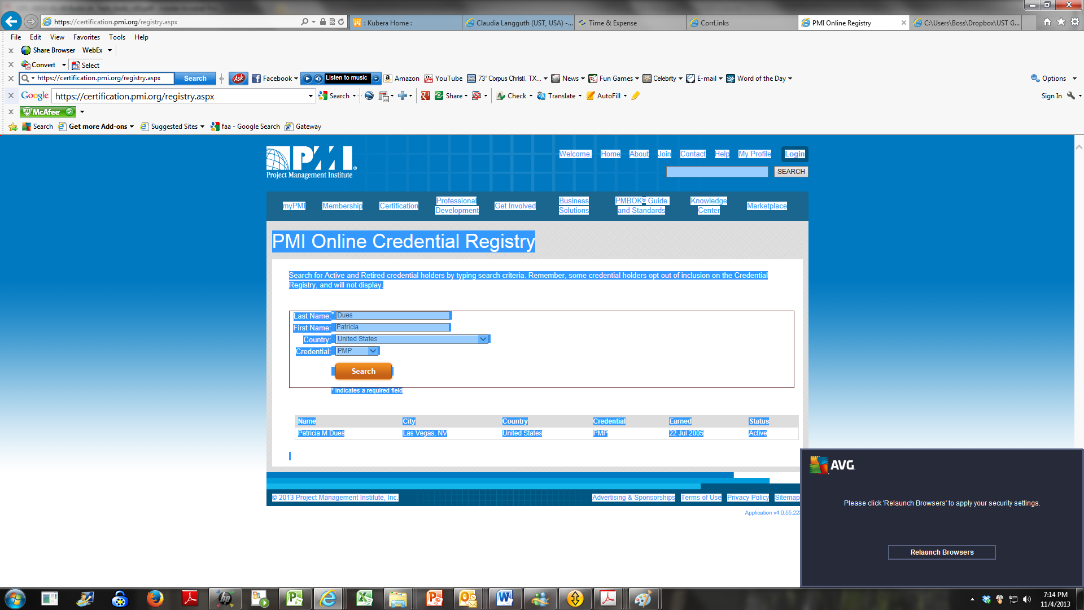

Appendix E.3 – Staff Experience Reference Form

Proposer Name: __UST Global_______________________

Prime Contractor/Subcontractor Organization: __Avolve Software_________________

Proposed Project Role: ________Technician_________________________________________

Key Role(s)* (if applicable): _____Technician________________________

* see RFP Section 3.1.3.2.1

Team Member’s Name: _____Steve Alexander___________

The Proposer must provide a completed Staff Experience Reference Form for each proposed staff person of this project. At a minimum, the Proposer must identify those individuals who will be performing specific key roles as stipulated in RFP Section 3.1.3.2.1.

**Projects Where Team Member Performed Role:**

For each project experience listed, indicate the customer name and customer contact information, whether the project was for a public sector agency, project name, **start and end dates the team member performed the role**, duration of the experience, whether the project included a land management and permitting system implementation, contract value, and the overall experience gained. Staff identified for Key Roles must include a minimum of two references.

|  |  |  |  |  |  |  |  |
| --- | --- | --- | --- | --- | --- | --- | --- |
| **Customer Name and Contact** | **Public Sector (Y/N)** | **Organization Size** | **Project Name and Description** | **Dates/ Duration\*\*** | **Scheduling/ Implementation (Y/N)** | **Contract Value** | **Experience Gained** |
| Los Angeles  Giovani O. Dacumus  [giovani.dacumos@lacity.org](mailto:giovani.dacumos@lacity.org)  (213) 482-0001  201 N Figueroa St., Ste 640  Los Angeles, CA 90012 | Y |  | Implementation sub workflow design & concept design for multiple departments | 02/2012 – 02/2013 | Y/Y |  | Implemen-tation |
| Chicago  Aprella Johnson  121 N. LaSalle, Room 900 Chicago, IL 60602 USA  [aprellajohnson@cityofchicago.org](mailto:aprellajohnson@cityofchicago.org)  312.744.7895 | Y |  | Implementation of Bldg. & Zoning Workflow, Developer Services | 02/2010 – 09/2013 | Y/Y |  | Implemen-tation |
| Las Vegas  *Diane Santiago Cornier*  Enterprise Project Manager  City of Las Vegas  Information Technologies Department  495 S. Main Street  Las Vegas, NV   89101  (702) 229-1050 (office)  (702) 429-1424 (cell)  (702) 464-2626 (fax)  [dcornier@lasvegasnevada.gov](mailto:dcornier@lasvegasnevada.gov) | Y |  | PreApplication & Planning Process | 2/2012 - 2013 | Y/Y |  | Implemen-tation |
| Hillsboro  Carol Brown  150 East Main Street  Hillsboro, Oregon 97123  503-681-5432  [carolb@ci.hillsboro.or.us](mailto:carolb@ci.hillsboro.or.us) | Y |  | Implementation & Upgrade | 2011 & 2013 | Y/Y |  | Implemen-tation & Upgrade |
| **Total Years of Experience in Role:** | | | | 15 years |  | | |

**\*\* Dates/Duration:** Provide the start and end date the vendor was involved in the cited project using MM//YYYY format.

|  |
| --- |
| **Summary Description of Skill Sets and Experience, Relevant Experience, Project Fit Description (Section 3.1.3.2.2):** |
| Proven project and leadership expertise in a career spanning over 15 years. Technically sophisticated professional reflecting strong leadership qualifications coupled with “hands-on” information technology expertise. Offer outstanding talents in team building, coaching, developing project scope (planning, controlling, and delivery), relationship building, process improvement, requirements solicitation, documentation, and communications. I am driven by new challenges and desire to be successful in all endeavors. |

|  |  |  |
| --- | --- | --- |
| **Individual Qualifications** | | |
| **Certifications (if applicable)** | | |
| PMI/PMP | Member ID#: | |
|  | Earned Date: | Expiration Date: |
| Other | Member ID#: | |
| Six Sigma | Earned Date: 2008 | Expiration Date: |
| CSM | Earned Date: 2007 |  |
| CSP | Earned Date: 2008 |  |
| **Education** | | |
| Bachelors: | Subject area | Earned date |
| 1. BS | Business Management | 2004 |
|  | Organizational Management | 2013 |
| Masters: | Subject area | Earned date |
| 1. | Sport and Business Administration | 2001 |
| Doctorate: | Subject area | Earned date |
| 1. |  |  |

Appendix E.3 – Staff Experience Reference Form

Proposer Name: TruePoint Solutions

Prime Contractor/Subcontractor Organization:

Proposed Project Role: Functional Lead

Key Role(s)* (if applicable): Functional Lead

* see RFP Section 3.1.3.2.1

Team Member’s Name: Paula Whittemore-Montoya

The Proposer must provide a completed Staff Experience Reference Form for each proposed staff person of this project. At a minimum, the Proposer must identify those individuals who will be performing specific key roles as stipulated in RFP Section 3.1.3.2.1.

Projects Where Team Member Performed Role:

For each project experience listed, indicate the customer name and customer contact information, whether the project was for a public sector agency, project name, start and end dates the team member performed the role, duration of the experience, whether the project included a land management and permitting system implementation, contract value, and the overall experience gained. Staff identified for Key Roles must include a minimum of two references.

|  |  |  |  |  |  |  |  |
| --- | --- | --- | --- | --- | --- | --- | --- |
| Customer Name and Contact | Public Sector (Y/N) | Organization Size | Project Name and Description | Dates/ Duration** | Scheduling/ Implementation (Y/N) | Contract Value | Experience Gained |
| City of Las Vegas, NV  Diane Santiago Cornier  Enterprise Program Manager  (702) 229-1050  (702) 464-2626  dcornier@LasVegasNevada.GOV  City Manager’s Office  400 East Stewart Avenue, 8th Floor  Las Vegas, Nevada 89101 | Y | Not presently available | Hansen v7.x for Accident, Billing, Building, Cashiering, Complex License, Customer Service, GIS (Asset, Customer Service, GeoAdministrator, Land, Permit, Viewer Address Parcel), HMS (Customer Service, Work Orders), Industrial Waste, Inventory Control, Building Permit, Code Enforcement, Licensing, Work Notice, Meter Management – Water, Meter Management – Sewer, Meter Management – Storm, Park, Plant, Roadway, Sewer, Storm, Street, Water, DynamicPORTAL (Building Permits, Customer Service, Licensing) | 03/2000 to 12/1/2004 (some projects ongoing)  Live with DP for Permits/Customer Service 03/08/2007 | Y | Contract Values are Confidential. Range for this project was $250 – 500K | Project Director, Data Conversion Manager, Data Conversion Analyst |
| City of El Paso, TX  Smyth, Ellen A., P.E. Administration Director (915) 621-6719  Director of Environmental Services  2 Civic Center Plaza  El Paso, TX 79901 | Y | Not presently available | Accela Automation implementation: This began as a business assessment with a full project team on board. TruePoint’s business assessment became the basis of El Paso’s upgrade from Tidemark to Accela Automation – a citywide, enterprise-wide project. | May 2008 – Present | Y | Contract Values are Confidential. Range for this project was $250 – 500K | Project Director, Data Conversion Manager, Data Conversion Analyst |
| San Diego County, CA  Lindsay, David David.Lindsay@sdcounty.ca.gov  858-245-8374 | Y | Not presently available | Subcontractor to Accela, Inc. serving as business analysis / consulting lead for initial high-level configuration analysis.  Planning and scoping large multi-year implementation effort that will provide functionality for Building Permits, Planning Case Management, Business and Contractor Licensing, Public Works / Right of Way / Infrastructure Permitting, and Code Enforcement. | Mar-08 – Present | Y | Contract Values are Confidential. Range for this project was $250 – 500K | business analysis / consulting lead |
| **Total Years of Experience in Role:** | | | | 16 yrs. |  | | |

**\*\* Dates/Duration:** Provide the start and end date the vendor was involved in the cited project using MM//YYYY format.

|  |
| --- |
| Summary Description of Skill Sets and Experience, Relevant Experience, Project Fit Description (Section 3.1.3.2.2): |
| During Paula’s 16 year career in the government sector, she has had the opportunity to fulfill many project roles. As a project director, it was her responsibility to manage all personnel, project timelines, invoicing and overall implementation design and vision. In the City of Chicago for four years, Paula had the opportunity to lead a team of 10 people in the analysis, configuration, implementation and long term support for their permitting and inspections software in the departments of Buildings, Construction and Permitting, Health and Fire. |

|  |  |  |
| --- | --- | --- |
| Individual Qualifications | | |
| **Certifications (if applicable)** | | |
| PMI/PMP | Member ID#: | |
|  | Earned Date: | Expiration Date: |
| Other | Member ID#: | |
|  | Earned Date: | Expiration Date: |
|  |  |  |
| **Education** | | |
| Bachelors: | Subject area | Earned date |
| 1. | University of California, Davis  BS, Computer Science,  Concentration in Computer Science | 1996 |
| 2. |  |  |
| Masters: | Subject area | Earned date |
| 1. |  |  |
| Doctorate: | Subject area | Earned date |
| 1. |  |  |

Appendix E.3 – Staff Experience Reference Form

Proposer Name: __UST Global_______________________

Prime Contractor/Subcontractor Organization: ___Excelerate Consulting, LLC________________

Proposed Project Role: Permitting and Land Use Management Workflow Subject Matter Expert/Senior Business Analyst

Key Role(s)* (if applicable): _____________________________

* see RFP Section 3.1.3.2.1

Team Member’s Name: __Douglas F. Witherspoon_____________

The Proposer must provide a completed Staff Experience Reference Form for each proposed staff person of this project. At a minimum, the Proposer must identify those individuals who will be performing specific key roles as stipulated in RFP Section 3.1.3.2.1.

**Projects Where Team Member Performed Role:**

For each project experience listed, indicate the customer name and customer contact information, whether the project was for a public sector agency, project name, **start and end dates the team member performed the role**, duration of the experience, whether the project included a land management and permitting system implementation, contract value, and the overall experience gained. Staff identified for Key Roles must include a minimum of two references.

|  |  |  |  |  |  |  |  |
| --- | --- | --- | --- | --- | --- | --- | --- |
| **Customer Name and Contact** | **Public Sector (Y/N)** | **Organization Size** | **Project Name and Description** | **Dates/ Duration\*\*** | **Scheduling/ Implementation (Y/N)** | **Contract Value** | **Experience Gained** |
| County of Orange - Public Facilities and Resources Department (PFRD Mike Jones, IT Manager, Planning and Development Services Department 714-834-5619)  333 W. Santa Ana Blvd, Santa Ana, 92701 | Y | 1,200 | PFRD Permitting and Planning System - A client/server-based architecture that provides three main integrated functions for county-wide permitting: Land use management, Plan Check Review and Workflow process. This system was well received by the development community | 1994-1998 | Y | $8M | Implementation, Lessons learned from Community Developers |
| County of Orange -PFRD & Planning and Development Service Department (PDSD)  David Marshall, Construction Manager (retired)  dnmarshall@roadrunner.com  (714) 454-4459  300 North Flower Street, Santa Ana, CA 92701 | Y | 2,100 | Automated Permitting and Planning System (APPS) – Development and implementation of an automated permitting and planning system with a customer facing portal for a streamlined customer experience and streamlined workflows for county personnel. This system is still in use today | 1995-2005 | Y | $45M | State of the art technology implementations, improved customer service, leading online implementation projects |
| County of Orange – PFRD  Mike Jones, IT Manager, Planning and Development Services Department 714-834-5619)  333 W. Santa Ana Blvd, Santa Ana, 92701 | Y | 700 | Telecom VOIP & Secure access for Buildings. The system provided swipe card access to all County-owned buildings with integrated security feature that allowed any-time monitoring and condition-based alert notification to mobile devices. As part of the project, we built a mobile app for various facilities managers to get instantaneous report on building access anytime anywhere. | 2009-2011 | Y | $1.5M | Streamlined security services, Mobile device implementation |
|  |  |  |  |  |  |  |  |
| **Total Years of Experience in Role:** | | | | 16 |  | | |

**\*\* Dates/Duration:** Provide the start and end date the vendor was involved in the cited project using MM//YYYY format.

|  |
| --- |
| **Summary Description of Skill Sets and Experience, Relevant Experience, Project Fit Description (Section 3.1.3.2.2):** |
| Highly accomplished Project Manager and Senior Business Analyst with a verifiable track record of managing complex projects and exceeding expectations in local government organizations. Over 30 years of experience with parks and recreation, public works, permit processing, surveying, interpretive program development and implementation of numerous projects. Very adept at clarifying business requirements, performing gap analysis between targeted goals and existing procedures and designing/re-engineering processes and system improvements to increase productivity and reduce costs. Extensive experience in strategic and tactical planning, defining business requirements (What), Business Improvement and Vendor Relationship Management. Strong interpersonal skills and highly adept at diplomatically facilitating challenging discussions while negotiating with stakeholders. |

|  |  |  |
| --- | --- | --- |
| **Individual Qualifications** | | |
| **Certifications (if applicable)** | | |
| PMI/PMP | Member ID#: | |
|  | Earned Date: | Expiration Date: |
| Other | Member ID#: | |
|  | Earned Date: | Expiration Date: |
|  |  |  |
| **Education** | | |
| Bachelors: | Subject area | Earned date |
| University of Phoenix | Bachelor of Science in Business Administration | 1999 |
| 2. |  |  |
| Masters: | Subject area | Earned date |
| University of Phoenix | Master of Arts in Organizational Management | 1994 |
| Doctorate: | Subject area | Earned date |
| 1. |  |  |

Appendix E.3 – Staff Experience Reference Form

Proposer Name: __UST Global_______________________

Prime Contractor/Subcontractor Organization: __Avolve Software_________________

Proposed Project Role: ________Trainer_________________________________________

Key Role(s)* (if applicable): _____Trainer________________________

* see RFP Section 3.1.3.2.1

Team Member’s Name: _____Nicole Thorne___________

The Proposer must provide a completed Staff Experience Reference Form for each proposed staff person of this project. At a minimum, the Proposer must identify those individuals who will be performing specific key roles as stipulated in RFP Section 3.1.3.2.1.

**Projects Where Team Member Performed Role:**

For each project experience listed, indicate the customer name and customer contact information, whether the project was for a public sector agency, project name, **start and end dates the team member performed the role**, duration of the experience, whether the project included a land management and permitting system implementation, contract value, and the overall experience gained. Staff identified for Key Roles must include a minimum of two references.

|  |  |  |  |  |  |  |  |
| --- | --- | --- | --- | --- | --- | --- | --- |
| Customer Name and Contact | Public Sector (Y/N) | Organization Size | Project Name and Description | Dates/ Duration** | Scheduling/ Implementation (Y/N) | Contract Value | Experience Gained |
| City of Springfield, Mo  Bob Hosmer  [bhosmer@springfieldmo.gov](mailto:bhosmer@springfieldmo.gov)  417.864.1198 | Y |  | Implementation of Building and Planning ePlan Review Processes | 02/2011 – 02/2012 | Y- Hansen 7 |  | Training |
| Polk County  Charlotte Fillmore  [charlottefillmore@polk-county.net](mailto:charlottefillmore@polk-county.net)  863.53.6488 | Y |  | Implementation of Growth Management ePlan Review Process and Hansen 7 integration. | 02/2010 – 09/2010 | Y – Hansen 7 |  | Training, PM |
| City of Chicago  Aprella Johnson  [aprellajohnson@cityofchicago.org](mailto:aprellajohnson@cityofchicago.org)  312.744.7895 | Y |  | Implementation of Building and Zoning ePlan review process | 05/20110-06/2011 & 07/2013 | Y – Hansen 8 |  | Training |
|  |  |  |  |  |  |  |  |
| Total Years of Experience in Role: | | | | 11 years |  | | |

** Dates/Duration: Provide the start and end date the vendor was involved in the cited project using MM//YYYY format.

|  |
| --- |
| Summary Description of Skill Sets and Experience, Relevant Experience, Project Fit Description (Section 3.1.3.2.2): |
| Avolve University Trainers develop all training materials be they standard or customized, and perform all training required for the Avolve product suite. These multi-talented individuals no the applications inside and out from all perspectives, be it user, administrator, or citizen. Delivery of some training is often online verses onsite, so these individuals need to be captivating and alert to their student’s needs. |

|  |  |  |
| --- | --- | --- |
| Individual Qualifications | | |
| Certifications (if applicable) | | |
| PMI/PMP | Member ID#: | |
|  | Earned Date: | Expiration Date: |
| Other | Member ID#: | |
|  | Earned Date: | Expiration Date: |
|  |  |  |
| Education | | |
| Bachelors: | Subject area | Earned date |
| 1. | Health and Education | 1997 |
| 2. |  |  |
| Masters: | Subject area | Earned date |
| 1. | Sport and Business Administration | 2001 |
| Doctorate: | Subject area | Earned date |
| 1. |  |  |

#### Project Organization (RFP 3.1.3.2.3)

**Organization Chart**

Team UST is organized in a collaborative team structure with clear one-to-one reporting accountability, enabling effective top-down and bottom-up communication with the City of Los Angeles as well as our subcontractors.

Our internal Team UST overall organization proposed for this engagement is shown in *Figure 1.3.4.2-1.*

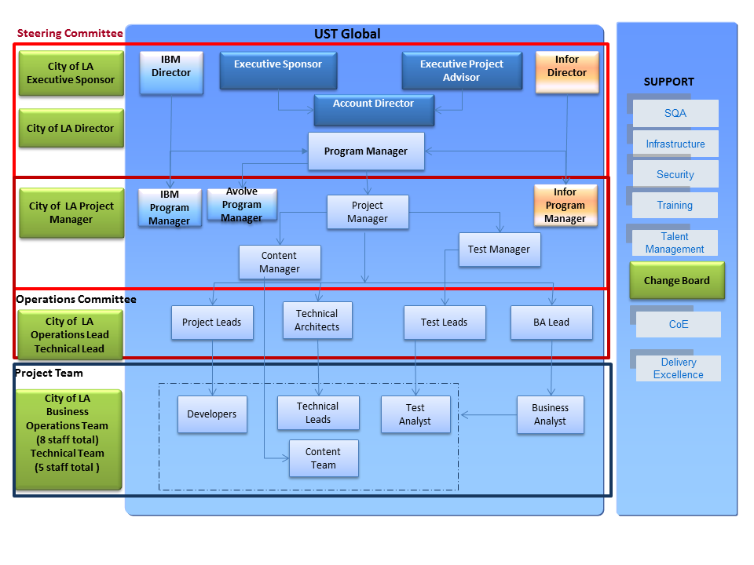

Figure 1.3.4.2-1: BuildLA Project Organization Chart.

The team is divided into three groups for better coordination and control:

**Steering Committee**: Consists of executive sponsors, sponsors and directors from all technology partners in the project who can assist and advise the project team, ensure alignment, and remove impediments from achieving the goals of BuildLA. The Steering Committee allocates and approves necessary budgets and defines high level project expectations.

**Operations Committee**: Consists of the UST Global project manager, managers, and program managers from our technology partners who can coordinate with external parties and support functions, and ensure that proper and timely help is available for the smooth functioning of project teams.

**Project Team**: Consists of our lead technical architect, technical staff, developers, testers, content designers, business analysts and the BuildLA IT development team who will develop and integrate the BuildLA solution. The City of LA will allocate 14 full-time staff to support the BuildLA project team each year or until project completion. The UST Project Manager will work closely with the BuildLA Project Manager on day-to-day operations. The eight City Business Operations team will work with the UST Business Analyst and Development team, and the five City Technical staff will work with the UST Technical teams. UST is expecting that the BuildLA Executive Sponsor and the BuildLA Director or designee to interact with the UST BuildLA Senior Management Team in the monthly steering committee meeting and critical project reviews on an as-needed basis.

Figure 1.3.3-1: Project Organization Chart. Our Team’s Project Organization provides Leadership and Governance to the BuildLA Project Roles and Responsibilities

Roles and Responsibilities

The roles and responsibilities of all personnel are shown in *Figure 1.3.4.2-2.*

| Roles | Responsibilities |
| --- | --- |
| BuildLA Executive Sponsor | * Sets project expectations and approve budgets |
| BuildLA Director | * Sets project expectation, approve budgets, and escalation point for all BuildLA project issues |
| BuildLA Project Manager | * Responsible for working with the UST Project Manager to achieve BuildLA project milestones * Works with the UST BuildLA Project Manager on a day-to-day basis * Manages the City’s BuildLA team assigned to BuildLA |
| IBM Director | * Ensures smooth functioning of IBM technical staff with other technical partners |
| Executive Sponsor | * Ensures overall functioning of project team within budget and deliver the product with expected quality |
| Executive Project Advisor | * Ensures overall functioning of project team within budget and deliver the product with expected quality * Participates in Steering committee meetings * Provides timely advise to project team to meet City of LA project expectation |
| Infor Director | * Ensures smooth functioning of Infor technical staff with other technical partners |
| Account Director | * Primary Point-of-Contact for City’s Delivery/PMO Sponsors * Helps the City in communicating and working collaboratively with the integrated project teams |
| IBM Program Manager | * Establishes and maintains regular communications with UST Program Manager * Ensures IBM project task are completed as per Master project work plan * Communicates project related issues and risk related to IBM product to UST Program Manager * Reports the progress of IBM’s project-related tasks regularly |
| Infor Program Manager | * Establishes and maintains regular communications with UST Program Manager * Ensures Infor project task are in progress completed as per Master project work plan * Communicates project related issues and risk related to Infor product to UST Program Manager * Reports the progress of Infor’s project related tasks regularly |
| **Program Manager**  **\*Key Position** | * Establishes and maintains regular communications with the City Project Management Office * Establishes and maintains regular communications with Program Managers from other technological partners * Establishes and maintains regular communication and status reporting to Account Director * Coordinates with QA leads to develop and implement quality assurance process to ensure all the objectives are met and milestones are achieved |
| **Project Manager**  **\*Key Position** | * Reports directly to the City Project Director/Project Manager * Provides overall management of project from end-to-end * Manages risks and issues, project planning and tracking * Coordinates UST Global management reviews * Ensures the highest level of customer satisfaction and engagement success |
| Content Manager | * Ensures the development of portal content and interface with City of LA users for content finalization |
| Test Manager | * Ensures portal testing is of high quality and manage and allocate testing team as per project requirements * Prepares and track the project plans * Manages all assigned Test resources |
| Project Leads | * Monitors project status and progress, and conducts reviews with the project team * Sets up periodic project status and progress reviews with the City * Represents UST Global for managing the change control process * Resolves functional, and execution-related issues * Ensures that all processes are followed |
| **Technical Architect (Lead)**  **Key Position\*** | * Spearheads creating the solution both on the application and the technical architecture * Defines the full set of application requirements: functional, quality, integration, and security * Works closely with Business Analysts and City of LA to confirm that application meets their needs * Serves as arbiter for cross-application or cross-team issues |
| Test Leads | * Creates test plan/strategy, system integration test strategy/plan, performance test strategy/plan * Leads test execution teams * Assists with City of LA reviews, and status reporting * Conducts Test audits * Facilitates configuration control and change control |
| **Business Analyst Lead (Functional Lead) *Key Position** | * Has overall responsibility for Business Analysts’ deliverables * Manages the design, analysis, and testing activities * Responsible for milestone achievement * Responsible for achieving application certification prior to commencing Pilot activities * Works with the Project Manager in aligning tasks with City of LA’s requirements |
| BuildLA Architect | * Ensures technical architecture is reviewed and approved by BuildLA architecture team on time * Ensures technical support to UST Global Architecture team to understand existing portal architecture * Participates in the technical architecture review process |
| BuildLA Business Operations Staff | * Ensures constant communication with UST and other technical partners’ Development team * Participates in code review * Ensures support to development team and business analysts * Ensures support in user training |
| Developers | * Configures, builds and tests classes and features for BuildLA * Develops common test data, fixes defects found during testing * Troubleshoots coding problems, identifies performance concerns, and contributes to new ideas/ implementations * Assists in evaluating the impact of new system functionality * Assists in developing technical design specifications * Ensures development meets BuildLA needs |
| **Transition/Deployment Lead**  **\*Key Position** | * Manages subcontractors, interact with the Quality and Testing teams, manages the hardware and software build and configuration management process * Prepares and follows service deployment plan * Coordinates with Configuration controller (CC) for latest Code for build * Review build scripts * Allocates necessary deployment/build engineers to each release * Prepares deployment reports and Release notes * Prepares knowledge transition plan * Prepares service transition plan * Coordinates with service owner and service leads to identify service SMEs * Prepares transition progress report * Defines Transition process. |
| BuildLA Technical Staff | * Ensures constant communication with UST technical leads and team. * Participates in technical reviews and status reporting * Works with the UST technical team to determine best solutions for any technical issues |
| Technical Leads | * Assists with City of LA reviews, and status reporting * Guides the team to develop solutions and disseminate requirements * Analyzes every issue for its impact on the entire scope of the project * Ensures quality of deliverables, enable code reuse * Escalates technical issues |
| Test Analyst | * Creates system test plan for the application * Creates functional (SIT) test cases and prepare test data * Executes test cases and reports defects * Identifies defects for assignment to the development team * Ensures defect resolution and generate metrics |
| Business Analyst | * Works with the project manager, architects and other team members to define, analyze and design new business processes * Defines and finalizes detailed product requirements * Serves as point of contact and connection to the business community * Takes part in transitioning the requirements and use cases to the designers, and ensures a clear and complete understanding of the requirements * Assists in translating requirements and use cases into test conditions that will be used for user acceptance test * Documents findings and results of working sessions |
| Content Team | * Collects Portal content material from City of LA users * Analyzes existing portal content and impact analysis for integration as part of content development * Designs the content for each services * Develops content * Participates in Content review with City of LA users and content lead * Supports deployment team for content deployment |
| SQA | * Attends project release kick off meeting * Plans for quality assurance related activities in each release * Prepares schedule for QA activities as per project work plan. * Performs process compliance review every month using process compliance checklist * Publishes process compliance reports and project health dashboard to BuildLA Management team |
| Infrastructure | * Participates BuildLA infrastructure planning meeting * Coordinates with BuildLA infrastructure team for each service deployment * Identifies hardware and software requirements for BuildLA solution. * Prepares and publishes infrastructure requirements for each service * Ensures network connectivity between UST development environment, SIT, Staging ,UAT, Pilot site and Production environment * Supports service decommissioning |
| Security | * Oversees all aspects of security for the project |
| **Training Lead**  **\*Key Position** | * Conducts training need analysis (TNA) for each service * Prepares and conducts process training * Coordinates with the Development team for L1 and L2 support training * Coordinates with Multimedia team for creating training content for Self-help videos * Coordinates with City of LA Portal competency development team to implement the Portal competency framework * Supports the implementation team during training. |
| Talent Management | * Ensures right resources at the right time in the right position * Mobilizes resources as per the project requirement * Ensures quick ramp up of resources as per agreed SLA between UST Global and City of LA |
| Change Board | * Appoints members to change control board * Appoints configuration controller for project * Defines change management process as per project requirement * Analyzes change request * Evaluates change request * Provides approval/rejection of change requests * Provides implementation of changes requests |
| CoE | * Provides technical guidance to the Project Team * Recommends tools and accelerators |
| Delivery Excellence | * Coordinates with focus groups to resolve project challenges * Conducts periodic review to ensure timely support to project execution * Provides support in process automation, metric reviews, and process engineering |

*Figure 1.3.4.2-2: BuildLA Roles and Responsibilities.*

**Governance Structure for Prime and Sub-Contractor Relationship**

As we have done in our other contracts where we have multiple subcontractors, UST Global will employ a “One Team” approach to the execution of the contract. Our approach ensures transparency of subcontractor activities to the City, as well as a single point of responsibility for the tasks and results. Our Project Manager will assign and clearly define the scope of work to be performed by our subcontractors during project execution, and associated quality and performance standards that must be met.

Our management philosophy drives accountability down to the lowest level, but tracks performance at higher levels. Consistent with this approach, our Project Manager tracks costs, schedule, quality, and other performance measures against the approved Performance Management Plan (PMP) and reports this information to the client. We will use the following approaches to ensure the efficient use of resources in support of this contract:

* Ensuring Staff Availability – We will use the processes and procedures for recruiting staff that have been successfully employed in building our internal staff resources on our other government contracts. In addition, we will use our subcontractor partners to supplement our core capabilities. Key roles are staffed at 100% for the duration of their engagement on the BuildLA project.
* Cross Training and Skills Development – We foster cross-training and encourage our employees to take training in related areas to expand their utility to the company. We offer employees courses to expand their skills, certifications, and specific vendor training as required.
* Early Identification of Risk – Our risk management process identifies and mitigates risks before they impact fiscal or staff resources, and well before potential impact to the client.

We implement sound business practices based on proven management approaches to ensure that project and task order cost, schedule, and performance objectives are controlled, reported, and managed by using project management tools and a time and cost accounting system to assist our staff with planning, monitoring, controlling, and closing out contracts and task orders on a consistent basis.

Approach for Integration and Interaction with the City Project Team

Our steering committee will be available for all required meetings and interaction with the City executive leadership. Our project team will be fully integrated with the City Project Team. The UST Global Project Manager will act as the primary interface with the City Project Manager. Our Project Manager will establish and maintain regular communications with the City Project Management Office, and provide daily/weekly/monthly reporting, including budget/cost reporting, issue reporting, and overall project reporting status as needed.

Our Technical Lead will interface with the City Architect Representative(s). Our Functional Lead will work with City designated personnel regarding objectives and milestones, software testing and evaluation, and application certification prior to commencing Pilot Activities. Our Transition/Deployment Lead will work with all City Department staff regarding the project plan and deployment readiness. Our Training Lead will coordinate training of City staff and work with all departments regarding training schedules.

Resource Plan

Our resource plan including the Team UST and the City of LA resources required by project phase, as well as the percent of time staff will be on-site and dedicated to the City project, and the percent of time each City resource will be utilized in the project per project phase is shown in *Figures 1.3.4.2-3 A and B.*

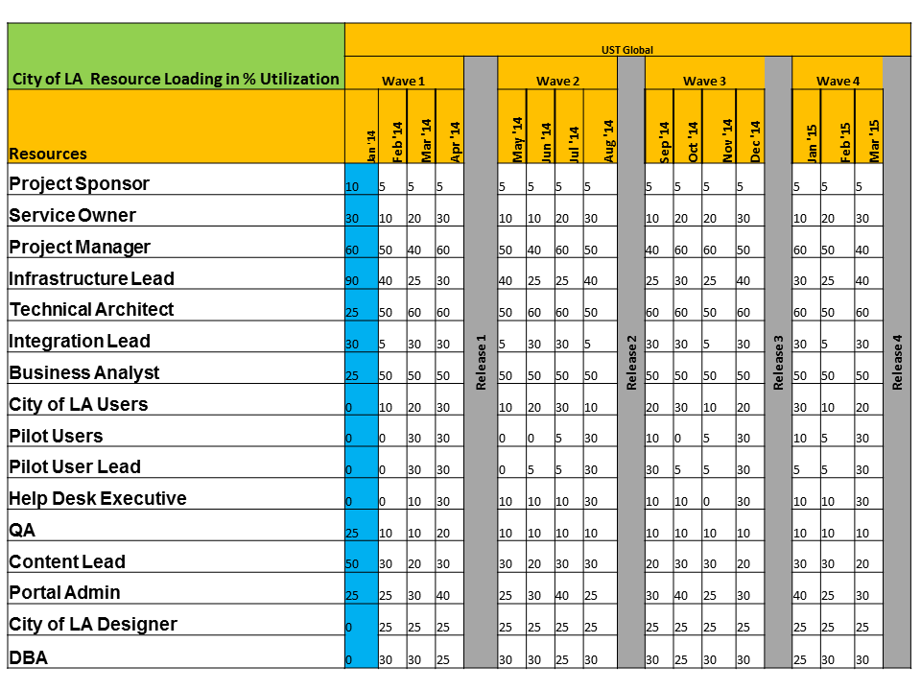

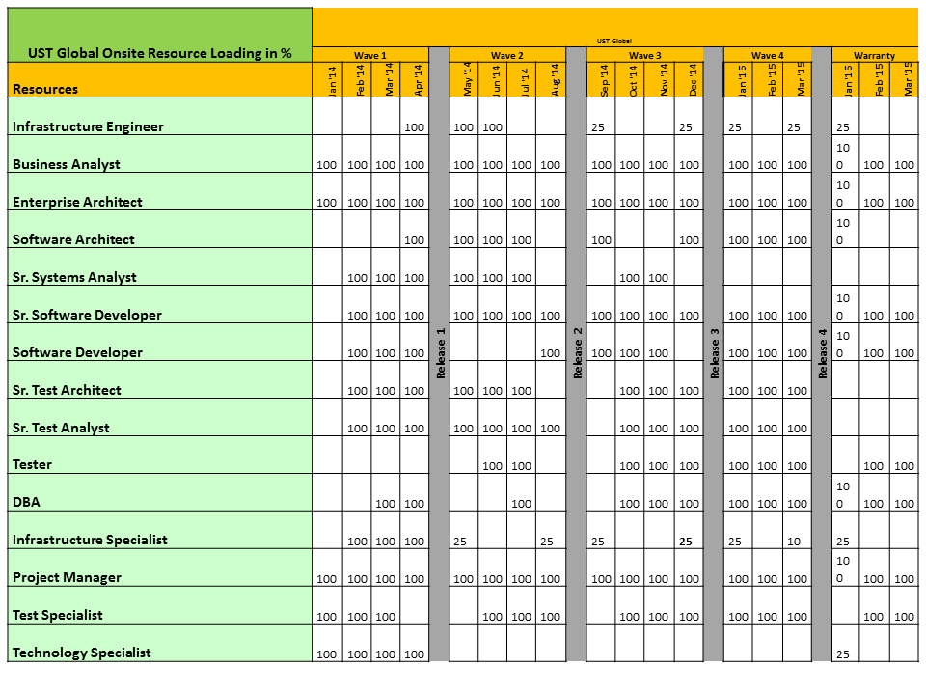

Figures 1.3.4.2-3 A & B: Resource Plans for BuildLA.

## Solution Response (RFP 3.1.4)

### Functional Solution Narrative (RFP 3.1.4.1)

The Team UST BuildLA solution incorporates all of the City of Los Angeles’ Portal, Workflow Management and Electronic Document Review requirements as specified in the BuildLA RFP (*Figure 1.4.1-1*).

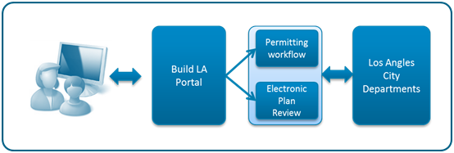

Figure 1.4.1-1: Team UST’s BuildLA Solution Delivers End-to-End Services for the City’s Departments.

Figure 1.4.1-1: Team UST’s BuildLA’ Solution Delivers End-to-End Services for the City’s Departments

Our BuildLA solution is built on a combination of IBM’s Intelligent City Planning and Operations, Infor’s Public Sector (IPS) suite of applications, and Avolve Software’s ProjectDox applications to address your Portal, Workflow Management and Electronic Plan Review requirements for the Department of Buildings & Safety, Department of Transportation, Fire Department, Department of Water & Power, Housing Department, Office of Finance and Department of Recreation & Parks. This advanced software solution has been designed specifically to streamline your processes and better manage complex community development and regulatory processes. Our team includes premier solution providers who bring the best in portal development, workflow management, and electronic document review solutions to BuildLA as shown in *Figure 1.4.1-2*.

**

Figure 1.4.1-2: The UST Team for BuildLA.

Figure : Components of the BuildLA

**Solution Overview and Benefits**

Team UST’s BuildLA solution uses a common platform with the fusion of data from different and separate sources to improve communication and collaboration across departments, with vendors, and with the public:

* Facilitate stronger and more effective coordination between agencies
* Shorten permitting cycle times
* Detect and mitigate issues and conflicts
* Improve citizen satisfaction with city services
* Infrastructure planners can efficiently create more accurate infrastructure plans.
* Permit managers can make quicker and more accurate decisions about permit applications.
* Analysts and investigators can encourage collaboration to find and remediate unlicensed businesses.
* City executives and managers can use the solution to encourage collaboration and to oversee activities that span multiple departments

This will facilitate the integration of city data for a holistic view of permit activity and more timely and accurate responses to requesters, analyze past and present permit applications, traffic assessments, crime patterns and more to identify patterns of success and constantly improve the quality of decisions being made.

Of equal importance, our BuildLA solution will help the City of Los Angeles successfully identify areas of lost or missed revenue. City agencies will be able to analyze data from a variety of sources, such as city permits, taxes and business records, to identify unlicensed businesses or fraudulent business practices, thereby increasing income to the City. The features and benefits to the City are highlighted in *Figure 1.4.1-3.*

| Features | Benefits |
| --- | --- |
| Unified system for the intake of the City’s many applications | A “one stop shop” for citizens and developers to interact with the City and obtain services tailored to their specific needs. |
| Workflow management tightly integrated to the portal | Applies appropriate and consistent business rules and routes applications to the appropriate departments and personnel for review. |
| Streamlined permit optimization capabilities | Aggregates, correlates and analyzes data and requests to improve decision time and quality |
| Revenue Management and Investigation Capabilities | Analyzes and visualizes data to identify missed business license fees and claim the ongoing revenue from business and sales taxes. Implements clear business practice guidelines and processes that reduce fraud and improve business oversight for health and safety. |
| Infrastructure planning capabilities | Aligns and unifies project plans to reduce costs and to coordinate digging up streets, utility infrastructure and other infrastructure. |
| Information from all agencies is presented in a consolidated, geospatial view | City officials and permit agencies can make decisions quickly and correctly. |

Figure 1.4.1-3: Features and Benefits. Our Solution Delivers Key Benefits to the City and Allows for Increased Revenues.

Finally, the overall architecture of Team UST’s solution provides a foundation for additional use cases prioritized by the City of Los Angeles. The City can, for example, implement the BuildLA solution to deliver the benefits described herein, but then use the platform as the foundation for other Smarter Cities initiatives such as Traffic Management or Intelligent Law Enforcement. This leads to operational and technical efficiencies that can result in cost savings and reduced risk.

#### Portal Solution (RFP 3.1.4.1.1)

C:\Program Files (x86)\Microsoft Office\MEDIA\CAGCAT10\j0195384.wmfThe Team UST Portal solution will be the entry point for citizens and developers to interact with the City and request services tailored to their needs. Self service capabilities provided by the Portal will include knowledge management, online applications and payments, plan upload and status tracking across all departments and services during the life of the project. Information collected through the portal will integrate with the workflow management system and trigger the workflow processes.

##### Portal Roadmap Implementation (RFP 3.1.4.1.1.a)

Team UST will utilize our Visual Engineering and Advanced Visual Studios (AVS) Practices to collaborate with the City of LA to realize the final solution prior to development implementation. By capturing both functional and business requirements, user stories, portal flow and user interface elements all parties will engage with the solution iteratively. Collective feedback will allow LA to shape and optimize the final portal experience. A functional simulation will also allow potential users and administrators to experience the portal prior to development; speeding up adoption, implementation and integration.

Our AVS team is comprised of highly skilled User Experience professionals, User Interface Designers and Production Designers. The AVS team works side-by-side with our Visual Engineering Practice to ensure quality engagement solutions. In addition, our AVS team remains involved with the development build of our solutions to ensure the user voice remains constant.

By leveraging our Visual Engineering process we will capture user and admin requirements, build the “low-fidelity” user experience based on functional and technical requirements, validate those requirements with the City, build out the complete portal experience as a simulation and finally apply an approved presentation layer (UI design) as a “high-fidelity” experience. These “quick wins” will be accomplished in a matter of weeks, not months.

Team UST will provide a flexible solution that allows the City of LA to release a unified experience that can be expanded upon. Leveraging Visual Engineering, Team UST, in conjunction with the City of LA, will collaborate on enhancements, user adoption, easy to understand language and an intuitive experience to better serve both the community and City support teams. Our goal is to adopt current taxonomy that aligns with both the users and the City of LA specifically and optimize features based on new technologies and alignment regarding system integrations. Working together, Team UST and the City of LA will improve the overall user experience and system management.

**Timeline of the Portal Work Stream**

The portal project work team will work in collaboration with the Portal Competency Center (PCC) established by the City of LA. The PCC will provide direction on strategy, change management, and content update.

Team UST will rely on the deliverables provided by our AVS team including story board, mockups, information architecture, content strategy, and guidelines on HTML generation such as image size, resolution, CSS, and usability standards.

The Team UST timeline for our portal work stream is shown below in Figure 1.4.1.1-1, including the various releases and activities against timelines.

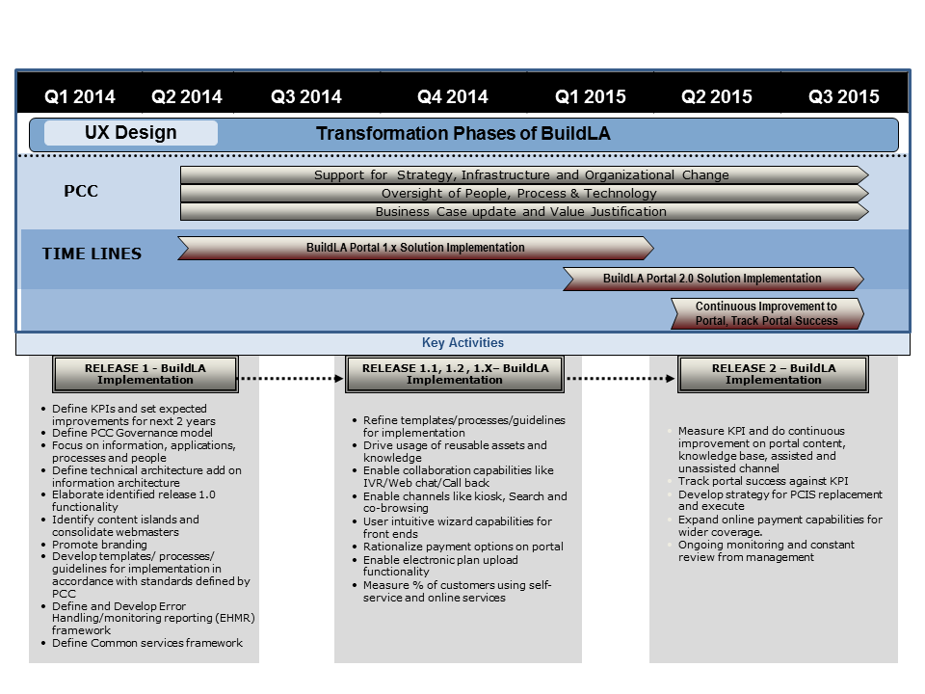

Figure 1.4.1.1-1: Timeline of the Portal Work Stream Showing Releases and Tasks.

References and Qualifications for UST Global Web Design

We provide six projects demonstrating our qualifications and results from our web design practice.

1. **H&R Block At Home**

H&R Block At Home is the Online Tax preparation software suite of products from H&R Block. This is being used by more than 17 Million customers to prepare their tax returns online by themselves, and file their returns with the Internal Revenue Service (IRS). H&R Block At Home is being used for preparing more than 8 Million tax returns every year.

UST Global started engaging with H&R Block At Home from 2003 to today. Currently, UST is involved in the end to end solution building, requirements gathering, design and development, functional testing, load and performance testing, production deployment and production monitoring. The portal can be viewed at: [www.hrblock.com](http://www.hrblock.com).

1. **H&R Block Appointment Manager**   
   Appointment Manager (AM) is an online application to set and manage appointments. Clients are identified and matched to prior or appropriate tax professional at first contact. It helps to set and manage the work schedules of tax professionals. The project is providing better experience to the client and reduces the labor cost by efficiently managing tax professionals. This is done by matching of clients to tax pros based on client needs and tax pro skill. Based on the need of client, labor will be arranged in the offices. The major functionalities included in the application are ability for clients to set appointments online, improved usability of appointment setting, work schedule management and enhanced contact management. This application handles 16.7 million transactions. It is used in over 20,000 offices of the client across US. Also the application has a set of web services that are exposed for other applications such as Mobile/IVR for setting an appointment.

UST Global started this engagement in 2006. Currently UST Global supports requirements gathering, enhancements, development, testing and production support activities. The application can be viewed at: <https://am.hrblock.com/>.

1. **KPMG Controversy Tracker (CTracker)**

KPMG Controversy Tracker (CTracker) is a web-based application integrated with KPMG Link Portal (a framework that is being developed by the KPMG Tax Technology Practice, for its entire client facing and internal apps). The purpose of the system is to track conflicts or disputes with the State and the Federal Government in a collaborative and effective manner. CTracker helps users to track Audits, Notices, share team-member & client information and help collaborate notes and comments amongst different participants of the Audits, track due dates, track upcoming meetings and get email reminders for due dates and meetings, upload and manage multiple document areas for each Audit or Notice and also to run meaningful reports. CTracker’s role-based and data level security allows numerous clients and their information to coexist on the same platform. KPMG users have access to data for their respective clients. External client users’ view is restricted to only their client data. State Auditors will have further restricted data access granted on an as-needed basis. All security can be managed by using easy-to-use screens and defining access control at the granular audit level.

1. **KPMG PartnerTrack**

This project is currently in development to support the data entry and generation of Partner K-1 forms. Work has commenced in the form of a work paper within a specific time period. Users will build a hierarchy of partners and investments in the application for each work paper. Users will then start entering the required information for each work paper, allocate the assigned percentages for each partner, map the allocations to entered amounts based on rules created for partner allocations and finally generate the reports leading to generation of K-1 forms for each.

1. **KPMG Link Portal** [https://www.kpmglink.com/](https://email.trv.ust-global.com/owa/redir.aspx?C=xhVbDwU5iky29-n8xyfhV4mMjExvp9AIHraxbL29M2aADEPxGVu38cmypq8Cbs5jkcUdAk4Cdzk.&URL=https%3a%2f%2fwww.kpmglink.com%2f) (KLP) is the gateway portal for its key application portfolio which provides a front end for employees and external client partners. The application is built on top of Orchard CMS and highly customized to fit the requirements for KPMG. It provides a standard framework for multiple application modules to integrate into it and provides a common and consistent user experience to the end user. The portal framework also provides many default capabilities such as navigation and routing, security, workflow, mywork, document management, deployment, user controls, filters, template code, etc. to each module that integrates with it. The Dashboard-like interface provides provision of the user to pick and choose the components he wants to see on each page. The data from various modules are filtered automatically based on Client and Project selections. Some of the main modules integrated with KLP are:

* Global Compliance Management system
* Partner Track
* FedTax
* Document Management
* Adhoc Tasks Management
* RSS Feeds (Tax News)

1. **HEB**

HEB.com was a project that UST Global developed from scratch in 2009. Before this time HEB did not have any online ordering capability. UST Global developed the HEB.com from requirements definition into a complete site launch. Main site features include:

* Improving the effectiveness of merchandising HEB products on the web
* Ordering, fulfilling, and accounting for online sales of HEB product
* Increasing partner efficiency for managing content on the Internet
* Providing a system that is available to the customer 99.99% of the time (maximum total downtime allowed of 1 minute per week or 1 hour per year)
* Ensuring online performance meets or exceeds standard customer expectations for Web Commerce
* Enabling faster speed of delivery for future ecommerce business needs

Technologies implemented include: ATG 9.1 (Art Technology Group, a leading provider of ecommerce software and related on demand commerce optimization applications, Endeca (Search engine owned by Oracle), CSC (ATG Commerce Service Center) and Tibco (integration server software for enterprises). The web application can be viewed at: [www.heb.com](http://www.heb.com).

##### Portal Assessment (RFP 3.1.4.1.1.b)

Working with our Visual Engineering Practice in conjunction with our Advanced Visual Studios Practice, Team UST will conduct two day workshops with content owners from the City to build a narrative that aligns with users, administrative and Search Engine Optimization (SEO) principals. These workshops will capture requirements and build them around a functional simulation of the final experience. Workshops can be done remotely, unless otherwise required by our on-site team.

During the workshop process with the City of LA’s content owners, Team UST’s Visual Engineering practice team will work on content strategy for the self-service portal. Content Strategy is a process and mindset that revolves around planning the content creation, taxonomy of information and how it is governed. Some of the key content strategy areas include:

* Designing a Self-Service portal to provide accurate, relevant and superior quality content to users which improves user experience
* Guiding users to perform an action or make appropriate decisions
* Extensive user research – Key users of City of LA will be interviewed if required, use cases will be created and aligned within the process and additional Persona Profiles will be defined to better optimize the delivery of content; a day-in-the-life of specific user types
* A structured approach to create and manage content that will result in regular and accurate updates. Continuous improvements to content based on feedback monitoring from users.
* Ease of use of publishing and editorial processes
* An emphasize on standards and re-usable content
* The ability to take corrective actions quickly; notifications and status updates
* Enabling users to connect with City of LA brand instantly

Team UST’s Visual Engineering Practice has time tested Content Strategy processes for Web and Portal applications. The various phases are highlighted below in *Figure 1.4.1.1-2.*

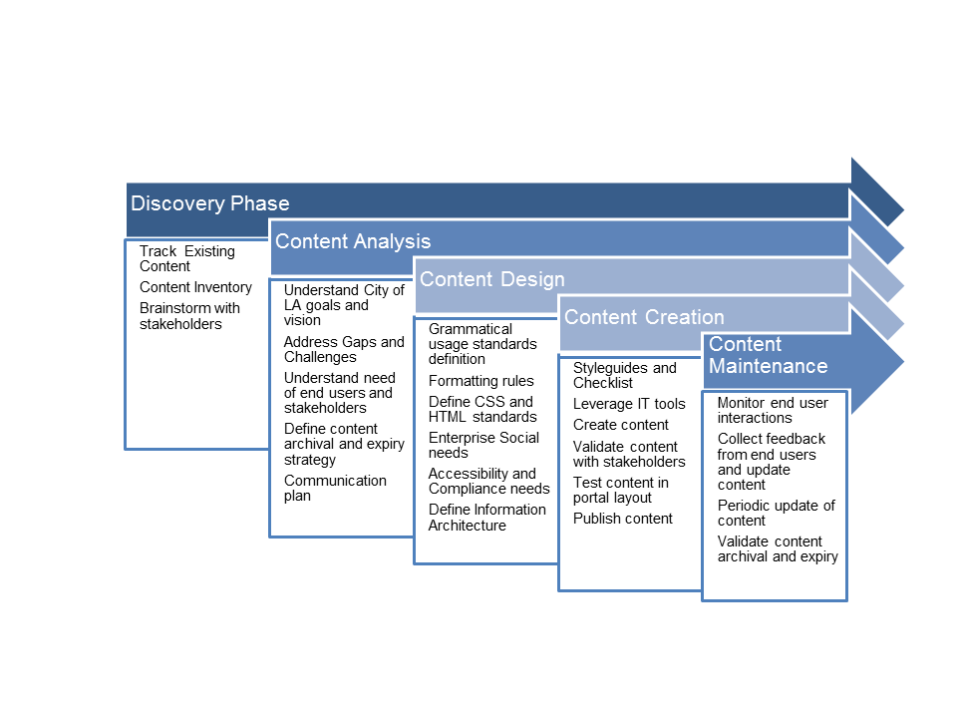

Figure 1.4.1.1-2: Team UST Utilizes a Structured Approach to Content Strategy.

Portal Technology Selection

Based on wide ranging portal implementation experience, Team UST has considered industry standard parameters for identifying true Portal Technology selection criteria for BuildLA needs, including the best of breed technologies based on COTS and feature-rich Open source toolsets. Team UST proposes to use the IBM Portal Server in conjunction with SOLR search engine and Drupal WCM for the BuildLA project. Some of the key criteria that Team UST considered for Portal technology selection are:

**Portlets:** Portlets are customer facing components which drive functionality to access backend systems and deliver rich content. While considering this parameter following are the key subset which has been taken into account

* Packaged Portlets
* Third party Portlets
* Portal development tools
* Portal architecture
* Portlet to Portlet communication
* Support for standards like JSR 268 and WSRP

**Customer Profile Management:** Customer profiles and customer profile management are important in the development, implementation, and support of customer facing self-service portals. Portals leverage directory information as part of the enterprise for authentication and authorization. Portals add preference properties or attributes for personalization and packages collaboration capabilities. IBM WebSphere Portal server has standard out of the box integration capabilities to enterprise directory services. It also provides rich Meta data attributes to drive personalization and pre-packaged with collaboration capabilities along with support for integrating with 3rd party solutions that enables Web2.0 functionalities.

**Process Management Services:** This is a key parameter for customer facing self-service portals to link the tasks of City of LA customers. Though the portal server comes with basic workflow capabilities, as part of BuildLA, Team UST will leverage the workflow capabilities of Infor and integrate those tasks and their status via Message Broker middleware to surface on to portal.

**Content Management Services:** Customer-facing self-service portals are implemented essentially by content and portlets. For key use cases including assisted and un-assisted channels of self-service, it is important to have the relevant content available for customers to take necessary decisions and move ahead in their permitting process. The content that will be surfaced via portlets will be managed using Drupal based WCM tool. Drupal will provide content management services including versioning, staging, publishing, localization, and archiving. The content that resides in Drupal will be delivered to customers via 3rd party portlets as part of the IBM WebSphere Portal Server.

**Search:** Search capability for BuildLA will be delivered using SOLR, a search engine from Open Source Apache Foundation. The SOLR search engine is blazing fast open source enterprise search platform from the Apache LuceneTM project. Its major features include powerful full-text search, hit highlighting, faceted search, near real-time indexing, dynamic clustering, database integration, rich document (e.g., Word, PDF) handling, and geospatial search. The indexed search results will be delivered to customers via portlets.

**Other Criteria Considered:** Team UST also considered criteria including personalization services, collaboration services, analytic capabilities, portal deployment architecture, and product viability.

**Portal Architectural Needs**

Team UST understands that the vision of the City of LA is to build a web-enabled technology platform that will be used by multiple knowledge workers from multiple City departments to service their customers. Included in that vision is self-service on assisted and unassisted channel for end customers, as well as having collaborative features that are needed to interact with knowledge workers. Team UST will be implementing a state-of-the-art portal solution for the City of LA. *Figure 1.4.1.1-3* represents the various components that will be part of our solution for the City.

Team UST proposed portal architecture will integrate seamlessly with various components of our solution including Infor CDR, Avolve ProjectDox, IBM Smart Cities, and other enterprise systems within the City of LA.

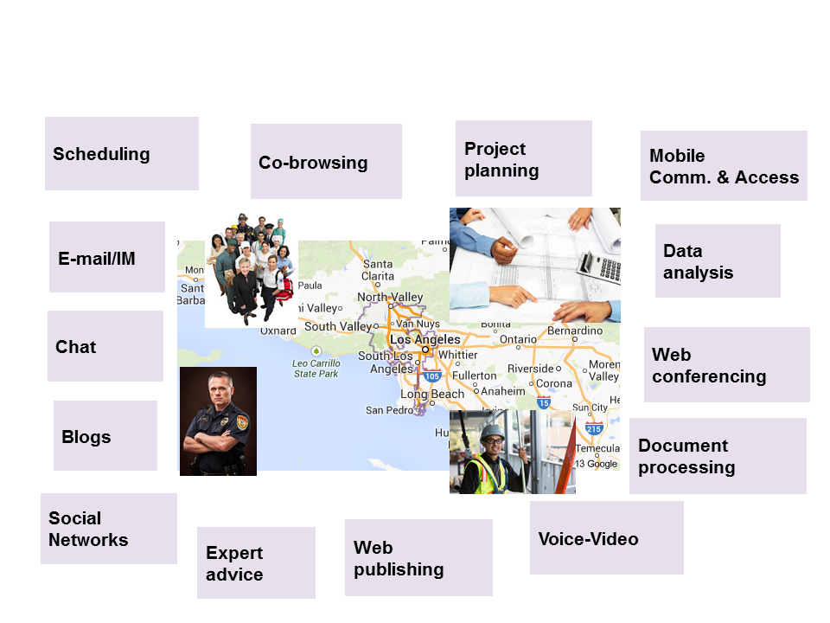

Figure 1.4.1.1-3: BuildLA Portal Will Provide Access through Multiple Channels.

**Portal Approach Review Workshop**

By leveraging our Definition Center, we eliminate the need for multiple layers of static documentation. The assessment and approach are leveraged in conjunction with the to-be-approved final simulation. If need be, we can export a final document from the system, but the benefits of working in a holistic ecosystem allow clarity to all parties involved.

##### Portal Design (RFP 3.1.4.1.1.c)

Our Advanced Visual Studios Practice will define and develop the Information Architecture leveraging iRise, an application that assists in the definition and creation of a working simulation of the final Portal. iRise produces reusable elements to simplify the development of the BuildLA portal and allows all parties involved to collaborate, ideate, and interact with the proposed Portal solution prior to build.

##### Portal Technologies Approach (RFP 3.1.4.1.1.d)

**Multiple Channel Support**

Team UST’s BuildLA Portal is based on IBM’s WebSphere Portal server, which along with IBM Web Experience Factory, offers multiple channel support for web fronts out of the box. As illustrated in *Figure 1.4.1.1-4*, the same portal page can be viewed using a desktop browser, a mobile web browser, or using an IBM Worklight hybrid mobile application that uses a device's native features. It is possible to render the same application differently depending on the requesting device type using a single code base.

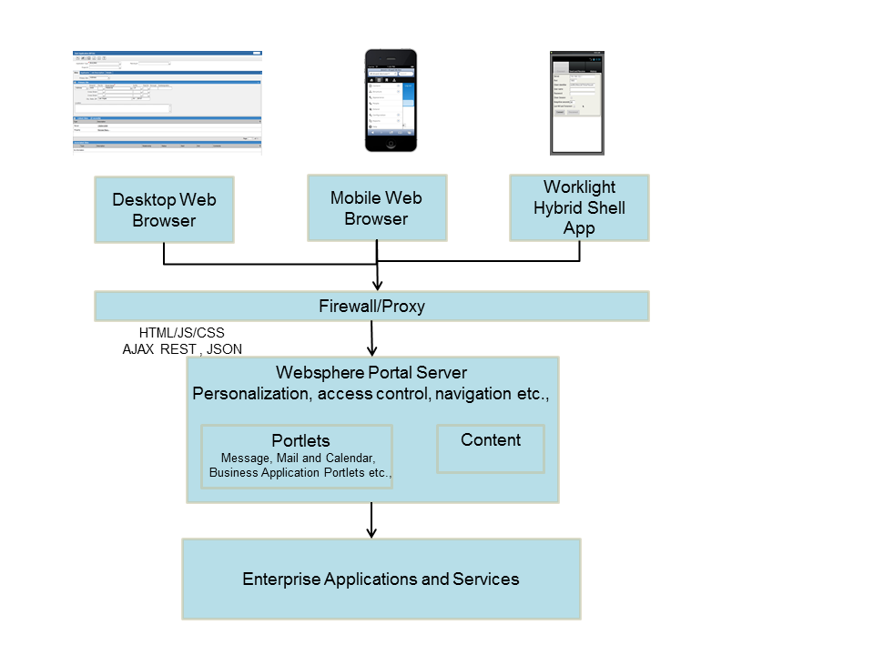

*Figure 1.4.1.1-4: Example for Multi-Channel Support.*

**Search Capabilities**

Our BuildLA portal provides search features out of the box to enable Web site/portal search with very few configuration changes. A search crawler runs in the background collecting and indexing documents configured under the Content Source URL. Search Enhancements provide more granular search index algorithms that optimize WebSphere Portal and Web Content Manager search results, allowing people to find the information they are looking for, with greater speed and ease. Our portal also allows the creation of a custom search portlet which can then be integrated with web content management and document management systems.

**Accessibility Considerations**

While developing UI simulations, the Visual Engineering Practice and AVS team will consider accessibility needs to accommodate both internal and external physically challenged users. These users will need access to information from the BuildLA Portal to the Presentation Layer (UI) of the Portal and we will design the Portal to comply with Section 508 of the U.S. Code.

Examples for accessibility considerations include:

* Visually impaired visitors will be able to see text alternatives when accessing websites
* Voice reading devices will be accommodated
* Visitors who have switched off images for faster downloading of pages will be able to read text alternatives for images

**Usability Best Practices**

Team UST will leverage our Visual Engineering and AVS teams’ best practices on usability. Based on our prior engagements, by embracing UX best practices and user-centered design principals, City agencies will be able to increase adoption by offering a less complicated solution that users can understand and work with. Some of the UX best practices Team UST will adhere to include:

* Ease of use for users based on core actionable items defined during the Discovery phase
* Working with both the users of the system and the organizational goals set by the City of LA to produce a Portal that aligns with all parties
* Interact with internal and external systems to provide a unified user experience to facilitate transactions for users
* Ability to deliver information via multi-channels to users which enables the City of LA web portal to be available anytime and anywhere
* Embrace social media and improve participation by users with the City of LA
* Increase productivity and efficiency with usable systems

**Information Architecture**

Team UST’s AVS Practice will focus on information architecture around organizing, labeling data, and structuring content in an effective and sustainable way. Our Information Architects will categorize and structure information that will address the following:

* Users – A unified taxonomy standard that allows for natural language to drive user action
* Content – Leveraging our Visual Engineering Practice, Team UST will structure both form and function leveraging models from a “low fidelity” perspective. Ideations of the solution will allow for the unified taxonomy to consistently and clearly inform users
* Context – In addition to structuring the IA based on best practices and requirements from the City of LA, Team UST will provide clear direction on content “types” best optimized for Natural Search (Search Engine Optimization [SEO]). Content types, including Meta Data, will be structured for Organic Search and System/Portal specific search

Team UST Information Architects will provide a clear experience for end-users which include consistent navigation, clear content heading, appropriate content length and structure, consistent content placement and targeted actions based on specific portal section/requirement.

In order for the interactive web portal to deliver meaningful information to users our Information Architects will analyze the interdependency between the nature of users, context and content during IA design stage.

Our Advanced Visual Studios Practice will define and develop the Information Architecture leveraging iRise, an application that assists in the definition and creation of a working simulation of the final Portal. iRise produces reusable elements to simplify the development of the BuildLA portal and allows all parties involved to collaborate, ideate, and interact with the proposed Portal solution prior to build.

**Personalization**

Personalization functionality in our BuildLA Portal is an out of the box feature. Personalization rules and content spots are used to display personal information based on a user’s attributes or profiles to automatically customize the site for individual users and groups. Three types of personalization functionality are included in our BuildLA Portal:

* Simple filtering: Content (pages, portlets, WebSphere Content Management elements, etc.) is displayed based on user access rights; for example, the managers group can view more links and content than the employees group.
* Rules engine: Content is provided based on business rules that define what content should be displayed when a specific profile visits the site.
* Collaborative filtering: Users rate content items (for example, products) and visitors receive content based on the ratings of others.

**Multiple Language Support**

To reach as many users as possible, the BuildLA Portal supports multiple languages since the City of LA interacts with users from many different demographic groups. The portal can concurrently serve portal views to large numbers of users, each in their preferred language.

In addition, the portal can support portlets in different languages. If portlets do not support a desired language, the portal tries to match the user's language preference as closely as possible. For example, if a page for a Spanish user shows several portlets in Spanish and a portlet is added that only supports English, then the page shows the new portlet in English but still show the other portlets in Spanish. Content within a portlet window can be translated using transcoded technology.

##### Portal Intake Capabilities (RFP 3.1.4.1.1.e)

Users will be guided through the intake process by means of wizards which will assist the user in researching information or filing an application. The Portal contains dynamic displays that are customized through a series of rules based on the type of application (e.g. construct a building, rezone a property, etc.) being filed. Using these rules, the Portal prompts the applicant for all required information and validates it for accuracy. If any of the validation rules fail, the applicant will be prompted to enter correct information and guided with help screens to enable them to progress to the next step. This has been depicted in *Figure 1.4.1.1-5* below.

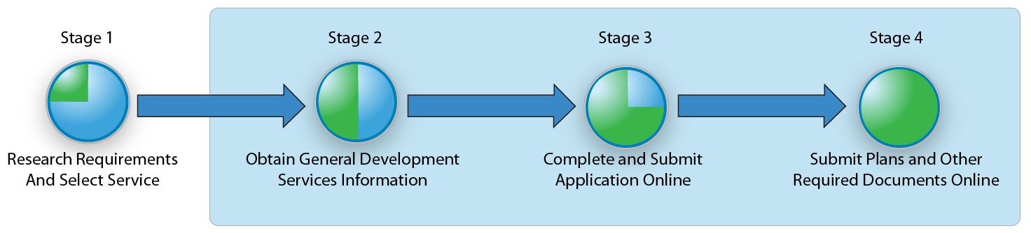

Figure 1.4.1.1-5: Example for Wizard, Decision Tree Design, and Document Upload.

Wizards will also be used to help the user determine the appropriate service. These business rules can be created, modified or deleted by authorized City of LA employees as circumstances change. This is a key functionality by which the City can be responsive and modify processes as business needs change.

During the intake process applicants will be able to leverage help available on the website or through the knowledge base. In addition to help screens and guided wizards, our BuildLA Portal will include a variety of assisted support options – webchats, integrated IVR, and other options − to work with an applicant to complete the intake process. We provide additional detail in the next two sections.

##### Portal User Experience (RFP 3.1.4.1.1.f)

The Knowledge Base is a key component in any self-service portal, and will be included as our BuildLA solution is deployed. Since maintaining a knowledge base is a continuous process, we will incorporate the following best practices to provide an outstanding user experience:

* Popular search terms should return an answer for the user’s specific needs within the top five results.
* Configuring and analyzing keyword search reports will help to refine the content and Meta tag them for future quality searches. For popular keyword searches a knowledge base decision table will be created which will enable authorized City of LA administrators to evaluate if correct content is being made available to customers.
* Apache Soir Enterprise search capabilities will be utilized for customers to use natural query language in searches. Apache Soir features:
  + Find relevant enterprise content more quickly
  + Turn raw text into rapid insight from internal and external content sources
  + Customize rapid insight to the specific needs of your users
  + Enable deeper insights through integration to other systems and solutions

An example of a knowledge base page is shown in *Figure 1.4.1.1-6*.

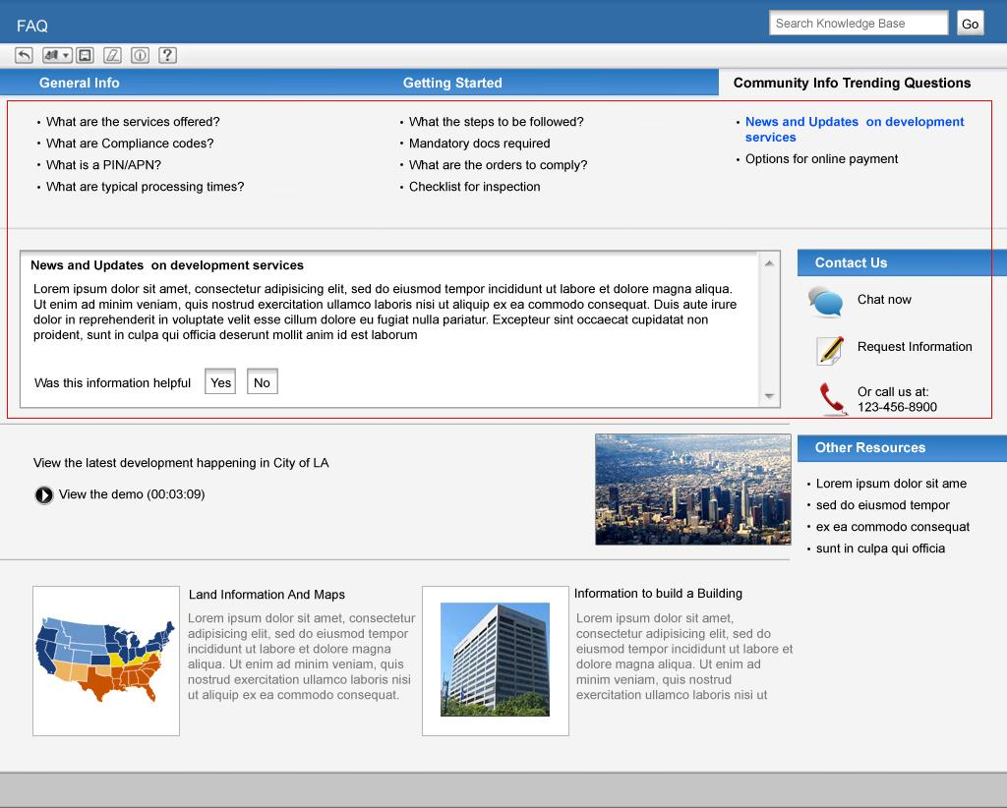

Figure 1.4.1.1-6: Example of a Knowledge Base Page.

##### Portal Self-Service Support (RFP 3.1.4.1.1.g)

Team UST’s BuildLA Portal will contain multiple channels for customers to get assisted and unassisted support. The following Figure 7 represents some of the assisted and unassisted channels options where customers can get relevant information. For example unassisted support could include the latest news and updates from the City, self-help videos and a library of documents based on service type (e.g. zoning laws, electrical requirements, dates for City Agency meetings, etc.). If further information is required, a variety of assisted channels will be available (e.g. a web chat with a live agent, a request for information via email, or directly calling the support center to speak with an agent.) An example of multi-channel integration is shown in *Figure 1.4.1.1-7*.

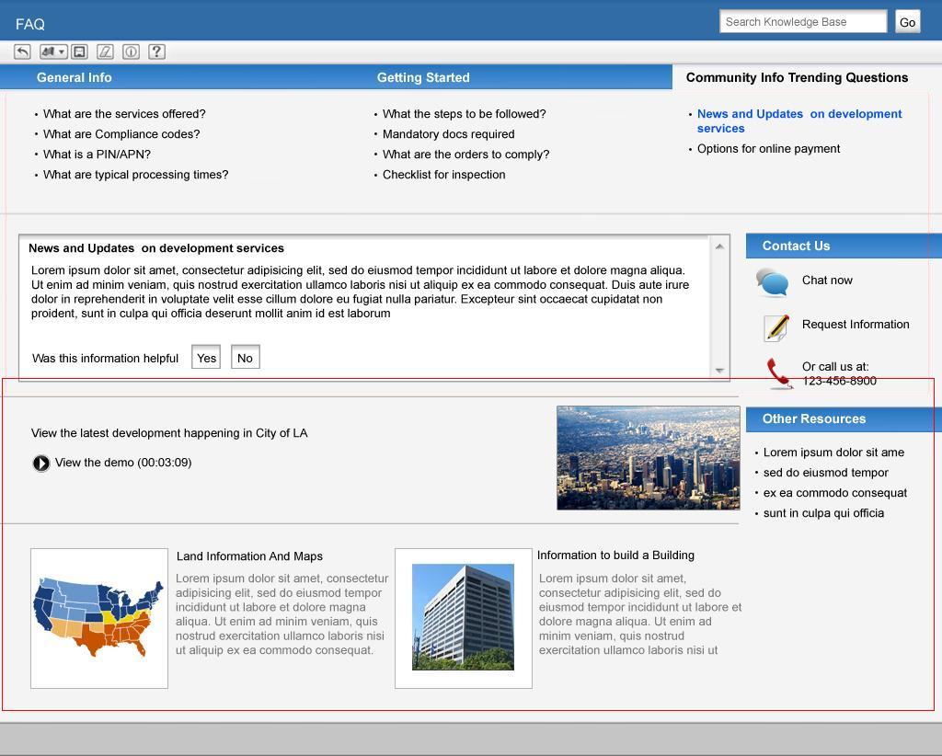

Figure 1.4.1.1-7: Multi-Channel Integration for Customers.

#### Permitting and Land Use Solution (RFP 3.1.4.1.2)

C:\Users\u36181\AppData\Local\Microsoft\Windows\Temporary Internet Files\Content.IE5\GGPR7WM9\MC900240161[1].wmfTeam UST’s BuildLA solution includes an integrated, workflow-oriented solution that streamlines processes for long-term land-use planning, manages the permitting process for construction, alteration, or repairs of commercial and residential structures, manages licenses for businesses and individuals and tracks and resolves all violations of local ordinances and rules.

##### Application Intake (RFP 3.1.4.1.2.a)

The City of Los Angeles has identified well over 100 different permit types that are issued to citizens including new construction, electrical or plumbing permits, rezoning requests, and temporary street closures. The entire business process for a particular application (including its related activities, fees, and business rules) is captured as an application type in the Planning, Project, Building Permits, or Use Permits modules within our system. Each of these modules provides purpose-built functionality targeting the broadest capabilities described in the RFP.

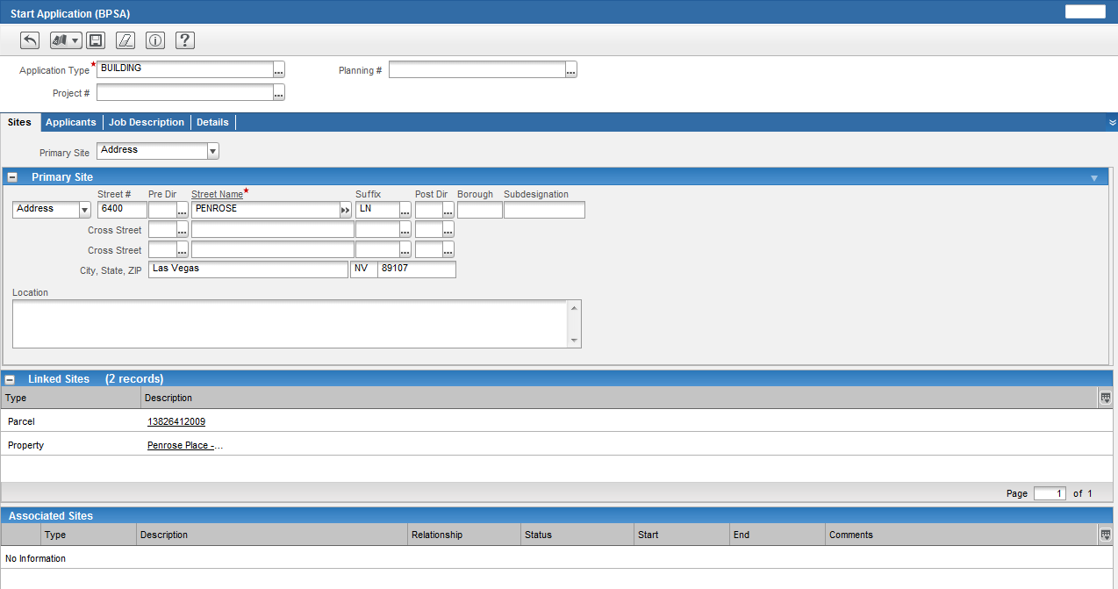Figure 1.4.1.2-1: Start Application Screen.

Every application once generated through either the Start process (refer *Figure 1.4.1.2-1*) or a bulk adds function, includes an identification number to track it. Lookups allow applications to be located, display summary for each application it returns, and allows bulk updates. Info Viewers display detailed information about a particular application along with the ability to edit information related to that application.

During the intake process, business rule validation and enforcement ensures that all required fields have been completed correctly. The first level of enforcement is the use of filters (shown in below figure) which occurs behind the scene to ensure that the person entering the data only sees fields that are relevant to the application that they are trying to complete. The second level of enforcement is the system field code validation. While the user is adding data and choosing fields, the system is validating the data to make sure it matches the proper code e.g. if the user is entering the data incorrectly, they will be warned that they cannot enter that code for this application type.

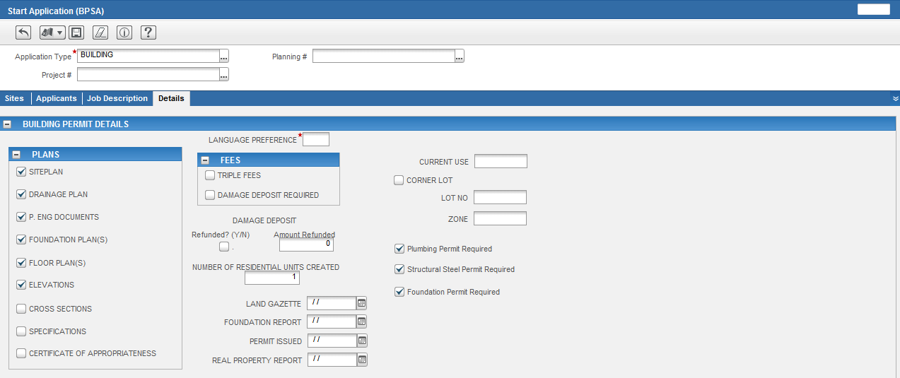Figure 1.4.1.2-2: Data Can Be Filtered so that Only the Relevant Details for the Application Appear on Intake.

Data can be filtered so that only the relevant details for the application appear on the intake scree as shown in *Figure 1.4.1.2-2*. Milestones and workflow are designed to handle the nuances of the entitlement process. Our system automatically adds conditions, fees, inspections, or reviews to an application. For example, if an application type requires an additional review per the California Environmental Quality Act (CEQA), or the completion of an Environmental Assessment Form (EAF), which informs DCP’s decision as to the level of environmental review necessary, the system will be able to automatically route the data to the proper department for review. Similarly, if the data isn’t included with the application, then it will be placed on ‘hold’ until the information is received.

**Document version control** is handled via the Attachment Catalog. Attachments that are uploaded and associated to a particular application or case are stored in attachment catalogs, which are directories on the server that contain the actual files. Our enterprise document management system (EDMS) interface allows agencies to use 3rd party document management systems such as SharePoint or Documentum to manage their attachments. Since agencies use a wide variety of systems to manage their documents, we have developed a generic interface that defines a universal set of standards for sharing documents. This means that you can use our systems’ standard Attachments controls to add new attachments to your preferred EDMS solution to retrieve documents.

**Location services** are handled via our GIS integration product, MapDrawer. Users are even able to start an application directly from the map by selecting the parcel where the work is to be performed as shown in *Figure 1.4.1.2-3*.

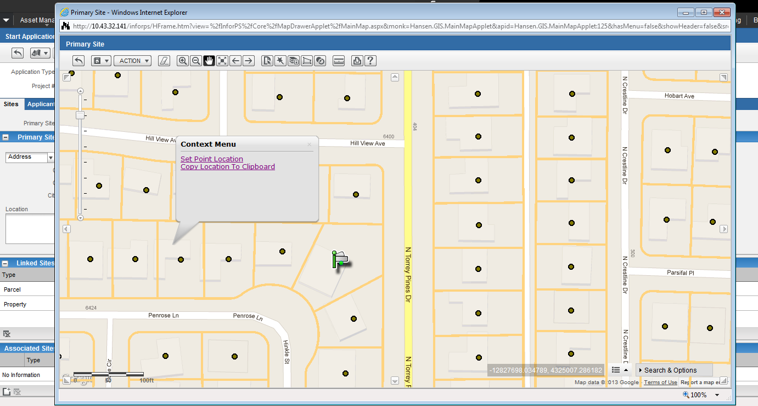

Figure 1.4.1.2-3: Start Application from the Map.

**Data entry design** is consistent throughout the system providing a similar user experience for all of the city and constituent users. While similar, the system is also flexible. Even for the intake process, a user can personalize it by putting the tabs in the order they want. Their settings will be saved and will not affect another user’s view.

**Contact support** is handled in a central part of the solution and is auto-populated if the contact information has already been entered into the system. The system keeps track of all involved parties e.g. property owner, tenant, contractors and is also able to track contact name aliases (refer *Figure 1.4.2.2-4*).

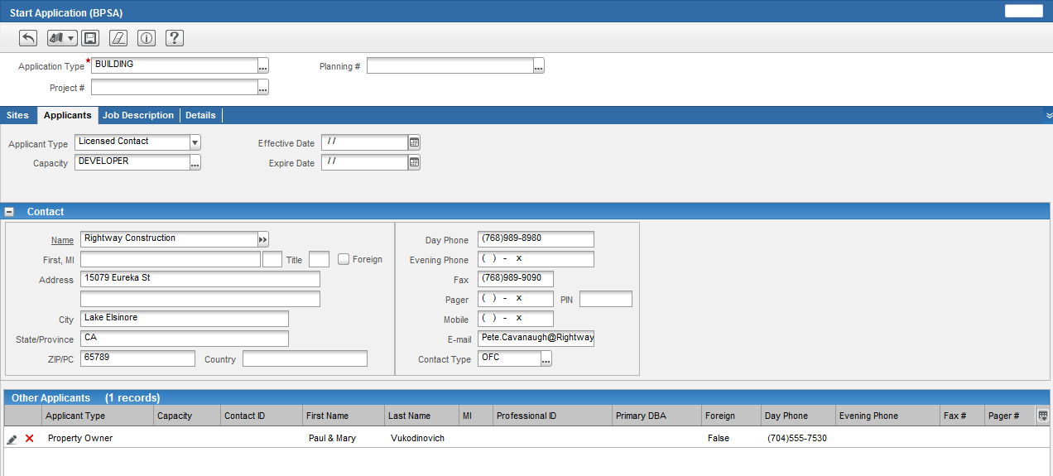Figure 1.4.1.2-4: Owner Information is Populated Automatically Based on the Address or Parcel ID.

No matter where a user is in the system, Help Functionality is just a click away (*Figure 1.4.1.2-5*). Users need only to click on the question (?) mark at the top of the screen to access the built-in online help.

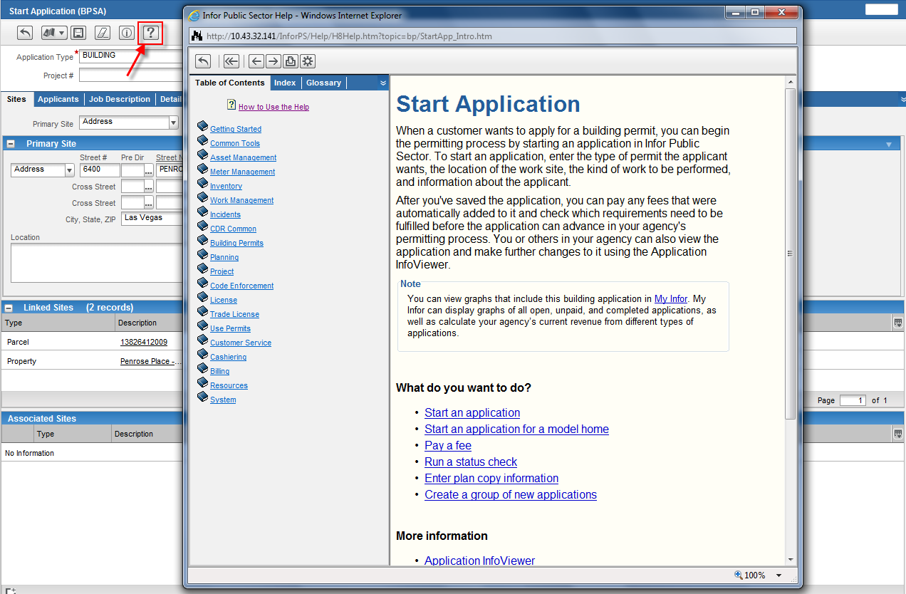

Figure 1.4.1.2-5: Access to Help Files.

##### Application Processing (RFP 3.1.4.1.2.b)

Once an application has been received and is ready to be reviewed by an actual staff member the application will be **assigned** automatically to the proper person based on your specific criteria. Auto assignments can be based on anything in the system, but typically most agencies want applications assigned based on location or type of inspection or review required. The solution also allows Supervisors to manage workloads in an easy to read scheduling view (refer *Figure 1.4.1.2-6*).

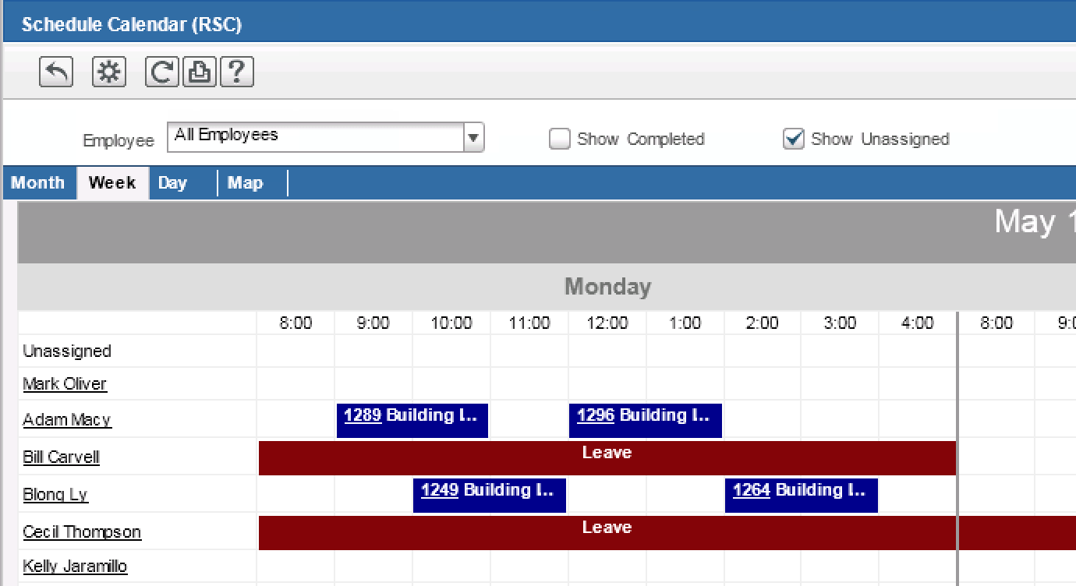

Figure 1.4.1.2-6: The Schedule Calendar Gives A Visual View Of Inspections For Supervisors And Their Subordinates.

Version control is inherent functionality within the system. By automating the process, the entire history of events stays with the location (address, parcel, property) and the contact(s). Applications can have multiple reviews, inspections, hearings (for certain entitlements). The entire history stays with the project. With the integration with the ProjectDox solution, version control on actual plan drawings is also captured and retained with the project. An example of a version control screen is shown in *Figure 1.4.1.2-7*.

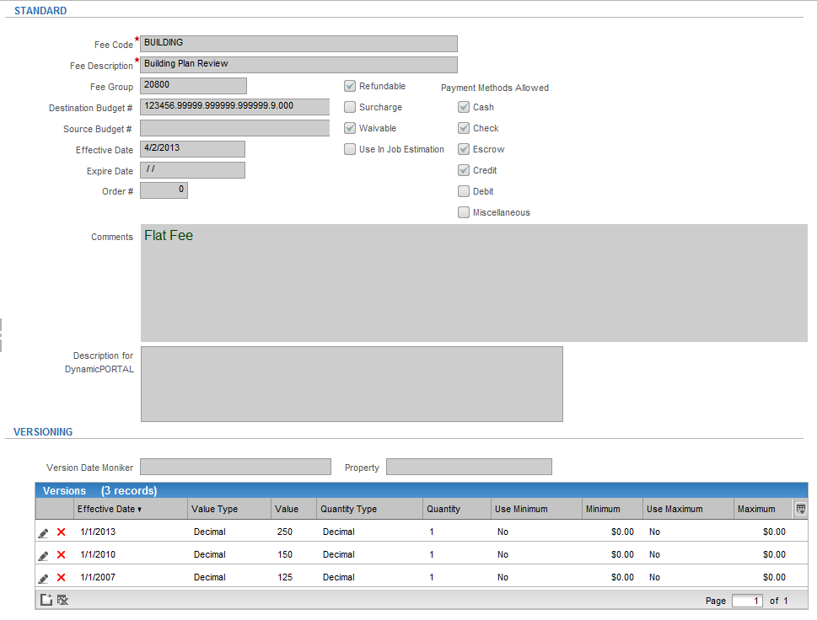Figure 1.4.1.2-7: Version Screen Showing Previous Versions of Plan Drawings.

**Application status** is automatically determined by how many of the required criteria have been met. In order to save the City calls and status inquiry by constituents, the system is able to automatically send email notifications, faxes or text messages (depending on the preferred method they select during the intake process), which will save the City’s staff countless hours fielding phone call inquiries. Citizens can also log-on to their account at any time to see where their application is in the process and see what the next steps are. This will save the City’s staff countless hours fielding phone call inquiries.

All related records that are attached to a permit can be viewed on the related records tab within the application/permit InfoViewer. The Application InfoViewer is the one-stop source for viewing and managing applications. Each InfoViewer includes a number of tabs, such as the Reviews tab or the Related Records tab, which displays information about the application and provides links, grids, and other items for performing actions against the application itself or against its activities, fees, and related information.

**Locks / holds /notices** are simply different status categories within the system based on the milestone reached and conditions that have or have not been met. They can be automatically placed on applications, locations and even contacts! Unique to the proposed system is the ability to handle contact name aliases.

**Contacts and contact relationships** are also managed within the system (refer *Figure 1.4.1.2-8*). In addition to standard contact information, the system retains all related information including name aliases, companies owned or worked for, licenses held, financial information, and known addresses.

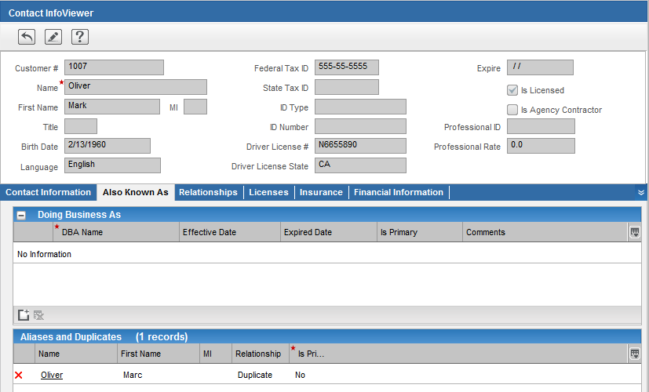Figure 1.4.1.2-8: Contact Relationships Displayed In the Contact Information Viewer.

**Workflow integration** is inherent throughout the system **Inherent Auto-Triggering Capabilities** based on the application status, unless of course it is being held up by a lock, hold or notice. Application status is based on the milestones and events that have occurred. Additional Workflow information has been included in the answer in the next section (*Section 1.4.1.2.3)*, Workflow Management.

The **User Experience** is consistent regardless of which module or application type the user is applying for since all screens have a similar layout to make user navigation easy for all end-users – supervisors, IT staff, and field staff alike.

##### Workflow Management (RFP 3.1.4.1.2c)

Our solution is based on Infor Public Sector’s (IPS) Community Development and Regulatory (CDR) Suite which consists of seven modules that all work in concert with each other (refer *Figure 1.4.1.2-9*).

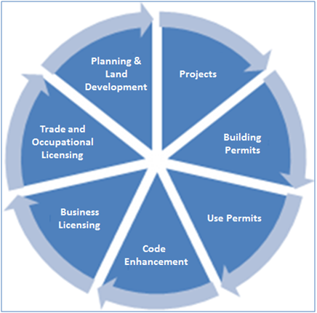

Figure 1.4.1.2-9: Modules of IPS Community Development and Regulatory Suite.

Each module is able to link to other modules in the suite giving IPS CDR the flexible configuration ability to connect multiple processes and workflows to each other. The ability to deliver these connections makes interdepartmental workflow and collaboration possible.

At the center of all IPS data, are data objects (or items) called “Resources”. Resources are all the common data that is shared throughout the IPS suite to minimize data entry and leverage existing data.

Within each of these modules is a central workflow manager. The workflow manager allows an agency to craft a workflow for one or many processes. The workflow can have an unlimited number of status/milestones that indicate the step in the workflow process that an application is currently undergoing. Each milestone contains defined activities that must be completed before the workflow can progress. Once all activities are completed (e.g. approvals are completed, inspections are passed, fees are paid, environmental reports are filed and approved, etc.) the IPS workflow manager will automatically progress the application to the next milestone as defined in the workflow setup.

Business rules such as contractor license validity, conditions of approval inheritance to the building permit process, doubling fees for work without a permit, parcel tags and holds and much more can all be configured into the milestones to ensure issues are resolved before milestone progression. Any business rule based on data within the IPS CDR suite can be configured to determine the next step in the workflow process.

Workflow definition can consist of a simple linear process or a complex set of decision paths resulting in the automatic routing of the application/permit/case. IPS CDR supports an unlimited number of workflow rules enabling our solution to handle the City’s complex entitlement and conditional planning applications. It is as simple as choosing to add a process ‘before’ or ‘after’ the required activities as shown in Figure 1.4.12-2-10. 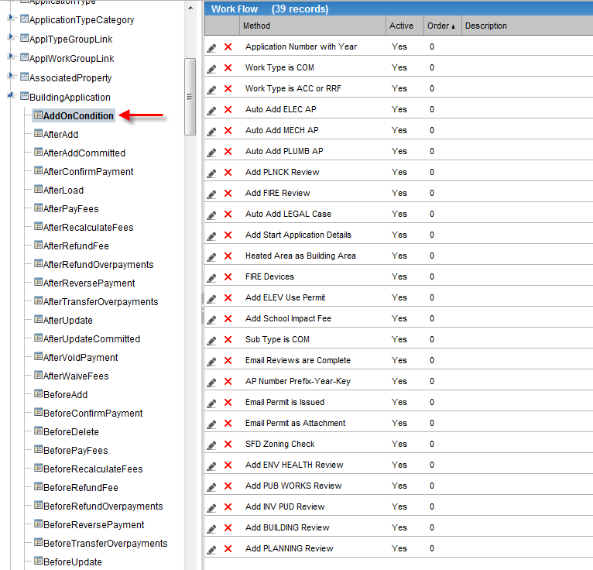Figure 1.4.1.2-10: Workflow Configuration Functionality.

As shown in the screen above, the ability to send **automatic notifications** at the desired stage of the process is an inherent part of the workflow configuration. **Triggering relationships to Fee Activities, Inspection Activities, Conditions, and relevant record event**s are done automatically based on application type, which is managed during the initial configuration using the workflow manager.

Additionally, related records and child permit status can serve a role in permit/license/case processing. Tasks that are required on any related record can prevent workflow progression on parent applications thus creating interdependencies, which can be leveraged in the City’s entitlement processes.

**Rule Storage and Versioning**: Versioning is not required on applications because we are able to expire items rather than deleting or archiving in order to preserve historical accurateness. We do have versioning on fees in order to allow for the occasions when certain fees are “grandfathered” into a process. You are able to access the fee that is relevant to that application exemption.

Full document versioning is handled through the document management system and for the ePlan review process, through ProjectDox.

##### Business Rules Engine (RFP 3.1.4.1.2d)

**Portal Accessibility**–The back-office (Infor IPS) solution is where all the rules are kept and configured for the different application types. When users access the portal, the portal walks them through the steps required for their specific application type via drop down options. Based on what information they choose e.g. “I want to re-zone a property, apply for a residential building permit, remove a tree, put in a swimming pool, etc.” the portal will walk them through the required steps for the action they are trying to complete. However, there are no ‘rules’ in the portal. The portal is accessing the information and workflow from the back-office solution.

As previously noted, the **Workflow Architecture** is built on the milestones and events for the application workflow. Scripts can be written on any event to add conditions or steps “before/add/after” on the business objects themselves, so it goes beyond the standard application workflow.

The **Rules Engine Architecture** is based off of each field’s business objects and the events on those business objects. As mentioned before, rules are stored in the back-office IPS solution.

**Rule storage and versioning** is handled in the workflow manager– show workflow formulas – enabled / disabled application workflows can be ‘expired’ when new regulations are put into place that require a modification to the process.

**Validation, Calculations, Decision, and Generation of Rules** are handled all in the back-office. During the configuration of the application workflow, the system performs data validation to ensure that the correct address, parcel and contacts are identified, fees are calculated based on the rates set up for that particular application type, decisions are made either by the system or by a physical user based on the rules defined in the workflow configuration. For instance, some of the entitlement procedures are reliant upon an individual supervisor or committee to make a final decision as to whether or not the permit will progress to the next stage. The solution will route the application through the appropriate stages and personnel (even for interdepartmental collaborative situations) making the process smoother for both the City and the constituent.

**Auto notifications** are simply events that are added on to the business objects. For example, you could write a formula that automatically sends an e-mail when a record is created, when it is closed, or when it reaches a specific milestone (e.g. inspection required or hearing scheduled). The emails can even contain .PDF copies of the final permit once it has been approved. Auto notifications can be sent to internal staff, or directly to the applicant, or both.

##### Cashiering Technology (RFP 3.1.4.1.2.e)

We are proposing an enterprise solution for managing the operations of the City of LA’s departments. Pioneering a citizen-centric data model that provides a 360-degree view of a citizen's transactions across the entire government enterprise, our integrated data model of business applications, government best practices, and leading performance indicators, make it easy to capture and maintain permitting, code enforcement, and licensing fees with its fee library solution.

Our BuildLA fee library (**Fee Management**) solution module (below figure) allows agencies to definer fee types for Planning, Project, Building Permits, Use Permits, Code Enforcement, License, and Trade Licenses. The fee library solution also includes an intuitive grandfathering tool to ensure that fees are calculated correctly without losing historical data. Moreover, the solution provides built-in functionality for automatically establishing and using deposit accounts to pay review and inspection fees.

It can integrate directly with your 3rd party payment processor currently in place for credit card online fee payments. In order to stay in compliance with PCI regulations, it does not store credit card information.

When fees are due, contractors and citizens can pay online via the Online Portal (*Figure 1.4.1.2-11* and *Figure 1.4.1.2-12)* using a credit card for fees required prior to issuance or renewal.

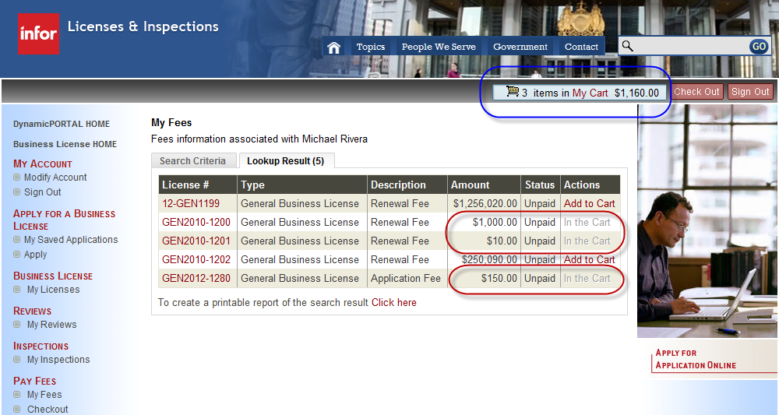

Figure 1.4.1.2-11: Portal Fee Summary and Selection Screen.

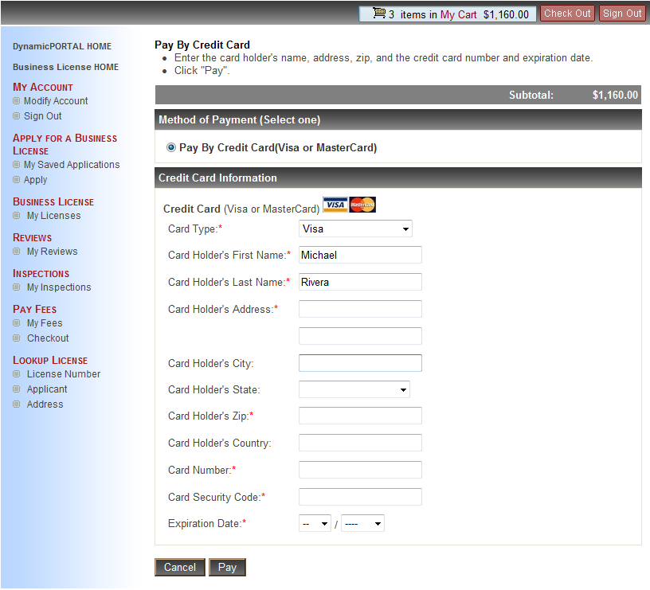

Figure 1.4.1.2-12: Dynamic Portal Payment Window.

For applicants that are not using the online portal or paying in person, once fees have been generated as part of the natural progression of the application, our system can automatically invoice the primary applicant. A **hold or lock** can be placed on the application, essentially freezing it in the status it is in thus preventing it from being approved and issued until all fees are paid. Fees that remain unpaid can progress to a **collection process**. Liens can even be placed on the property, which can put a hold on any desired activity for that property and the contact listed. *Figure 1.4.1.2-13* is a screenshot showing an accounts history of delinquency from the Manage Account page.

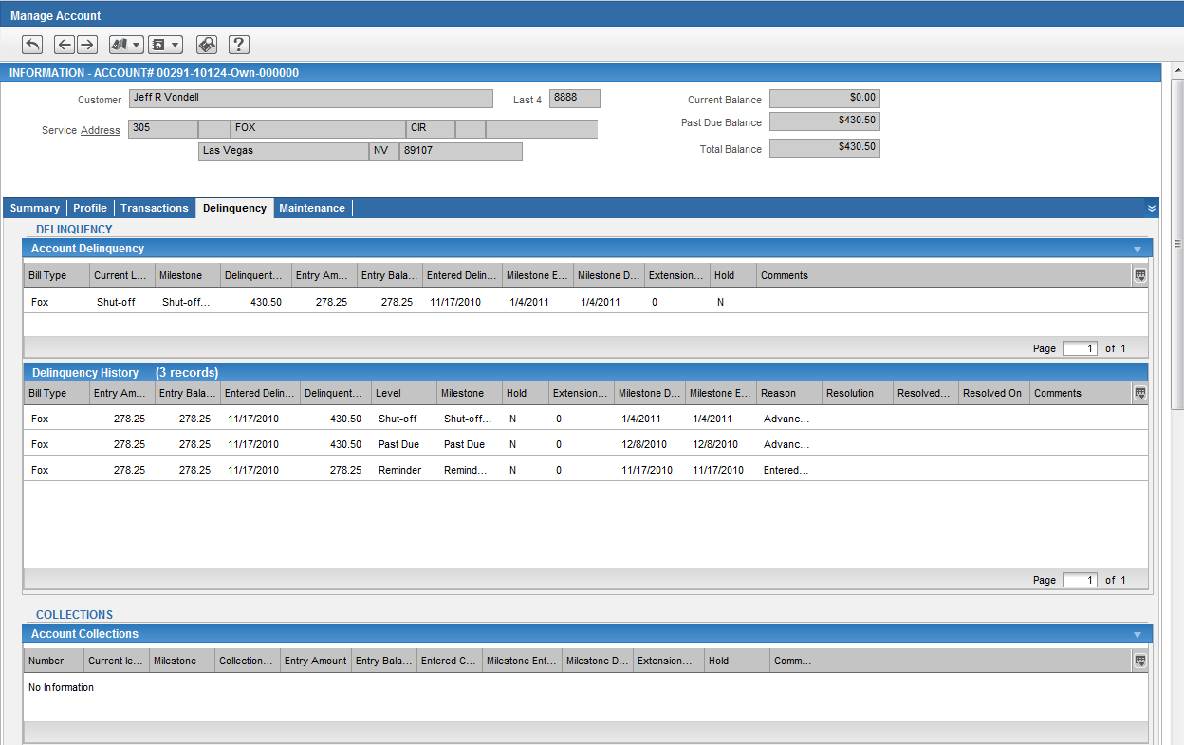Figure 1.4.1.2-13: Delinquency History Page.

**Fee Versioning**—the version of a fee type contains the rules for calculating its charge, including the effective date for those rules (used for grandfathering), a value, and a quantity. The version also provides a way to set minimum and maximum caps on the charge.

The value of a fee type is a dollar amount used to arrive at the final charge. It can be based on a decimal, a rate code, or a formula. Decimal-based values are for fee types that charge a fixed amount. Rate-code-based values allow standard fee types to use a rate code from the rate table solution (which will be discussed later on). Formula-based values are for highly complex fee types that are not well suited as either a decimal or a rate code.

The quantity of a fee type is the number of times the value should be charged. Quantity can either be based on a decimal or a formula.

The Application InfoViewer includes a Fees tab that provides employees with critical information about fees (*Figure 1.4.1.2-14* and *Figure 1.4.1.2-15*). It lists every fee currently on the application that is loaded into the InfoViewer, indicating whether those fees have been paid, whether they have been penalized, and so forth. It also shows application balances to provide at-a-glance-information that can answer the most common customer questions about fees. The InfoViewer lists all of the payments that have affected the fees on the application along with a complete history of all transactions that have been recorded for the application.

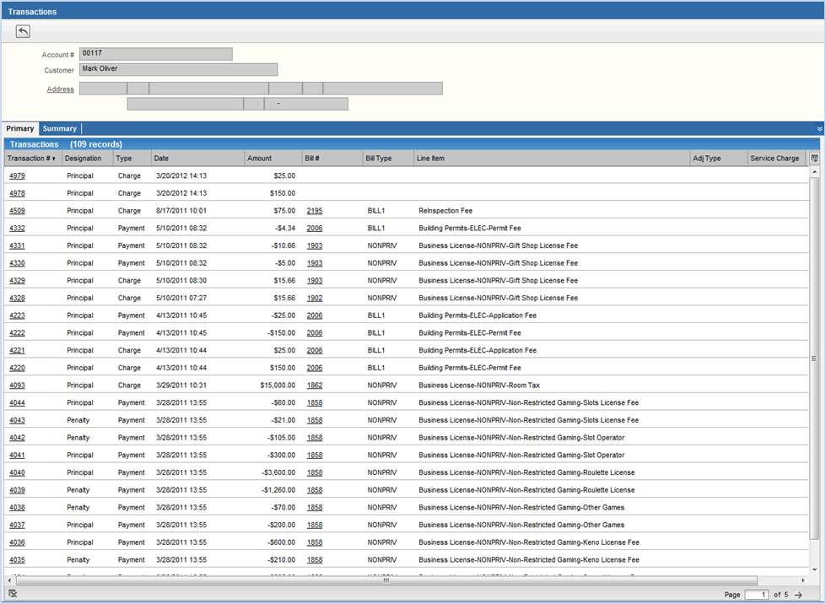Figure 1.4.1.2-14: Transaction Summary Sorted By Customer.

Figure 1.4.1.2-15: Fee Version History with Effective Dates.

##### Inspections Technology (RFP 3.1.4.1.2.f)

Our BuildLA solution can interface with a variety of mobile solutions, including m-power, which allows the City to leverage its existing technology and devices in place today. This will work in the same way that it does with the portal, in which the business process rules will be configured and enforced in the back office Infor solution. Inspection can be performed and violations noted in the field with either a real-time or batch transfer when an internet connection is available.

Infor Mobile Solution (IMS) retrieves data from the City’s Infor IPS database through a web services interface. In addition, IMS is required to post data back to the Infor database. The web services interface is used to ensure system integrity.

The exact data required for retrieval and posting by IMS is determined by final product definition, include agreed-upon business rules and work process. IMS configuration is dependent upon both the City’s purchased Infor application and its configuration. Additionally, the functionality outlined in this proposal is subject to change based on the needs analysis gathering.

Functionality

IMS uses data synchronization technology to give users access to updated and accurate activity information while in the field. IMS is comprised of two primary components: the IMS field application, and the IMS server.

The field unit runs the IMS application which field staff uses to enter inspection results while in the field. Typical field units might include laptop, notebook, or tablet PCs. The IMS server stores inspection results and then transfers inspection information to the Infor database. Communication between the field application and the server occurs during synchronization.

Synchronization occurs when an inspector connects to the City’s network and initiates the process. During synchronization, updated inspection information is sent from the field unit to the IMS server. The IMS server then connects to the Infor database and updates the Infor system.

Route Creation/Builder

Field staff can build routes for themselves using the IMS field application and selecting any inspection by using the Find and Filter options. Using the Find option, inspectors can query IMS about specific information associated with a case (e.g., case number or site address), while the Filter option allows inspectors to use general search criteria to locate cases. The fields used to find and/or filter information can be configured to meet the City’s specific requirements. Once a route exists, field staff can fine-tune the route by changing the order of inspections in map view or list view or removing inspections from the route.

Inspection Result Recording

Field staff use the field unit to record inspection results and other inspection-related data. Inspection result codes are associated with a disposition (pass, fail, etc.) and description. Inspection types and result codes are derived from configured settings in the Infor database.

For each inspection, field staff may choose to enter certain corrections, which denote specific code violations. When necessary, the inspector can mark corrections with the specific location at the inspection site and any additional information that might be required for clarity. An inspection cannot have a passing result until all corrections have been passed. Correction codes, correction dispositions, and location choices can be configured to meet the City’s requirements.

When re-inspecting a previously failed inspection, field staff may want to pass the previously marked corrections. Field staff may update the correction information as needed and pass the outstanding corrections, as merited.

Synchronization

The SmartSync feature allows for optimized synchronization between the field unit and the IMS server, benefiting inspectors with reduced bandwidth connections (i.e., wireless or dial-up). Only pertinent information, such as inspection status or scheduled inspections, will be synchronized throughout the day. Supplementary information, such as notices or digital attachments are reserved in the field unit until a full synchronization is performed. The amount and type of data transferred during remote synchronization can be configured to meet the City’s requirements.

If remote connectivity is not available, synchronizations can take place when inspectors arrive at the office at the beginning and end of the day via a direct connection to the LAN. However, while in a disconnected state, updated information in the Infor database will be unavailable in the field until synchronization occurs.

IMS is designed to function independently from network connectivity. AutoSync functionality enables IMS field units to be aware of current connectivity status. When connectivity is available, AutoSync performs periodic synchronizations with the Infor system to ensure field units possess the most current data. As with the manual sync process, result data from completed inspections are updated from the field unit to the Infor system. AutoSync may be enabled or disabled by system administrators.

Messages

Field staff can apply messages (locks, holds, safety messages) to permits while in the field. Additionally, the City can decide how workflow is affected when a message has been attached to a permit. For example, field staff can be prevented from recording an inspection result or be asked to acknowledge a message prior to recording a result. IMS only allows messages to be applied to permits.

Permit Information Access

When viewing general permit information, field staff can see permit information such as permit number, address, status, type, parcel number, project number and description. When viewing general permit information, field staff may also view contact information for the permit holder. If more than one contact is associated with the permit, IMS displays all contacts. Parcel information is also available to field staff; displayed parcel information is configurable.

Digital Attachments

When using a Tablet PC, field staff can sign an inspection notice or correction notice in the field, as well as collect a signature from the contractor or permit-holder. Each signature will be associated with a name. When collecting a signature, field staff can identify whose signature is being collected with the signature name drop-down field. If none of the pre-defined names are correct, field staff may type an additional name into the signature field. All signatures will be added to correction or inspection notices and the name of the inspector/contractor/permit holder is printed under the appropriate signature line. The date of the signature is also included. Supervisors can view signed notices in the Mobile Access Center.

Field staff can attach digital photographs to the permit, inspection results, or code violation. After the field unit has been synchronized with the IMS server, the attached photos can be viewed by other field staff. During an inspection, field staff can select the photo to be attached. Photos can be uploaded to the field unit using a City-provided capture device. Field staff is not able to remove previously committed attachments. They are able to save a new version with edits, but all previous attachments are saved and available for review in the Mobile Access Center.

GIS

Field staff can view a map showing points that correspond to all inspections listed on their route. By selecting an inspection point on the map, inspectors will be able to post inspection results. If detailed street information is required for a particular inspection, field staff can view a map that focuses on the area immediately surrounding the site address. IMS provides integration and support of agency specific GIS data.

GPS

Additionally, IMS provides location tracking on field units in the Mobile Access Center. When combined with GPS device integration, Location Management Services will provide live updating of current location. In addition, individual units can be selected to view location history. In units with no GPS or no current location information, presumed locations are provided based on route and activity. GPS device integration provides integration and support of GPS physical devices (either connected peripheral or embedded device).

##### Issuance Capabilities (RFP 3.1.4.1.2.g)

Once the application has successfully met all of the required conditions of approval and fees have been paid, its status will be changed to “Approved” and the formal permit or license will be issued. Using the workflow manager, this can be an automatic email with a .pdf of the final document emailed to all interested parties, or it can be sent via hard copy to them as well.

**Reporting Solutions** — Our solution comes with powerful lookups and Information Viewers that provide deep queries into the system out of the box. We also provide a Reports Manager which allows you to link relevant reports to selected pages in the IPS modules. You can also use the Reports Manager to link other types of files to pages, such as documents or spreadsheets. The only requirement is that the files must be identifiable based on a URL or a file path on the server.

**User-based Roles** — The system provides numerous levels of inherent application access control. The system typically houses over 200,000 permitted items, which provide grant or deny access. Each item is assigned an integer value (access ID) that uniquely identifies it. When a user attempts to view or access an item in the application, the system determines whether the user is associated with that access ID and then grants or denies access accordingly.

Users typically perform similar functions in an application and therefore require similar levels of access, therefore role types is used. Roles allow administrators to create sets of permissions that can be granted to either a single user or groups of users. Just as a user can perform multiple functions within an organization, a user can also be associated with any combination of roles, collectively defining the user’s access. Access control also allows you to assign permissions to personalized detail pages that you create. With Single-Sign-On (SSO) Windows integration, users can also be assigned domain credentials and completely bypass the application’s login screen.

**Supervisor Review and Queuing** — Workflow control is completely in the hands of each City department. A combination of manual, automated and prompted processes can be defined in a workflow to tightly wrap around an agency’s process. Additional authorizations and overrides are available to confirm workflow steps or even workflow circumvention. The Workflow Manager also allows for supervisor authorization for certain tasks that are defined as requiring a supervisor’s authorization to continue. Items that require a supervisor’s approval can appear on their To-Do list and/or trigger an email notification.

**Lock, Hold, or Notice on Projects** is also handled via the workflow process. All mandatory conditions must be satisfied before a permit or license is issued, so if there are any outstanding inspections, reviews or unpaid fees, a lock, hold or notice will automatically be applied. For projects that require inter-departmental and intra-departmental notifications, notices will be automatically sent at specific milestones and events in the process where they need to be notified.

Internal and External User Experience is similar throughout the system.

##### Enforcement Capabilities RFP 3.1.4.1.2.h)

**Intake**—When an external user contacts an agency to report a problem, it is submitted as a Service Request (*Figure 1.4.1.2-26*) that records the problem type, its location, and the customer's contact information. The system then assigns a Unique Identification Number that will be used to track the request. After the request is submitted, internal users will typically assign an inspector who will inspect, record, and resolve the request while tracking progress and costs along the way.

**Internal Users** can also create a service request, or they can report a violation that is seen directly on the application, which will then place a hold on it while the investigation is conducted. Sometimes the violation becomes more serious, in those circumstances; it can then turn into a case via the Code Enforcement module within the IPS suite.

The **Code Enforcement** module manages violations of local codes and ordinances, such as a hazardous condition or a nuisance that requires abatement. These violations are different from those cited during an inspection or review for an application or license. Code Enforcement tracks a case through the entire enforcement process, from the initial filing, through investigation, potential court involvement, and final resolution. It also tracks all fines associated with the case. The following are key components of Code Enforcement:

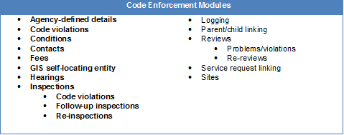

Figure 1.4.1.2-16: Code Enforcement Modules.

*Figure 1.4.1.2-17* shows a Start Case screen for code enforcement.

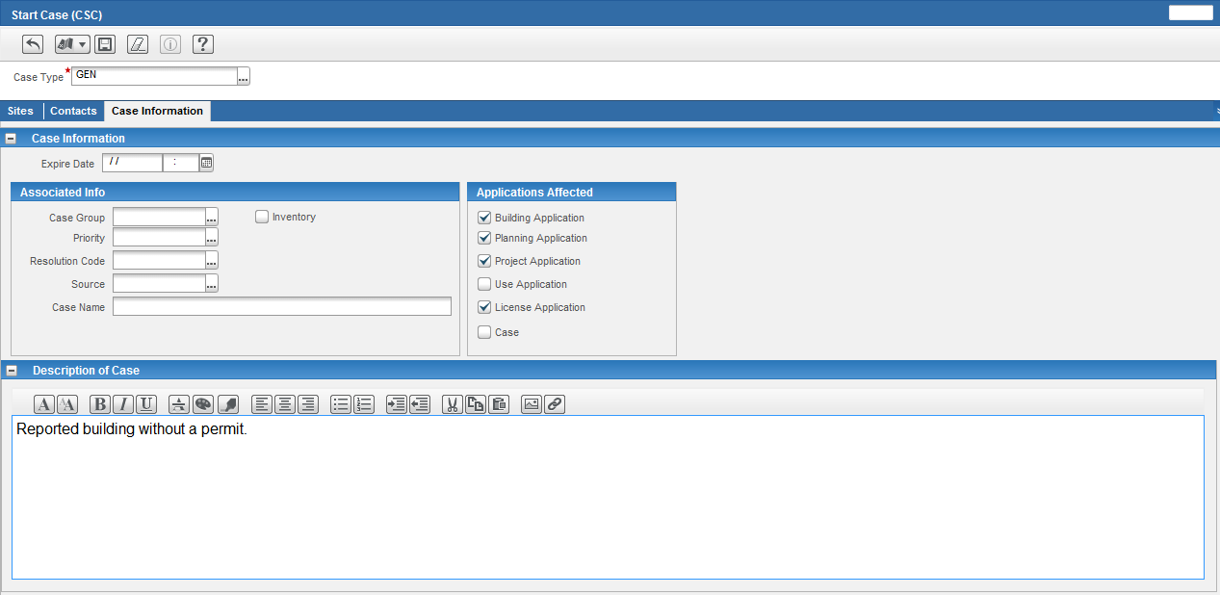Figure 1.4.1.2-17: IPS Start a Case Screen.

Interdepartmental notifications can occur via the natural progression of the case through the workflow process, or via the use of the Infor Mingle product (refer *Figure 1.4.1.2-18*), which can alert an inspector from a different City department, real-time.

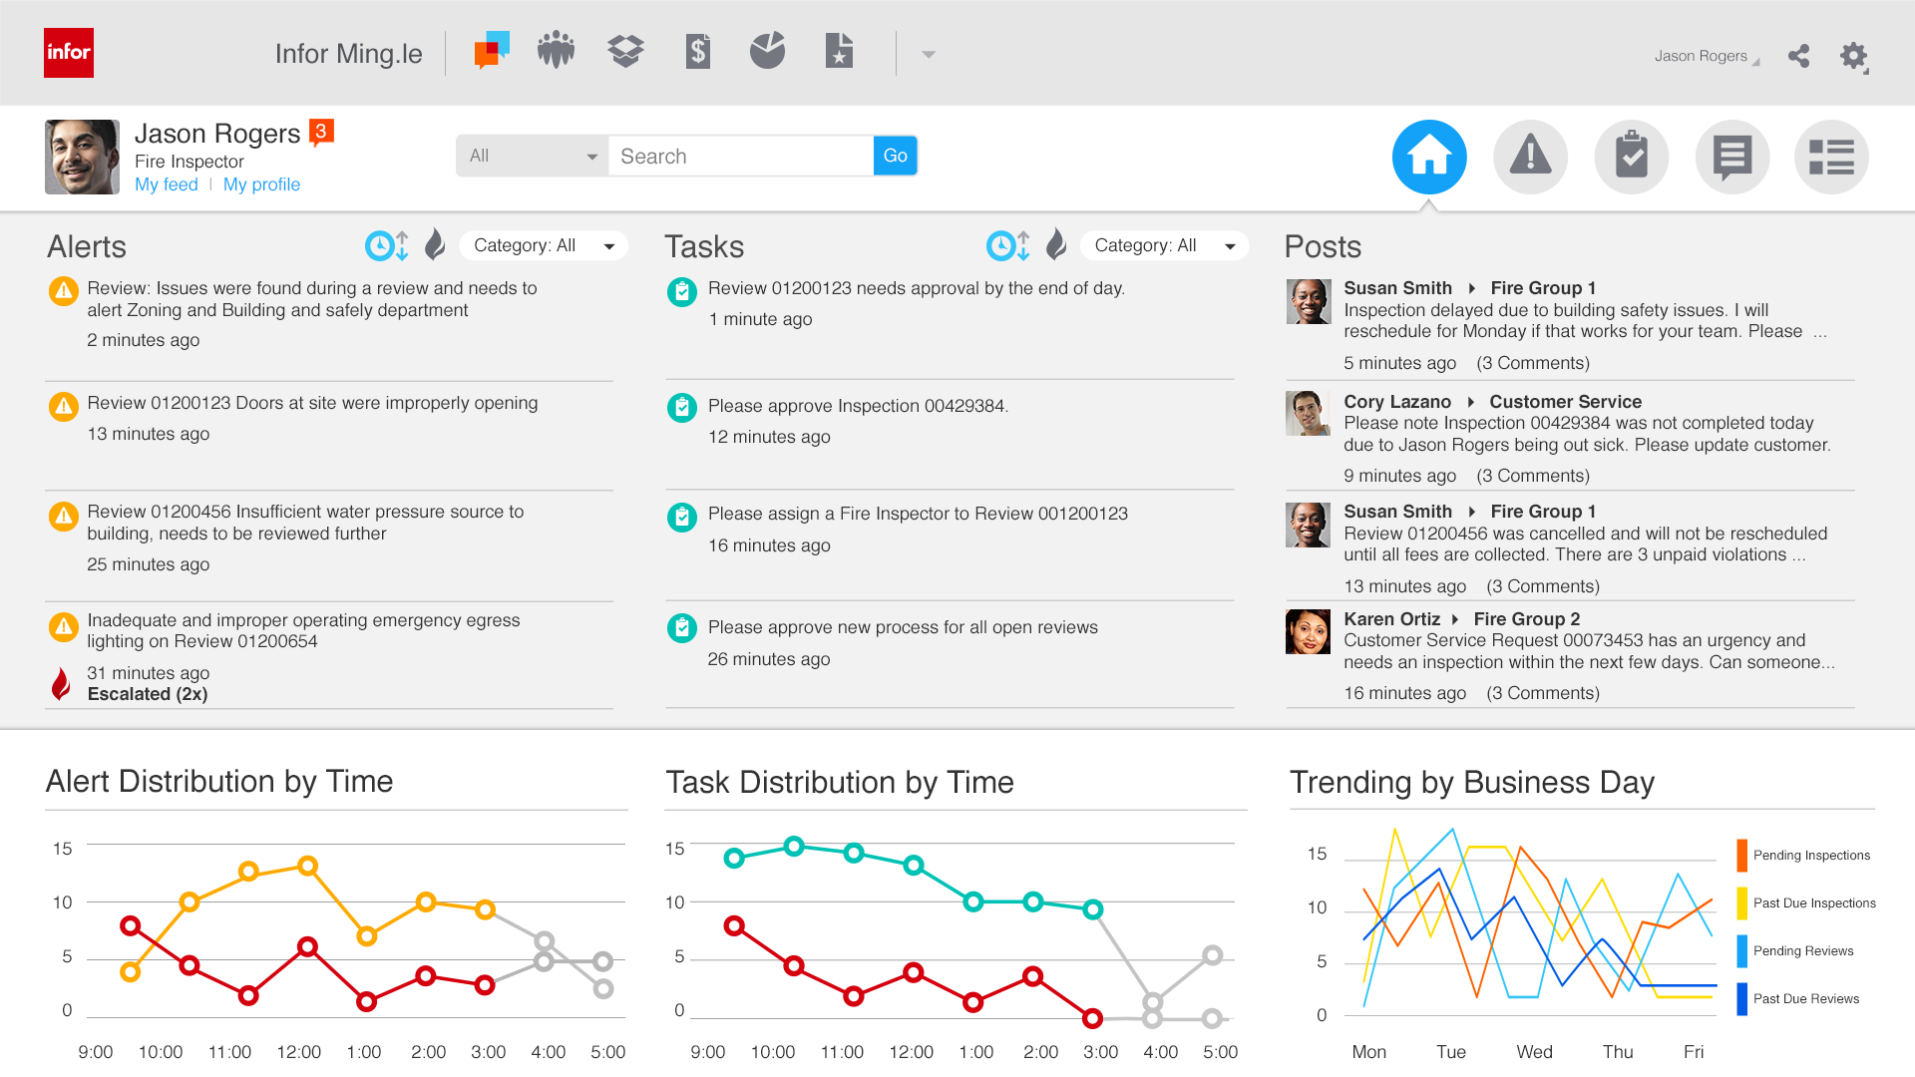Figure 1.4.1.2-18: Using Infor Ming.le, Alerts Can Be Posted Which Make Interdepartmental Communication Faster.

**External users** can check on the status of the complaint and investigation via the online portal. The City can choose which items are posted in a public area, can be searched on publically, or remain private to the individuals in the investigation.

As with all the other modules, a lock, hold, or notice can be placed on the project, location and on the contacts listed. **Stop Work Notifications** can also be sent automatically to all applicable parties once the event has occurred. The system will produce the documentation as preferred e.g. email, hard copy mailed notice, etc. and will keep track of the correspondence that has been sent out regarding the issue and potential next steps towards resolution.

The MyInfor page comes with built-in **performance dashboards** (*Figures 1.4-1.2-19 and Figure 1.4.1.2-20*) that supervisors can modify to track the progress of each case.

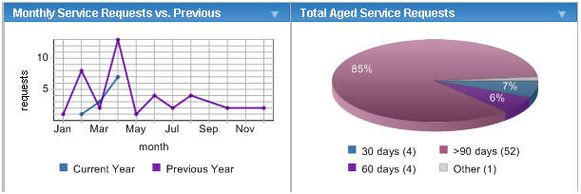Figure 1.4.1.2-19: Sample Performance Metrics.

Supervisors can easily see how many outstanding violations need to be addressed and to whom they have been assigned.

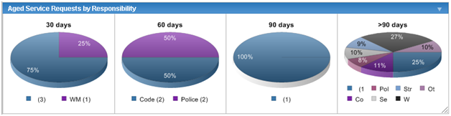Figure 1.4.1.2-20: Aged Service Request Screen Example.

For cases where the parties involved do not pay the applicable fee, the collection and delinquency process can be put into place to make sure that the individual is not able to start any additional projects until all of their outstanding fees have been paid.

##### Trade Licensing Capabilities (RFP 3.1.4.1.2.i)

Our proposed solution handles the licensing processes for all of the City’s licenses, starting from the time a customer files an application.

When a customer applies for a license, they complete an application for the type of license wanted and record their contact information. We then assign a license number that can be used to track it throughout the licensing process (refer *Figure 1.4.1.2-21*).

Before issuing a license, your department may require reviews, such as background checks or exams, and inspections, such as health and safety inspections. Our solution can schedule and record the results of these reviews and inspections. You can place conditions on the license that must be satisfied in order for the licensing process to continue. You can also calculate and charge fees throughout the licensing process.

We provide several tools that allow for the tracking of licenses including License lookups searching for licenses and reviews based on search criteria that you enter and InfoViewers to update existing licenses.

.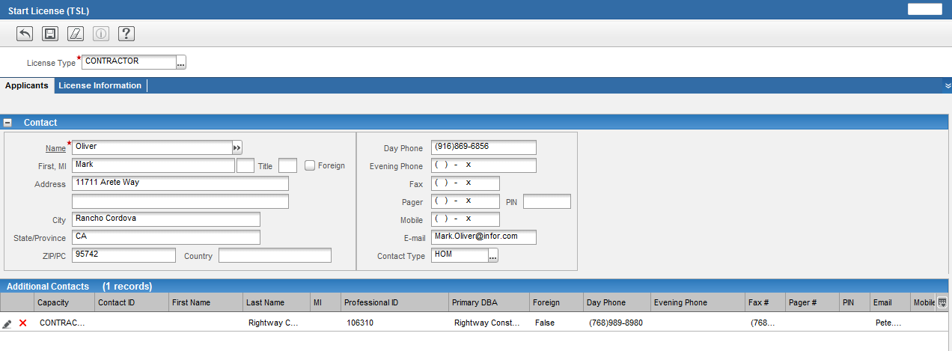Figure 1.4.1.2-21: Starting a Trade License Application Screen.

**Expiration Lifecycle and Flexibility**—How long a license is valid is fully configurable by license type. As well as the conditions that are required e.g. California State License, City Business License etc. As with all other applications in the system, you can modify the requirements as new regulations are required.

**Notifications and Renewals** are simply part of the workflow process for each license type. They can be bi-annual, annual, or once every two years, etc. It is all user-definable as well as the ability to automatically send renewal notifications with the required fees, exams and other requirements such as a business license.

**Portal Accessibility for Online Transactions** is standard with our Portal technology. Any user that wishes to perform their initial application or renewal online may do so.

**Education and Experience Lifecycle Functionality** that may be required before a license is issued can be built into the standard workflow for the type of license they are applying for. For instance, a contractor requesting a license for Asbestos Removal, the system can have the steps and certifications required in order to obtain that license built into the process so that it will not be issued before all conditions are met.

**Batch Processing** is managed through the Batch Manager within the IPS solution. **Export functionality** is achieved through a variety of means, including the ability to export all data in a lookup display grid directly into Excel.

Via the use of interfaces, the application workflow can also **leverage external trade systems** certifications that may be required (such as a California State Contractors License).

**Project Integration for Locks, Holds, or Notices** is standard throughout the IPS solution suite and is based on the milestone and event that the application is in.

##### Materials Control (RFP 3.1.4.1.2.j)

Within the Trade Licensing module, users are able to add License details, which are agency-defined pieces of information that you can record for a particular license, such as the number of persons that will be employed or the types of hazardous materials that will be at the business. You can use Record Inspection Results to add a license detail to the license associated with an inspection, and to record detail information.

Via the use of detail pages, it is also possible to capture the **quantity of materials** that are available at a particular location that is associated with a permit or a licensed contractor. LA inspectors can update the inventory if an on-site inspection is required, or contractors can update the information on good faith via the **Online Portal**.

##### Location and People Based Technology (RFP 3.1.4.1.2.k)

Our solution offers two components for municipalities looking to integrate GIS into their overall business processes: Map Drawer and GeoAdministrator. Map Drawer is an interactive query tool that lets you perform your tasks visually. It brings GIS information into the day-to-day processes of your organization, using maps to set up work orders, associate assets, schedule inspections, for example. GeoAdministrator is a data creation and maintenance tool that brings IPS functions into your GIS application. When the GIS department updates data, that data is simultaneously updated in IPS for a seamless integration between GIS and the other agencies that access that data. GeoAdministrator maintains your geographic information, providing one central location that all departments can access. Together, Map Drawer and GeoAdministrator provide a robust GIS-integrated system that is easy to use for both GIS experts and those who have never worked with GIS.

Our solution offers two components for municipalities looking to integrate GIS into their overall business processes: Map Drawer and GeoAdministrator. Map Drawer is an interactive query tool that lets you perform your tasks visually. It brings GIS information into the day-to-day processes of your organization, using maps to set up work orders, associate assets, schedule inspections, for example. GeoAdministrator is a data creation and maintenance tool that brings IPS functions into your GIS application. When the GIS department updates data, that data is simultaneously updated in IPS for a seamless integration between GIS and the other agencies that access that data. GeoAdministrator maintains your geographic information, providing one central location that all departments can access. Together, Map Drawer and GeoAdministrator provide a robust GIS-integrated system that is easy to use for both GIS experts and those who’ve never worked with GIS.

With Map Drawer (refer *Figure 1.4.1.2-22*), you can perform many queries and tasks visually, making it easier to perform similar tasks on other nearby assets. For example, if you need to schedule inspections of street lights, you could use Map Drawer to find all the lights in a certain area and create an inspection for all of them at once, rather than selecting each one individually. Map Drawer is accessible anywhere where geographic information is used to perform a task. With Map Drawer, you can:

* Use a browser-based map display and query tools embedded within the BuildLA user interface.
* Interact with BuildLA and a map through a browser.
* Display all operational data on a map from BuildLA, such as assets, parcels, addresses, permits, code violations, work orders, service requests, and scheduled maintenance.
* Start permit applications, work orders, or service requests by selecting a location on map.
* View the location of related service requests and work orders on a map.
* Link service requests or work orders together from a map.
* Assign, reassign, change, dispatch, or delete inspections from a map.
* Attach addresses, parcels, or properties to applications, cases, or projects from a map.
* Generate mailing lists for electronic notifications, pulling property ownership directly from the BuildLA database.
* Access local spatial data and map layouts or projects from a browser.
* Search and Query both BuildLA and GIS directly from the map
* Dynamic Action Commands based on the type of BuildLA feature activated in the map
* Group layers based on Profiles e.g. Department, individual (inspector, supervisor)
* Renders multiple services in the same map view (multiple resource databases)

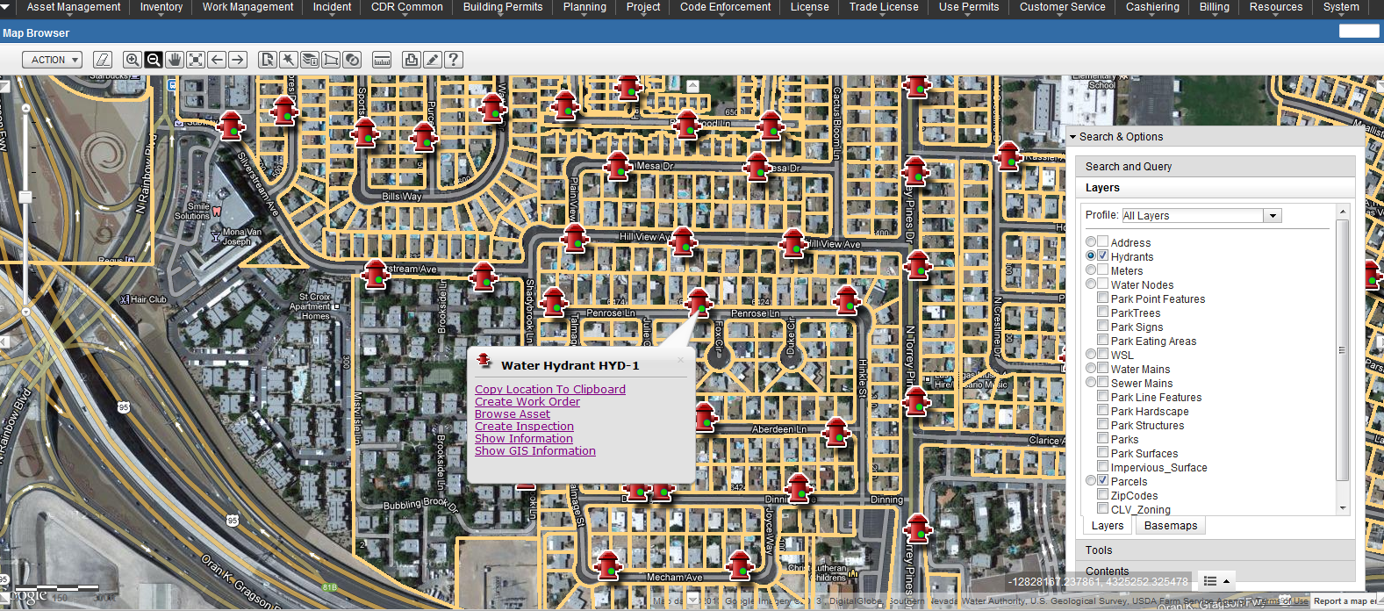Figure 1.4.1-22: Map Drawer Showing Activated Hydrants and the Ability to Create Work Orders From the Map. This View Also Includes the Search and Query Window On the Right Hand Side.

GeoAdministrator is an extension for ESRI’s ArcGIS. Geographic data is created and maintained through GeoAdministrator, and that database connects directly to the IPS application for a seamless GIS integration. When you make updates to your data in GeoAdministrator, the change is immediately visible in BuildLA.

With GeoAdministrator, you can:

* Create spatial features and BuildLA inventory records on-the-fly form ArcMap.
* Join or split linear public utility assets on a map and update BuildLA inventory records enterprise-wide.
* Link spatial features to BuildLA inventory records.
* Synchronize attributes between the BuildLA and GIS databases.
* Identify and create any orphan inventory records in BuildLA from a map.
* Identify and repair any mismatched attributes between BuildLA and GIS databases.
* Associate assets along a roadway on map to roadway inventory records in BuildLA.
* Use the powerful GIS functionality of ArcMap for printing, spatial queries, geoprocessing, and more.

The synchronization of a parcel between GIS and Infor/Hansen using Infor/Hansen’s ArcMAP extension, GeoAdministrator is shown in *Figure 1.4.1.2-23*.

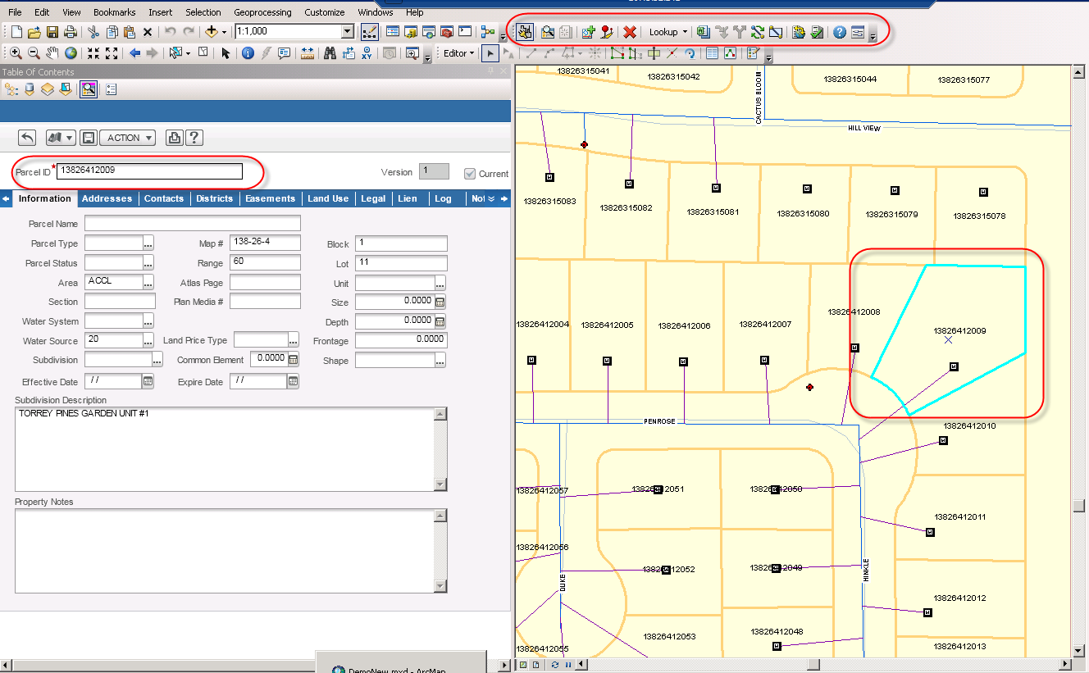Figure 1.4.1.2-23: Synchronization of a Parcel between GIS and Infor/Hansen Using GeoAdministrator.

**Location-based reference data and Contact-based reference data**

The user can initiate searches based on Address, Parcel, Property or Asset as shown in *Figure 1.4.1.2-24*.

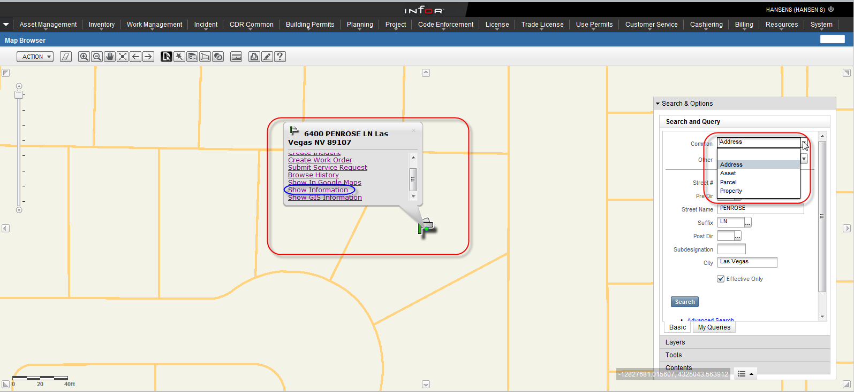Figure 1.4.1.2-24: Search and Query from the Map.

Information about attributes such as contacts can be shown from the map also from the menu option (refer *Figure 1.4.1.2-25*).

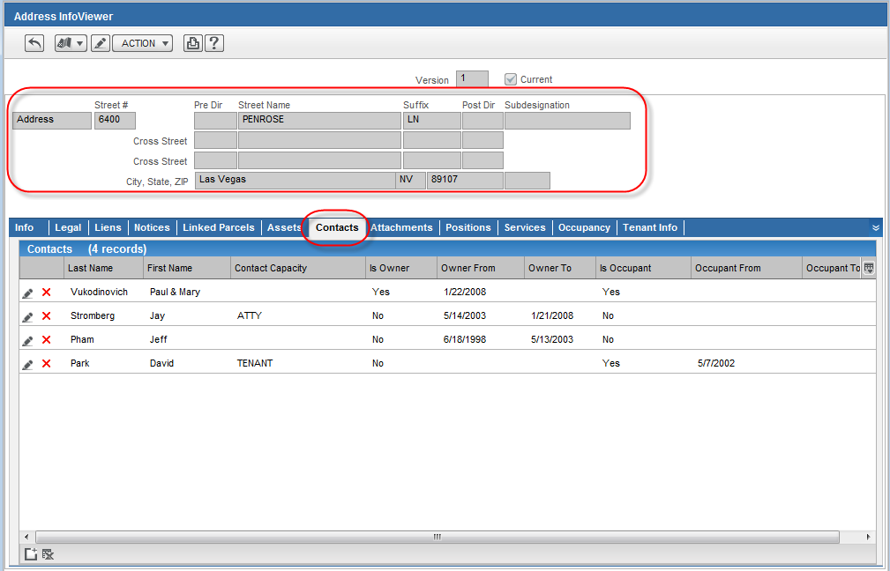Figure 1.4.1-25: Users Go Directly to the Record from the Map via after Clicking ‘Show Information’.

GIS Integration and Tools

Inspections can be initiated, searched for and reassigned from the map. They can be tied to an asset, address and parcel. The inspections can be placed at a user defined location through the Map Browser as shown in *Figure 1.4.1.2-26* and *Figure 1.4.1.2-27*.

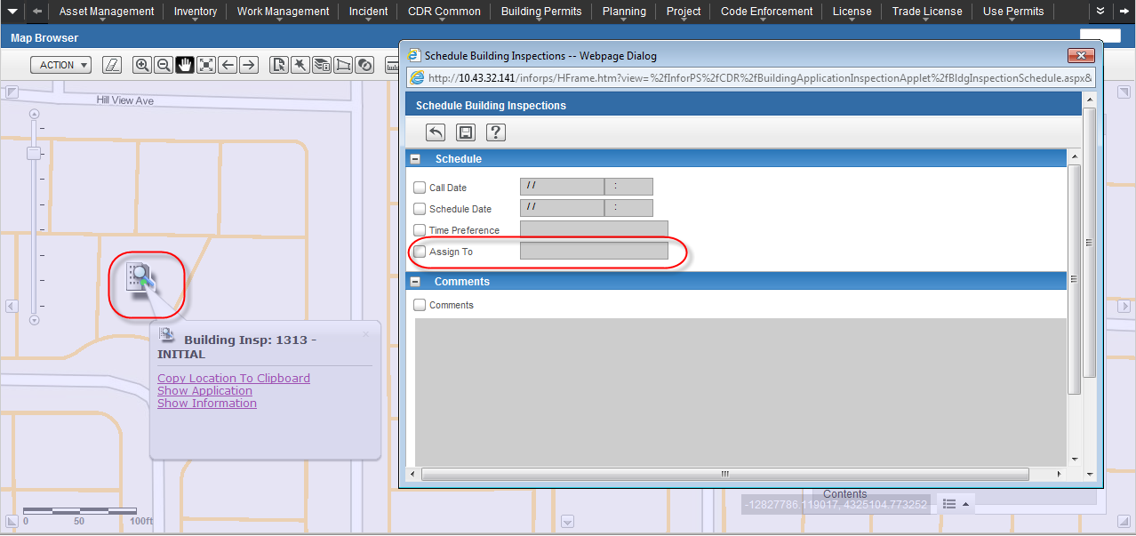

Figure 1.4.1.2-26: Reassign Inspections from the Map.



Figure 1.4.1.2-27: Starting Application from the Map.

#### Electronic Plan Review (EPR) Solution (RFP 3.1.4.1.3)

C:\Users\u36181\AppData\Local\Microsoft\Windows\Temporary Internet Files\Content.IE5\XR9IEU68\MC900157021[1].wmfUST’s BuildLA solution includes Avolve Software’s ProjectDox electronic plan review application to manage engineering plan review and associated business processes across the City’s entire spectrum of government agencies. ProjectDox scalability allows it to support end-to-end, life-cycle management for engineering plan data moving through multiple departments and their respective rule-based workflows, remaining fully accessible to the City’s authorized applicants and staff users. The ProjectDox application addresses specific project types, supporting cross-functional business processes for data and document management across internal and external departments and agencies.

Our approach to the Electronic Plan Review (EPR) Solution for BuildLA is addressed in the EPR process flow below with specific notations where the Appendix D “Use Cases” are incorporated.

ProjectDox Electronic Plan Submission and Review

**The Process:**

* Application Request for Permit or Engineering Review – The initial application is submitted via the web using a citizen access web portal (BuildLA portal). Application Request details are filled out by the Applicant and sent to the jurisdiction’s permitting system. Through the portal, ProjectDox begins the process of knowledge management from end-to-end of the project. As each reviewer, department, and applicant contribute information, ProjectDox manages this knowledge for the purpose of completing the project as transparently as possible. (Ref. BACKGROUND 1.0 Transparency in the development services process).
* ProjectDox Project Creation – Once application information is in the permitting system, ProjectDox queries the permitting system for new permit requests that meet customer-defined criteria for permits requiring plan review. Utilizing its own workflow tools, ProjectDox then automatically creates a review project from a template that is specific to the requested permit or plan review type.
* Our solution provides customizable project templates that can be tailored for each specific plan review. The template contains pre-defined workflow business processes and eforms that can route tasks for different stages (including ad hoc reviews), departments and specific review team members. Review Departments include: Building and Safety, City Planning, Public Works, Transportation, Fire, Water and Power, Housing, Finance, Recreation and Parks. These project templates are then used for the creation of a plan review project. Using web services, ProjectDox automatically creates a new project by integrating information from ProjectDox with the permitting application. ProjectDox drives the project forward by enabling features of other systems. (Ref. USE CASE 2.1.5 List of BuildLA Use Cases)
* Fee Payment Integration – Some review departments allow for the Applicant to submit their drawings and documents for a pre-review or pre-screening so proper review / permit fees and/or bond amounts can be determined prior to formal plan review. To do this, an integration point within the permitting system is required so the ProjectDox Plan Review Workflow knows when the Applicants have paid their fees via the portal and the plan review process has begun. The timing of fee payment can take place at the application stage, pre-screen review stage (following pre-screen of plans, a bond amount may be required), review department stage (an additional bond may be required) and at the approval stage. (Ref. USE CASE - 3.4.7 Input Bond Amount)

The project review process is shown in *Figure 1.4.1.3-1*.

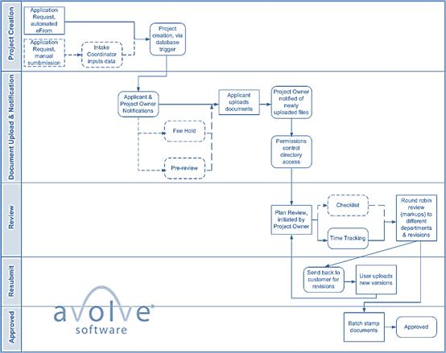

Figure1.4.1.3-1: Project Review Process. Items That Are Outlined With a Dotted Line Are Optional Steps.

* Drawing & Document Intake/Upload Notification and Process – During the file upload process, ProjectDox uses publishing technology that creates a high fidelity read-only rendition of the original file and conveys all the necessary attributes to the screen for use by all review team members. This publishing process protects the original native files from modifications and guarantees the integrity of the intellectual property while delivering everything needed to optimize and automate the plan check process. ProjectDox supports full version control of all plan review documents and all file history is maintained within ProjectDox with easy access to audit tracking of documents and users. There are several things to be considered in this process step including, but not necessarily limited to, the following: (Ref. USE CASE - 3.4.1 Review Plans for Completeness and 3.4.7 Input Bond Amount). The ProjectDox plan upload screen is shown in *Figure 1.4.1.3-2*.
  + Email Notification – When the Applicants submits their permit requests via the BuildLA portal, ProjectDox creates a project based on established business rules. ProjectDox then sends the Applicant a “Project Invitation” email with details on how to log into ProjectDox, which file types the jurisdiction requires, which document and drawing check-lists, and which processes to use to upload their drawings and documents for review.
  + Some review departments do not allow the submission of drawings and documents until the Applicants have paid their application review fees. In that case, the Applicant would not be presented with an upload option until fees have been paid.
  + Some review departments require a pre-screen step where the Applicant is required to submit their drawings and documents to determine what fees will be charged. In this case, the Applicants submit their drawings and documents along with the Application Request, but the actual review does not begin until the pre-review is complete and the Applicants have paid their fees.

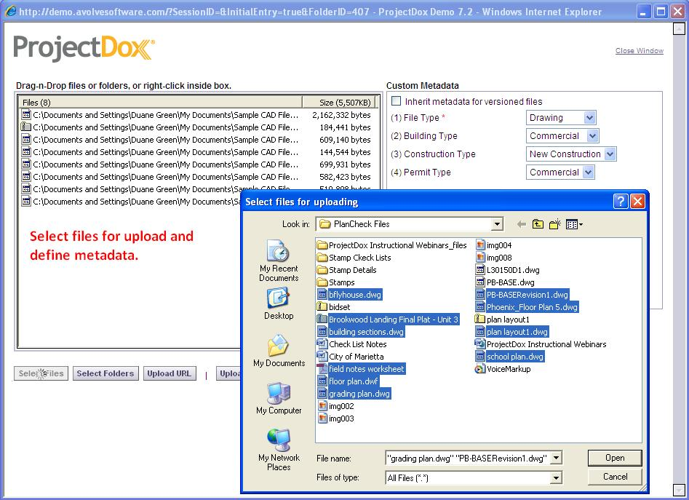

Figure 1.4.1.3-2: ProjectDox Plan Upload Screen.

* Confirmed Upload Notification – Once the Applicants upload their drawings and documents into ProjectDox, an email notice is sent and a ProjectDox task assignment is presented to the Plan Check Coordinator or City Employee, alerting her that the Applicant’s upload is complete and the plan review workflow process can begin. (Ref. USE CASE - 3.4.1 Review Plans for Completeness)
* Drawing and Document Access – The automated email notification that ProjectDox sends to the Plan Check Coordinator includes a hyperlink that takes the Coordinator to the ProjectDox login screen. Once logged in, the Coordinator is taken directly to the Drawings folder to view files. (Ref. USE CASE - 3.4.1 Review Plans for Completeness)
* Check-list Review (optional) – Some review departments go through a pre-screen check-list process prior to the start of the official plan review. The Plan Review Check-List Form (e-form) can be created in ProjectDox to be completed by the Plan Check Coordinator or by the individual plan review department teams. A ProjectDox workflow then routes it to the Applicant to complete and submit along with any missing or incorrect permit application files. The completed check-list e-form can be optionally saved as a PDF in ProjectDox and / or the permitting application for future reference. The check-list form can also be made accessible in the permitting system via a hyperlink.

In addition, some review departments allow the Applicants to complete the check-list form upon submission of their application drawings and documents, to ensure that the correct files are provided. Additionally, some review departments perform a pre-screen/review and then complete the check-list as the first step of the review process.

Department specific check-lists can also be used by the Plan Reviewers during their review process and all check-list items selected by all Plan Reviewers would be consolidated automatically into the Applicant’s Resubmit Form to be addressed upon re-submittal of their revised drawings and documents. (Ref. USE CASE - 3.4.1 Review Plans for Completeness)

* Initiating Plan Review – Once the drawings and documents have been uploaded by the Applicant into their ProjectDox Plan Review Project, the Plan Check Coordinator will initiate the plan review workflow process and ProjectDox will update the permitting application with this status change. This can be done in several ways, including, but not be limited to, the following: (Ref. USE CASE - 3.4.2 Monitor Plan Checker Workload).
  + *Initiated by Plan Check Coordinator* – The ProjectDox Plan Review Workflow is initiated by the Plan Check Coordinator at the appropriate time.
  + *Initiated by Specific Business Process Event* – The ProjectDox Plan Review Workflow is initiated by a specific business process event. An example is when the Applicant makes their application fee payment. Parallel plan review can also auto start the plan review workflow process based on the specific review requirements.
* Plan Review Workflow e-Form Contents – The ProjectDox Plan Review Workflow contains a Review e-form that includes information regarding the plan review request from the permitting application that would be beneficial to the Plan Reviewers during their review process. The plan review e-form contains but may not be limited to, the following: (Ref. USE CASE - 3.4.2 Monitor Plan Checker Workload).
  + *Plan Review Information* – The ProjectDox Plan Review e-form is populated with plan review, engineering, and construction information. This information, along with the Applicant data, is maintained in the BuildLA’s permitting system software, with ProjectDox querying this information as needed. The data pulled from the plan review and permitting system software will vary depending on what is required by the review department’s ProjectDox Plan Review Workflow and e-form – this is specific to each plan review type. Typically in this scenario, Applicant data itself can only be modified in the jurisdiction’s permitting system. However, some review departments require that this data be editable from within the ProjectDox e-form, with updates being pushed back to the permitting system. A best-practices discussion is normally scheduled to identify all required interfaces and data types.
  + *Review Departments* – The ProjectDox Review e-form contains a list of all possible review departments specific to the specific plan review type (example: Building and Safety, Planning, Public Works, Engineering, Fire, Electrical, Structural, Plumbing, etc…). Based on the permit request, the BuildLA portal or permitting system software would pass the specific permit type to ProjectDox, which would then select the required departments for the review. Default review departments are pre-defined in the ProjectDox Project Template and invoked based on the type of permit applied for by the Applicant. The Supervisor can be given the option to add more review departments as required during the review process. If the Supervisor adds a review department, the department is sent an email and a task is added to that department’s Reviewer task list in ProjectDox, making them part of the review team. (Ref. USE CASE - 3.4.2 Monitor Plan Checker Workload).
  + *Plan Review Assignment Process* – ProjectDox provides several ways to assign review tasks to specific Plan Reviewers and review tasks can be easily reassigned as needed: (Ref. USE CASE - 3.4.2 Monitor Plan Checker Workload).

Supervisor Assignment – This option allows a department manager or supervisor to assign a plan review task to a specific Plan Reviewer. The department manager can review the application review request and decide who on their staff should complete the required tasks, based on Reviewer availability, skill set, etc.

First Selected Approach (most popular task assignment process) – ProjectDox assigns the review task to all Department Reviewers. The first Reviewer to select and accept the review task has it assigned to him/her. The review task is then removed from the other Department Reviewers’ task lists.

Direct Reviewer Assignment – This option is commonly used with parallel plan review when an Applicant submits plans for a specific department review and the review assignment is assigned to a specific reviewer.

* + *Time Tracking* – The ProjectDox Review e-form tracks review state time duration for the following plan review states: Assign Time, Review Time, On-Hold Time, Revision Time and Start-to-Approval Time. Each plan review state is tracked per review department, per review cycle. Tracking data is stored in the ProjectDox SQL database and is accessible for reporting and other uses. Plan review states can be customized to meet specific requirements.
  + *Plan Review State Tracking* – ProjectDox also tracks “current status” states for each review department. The states include but are not limited to: Assign, Review, On Hold, Revision and Approval. Plan Reviewers use the Review e-form to update current status as they complete their respective tasks. Plan review state tracking is auto-updated back into the permitting application when a Plan Reviewer updates their current status within ProjectDox. Current Status reports can be generated for review by internal staff and the Applicant, providing up-to-date information on the process of the permit review. (Ref. USE CASE - 3.4.2 Monitor Plan Checker Workload).
  + NOTE – If the Applicant is given access to the Review e-form, the City can control exactly what e-form sections and information the Applicant can view.
* Plan Review Process:
  + *Task Assignment, Stages, and Review Teams* – The plan review process begins with the Supervisor initiating the plan review workflow (or it may be auto started by the specific review department workflow process) which assigns the review departments and the Plan Reviewers. This plan review step auto-updates the current review status to “Assigned” within permitting application via the ProjectDox integration. (Ref. USE CASE - 3.4.2 Monitor Plan Checker Workload).
  + *Plan Review Begins* – Once departments and Plan Reviewers have been assigned, they may each begin their concurrent individual plan reviews by clicking on the plan review task on their ProjectDox task list. Plan Reviewers will have full access to the plan review project where they can open and review any and all drawings and documents. Plan Reviewers can also use ProjectDox to collaborate among each other with questions and comments regarding the plan review. This plan review step auto-updates the current review status to “In Review” within permitting application via the ProjectDox integration. Plan Reviewers will also have access to GIS data via NavigateLA for their specific plan review as required. (Ref. USE CASE - 3.4.3 Review Plan for Compliance and Record Clearance).
  + *Department Review Check-lists (optional)* – Custom check-lists can be created as a single e-form, where check-list items are divided into individual sections for each plan review department. Unnecessary items can be hidden to reduce margin of error. For example, if a Fire Review section has 20 check-list items on it and Fire Review selects 4 out of the 20 items for the Applicant to resolve, the Applicant would only see the 4 items they are required to address or complete. The ability to display only required information in the e-form assists the Applicant from missing a check-list item. Previously, applicants needed to scan the entire document to find required items. The check-list e-form can be updated as items are added or removed, at any time during the review process. Check-list items are tracked per review cycle. (Ref. USE CASE - 3.4.3 Review Plan for Compliance and Record Clearance and 3.4.5 Record Quality Assurance Review).
  + *Markup Process* – Each plan review department can add text, graphical notes and comments to any file in a plan set using ProjectDox view/markup tools. Each Plan Reviewer can create a unique markup file/layer for each file. Markups can contain hyperlinks to external data sources (building codes for example) as well as information stored on the City’s website.

Each department can also maintain its own stamp library of standard notes, codes, or graphical items (like manhole covers and electrical outlets). These libraries are often department-specific to maintain consistent verbiage among plan review team members. Stamps can also be dynamic and contain Reviewers’ signatures, date, and time information. Markup files and stamps are used to complete the formal Resubmit notice that is sent back to the Applicant, displaying visual redlines that are easy to track and understand. (Ref. USE CASE - 3.4.3 Review Plan for Compliance and Record Clearance).

* + *Resubmit Notification* – The most common forms of resubmit notifications are called Group Notification and Departmental Notifications (for parallel plan review), where a single resubmit notice is sent to the Applicant after all review department(s) have completed their portion of the review process. The notice contains all departmental corrections and issues to be resolved by the Applicant. The Resubmit Notice eform includes links to the drawings and documents in question with respective markups and notes. A single resubmit document containing all requested changes greatly reduces conflict and allows for more unified collaboration concerning identified issues. This plan review step auto-updates the current review status to “Resubmit” within permitting application via the ProjectDox integration. (Ref. USE CASE - 3.4.4 Request Plan Correction from Applicant).

Hyperlinks to ProjectDox notes, comments, drawings and markups can also be provided via the permitting system software interface, which has advantages over storing notes, etc. as separate text in the permitting system software alone – because in ProjectDox the drawings are always available as a visual reference.

* + *QA Review Process (optional review step)* – As an optional plan review step, ProjectDox can route the Resubmit Notice to the Plan Check Supervisor or other Supervisor for a QA Review to ensure the requested changes and corrections being made by the Plan Reviewers are complete, accurate and non-conflicting prior to the Resubmit Notice being sent to the Applicant. This plan review step auto-updates the permitting applicant via the ProjectDox integration. (Ref. USE CASE - 3.4.4 Request Plan Correction from Applicant and 3.4.5 Record Quality Assurance Review).
  + *Completed Resubmit Notice* – Once Applicants have completed the required changes to their drawings and documents, the Applicant uploads the updated files and completes the Resubmit Notice e-form. An update notification and task is then sent to each plan review department member on the project, signaling that the updated drawings and documents are ready to be reviewed and compared to previous versions. To improve completeness of the Applicant’s resubmit, Applicants must place a “Check Mark” beside each resubmit change correction, markup, and check-list item prior to the Applicant completing the Resubmit Notice task. After checking the changes, the Applicants can upload their revised drawings and documents. This ensures the Applicant has acknowledged all changes requested by the jurisdictions. This plan review step auto-updates the current review status to “In Review” within the permitting application via the ProjectDox integration. When the Applicants upload their revised / corrected drawings and documents, ProjectDox manages the new version via version control and auditing. All markups and corrections are version specific to maintain file history. (Ref. USE CASE - 3.4.6 Assign Quality Assurance Correction).

Note – The ProjectDox Plan Review Workflow also controls the Applicant’s access to the Drawings folder while the review process is in progress. The Applicant cannot upload any new or revised files while the review is taking place. The Applicant is only allowed to upload new or revised files as part of the Resubmit process or by special permission from the Plan Check Supervisor or other supervisor. This process adds a significant layer of security and ensures the integrity of the process.

* + *Review and Overlay Compare* – Once the Applicant has resubmitted revised drawings and documents for the next review cycle, the plan review team can use ProjectDox’ s unique side-by-side and overlay feature to view current and previous versions. This feature allows the plan review team to see the differences or changes (both additions and deletions) between two similar files. It can also be used with two different files – for example, a site plan overlaid with a building foundation plan. Side-by-side and overlay compare provide the plan review team with a truly valuable and time-saving tool that helps them catch changes early in the process. This avoids costly corrections when and if they are caught during the building stage. Worse, the error goes unnoticed and a dangerous building is constructed. This exposes individuals to life-safety issues and the City and builder to litigation.
  + *Resubmit Required (optional)* – If the plan review process requires an additional resubmission, this is the point in the plan review process that the Plan Reviewers would reject the plan review plan set and complete steps d. – h. again. (Ref. USE CASE - 3.4.4 Request Plan Correction from Applicant).
  + *Approval Process* – Once all review departments have completed their reviews and approved the drawings and documents, ProjectDox routes them back to the Plan Check Supervisor (or final supervisory review person) for final sign-off. This step changes the Applicant’s permission and project access from the Drawings folder to the Approved Drawings folder, where he/she is able to download approved drawing files. This plan review step auto-updates the current review status to “Approved” within permitting application via the ProjectDox integration. (Ref. USE CASE - 3.4.5 Record Quality Assurance Review).
  + *Stamping Approval Process* – Once all drawings are approved, the most current version of each approved drawing is copied from the Drawings folder to the Approved Drawings folder. The files are electronically batch-stamped “Approved” by the Plan Check Supervisor or Supervisor using an appropriate dynamic stamp. ProjectDox stamps all drawings in the Approved Drawings folder and then converts them to PDF (or TIFF or DWF) as the final approved format. Applicants are then automatically notified via the workflow that they can now download approved drawings.

Option 1 – Some review departments do not allow the Applicants to have access to the Approved Drawings folder until they have submitted payment for all permit fees, at which point access is granted.

Option 2 – Some review departments have automated the approval process through a ProjectDox workflow.

Option 3 – Other departments will run this process manually.

* + Pushing Approved Drawings – Following approval, many review departments push the approved drawings to external electronic document management (EDM) or imaging systems for storage. Depending on the City’s legal requirements, the rules for exporting the approved files needs to be specified through a formal SOW. ProjectDox can be setup to complete this “push” process. The storage system can also be configured to pull files from ProjectDox. Optionally, hyperlinks and access to approved files can be made available via ProjectDox or EDM/storage systems through the permitting system software user-interface.
* Sharing Approved Files – Following the approval process, the drawings can go on to become useful data for other departments and agencies like the inspection and GIS departments (NavigateLA), as well as first responder agencies like Fire, Police, and EMT. ProjectDox can manage access to these project files for each department or agency needing access. ProjectDox also provides search tools for locating specific project information like specific drawings, floor plans, and information within the drawings and documents like street addresses, lot numbers and room names.

### Technical Solution (RFP 3.1.4.2)

The UST Global BuildLA solution is a complete package to cover the. permitting and land use management services provided by the seven City departments included in the RFP. The UST solution will support all core services including Application Processing, Plan Reviews, Inspections, Entitlements and Enforcements. A highlight of our solution is the integration of inter and intra department functions through business process workflows. This will empower the city to create efficient, transparent and predictable process. All business processes will be tracked from start to finish with performance measures captured at every step. Performance analytics derived from this data will enable the city to proactively monitor and optimize all their services.

The UST Global BuildLA solution will include a public facing Citizen’s portal and an internal employee portal. The Citizens portal will be the primary interface for the general public to raise requests for various services as well as monitor the progress of the requests currently in progress. The citizens’ portal will also include a Knowledge base with embedded rich media resources to assist the citizens in understanding the city’s guidelines and processes.

The portals will include social interaction capabilities including forums to facilitate interaction between citizens and employees. The portal will also add an assisted channel that will proactively help users while on the portal site through interactive chat and when required guided through a co-browsing experience. The citizen’s portal will be implemented on IBM WebSphere portal and will leverage Drupal for the Knowledgebase and interactive forums (Drupal Forums) & Web chat (Drupal Chat).

Infor public sector will be the primary back office system for the solution. The Infor Dynamic Portal will be the employee portal that employees will use to interact with the system. When new service is requested by a citizen through the citizen portal or any other channel the system initiates a business process that will manage the request as it moves through the various stages of process. This macro workflow will be implemented using the IBM ICPO product. The macro workflows will be based on standard operating procedures and can be easily updated with very minimal time and effort thereby reducing the TTM and maintenance costs for the solution.

The back office processes pertaining to a service are managed by the Infor Public Sector solution based on workflows defined in the system. These micro workflows like the macro ones can be easily updated and maintained by the city without the need for developers. Applications that require a **plan review will require** the requestor to submit the plans electronically. These plans are electronically reviewed and approved/rejected using Avolve ProjectDox.

The solution will provide rich process analytics & monitoring KPIs through the IBM Intelligent Operations Center (IOC). IOC implements an event reporting and data tracking mechanism to enable identification and understanding across the various stages of an application process. IBM Intelligent Operations Center will also enable the creation and display of KPIs to summarize high-level status for a single department or work flow stage or across the entire workflow. The KPIs will highlight issues and identify problems and facilitate further investigation by drilling down into the KPI details**.**

#### System Architecture

Technical Capability View

The technical capability map (Refer *Figure 1.4.2.1-1* below) is a representation of the ensemble of key technology components that collaborate to provide the BuildLA solution. This is derived from the analysis of the functional & non-functional requirements stated.

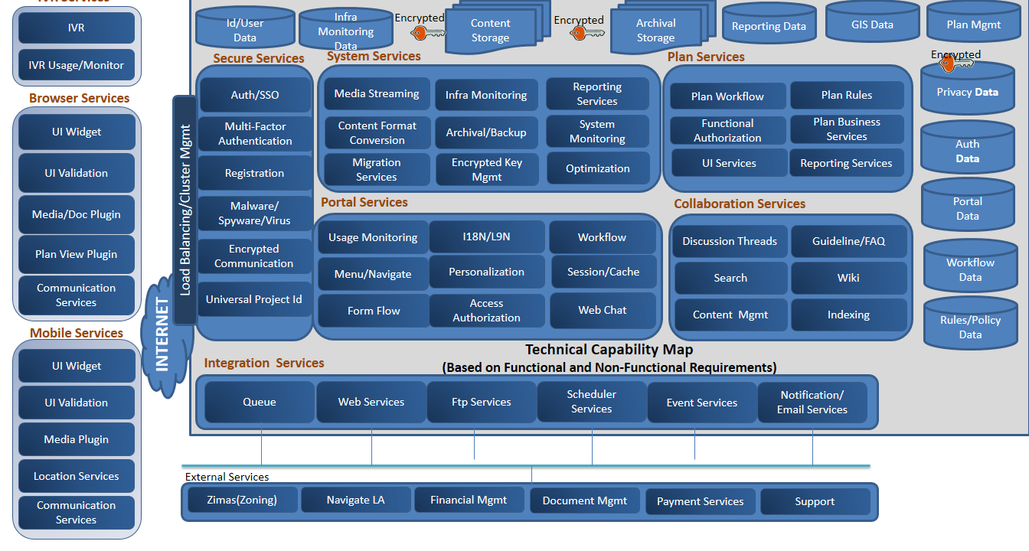

Figure1.4.2.1-1: Technical Capability Map.

Tools Mapping

The view in *Figure 1.4.2.1-2* below maps the tools/technology stacks that have been selected to implement the technical capabilities identified above.

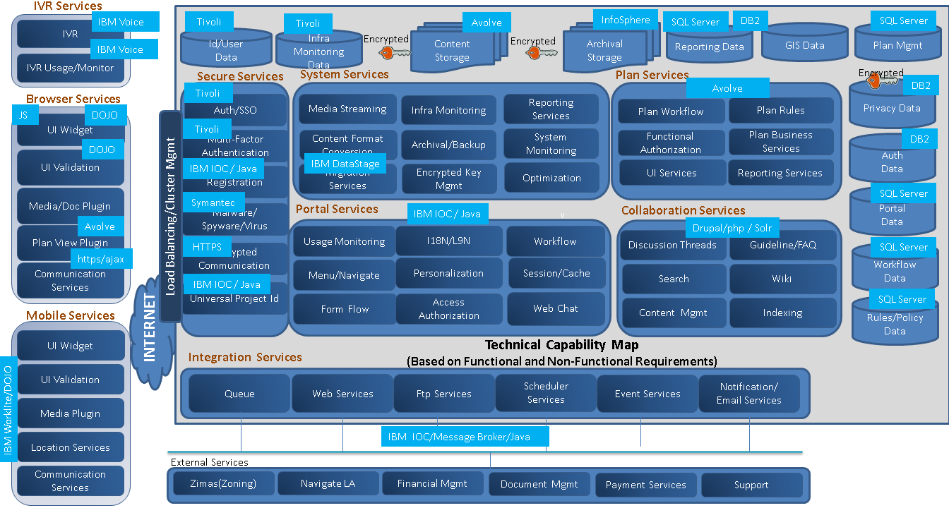

Figure 1.4.2.1-2: Tools Mapping.

UST Global’s architecture COE and extensive technical expertise augmented by the best in class technology solution partners enables us to conceive, design and implement the an optimal technical solution.

BuildLA Products List:

The following tables depict the IOC Bundle Services, Products and Components (*Figure 1.4.2.1-3* to *Figure 1.4.2.1-5*).

| IOC Bundle Products/Components | | Comments |
| --- | --- | --- |
| Service | Component | IOC Bundle.  IBM IOC Bundle - IOC, Content Manager, SameTime |
| Business monitoring | IOC/WebSphere Business Monitor |  |
| Business rules | IBM WebSphere Operational Decision Management |  |
| Contacts | IBM Lotus® Domino® |  |
| Database | IBM DB2® Enterprise |  |
| Directory | IBM Tivoli Directory Server |  |
| Event handling | IBM Tivoli Netcool/OMNIbus |  |
| Event processing and enhancing | IBM Tivoli Netcool/Impact |  |
| HTTP server | IBM HTTP Server |  |
| Identity management | IBM Tivoli Identity Manager |  |
| Instant messaging | IBM Sametime® |  |
| J2EE application server | IBM WebSphere Application Server Network Deployment |  |
| Message bus | IBM WebSphere Message Broker |  |
| Messaging handling | IBM WebSphere MQ |  |
| Optimization | IBM ILOG® CPLEX® Optimization Studio |  |
| Portal | IBM Portal Server Enable |  |
| Registry | UDDI |  |
| Report administration | IBM Cognos® Business Intelligence |  |
| Security | IBM Tivoli Access Manager |  |
| Semantic model | Semantic Model Services |  |
| Standard operating procedure administration | IBM Tivoli Service Request Manager® |  |
| System management | IBM Tivoli Monitoring |  |
| IBM Tivoli Composite Application Manager |  |

Figure1.4.2.1-3: BuildLA Products List

| BuildLA Component to Product Mapping | | Comments |
| --- | --- | --- |
| Software Component | Partner - Product |  |
| Portal | IBM - WebSphere Portal | Bundled in IOC |
| Wizard | Infor | Infor Bundle |
| Infor - Annual Standard Support Cost | Infor | Standard annual support cost. |
| Document Management | Avolve ProjectDox | Document Management functionality in the solution is provided by the Avolve ProjectDox. Additionally, the solution will interface with the various departmental document management systems either through XML or SOAP. |
| Workflow (modeling, execution) | Infor – IPS | Bundled in Infor |
| Asynchronous tools - facilitating discussions or the exchange of information without requiring participants to be communicating at the same time, such as collaborative authoring (e.g., document libraries, wikis, or other forms of online documents) | Drupal | Open Source |
| Synchronous tools - The exchange of information among participants in real time so that participants can be simultaneously focused on an exchange. These include capabilities such as web conferencing, instant messaging, or group chat. | Drupal Chat (Web Chat) | Open Source |
| Business Rules (Execution, Automation, Management) | Infor | Bundled in Infor |
| Content Management (management, repository) | Drupal | Open Source |
| Security (access, PCI, PCI related data) | Custom Solution | Bundled in IOC |
| Single sign-on (Federated Security) | ADFS | Custom solution with existing City framework |
| IBM – IIB | IBM Integration Broker | Formerly known as ESB. |
| Database | MS SQL Server 2012(Avolve ProjectDox & Infor Hansen), DB2 for IBM IOC |  |
| Data redundancy, storage, backup, archive | IBM SoftLayer | We will assist the city to determine storage requirements necessary to achieve expected level of data redundancy, backup, and archive. |
| DRP/BCP | IBM SoftLayer | UST Global will work with the city of LA to define the DRP/BCP and validate the same during the testing phase with an active failover test. |
| Reporting (150 reports) | IBM - Cognos included in IOC | Bundled in IOC |
| Web Chat | Drupal Chat (Web Chat) | Open Source |
| Interdepartmental/intradepartmental communication | Infor -  Ming.le | Bundled in Infor |
| Data Conversion Tool/ETL product | IBM - InfoSphere Data Stage | Has enterprise capabilities |
| BI/Analytics (value-add) | IBM - Cognos included in IOC | Bundled in IOC |
| GIS (must be able to integrate with existing ZIMAS and NavigateLA GIS databases) | Infor – IPS | Bundled in Infor |
| GIS Gateway | IBM - IOC has ESRI integration - integrate with existing |  |
| Electronic Plan Review | Avolve – ProjectDox |  |
| BuildLA Portal UI, development, validation & Integration | UST Global | Listed in the Effort Estimates |
| GIS Information Store | Existing GIS stores - ZUMAS and NavigateLA with ESRI | Use existing GIS stores - ZUMAS and NavigateLA with ESRI |
| Collaboration for parallel processing (Shared calendars, Tasks) | Infor - Ming.le | Bundled in Infor |
| Infor Learning Management System (LMS) | Infor Public Sector Learning Mgr. (LMS) - SaaS (annual) | Need to manage learning requirements and track progress. |
| Knowledge Management | Drupal | Open Source |
| Workflow Analytics | Using Cognos - Custom Solution | Bundled in IOC |
| Workforce Management | Infor - Dynamic Portal | Bundled in Infor & Custom solution |
| Web Analytics | Google Analytics | Free |
| Mobile | Integrate into existing system | Integrate into existing mobile platform |
| IBM - WorkLight | Mobile solution for the citizens |  |
| IVR | Integrate into existing system | Integrate into existing IVR system |
| Enterprise Search | Apache Solr - Open Source | Open Source |

Figure1.4.2.1-4: Components to Product Mapping.

| Citizen Facing | | Comments |
| --- | --- | --- |
| Software Component | Partner - Product |  |
| Self Service Knowledge Base | Drupal v.8 | OpenSource |
| Virtual Assistants | Online Virtual Assistants | Artificial Solutions |
| Self Help Videos | Drupal v.8 | OpenSource |
| Self Help Videos − Streaming | Hosted by third party | Stored internally and published on third party. Subscription based. |
| Peer-to-peer community | Drupal Forums | Previously accounted for |
| Public Inquiry | Infor IPS | Bundled in Infor |
| Email Response Management | MailManager 2.0 | OpenSource |
| Collaborative Browsing | Glance | OpenSource |
| Digital Attachments | Avolve - ProjectDox | Bundled in Avolve |
| GIS | Existing GIS stores - ZUMAS and NavigateLA with ESRI |  |
| GPS | Existing GIS stores - ZUMAS and NavigateLA with ESRI |  |
| Phone | Existing system integration |  |
| SMS | Integrate into existing system | Custom solution to integrate with Email Exchange server |
| Digital Signatures | Avolve - ProjectDox | Bundled in Avolve |
| Barcode Scanning | Open Source | Custom solution |

Figure 1.4.2.1-5: Citizen Facing Components.

Component View

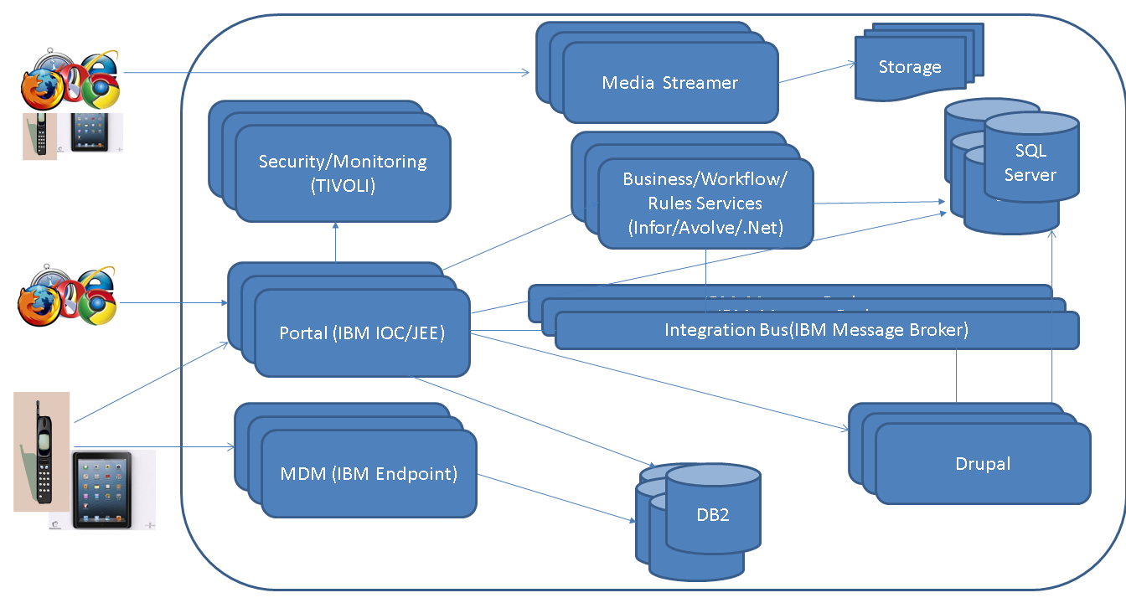

Figure 1.4.2.1-6: Component Mapping.

A high-level view of the various technical components of the system and their relationships are depicted above in *Figure 1.4.2.1-6*. The tools and technologies identified and their roles and dependencies within the system is evidenced in this perspective.

**Deployment View**

The deployment view represents the physical components of the BuildLA system and the software components they house (*Figure 1.4.2.1-7*).

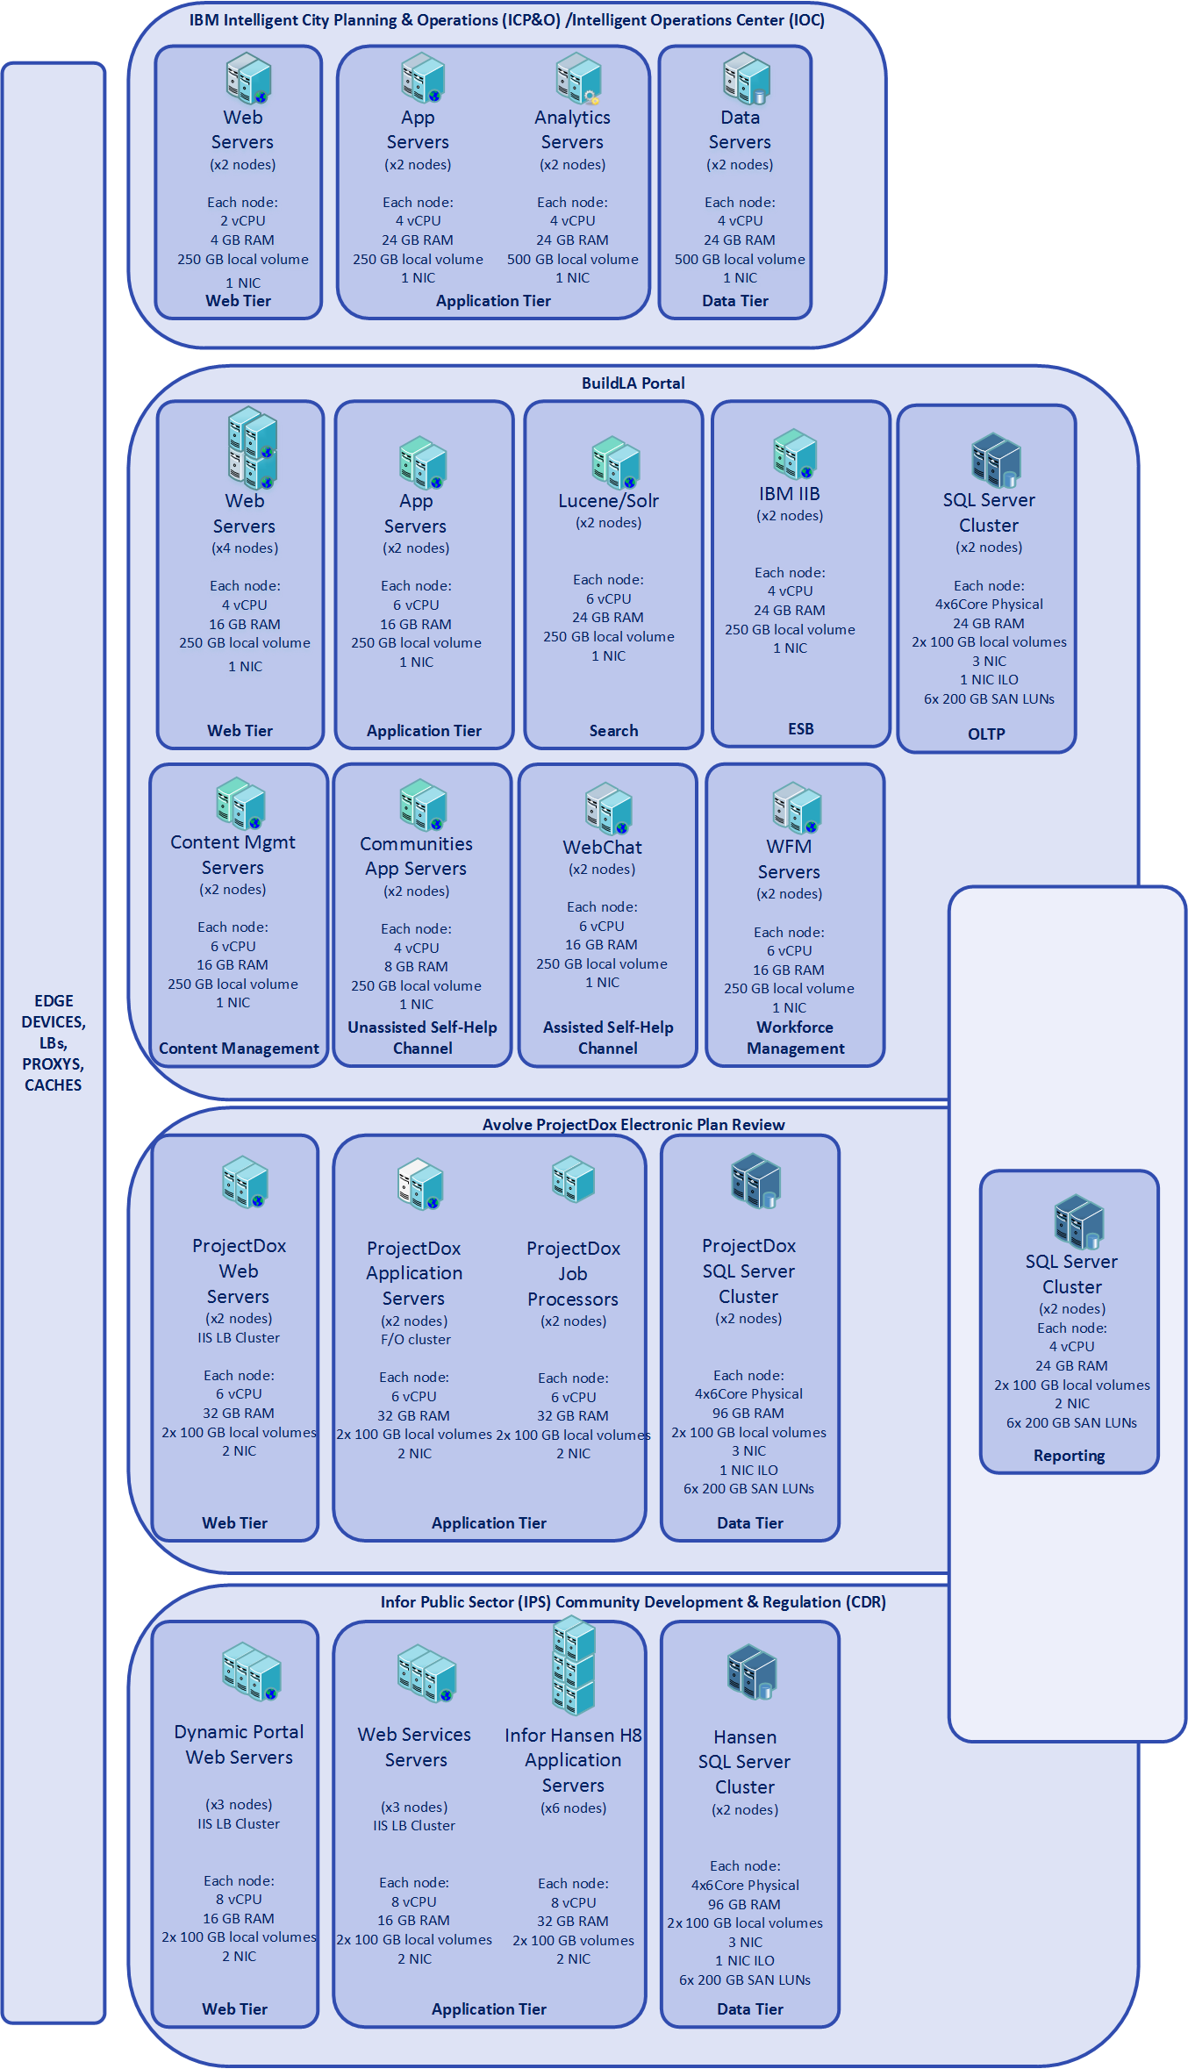

Figure 1.4.2.1-7: BuildLA Physical Components and the Software Components Housed Within.

Interaction View

The sequence diagrams below (*Figures 1.4.2.1-8 to 1.4.2.1-10*) communicate the behavioral perspective of some major use cases of the solution. It outlines how the various technology components interact to provide the necessary functionalities within the system.

Application Submission

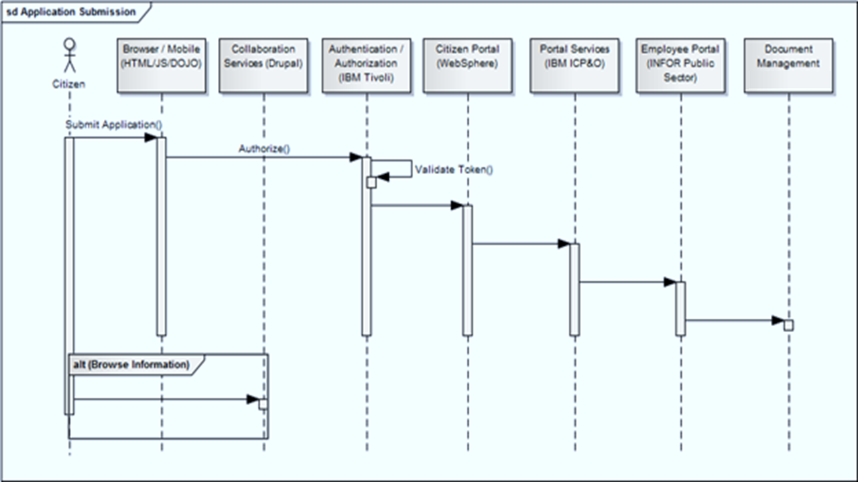

Figure 1.4.2.1-8: Application Submission.

Application Processing

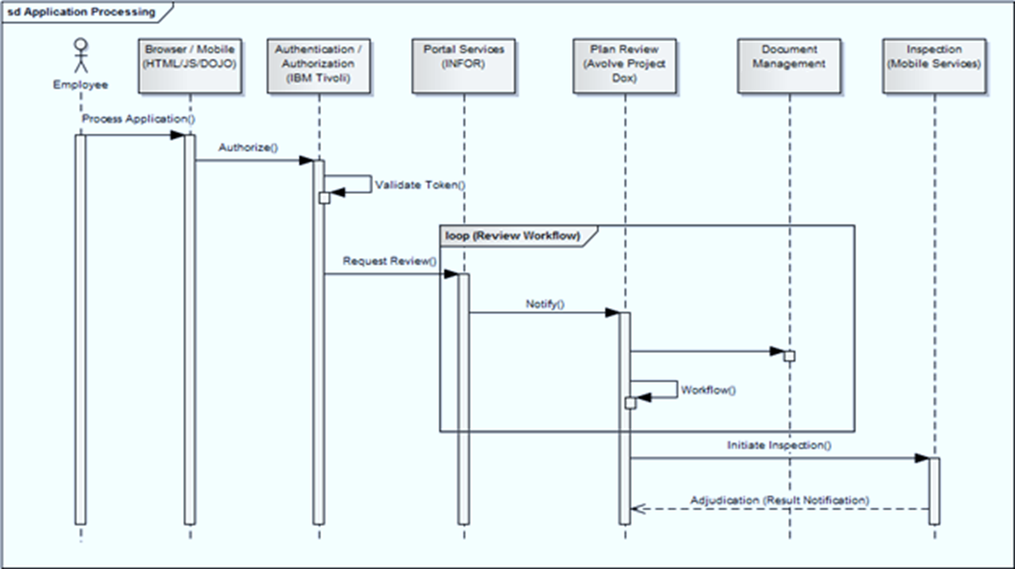

Figure 1.4.2.1-9: Application Processing.

Payment Processing

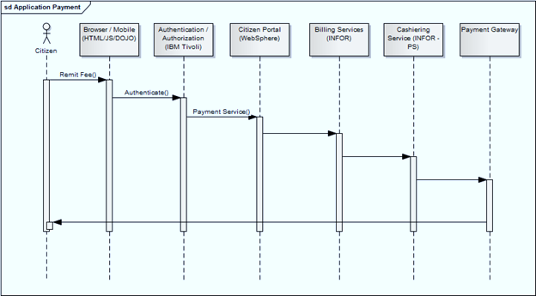

Figure 1.4.2.1-10: Payment Processing.

#### Conceptual Architecture

The conceptual architecture diagram below (refer *Figure 1.4.2.2-1*) explains how the various systems / features interact with each other to provide all the services provided by the LA’s Department of City Planning & Development and Land Use. The core of the package is the BuildLA Portal which will be directly accessed by the Citizens via their internet browsers or through public kiosks. The BuildLA Portal will be implemented using IBM WebSphere Portal and will interact with Infor Public Sector which will function as the back office. The plan review workflows will be provided by Avolve ProjectDox and the document management will be handled by Avolve ProjectDox. The solution will additionally integrate with the City’s various departmental document management systems either through XML or SOAP.



Figure 1.4.2.2-1: High Level Conceptual Architecture View.

The overall process flow for most applications will include the same core steps. The solution will map each application to a distinct macro and micro workflow that can be managed and maintained independently. Given below is representative mapping of the core steps in the Entitlement project, permit and licensing lifecycle (*Figure 1.4.2.2-2* and *Figure 1.4.2.2-3*).

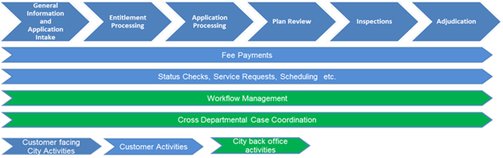

Figure 1.4.2.2-2: Process Flow Provided by the City of LA.



Figure 1.4.2.2-3: Representative Mapping of the Entitlement Process to the Technical Capabilities/Tools.

As shown in Figure 1.4.2.2-3, Avolve’s ProjectDox application provides Electronic Plan Submission and Electronic Plan Review as part of Entitlement Processing and Application Processing.

#### System Security

Single Sign-on Between Solution Components

IBM Tivoli suite of products (Tivoli Identity manager and Tivoli access Manager) is used as Authentication/Authorization system. Since UST solution is based on multiple product offerings, we are proposing a Security Assertion Markup Language based solution for Single Sign On. Tivoli system will leverage the LDAP database available with LA Corporation. *Figure 1.4.2.3-1* depicts the System Security at a high level.

Encryption of Data Communication

For the Transport Layer, we are planning to use SSL/TLS using Asymmetric encryption scheme. We will be using a dedicated Hardware Security Module to store Cryptographic keys. A 1024 bit RSA key is proposed to be used for key exchange and AES (Rijndael) key strength will be 256 bits. The System will be certified for FIPS 140-2 compliance.

Security Strategy

The general strategy for the whole application suite is

* SSL/TLS for transport level encryption
* SAML based SSO between modules
* Tivoli based Identity/authorization solution
* Digital signature for anti-tampering
* Hardware Security Module for Key Storage
* PCI based encryption for Credit cards
* Full Table encryption for DB2 and SQL server
* Future support for Multi-factor Authentication

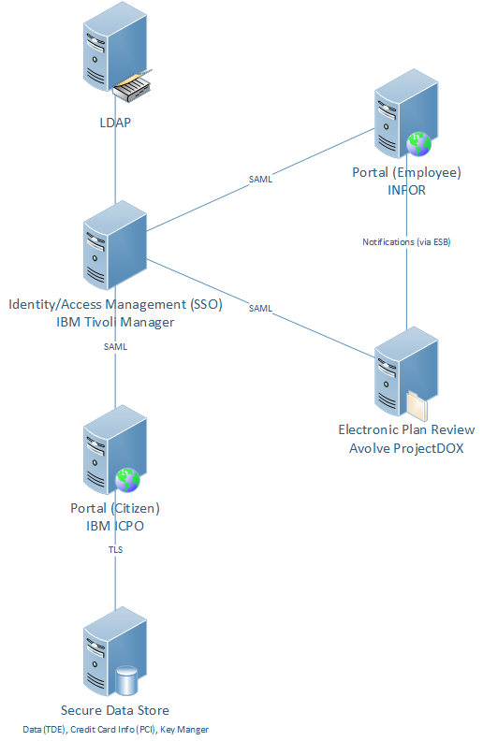

Figure 1.4.2.3-1: System Security.

Digital Signature

When a citizen uploads a document, he has to digitally sign it using his private key. The document will be verified by using OpenSSL library’s Digital Signature module.

Security Architecture

On Demand Security Arch

Figure 1.4.2.3-2: On Demand Security Architecture.

The Logical architecture which we are following is based on IBM consulting’s Tivoli practice endorsed On Demand Security Architecture (refer *Figure 1.4.2.3-2*).

Security Level Management

A Security Level Management (SLM) will be put in place by UST consulting’s (COBIT/ITIL certified) security professionals which broadly comprises of

* Defining the Security Level
* Data Analysis based on logs and audit trails
* The Current Security Analysis based on empirical facts
* Closing the gap by preventive measures

Security Procedures and Policies

Being a secured infrastructure UST consulting’s Standard Operational Procedure (SOP) for secured systems will be applied. Samples of aspects covered are

* Network Access Control
* Security logs
* Physical Security
* Cryptographic Parameters
* Password Policies
* User Account Policies
* Security Incident handling
* Computer System Usage Policy
* Device Management and Security

PCI Compliance

The System will compliant to PCI DSS standard version 2.0. A check list of items which we are planning to implement is given below. It has got correspondence to PCI 2.0 compliance rule.

* A firewall configuration to protect cardholder data is present
* Preclude usage of vendor-supplied defaults for system passwords and other security parameters by enforcing it
* Cardholder data is stored in a secure hardware device
* SSL/TLS Encrypted transmission of card holder data between systems.
* Malware protection for Systems running in the Realm
* Secure System and Application coding practices.
* Restrict access to cardholder data by business need-to-know
* Assign a unique ID to each person with computer access
* Restrict physical access to cardholder data
* Tracking/monitoring all access to network resources and cardholder data
* Regular test of security systems and processes
* A constantly maintained policy that addresses information security

#### Data Integration

This section describes the approach, methodology, technologies, and tools used for integrating other systems primarily departmental systems (Table 3.5 in RFP) with BuildLA. *Figure 1.4.2.4-1* represents a high level conceptual architecture of an ESB deployment for BuildLA.

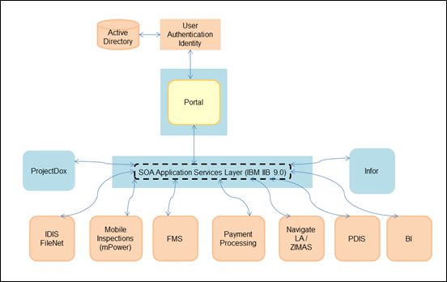

Figure 1.4.2.4-1: Data Integration.

IBM Integration Bus technical architecture and internal components are depicted in *Figure 1.4.2.4-2*.

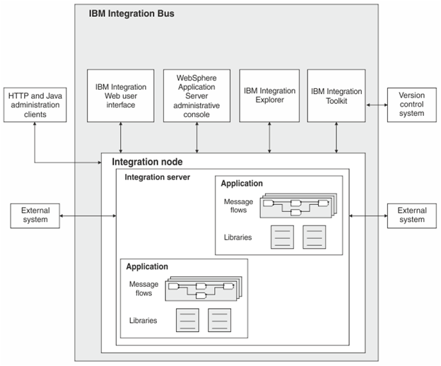

Figure 1.4.2.4-2: IBM Integration Bus.

Approach, Methodology, Tools & Technologies

Team UST proposes to use Enterprise Service Bus for data integration between Portal and enterprise systems within City of LA. IBM Integration Bus (IIB) provides the following features which can be leveraged for BuildLA solution

* Web standards connectivity like HTTP, SOAP, REST, XML, JSON
* Java Connectivity and JDBC provides Database access, JMS and MQJMS
* MQ connectivity for asynchronous messaging using transport layer
* Content Based filtering
* Graphical Mapping of source and target fields and XSL support
* Flow control for correlation and state management
* Routing capability
* Email, File and (S)FTP connectivity
* User defined business logic for complex algorithms
* WSRR support
* Administration interfaces
* Record and replay of messages
* Built-In Caching for in memory computing
* Mobile integration

Team UST based on past ESB implementation experience will bring in best practices to build a SOA based integration for BuildLA. Key implementation experiences around identifying fine grain and coarse grain services will be identified during the requirements phase for reusability of service layer. Team UST will leverage its Integration Competency Center (ICC) knowledge base for standards, templates and best practices. During design phase of the project Team UST will leverage ESB design patterns like

* Integration Styles – A template that will be used to document different ways the application can be integrated.
* Messaging Systems - Interrelationships between different features and highlights implementation trade-off
* Message Construction Pattern – A template that will be used to document the different ways messages can be transported between systems
* Routing Patterns – Mechanism describes directing messages from sender to the correct receiver.
* Transformation Patterns – Message formatting documentation when sending and receiving data across systems in the enterprise
* End Point Patterns – Behavior of messaging system as which application can produce or consume messages
* System Management Pattern - The solution has to deal with error conditions, performance bottlenecks and changes in the participating systems and provides the tools to keep a complex message based system running

During development Team UST shall leverage its ICC frameworks like Error Handling and Logging framework. Integration development involves high skill to componentize the code in such a way that can be reused. Team UST will take utmost care during development phase to build SOA based service integration that can scale and be available for a large enterprise like the City of LA.

Both the ETL and SOA based data service will interface with the Universal ID (UID) provider module. The UID module provides the correlation service for projects across disparate systems, which will be implemented as a reference based solution which exposes SOA based services to search and lookup departmental system Local IDs and Universal ID.

Governance & Support

IBM® InfoSphere® suite (primarily QualityStage®, Metadata Workbench®) enables the data integration solution to deliver consistent, accurate information and manage information lifecycle management.

Financial System Integration

The BuildLA systems will integrate with the financial system (FMS) via the data service layer. Financial data are critical and needs guaranteed delivery once to the FMS system. While integrating to FMS IIB’s out of the feature record and replay will be leveraged for guaranteed delivery once.

GIS Integration

There will be a resource tier integration between the existing GIS system (NaivgateLA / ZIMAS) which is based on ESRI's ArcGIS format and the BuildLA systems which require GIS functionality (namely Infor Hansen, and Avolve GIStream). The metadata will be converted and transferred via ETL, and the BuildLA systems will be configured to work with the GIS data-store.

Estimation Methodology

The complexity of the data integration components will be decided based on service complexity and data complexity.

Data complexity will be decided based on various parameters including number of tables, columns, relationships, data volume, and response time constraints.

Various factors including service granularity, layers, and encryption determine the service complexity. Figure 1.4.2.4-3 represents a single interface needed to be created between a source and target system using the interface estimation in person-hours.

|  |  |  |  |  |
| --- | --- | --- | --- | --- |
| S.No. | Interface Estimation Tasks | Simple | Medium | Complex |
| 1 | Requirements Gathering | 8 | 16 | 24 |
| 2 | Design | 12 | 20 | 40 |
|  | Business Object design (40%) |  |  |  |
|  | Interface design (30%) |  |  |  |
|  | Service design (30%) |  |  |  |
| 3 | Review and Sign-Off | 4 | 8 | 8 |
| 4 | Interface Development | 16 | 32 | 48 |
|  | Compensation |  |  |  |
|  | Logging, Security and Auditing |  |  |  |
| 5 | Unit testing | 8 | 12 | 20 |
| 6 | System testing | 12 | 20 | 36 |
| 7 | UAT Support | 12 | 20 | 32 |

Figure 1.4.2.4-3: Interface Estimation in Person-Hours.

*Figure 1.4.2.4-4* shows the definitions of “Simple, Medium, and Complex” in the table above.

|  |  |  |
| --- | --- | --- |
| Simple | Medium | Complex |
| * 1-5 Service Invocations * No transformation/mapping/trans-lation * Flat record structure * Basic routing logic * No data validation | * 5-20 Core Steps * Some Business Rules (less than 5) * <= 80 fields * Mapping look-ups * Hierarchical record structure * Content routing & filtering logic (< 5 branches) * Message level validation * Basic transformation/mapping/trans-lation | * Data Alignment against MDM Solution * Many Business Rules (More than 5) * Compensation * >80 fields * Complex relationships * Complex routing & filtering logic (> 5 branches) * Field level validation |

Figure 1.4.2.4-4: Complexity Definitions.

#### Data Conversion

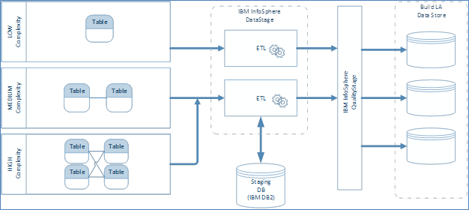

Figure 1.4.2.5-1: Data Conversion.

IBM InfoSphere will be leveraged primarily for the data conversion. IBM DataStage jobs will be leveraged for defining the transformation steps and stages by which PCIS/PCAM data is selected, converted, and mapped to the Build LA Data store Schema. The key steps envisaged include aggregation, conversion, cleansing, derivation and normalization.

The data conversion jobs to be created in IBM DataStage will be categorized into Low, Medium and High complexity jobs. Similar to the data integration strategy, a combination of the following criteria will be used to determine the complexity of the jobs:

* Source file(s) definition (structured, unstructured, sequential, etc.)
* Number of mandatory/optional fields
* Usage of Lookups, Joins and Merges
* Change data capture strategy
* Field level validations
* Restart logic/volume of data
* Calculations and conversions
* Schema match and aggregation/normalization requirements

Of these, the simple or low complexity data conversion (usually implies direct jobs with little no transformation needs) will most often be a direct load into the BuildLA schema. However, this process involves proper schema mapping between the source systems and BuildLA data store, and will usually be a one-time exercise undertaken during the detailed analysis phase.

The medium and high complex jobs usually involves multiple stages of conversion and transformation activities and hence the processing will be carried out after loading the source data into an intermediate staging data store (IBM DB2).

Key activities in this process are:

* Analyze and define the transformation requirements by
  + Source data analysis – data quality, definitions and periodicity
  + Schema mapping
  + Validation of sample data
  + Running the analysis for an extended set
  + Define success criteria and tolerance levels
* Identify and classify the ETL jobs needed for the transformation
* Build and Validate
* Setup schedules and operating procedures

The data that has gone through the ETL process will then be routed through the IBM Quality Stage. It helps to create and maintain consistent views of key entities including locations, customers, vendors, and products. This allows us the ability to investigate, cleanse and manage the data. This will ensure that the data delivered to the BuildLA data store is of the highest quality. It enables cross-organization data quality and capabilities necessary for proper information governance policies. The following stages of the IBM Quality Stage will be leveraged for ensuring data quality in the BuildLA data store:

Investigation − Helps to understand the nature and scope of data anomalies

Standardization (Conditioning) − Parses individual fields and makes them uniform according to business standards.

Matching − Identifies duplicate records within and across data sources

Survivorship − Helps eliminate duplicate records and create the best-breed record of data

Since the input data to the Quality Stage is provided by the Data Stage process, the analysis done for ETL processing will also consider the Quality Stage activities.

The set of activities in this stage include

* Analyze the data cleaning requirements – This activity will be included in the ETL analysis phase and will be used to determine the standardization and matching activities to be carried out as part of the cleansing process.
* Define standardization / matching needs – Leverage the probabilistic matching capability and dynamic weighting strategies of the IBM Quality Stage to find records in the data sources that refer to the same entity
* Build and validate
* Set up schedules and operating procedures.

Roles and responsibilities of the key data conversion stakeholders are shown in Figure 1.4.2.5-1-1.

| Data Conversion Activities | Team UST Role | Team UST Responsibilities | City of LA Role | City of LA Responsibilities |
| --- | --- | --- | --- | --- |
| Analyze and define requirements | Business Analyst/ Technical Architect | * Defines the full set of data conversion requirements: functional, quality and security * Works closely with Business Analysts and the City of LA to confirm that the solution meets their needs * Evaluate impact on system capacity and performance * Finalizes the solution and provide overall technical approach | BuildLA Technical Staff | * Participate in analysis sessions with Team UST, providing domain knowledge of existing data sources and assisting with data identification and interpretation (source and data elements) * Review data conversion requirements for correctness and completeness * Grant access permissions to databases and source systems required for Team UST to conduct appropriate levels of analysis |
| Design | Technical Architect/ Developers | * Identify the ETL jobs needed for the transformation * Prepare the detailed design detailing the jobs to be created, interfaces needed, including schema designs * Review and refine detailed design | BuildLA Technical Staff | * Provides domain knowledge of existing data sources |
| Build | Technical Architect/ Developers | * Configures, builds and tests DataStage and QualityStage jobs in accordance with the functional requirements and detailed design * Develops common test data * Performs unit tests | BuildLA Technical Staff | * Participate in routine communication and collaboration with Team UST * Cleanse source data if required * Provides domain knowledge of existing data sources * Provide timely answers to late discoveries and emerging questions related to source data |
| Testing & Validation | Test Analyst/ Testers | * Creates data conversion test cases * Executes functional and integration test cases and reports defects * Identifies defects for assignment to the development team | BuildLA Technical Staff | * Reviews the validation results * Participates in the review and validation process |
| Test Leads | * Create overall test plan/strategy * Lead test execution teams * Conduct test audits * Assist with reviews and status reporting to the City of LA | BuildLA Program Manager | * Reviews and provides sign-off on data conversion validation results |
| Technical Architect /Developers | * Troubleshoot and correct problems found during testing * Maintain technical and architecture documentation | BuildLA Technical Staff | * Validates and provides sign-off on the overall data conversion |
| Perform Data Conversions | Technical Architect/ Developers/ Infrastructure Team | * Perform data migration: extraction, transformation, and load * Define and implement job schedules and sequences * Setup monitoring processes * Recommends tuning/optimization | Program Manager | * Manages escalations |

Figure 1.4.2.5-1-1: Data Conversion Key Stakeholder Roles and Responsibilities.

The Low complexity data conversion strategy employs a set of direct ETL jobs that would need little or no transformation/normalization. This strategy will directly leverage the schema mappings, which will be a pre-requisite task for data conversion.

The Medium and High complexity integrations will employ a staging data store (IBM DB2), as these involve aggregation, transformation, derivation and normalization.

The probabilistic matching capability and dynamic weighting strategies of InfoSphere QualityStage along with its data cleansing modules will be leveraged for achieving high data quality in the data conversions. The key data conversion stages include Data investigation, Data standardization, Data matching and Data survivorship.

#### Standard Forms, Correspondence and Reporting (RFP 3.1.4.2.6)

**Reporting Approach for BuildLA**

The City has defined the reporting requirements in terms of the level of complexity. Currently, 150 reports have been identified for development (Low- 70, Medium- 50 and High- 30) and these need to be implemented by the end of Phase 2. UST Global will take an iterative approach for reports development, which will enable more visibility to the City during the development. The following image (*Figure 1.4.2.6-1*) depicts our reports development methodology:

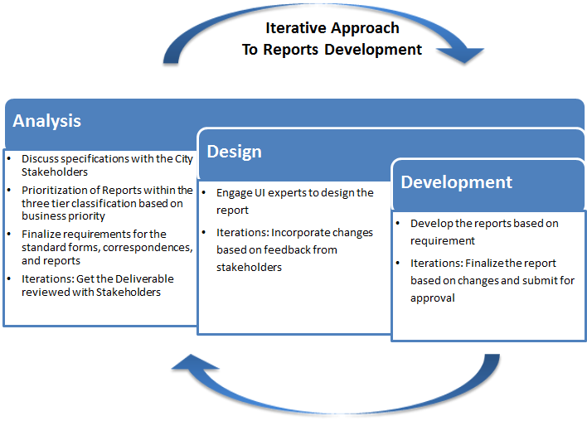

Figure 1.4.2.6-1: Iterative Approach to Reports Development.

Team UST will study the current reports during Analysis phase and determine the new reports that will add tangible benefits to the City. The team will then discuss the specific requirements with the City stakeholders and finalize the implementation plan. Based on the discussion and business priorities identified, reports will be grouped and developed in waves. This will be finalized based on discussions with the City. Following is a sample of how this will be executed based on business priorities:

* Wave 1: High Business Priority Reports for High, Medium and Low complexity reports
* Wave 2: Medium Business Priority Reports for the three categories
* Wave 3: Low Business Priority Reports for the three categories

The reports will be developed in iterations, to ensure that changes/ modifications to the reports can be identified early on.

From a performance management and accountability perspective, the approach for Project Status reporting has been discussed in *Section* *1.4.3.1* ‘Project and Program Management Methodology’. The Status Reporting will include the Controlled correspondence documents, as explained in Attachment 5 of the RFP.

These Reports will include performance review (response time, resolution rate, etc.) of various Assisted Channels as defined in Appendix B of the RFP, such as the Email Management System, and others. Also, as discussed previously in ‘Section 1.4.1.2 Permitting and Land Use Solution’, our solution comes with powerful reporting tools that will enable deep queries into the system, and a ‘Reports Manager’.

**Tools and Integration with Current Systems**

UST Global intends to leverage IBM Cognos (included in the IBM IOC package) and SQL Server Reporting Services (SSRS) for reporting purposes, at **no additional cost to the City and** in conformance to BuildLA requirements

Per requirement T1-159, Team UST’s Solution for BuildLA also allows the City to leverage its existing reporting tools against the system's databases.

As illustrated in Figure 1.4.2.6-1-1, our solution includes a unified reporting environment which aggregates and consolidates data from multiple BuildLA databases for reporting purposes, minimizing the complexity and effort associated with creating reports. Real-time data replication keeps the BuildLA reporting environment in sync with the operational databases, ensuring that the reporting environment always contains the most current “live” data.

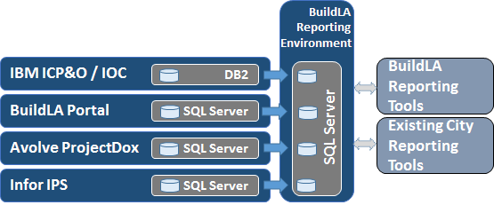

*Figure 1.4.2.6-1-1: BuildLA Operational Databases and Reporting Environment.*

**Estimation Methodology**

UST Global follows industry standard estimation techniques for Reports development, including Function Point based estimation and expert judgment. Figure 1.4.2.6-1-2 below lists the databases in the proposed solution and the characteristic data contained in each of these databases.

| **Solution Component** | **Characteristic Data** | **Database Platform** |
| --- | --- | --- |
| **IBM Intelligent Operations Center** | * Citywide Events & Information Streams * Complex event processing & correlation * Events * KPIs * City wide dashboards * Operational outcomes reporting * Historical reports * SOPs * Performance Analytics Data aggregated from citywide information systems * Citywide Dashboard Definitions | DB2 (bundled with IOC) |
| **Infor Public Sector (IPS) Community Development & Regulation (CDR)** | * Module configuration data: Planning & Land Development module configuration, Projects module configuration, Building Permits module configuration, Use Permits module configuration, Code Enforcement module configuration, Business Licensing module configuration, Trade & Occupational Licensing module configuration * Workflow and Business Process definitions: Activities, Milestones, Events, Tasks, Business Rules, Fee types and fee schedules, Permit type definitions, Alerts & Notifications, Validations, Versioning & History, Workflow Data Objects, application assignment, workloads, scheduling * Permit Information: Parcel #, Project #, Permit #, Permit Type, Description, Parcel Information, Address & Contact info for permit holders, Permit Status, Conditions, Inspections, metadata on Attachments & Documentation attached to the permit * Applications: Application data, metadata on application attachments * Accounts history: Due dates, Transaction history, Application balances, Fee History w/Effective Dates, Penalties, Delinquencies, Collection process status, Liens * Contacts & Contact relationships: Applicants, Property owners, Tenants, Contractors, Contact name aliases, Companies owned/worked for, Licenses held, Financial information, Known addresses * Location data: Address, Parcel, Property, GPS location history for field units, GIS metadata, mailing lists for electronic notifications * Inspections: Scheduled Inspections, Inspection Activities, Inspection History, Result Codes, Inspection Results, Correction Codes, Corrections & dispositions, Code violations, Locations and Routes, Updates, Messages (Locks/holds/safety messages), Message Acknowledgements, Reviews, Hearings, Clearances, Application Status, Locks/Holds/Notices, Permit status, and related data/metadata * Adjudication: Orders to Comply, Appeals, Public Information & Documentation, Comments, Hearings, etc. * Trade Licensing & Materials Control: trade license & test facility applications, business & individual licenses, License Reviews, Background Checks, Exams, Inspections, Health & Safety, License Conditions, License Fees, License Reviews, License History, License Expirations, Notifications & Renewals, Education & Experience Lifecycles, Certification Steps, Performance Tests and Outcomes, Test Facility Exams & Schedules, Examination Outcomes, Materials for Approval applications, Materials Field Tests, Approved Materials Renewals, Materials Control data (persons to be employed, hazardous materials inventories), and related data/metadata * Code Enforcement: Service Requests, Complaints and reported problems, Inspector Alerts, Violations, Code Enforcement Cases, Codes & Ordinances, Filing & Investigation History, Hearings, Court Involvement records, Fines, Resolutions, Outstanding Violations, and related data/metadata | SQL Server |
| **Avolve ProjectDox** | * Project Templates * Project history * Project invitations * Electronic forms definitions * Checklists: Drawing checklists, departmental pre-screen checklists, departmental plan review checklists * Documents: Document and versioning metadata, submitted plans & documents, revisions and resubmissions, approved drawings and documents * Workflow and business process definitions: Plan Review workflows, QA review workflows, supervisory reviews & signoffs, approval process definitions, approval process tracking, plan review time & state tracking * Plan Review Task Assignments * Plan markup: text, comments, graphical notes, markup files/layers, hyperlinks, stamp libraries, codes, graphical items, reviewer signatures, dates/times, * Resubmit notifications * Departmental corrections and issues to be resolved by Applicant * Completed resubmit notices: change acknowledgements, corrections, markups, checklist item tracking * Review and overlay compares * End-to-end lifecycle management data for engineering plan data moving through multiple departments * Related plan review data & metadata | SQL Server |
| **BuildLA Portal** | * Portal & portlet configuration data * Portal user profile & preferences data * Portal user activity data * User session tracking * Citizen-side workflow definitions * UI state tracking * Application status tracking metadata * UI metadata * UI value Lookup tables * String tables * Pre-intake workflows * Navigational rules & metadata * Validation rules * Decision tables * City guidelines and processes * Assisted & Unassisted channel metadata * Exception data * Data-driven interactions * Business service configurations * Knowledge base data and metadata * Chat data and metadata * Knowledge base metadata * Social interactions metadata * Forum data and metadata * Data-Driven Content * Service research and selection data/metadata * Content indexes * Universal ID store | SQL Server |

*Figure 1.4.2.6-1-1: BuildLA Databases and Characteristic Data.*

Based on the details provided on the classification of the reports, taking into account the distribution of data across the various databases within the BuildLA solution (as shown in Figure 1.4.2.6-1-1) we have currently gone with expert judgment, and the following figure (*Figure 1.4.2.6-2*) gives the estimated breakup based on the number of hours.

| Complexity Level | Count of Reports | Estimated Effort (Hours) | Total Hours |
| --- | --- | --- | --- |
| Low | 70 | 20 | 1400 |
| Medium | 50 | 28 | 1400 |
| High | 30 | 40 | 1200 |
| **Total** | **150** |  | **4000** |

Figure 1.4.2.6-2: Estimation Techniques.

**Knowledge Transfer**

UST Global will use its approach described in Section 1.4.3.3 below for ensuring that all BuildLA solution knowledge resides with the City. All the artifacts and learning from the development of reports will be stored in the integrated Knowledge Repository- the “City of LA Client University”. UST Global will also train identified points of contact from the City to ensure that the knowledge is passed on, and the City can continue to develop its own reports in the future.

**BI Reporting Capabilities and Tools**

UST Global is committed to providing world class business intelligence and reporting solutions to all its clients. Our Business Intelligence Practice has delivered services to a substantial client base of Fortune 500 companies. Our focus is on enabling decision makers to derive sustainable value from their critical business data - by converting business data into actionable information. Our service spectrum includes Operational and Analytical Reporting, Dashboards and Visualizations, and Predictive Analysis.

* Services focused on analyzing the organization’s information assets and creating reports and analytics that enable the decision making process.
* Certified consultants across the most widely used business intelligence technologies (Oracle, Microsoft, IBM, Business Objects, MicroStrategy, SasS, Pentaho, etc.) that align with our clients’ objectives.
* By leveraging our global delivery model, our clients can maintain a high ROI and benefit from the continuity associated with using a long term partner who understands their business.

The following examples outline some of our previous engagements in reporting and analytics area:

**1. Marketing Analytics for One of the World’s Largest Cruise Operator:**

* Automated and customized the lead qualification process utilizing Siebel CRM.
* Implemented IQ8 for Data cleansing and standardization.
* Implemented OBIEE for all CRM reporting including Customer Satisfaction and Service Requests.
* Solution provided Call Center and Marketers a 360 degree view of their customer resulting in higher customer satisfaction.

**2. Medical Management/ Grievances and Appeal Reports Development and Support for a Leading Healthcare Provider:**

* Existing legacy reporting solution did not meet business needs, due to scalability and extensibility of the legacy data model.
* UST Global designed and implemented a Cognos solution that improved reporting accuracy and timeliness, which led to better business decisions and the bottom-line.

**Transportation Analysis for a Specialty Retailer:**

* Developed a set of MicroStrategy analytics to analyze and control Transportation costs.
* Solution utilized MicroStrategy 8.3 against a Netezza data warehouse.
* These analytics identified opportunities to help meet their goal of $2 million in cost savings.

Our partnerships are market-driven and designed to provide the best value to our clients. The image below (*Figure 1.4.2.6-3*) depicts our partnership ecosystem around Business Intelligence.



Figure 1.4.2.6-3: UST Global BI Tools and Partnerships.

### Implementation Approach (RFP 3.1.4.3)

UST Global has customized its ABUILD® - Iterative delivery methodology for the BuildLA Portal implementation in an agile development model. This will result in early prototypes that can be reviewed by the City to ensure that it’s in line with the vision of a customer centric business model. With our implementation approach, there will be minimum downtime for upgrade and integration with the existing application.

The current BuildLA portal release 1.0 has a series of 24 incremental mini projects (as per Appendix I). UST Global’s implementation approach is in line with the City’s implementation plan in terms of process and support, enhancing and establishing the portal competency center. We understand that the City has evaluated a number of implementation options for BuildLA, and chose implementation by service in parallel across all impacted departments, to be the best option. Our customized ABUILD® approach will complement the City’s expectation in terms of a seamless implementation.

All developed services will be implemented through a strict toll gate process to ensure high quality and maintainability. A high level process flow has been depicted in *Figure 1.4.3-1*.

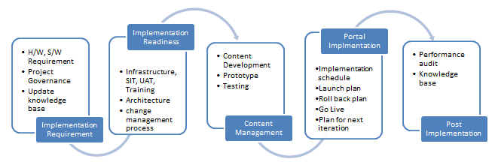

Figure 1.4.3-1: Implementation Approach Process Flow.

Figure : Implementation Approach- High level process flow

During the implementation phase, the knowledge base will be updated with the respective service description, use of service, technical dependency, service workflow, walk through, and user guide. This will ensure that documentation related to a service is updated and available for training before the service goes live.

The BuildLA portal will be implemented in multiple streams in line with the development and deployment cycle of common services under the following functionalities:

* Customer self service
* Support service
* Enterprise enabling technologies
* Integration with existing city systems
* Implementation and Integration of existing departmental systems

BuildLA Implementation Road Map

Our BuildLA implementation road map is shown in *Figure 1.4.3-2*. This road map is described in detail in the following sections. 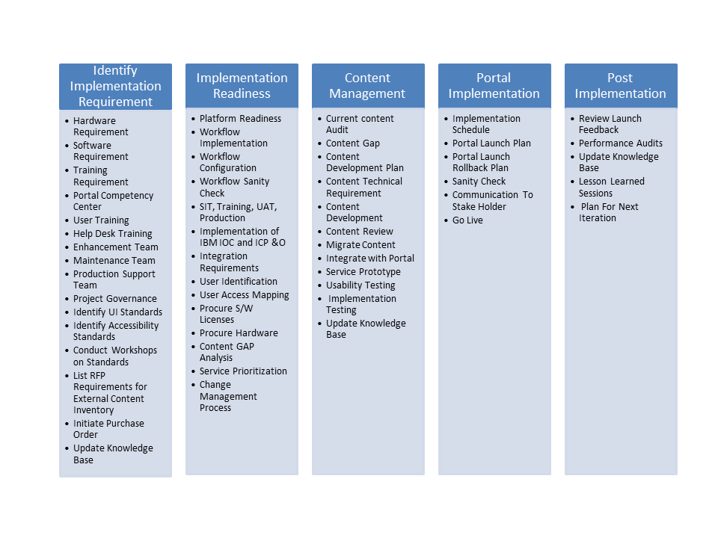

Figure 1.4.3-2: BuildLA Implementation Road Map.

Figure : Implementation Roadmap

Implementation Requirement

* Hardware and Software
  + The UST Global technical team will identify hardware and software requirements for each service. All the servers and software tools for BuildLA portal will be in compliance with City Information Technology Agency (CIT) guidelines as detailed in Attachment 29.
  + The UST Global technical team will focus on server optimization and virtualization, to maximize resource utilization for better maintenance and enhancement. UST Global’s Infrastructure Center of Excellence (CoE) will review and evaluate hardware and software specification of each service.
* Training Requirements
  + As soon as the development phase is completed, our training team will perform a Training Need Analysis (TNA) and schedule appropriate training for all stakeholders. The trainer(s) will be from the development team or from UST Global training partners. The training program will be coordinated by UST Global’s Corporate training team G.A Menon Academy (GAMA).
  + User Training - End user Training methodology, which includes end-to-end business process training, will be finalized based on the number of users and complexity of services. In order to create a sustainable training model, UST Global will conduct the train-the-trainer (TTT) program with training materials, which will be updated into the knowledge base. This will help to develop portal competency within the City of LA staff, and that will lead to progressive development of the Portal competency development center. Availability of users and starting the training using self-video service, walk through and service workshops will depend on the size and complexity of service.
  + Training for enhancement, maintenance and production support teams: UST Global follows a standard methodology called AMUST® (Application Maintenance by UST) for application maintenance. Our support team will leverage the robust tools and processes as per this framework to provide effective services for ongoing enhancements, maintenance and production support.
  + All the team members will complete the Account level induction, Project level induction and domain training and technical training assessment before they are allocated to the BuildLA project team. The process, standard and template will be covered in Account level induction training program, and Project related domain training and assessment will be done as part of domain training. All the training and assessment programs will be coordinated by our Lead Trainer and our Corporate training team (GAMA).
  + L2 Help Desk Training: L2 Help Desk staff will undergo portal navigation training to capture and enter issues reported by customers, prior to the deployment of the portal.
* Project Governance
  + *Figure 1.4.3-3* depicts the governance model for portal implementation activities.

| Role | Organization | Responsibility |
| --- | --- | --- |
| Change Board Executive | City of LA,UST Global, IBM | Ensure approved change request are implemented by following change board process. |
| Account Managers | City of LA, UST Global , IBM | Escalation point during Implementation process. |
| Project Managers | City of LA, UST Global , IBM | Ensure that all the teams are well coordinated and resolve any impediment within the teams. Raise necessary purchase request as per the requirements. |
| IOC Technical Lead | IBM | Ensure portal component and IOC components are integrated and tested. |
| ICP & O Technical Lead | IBM | Ensure ICP & O environment and Portal environment are integrated and tested. |
| Release Manager | UST Global, City of LA | Ensure that release process as per City of LA release standards and compliance with project release calendar. |
| Implementation Lead | UST Global | Ensure that proper coordination with other support team and resolve all impediments and prepare implementation schedule. Procure required software license. |
| Portal Developer | UST Global | Ensure technical support for implementation. |
| Infrastructure CoE | UST Global | Ensure that environment is configured properly to implement the services. |
| Configuration Controller | UST Global | Ensure that correct versioned sources code are moved to production environment. |
| Server Team | UST Global | Ensure that required servers are allocated and configured for service implementation as per implementation requirement. |
| Support Team | UST Global | Provide all the technical support for implementation including the Network Team, Security Team, Licensing Team etc. |

Figure 1.4.3-3: Governance Model for Portal Implementation Activities.

* UI Standards and Accessibility
  + UST Global will define User Interface standards for the Portal UI, and conduct workshops on standards as and when a new process or standards are implemented.
  + Different set of users and accessibility will be configured into the system.
* Update Knowledge Repository
  + Two sets of Knowledge Bases will be maintained. The first is a Self Service Knowledge Base that helps the City’s customers who are the actual users of the BuildLA Portal in accessing FAQ, User guide, service work flow, etc. The second Knowledge Base is the “Client University” (City of LA University) as illustrated in Figure 1.4.3-4 that will help City staff and the development team to understand the system for future maintenance and enhancements and training, with all the relevant artifacts stored.

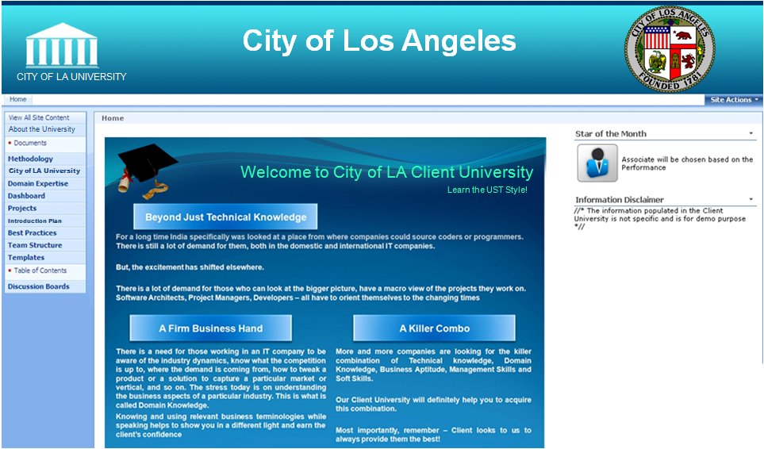

Figure 1.4.3-4: City of LA Client University.

* Pilot UI Implementation
  + From our experience in piloting web portal applications, we anticipate a number of innovative ideas for representing data through customer centric UI models. We expect multiple iterations from different teams before finalizing the UI. Before implementing the rules engine, the UI design will be finalized and implemented. This will help to speed up the creation of the self-service knowledge base including statistics and data.

Implementation Readiness

* Platform Readiness will be a one-time activity to set up the Development, User Testing, System Testing, and Production environments. All of these environments will have access controls in place to maintain environment consistency. Configuration control tools can be installed in all environments to maintain code consistency.
* Workflow Implementation and Configuration: As per the project execution plan, Build LA functionalities will be developed and deployed in multiple iterations. After each Wave or iteration a set of high priority functionalities will be deployed based on the City’s prioritization (tier 1, 2 and 3). Before implementing each one of the functionalities, necessary workflows will be implemented and configured to ensure the end-to-end application is working correctly.
* IBM IOC and ICP & O suite will be installed on the server farm and all the environments will be connected to the IBM Smart City application suite. Configuration control tools will be installed and will control the code movement from one environment to another.
* Integration Requirements: Integration checklists will be maintained for each service implementation process, to ensure that all the integration points are covered and implemented in the portal.
* User Identification and User Access Mapping: The BuildLA system is a collaborative space for all services; each service has a unique set of user groups. During the implementation phase, necessary user names will be created to access different services and necessary access rights will be provided. A sample user access mapping table is shown below in *Figure 1.4.3-5*.

| BuildLA Login ID | City Login in | Dept. | Services category | Admin | Staff | Reviewer | Approver |
| --- | --- | --- | --- | --- | --- | --- | --- |
| AR0001 | C0001 | BOE | Review Project | Yes |  | Yes |  |
| ST0001 | C0002 | BOE | Review Project |  | Yes |  |  |
| AP0001 | C0003 | BOE | Review Project |  |  |  | Yes |
| SR0001 | C0004 | BOE | Issue Permit |  | Yes | Yes |  |
| AA0001 | C0001 | BOE | Issue Permit | Yes |  |  | Yes |
| ARP001 | C0005 | BOE | Survey Division | Yes |  | Yes | Yes |
| ST0001 | C0006 | BOE | Survey Division |  | Yes |  |  |

Figure 1.4.3-5: Sample User Mapping Table.

* Procure Software Licenses:The UST Global Implementation Team will abide with the City software procurement process. Our Implementation Team lead will communicate all the software license requirements to the City’s team. Purchase requests will be send to the City’s purchase department by the City Project Manager.
* Content GAP Analysis: This process is applicable to those services that are marked as Partial Replacement (PR) and existing templates and forms are used by the existing application. Service vs. Content mapping will be done to ascertain the quality of content and effort required to develop new content. A snapshot of our sample Content Gap Analysis tracker is shown in *Figure 1.4.3-6* below. The Content Reference can be an application screen name, an input or output template, a report or a document.

|  |  |  |  |  |
| --- | --- | --- | --- | --- |
| Service Category | Service Component | Content Reference | Content Finalized | Content Owner |
| Pay My Bill | Submit Payment | Screen Name | Yes | Owner name |
| Pay My Bill | Request Receipt | Template | No | Owner name |

Figure 1.4.3-6: Example of Our Content Gap Analysis Tracker.

* Service prioritization: Service prioritization will be done based on our conceptual view of the BuildLA Implementation strategy. All the Tier 1 services related to governance challenge will be considered for early stage of portal development and implementation. Service prioritization will be done in line with application development, and in coordination with the City BuildLA team, as illustrated in *Figure 1.4.3.7*.

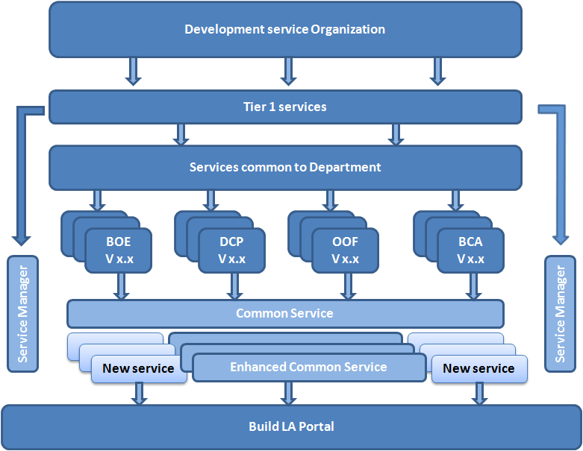

Figure 1.4.3-7: Service Prioritization for BuildLA.

* Change Management Process: UST Global’s Change Management protocols for BuildLA will ensure that standardized methods and procedures are used to manage all changes to the service environments in scope. This process will also ensure that all changes to service management processes, service assets and configuration items are recorded and maintained in the Change Management repository. All changes will be in accordance with established service policies and procedures that will minimize risk to the business. The UST Global Change Management team will assess and evaluate the risks associated with a change and develop contingency plans to follow if implementing changes yields an unexpected result. Further details are included in *Section* *1.4.3.1.8*, Change Management.

Content Management

* Audit the Current Content: The content GAP analysis tracker will be used as input to audit the current content of the portal, which includes Static content, Standard template, Reports, Permits and other materials in the content library. Auditing will be accomplished with the help of the Content Audit checklist to ensure quality and content standards are maintained. The Content Inventory will be updated based on the Audit Report.
* Develop Content Development Plan: The UST Global Content Management team will prepare a content development plan using our Content GAP Analysis tracker, Audit report, and content inventory. The Plan consists of identifying the content requirements based on the GAP analysis, innovating content presentation, and designing the content material to make the content benefit the customer. Finally, content will be integrated and delivered to the Content repository. Each service area will access the Content repository for its operation. The content development workflow is shown in *Figure 1.4.3-8*.

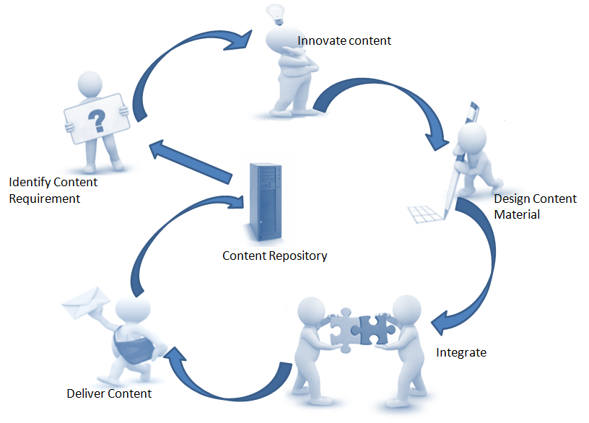

Figure 1.4.3-8: Content Development Workflow.

* Develop New Content & Migrate Existing Content: UST Global’s Content Development team will work closely with BuildLA business analysts and users to identify content requirements and innovative content to be used for the BuildLA Portal. The team will maintain similar processes for creating new content as well as modifying or migrating existing content to the Content repository.

Portal implementation

* Configuration and Customize of the Portal: The BuildLA Portal will be hosted on the IBM Smart City Portal solution, which will provide a common framework for all services. Service will be implemented in multiple releases, and portal configuration will be performed after each release to ensure optimum performance of the portal.
* Integration with Content: Each service in the BuildLA portal is unique, and the content will be unique as per the requirements. All new content will be developed by the content management team and integrated with each service.
* Integration with Third Party Components: The BuildLA Portal is a single window solution for all the City of LA requirements. Currently, many third party software packages are used in the existing system to meet requirements. The proposed solution will try to accommodate and integrate existing third party tools, or recommend a new tool that will fit best to the portal solution as per industry standard.
* Deploy Release: The BuildLA portal development project will adopt an iterative development cycle to make sure that each iteration implements a workable product. Depending on the priority, services will be deployed in multiple releases and follow a defined release management process as illustrated in *Figure 1.4.3-9*.

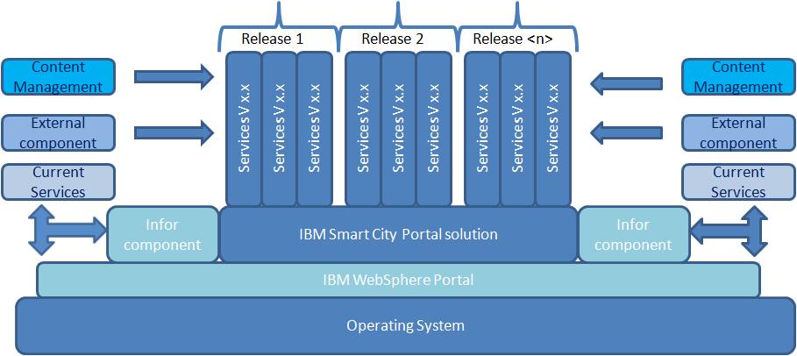

Figure 1.4.3-9: Release Deployment Will Be Iterative.

Post Implementation

After the portal implementation the team will review the implementation checklist to make sure that all the processes which are supposed to be completed are accomplished with 100% accuracy. Any discrepancy will be highlighted to the team for remedial action. A performance audit will be conducted for the planned duration, based on the complexity of application.

Warranty Period

UST Global possesses a robust and mature set of Application Maintenance Processes called AMUST® that has been used for providing Application and Operations support services to different Fortune 500 customers in the United States and throughout the world. During the project duration UST Global proposes to have the Service Support team located within our UST Development Center and having remote access to the application to be able to seamlessly provide Support Services for BuildLA.

Team UST is committed to ensuring the success of our BuildLA solution for the City of Los Angeles. As mandated in the RFP, we will provide complete support during the phased project implementation and a two year FULL software warranty period starting after the full scope of the project is released into production.

As each wave of the project is implemented Team UST will ensure that the System has passed all testing and is ready to be put into production and will provide ongoing support until all of the releases have been implemented. Should the functionality currently being deployed break functionality already in production, UST Global will be responsible for correcting all discovered faults within the production system.

The two-year FULL Software Warranty period starts after the full scope of the project is released into production and applies to all corrective maintenance and reactive modification of the new System performed after completion of deployment to correct discovered faults with all functionality within the scope of original software development effort

It is assumed that the City of LA Helpdesk will be the first point of contact (PoC) for all incidents and queries to be raised by users. The City of LA Helpdesk in turn will make use of the solution documentation or knowledge repository to provide resolution or workarounds to known issues. The same can be termed as Level 1 to application users, and may not require any fixes from UST Global’s support team. Team UST will provide Level 2 Support for the BuildLA Solution.

Incidents which are identified as “Defects” will require classification for Severity based on the impact on the system. The helpdesk will be responsible for prioritizing such incidents for the UST Global support team. Upon prioritization, the incident will be assigned to the UST support team which will initiate action on the same as per the process and Service Level Agreement (SLA) agreed. For incidents identified as “Enhancements” UST will follow the defined Change Management process and provide the City of LA with the necessary impact analysis and effort estimates with a new CR (Change Request).

All issues reported during warranty, maintenance, and technical support periods will be classified based on severity levels shown in *Figure 1.4.3-10*.

| Severity Level | Description |
| --- | --- |
| One | The BuildLA production system is not operational – complete loss of service or functionality. The core business is impacted and unable to go ahead with day-to-day operations. |
| Two | Core business is impacted but work-around is available. Minor loss of Service; system is unavailable and non-functional for a set of users or only a part of the system functionality is impacted. |
| Three | System is available and functional for all users but a non-critical function/feature of the system is not working. |
| Four | Very trivial issues, does not impact the users or application functionality. |

Figure 1.4.3-10: Severity Levels.

All Severity Level One defects will be responded to within one hour of notification or identification of defect during working hours. It will be UST’s endeavor to resolve all Severity Level One defects in the shortest possible time by providing telephonic support; or by logging into the City of LA Bug tracking tool; or onsite or via remote connectivity software .The defects which need changes to code will go through the Patch Release process. The detailed SLAs and the applicable processes will be defined and documented prior to initiation of support phase.

The change management process will be followed for enhancements. UST Global will provide a detailed analysis and effort estimate to the City of LA service owners and on approval of the same, will make the necessary changes.

Dependencies:

UST Global support team will require the following to perform the correct diagnostic:

* Access to all the information provided by users to helpdesk
* Access to Testing, Staging and Pre-Production systems to be able to replicate the incident reported.
* Onsite or Remote access to the production system

All other dependencies will be identified and documented prior to initiation of support phase of each service.

Reporting and Escalation:

A Monthly Report will be published listing details of all the issues reported during the month. As part of the report, metrics on issues reported will be categorized by type of defect and the time it was reported. Productivity reports will be generated to determine the bottle necks in response time, average time taken for resolution of those issues, etc. For any specific issue which remains unresolved beyond the agreed resolution timeframes, the escalation will be initiated as per the published escalation matrix during the project initiation phase.

#### Project and Program Management (RFP 3.1.4.3.1)

##### Project and Program Management Methodology

UST Global’s Project Management methodology is based on the Project Management framework developed by PMI (Project Management Institute). Our Project Management Methodology will ensure seamless execution of the project for the City of LA.

Our Project Management expertise has been developed and perfected through numerous engagements with our Fortune 500 clients. Our project management methodologies, processes and tools help the Project Manager and team to organize, document, track and report on project tasks and progress. It brings in a systematic approach of project execution for team members and provides Project Managers easy-to-use checklists and templates that target the fundamental concepts of Project Management. Some aspects of our Project Management processes are:

* Defined and sponsored project scope
* Roadmap for deliverables
* Documented roles and responsibilities
* Common language for communication relative to project phases, tracking and reporting
* Processes to enable communication, accomplish the work, facilitate issue resolution and risk mitigation

An overview of our project management process is illustrated in *Figure 1.4.3.1-1*.

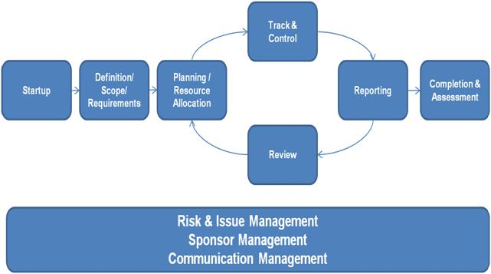

Figure 1.4.3.1-1: The UST Global Project Management Process.

Our Project Management Methodology for BuildLA project will include the following elements:

* **Startup**: This will be the kick-start of the project, engaging potential team members and stakeholders, starting project initiation activities establishing the scope, goals and preliminary plan. Most of the activities highlighted below have been completed while preparing the response to the RFP.

| Key Activities | Checklists | Templates |
| --- | --- | --- |
| * Document and/or confirm scope and assumptions * Confirm sponsorship and funding * Draft high level plan | * Project Startup and Sponsor * Project Charter | * Project Scope, Gantt Chart and Resource Planning * Project Role and Responsibility Descriptions |

* **Confirm Scope and Define Requirements:** This entails discussing and finalizing the scope based on further discussions with the City. The team will engage with the sponsor and business stakeholders to confirm the project scope and clarify business requirements.

| Key Activities | Checklists | Templates |
| --- | --- | --- |
| * Confirm baseline project scope with Sponsor * Define, document and confirm business and technical requirements * Identify impact on business processes * Identify what is not in scope * Test Strategy and approach | * Stakeholder areas * Functional areas * Systems interactions * Operations procedures * Non-functional criteria | * Project Scope * Use Case * Test Scenario * Data Schema |

* **Develop Plan and Secure Resources:** The initial detailed project plan will provide a project roadmap and baseline for all team members and stakeholders. The Project Work Plan (PWP) has been shared as a separate attachment and will be refined based on further discussions.

| Key Activities | Checklists | Templates |
| --- | --- | --- |
| * Identify who needs to provide inputs into the plan * Develop preliminary detailed plan based on scope, requirements, etc. * Identify skills sets needed to accomplish tasks * Develop communication plan * Identify and secure resources * Conduct pre-kickoff meeting with Sponsor * Conduct kick-off meeting * Conduct risk assessment with team staff * Update detailed plan and get buy-in from team and Sponsor | * Project Planning * Deliverable and Quality Assurance * Transition | * Activity List * Detailed Project Plan * Project Resource Plan * Communication Matrix * Project Risk Assessment * Change Management |

* **Track, Control, Reporting and Review:** Once the project is kicked off, track, control, reporting and review activities will be iterative and comprise the bulk of the Project Management tasks.

| Key Activities | Checklists | Templates |
| --- | --- | --- |
| * Implement communication plan * Hold regular team meetings to share progress/status, and identify/resolve issues * Keep sponsor and stakeholders informed * Monitor progress and report status * Monitor risks and take action as necessary * Identify and manage issues * Manage scope and track changes * Update plan as needed | * Sponsor * Transition * Risk and Mitigation | * Project Scope Change * Communication Matrix * Project status Snapshot * Detailed Project Plan * Risk Assessment * Issue Log |

* **Completion and Assessment**: The following activities will help to ensure a smooth transition and leverage the lessons learned, for a successful implementation of this project.

| Key Activities | Checklists | Templates |
| --- | --- | --- |
| * Develop a cutover plan or checklist * Complete documentation, training, and knowledge transfer * Conduct final project review * Obtain sponsor sign-off * Transition to support/service organization or next project team * Close-out final tasks and issues * Share knowledge on lessons learned | * Transition * Project Closeout | * Issue Log * Detailed Project Plan * Communication Matrix |

Our Project Management processes, tools, and methodologies are designed to ensure the integrity of our process maturity rating. Through our Corporate Quality Office, quality controls are in place to validate that results are aligned with our contractual and customer satisfaction requirements for each service, project, and account.

Some of the tools we use for the management of our projects include:

* ABACUS integrated with Microsoft Project - For Work Breakdown Structure (WBS), project scheduling and tracking including capturing actual effort. Abacus also has inbuilt review and defect logging and tracking feature, using which a team member can be assigned review of a work product and defects can be logged against the work product itself
* Synergy One (Innotas) - For resource allocation, time and task tracking, and weekly projects status reporting
* DERisk Tool - For Risk tracking and management, Issue tracking and management, Project Health tracking, and Project Focus Assessment
* Project Health Dashboard (PHD) – Project delivery uses the metrics collation feature of PHD tool to regularize reporting of project metrics
* Source Rating Tool – Used to rate project against the control points
* Enterprise Defect Tracking (EDT) – Used for defect logging and tracking. This can be used by projects or engagements that use customer provided scheduling and tracking tools
* In addition to the above tools, we also provide dashboards to provide visibility and a comprehensive picture of project status and health including Project Defects Dashboard, Project Efficiency Dashboard, Issue Management Dashboard, and SLA Management Dashboard.

All the above mentioned tools are UST‘s internal tools. All the dashboards, status reports, and metrics will be created by Team UST, with feedback from the City’s BuildLA team. These tools will be used only when the City does not have standard project management tools that would be appropriate for the BuildLA solution. All the stakeholders of the BuildLA project should be aware of these processes. Stakeholders will be invited to attend a process training session during the initial phase of the project, so that all BuildLA stakeholders will follow a common process for entire project.

*Figures 1.4.3.1-2 through 1.4.3.1-5* depict some of the sample reports we provide for project management.



Figure1.4.3.1-2: Sample Engagement Status Report.

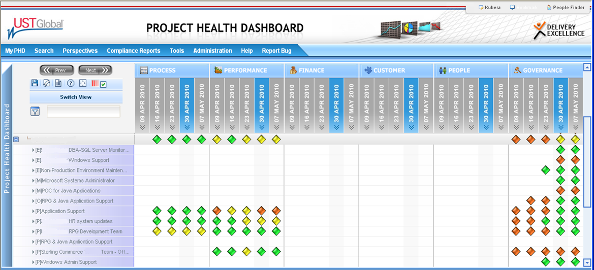

Figure1.4.3.1-3: Sample Project Health Dashboard (PHD).

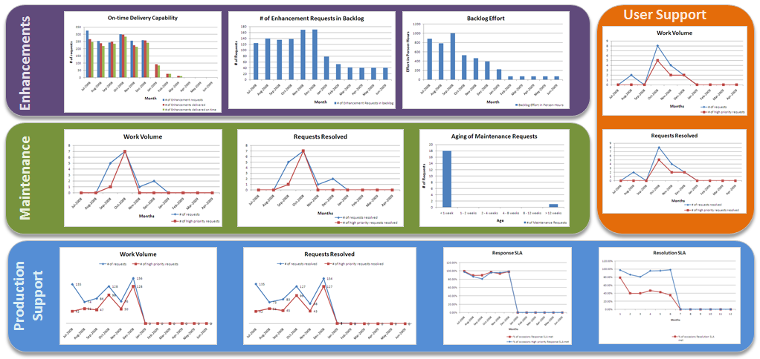

Figure1.4.3.1-4: Sample Status Report.

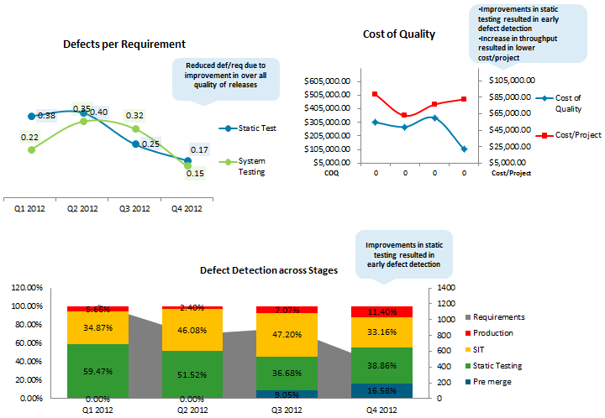

Figure1.4.3.1-5: Sample Report on Engagement KPIs.

##### Detailed Project Work Plan (PWP) (Appendix B)

A detailed project work plan has been attached separately to this volume as *Appendix B* - BuildLA Project Plan in Section 4. The project work plan has been updated for the Final Proposal Response.

##### Governance Model

UST Global believes that the success of this engagement strongly stems on an established “**Governance Model**” which governs the program at a **Strategic Level** enabling the realization of the vision of the BuildLA project. At an **Operational Level** this will be done through appropriate team organization, seamless project execution, efficient communication, and well-defined escalation procedures enabling a strong process for deploying the strategic plan.

Our strategy is to deliver a client intimacy model that results in deep, long-term relationships with our clients. Therefore every aspect of our engagement governance and supporting process is designed to accomplish this primary goal. To that end, we provide senior executive oversight and management for each of our partnerships.

In order to facilitate these goals, UST Global recommends the following tiered approach to BuildLA project governance, consisting of two committees:

* **Steering Committee**: Maintains the overall management of the relationship between the City of LA and UST Global and resolves issues escalated by the Operations Committee.
* **Operations Committee**: Oversees the activities, risks, and issues associated with the ongoing operations and resolves issues escalated by the application teams. The Operations Committee will raise serious issues to the Steering Committee.

For this engagement, UST Global will employ a hybrid global delivery model to provide a best-in-class team, with increased touch points, which form the basis for our client-centric engagement model. The hybrid global delivery model is focused at providing more touch points to the client in terms of senior resources including our Project Manager and other key personnel located at the client site to work closely with the client while leveraging talent from our centers to optimize the experience for our clients. To that end, we also provide senior executive oversight and management for each of our partners. A high level view of proposed UST Global Team for this engagement with the City is provided below.

Through our client-centric engagement model UST Global will assign the following executive roles for the entire duration of the project, for relationship management and account management. These individuals will help ensuring the success of this project, and will be **non-billable to the City of LA**:

* **Chief Information Office (CIO):** Member of our leadership team responsible for building strategic partnerships with innovative technology partners and clients.

**Tony Velleca** is the Chief Information Officer of UST Global, responsible for information technology, communications and security services for global operations spanning more than 26 countries. Tony was selected by ComputerWorld as one of 2010’s Premier 100 IT Leaders for driving positive change and innovation through technology. In addition to his role as CIO, Tony is responsible for strategic partnerships.

* **Executive Sponsor:** Senior member of UST Global’s leadership team who will be accountable for all strategic business and relationship matters involving the City and will be involved in steering committee meetings.

**Bipin Thomas**, Head of UST Global’s Public Sector Business Unit, will be the Executive Sponsor for this engagement. Bipin has over 22 years of global technology leadership cutting across geographies and industries, including healthcare, pharmaceuticals, and life sciences. He specializes in designing solutions to business problems using a congruence of organizational, operational, and strategic initiatives. He has led global businesses providing executive leadership to foremost Global Fortune 1000 clients.

* **Head of Sales, Public Sector:** Accountable for planning and commitment of UST Global activities in support of client initiatives and maintaining the day-to-day and long-term relationship.

**Giri Rajaiah** is the Global Head of Public Sector and Healthcare for UST Global. Giri has worked in the last two decades extensively with Public Sector and commercial clients worldwide. He has overseen many large projects in the Portal and eGovernment space, as well as managed several state and local clients. These include managing one of the largest portal platform initiatives based on the IBM stack in the world, with World Bank in Washington DC, which enable 3,000+ portals in a single framework; launching a US based eGovernment Portal initiative for 15,000 students coming for higher education in US from Saudi Arabia (working with their Cultural Mission); and working on an innovative cloud based Unemployment Insurance system ($100m+ solution) for WYCAN (Wyoming, Colorado, Arizona & North Dakota) consortia, which is the first such solution in the US Government space.

* **Onsite Account Director:** Accountable for the execution of all projects/baseline activities in accordance to scope, timeline and budget expectations established with client in pursuit of service level objectives. The Account Manager will be the **primary Point-of-Contact** for City’s Delivery/ PMO Sponsors; and will help the City in communicating and working collaboratively with the integrated project teams, UST Global Technology Subject Matter Experts (SMEs) and corporate functions, to achieve project objectives.

##### Issues Escalation Model

A well-defined escalation process is one of the channels that when exists, will allow both the City of LA and UST Global the opportunity to properly and quickly resolve project related concerns. An escalation procedure with time schedules will be defined at the beginning of the project, which will clearly identify persons responsible from both sides and enable issue resolution. UST Global will work with the City of LA to understand how and when to escalate issues and define an escalation process that is mutually acceptable for this engagement. UST Global will not impose our pre-defined escalation criteria, but will formulate one of BuildLA engagement based on its unique needs and requirements.

*Figure 1.4.3.1-6* represents UST Global’s standard escalation model:

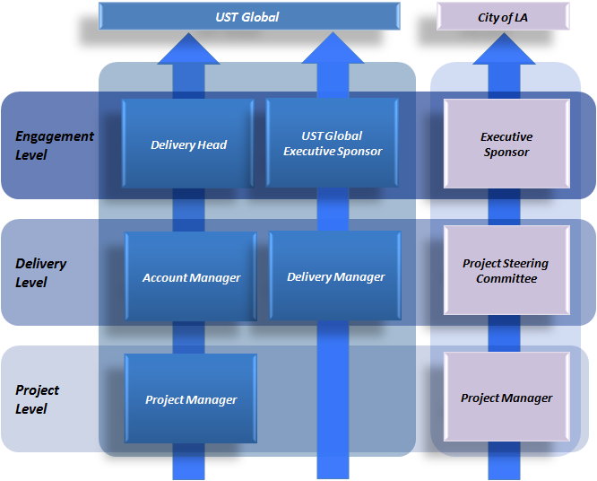

Figure1.4.3.1-6: UST Global Issue Escalation Model.

##### Communication Plan

Regardless of the medium used to communicate with the stakeholders, UST Global’s project team has well defined objectives: timely resolution, high customer satisfaction and operational efficiencies. Our focus is on maximizing the quality and ROI for the City of LA.

UST Global will put in place a well-defined communication plan which will ensure that all parties have a role-appropriate visibility into the team’s progress and direction. A sample communication model, based on our proven practices in similar engagements, is depicted in *Figure 1.4.3.1-7*. A mutually agreeable communication plan, tailored to the unique requirements of the project will be defined prior to project commencement.

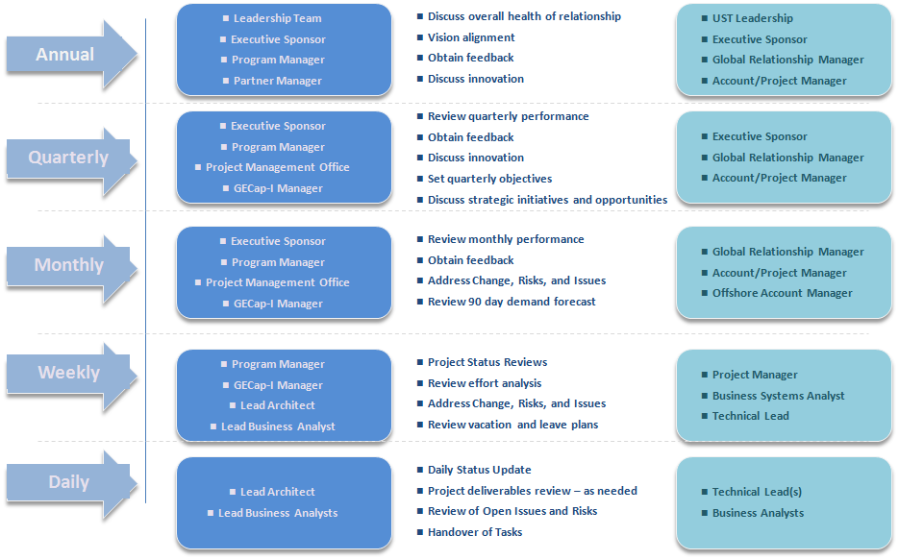

Figure 1.4.3.1-7: UST Global’s Communication Model.

##### Quality Management

UST Global exercises high diligence in the delivery of high quality services while maintaining control of its operational costs. A detailed response for our Quality Management framework has been provided in response to RFP Section- 3.1.4.3.5 below. The Center of Excellence (COE) is a key tenet to our approach and is the enabler to maintaining strong centralized control, managing issues, risks and facilitating distributed project execution. The COE also act as the quality control body to confirm that documents, code, designs, and other requirements meet the City of LA’s expectations and standards.

Processes are defined for quality check and various levels of reviews and audits are conducted to ensure that the processes are followed judiciously. Each project will have a Formal Project Review, Internal Quality Audit, Support Process Review and Software Quality Assurance Review, as per the Delivery Review and Audit Process.

Configuration Management Audit and Defect Prevention Audit of projects are planned as per the Configuration Management Process of the organization. We use the same process with defect prevention and causal analysis activities.

Quality Control Plan

UST Global proposes the following audits for implementation of the BuildLA project to ensure quality and process compliance and to ensure that all work products as required adhere to the Master Services Agreement.

* Quarterly CM Audit by the CM Audit Panel
* Baseline audit by the Configuration Controller (CC) after final release
* Biweekly PM Review
* Quarterly Audit by the PMO
* Periodic reviews by Delivery Excellence team and ISMS team
* Quarterly Formal Project Review by the Account Manager

All audits and reviews planned in the project will be tracked in the program schedule.

##### Configuration Management

The objective of UST Global’s Software Configuration Management (SCM) framework is to establish and maintain the integrity of software work products and Project Management data. This has to be maintained throughout the project’s software life cycle using configuration identification, configuration control, configuration status accounting, and configuration audits. The SCM process involves the following:

* Identifying the configuration of selected work products that compose the baselines at given points of time
* Controlling changes to configurable/version-able items
* Building or providing specifications to develop work products from the configuration management system
* Maintaining the integrity of baselines
* Providing accurate status and data to affected groups and individuals

SCM activities include creating the configuration management plans; identifying software work products and establishing a baseline library; defining and controlling the access to the baseline libraries; controlling the changes to baselines; and the release of software products. The image below in Figure *1.4.3.1-8* depicts key activities performed as part of the SCM process.

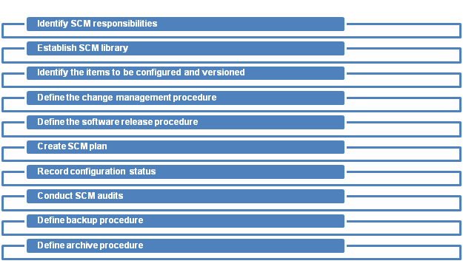

*Figure 1.4.3.1-8: UST Global Software Configuration Management- Key Activities.*

##### Change Management

UST Global’s Change Management protocols for BuildLA will ensure that standardized methods and procedures are used to manage all changes to the service environments in scope. This process will also ensure that all changes to service management processes, service assets, and configuration items are recorded and maintained in the Change Management repository. All changes will be in accordance with established service policies and procedures that will minimize risk to the business. The UST Global Change Management team will assess and evaluate the risks associated with a change and develop contingency plans to follow if implementing changes yields an unexpected result.

Request for Change (RFC) Initiation

Change Management will be initiated with the City of LA Business Users logging a RFC. The impetus for this RFC could be introduction or removal of a Configuration Item (CI) and due to Problem Management activities. UST Global’s team will facilitate all RFCs by using clear procedures, checks, and balances. The team will collaborate with the City of LA User Group in identifying metrics to measure if the change is successful and is in alignment with the City’s business processes.

RFC Review

UST Global’s project team will perform an initial evaluation of the information provided for completeness and feasibility. The team will also ensure that adequate change lead times are in place and in line with the City of LA’s business interests.

Change Assessment & Evaluation

The team will evaluate the potential impact of the change on the pertinent business flows and processes, and define the following parameters for evaluation:

* For which business function(s) it RAISED?
* REASON for change?
* RETURN expected from the City of LA business/process users?
* RISKS involved with the change
* Appropriate RESOURCE (consultant) allocation
* RESPONSIBILITY matrix definition
* RELATIONSHIP definition between this change and other changes?
* UST Global will adopt the following steps in evaluating a change:
  + Perform impact assessment using UST Global Tool (Configuration Management System) by performing impact analysis against related services, infrastructure and business processes
  + Perform business and IT Risk assessment pertinent to the change request
  + To measure the associated risk, our team will assess the actual risk by implementing the change on the test environment, and then compare it against risk of failure if the change is not implemented. We will evaluate both risks and cost-analyze them. Depending on the change request, the team will account Risk remediation
  + We will evaluate the change based on its impact and urgency and take the City of LA’s Change Advisory Board’s (CAB) consent to support and prepare them for changes associated with the RFC
  + We will categorize the changes into minor and major, depending on their impact.
  + UST Global team will get the change authorized from the City of LA CAB
  + We will ensure change scheduling for all RFCs to meet both the City of LA’s business needs as well as their IT requirements
  + We will come to a mutual agreement with the City of LA on the acceptable window timelines to implement the change
  + After the City of LA’s approval of the change scheduling, we will update the Change Schedule and Projected Service Outages processes to give full visibility to the change

Change Implementation

* The changes that are approved by the City of LA’s CAB will be scheduled in the change window for implementation
* Our team will publish a change implementation report for review by the City of LA CAB to ensure that the business objectives were met and risks and costs were minimized
* We will ensure that change process is aligned with City’s business objectives
* Change Record Closure: We will wait for a number of cycles to complete to ensure that the problem is not recurrent, if applicable
* We will also complete the success factor matrix associated with that change, formulated during the change initiation phase
* After a thorough review of the RFCs by the City of LA’s CAB, our team will close the RFC in the UST Tool and inform all the relevant stake holders

##### Cost and Risk Management

UST Global has a comprehensive risk management process that, when combined with the processes for requirements management, project planning, monitoring, and control serves as an effective mechanism for identification and mitigation of risk.

During the engagement, UST Global managers establish and maintain a risk issues log; each element of risk is identified, and tracked. A mitigation plan is established and followed through completion. Risk areas are reviewed and given specific priority levels. An overview of our risk management approach is shown in *Figure 1.4.3.1-9*.

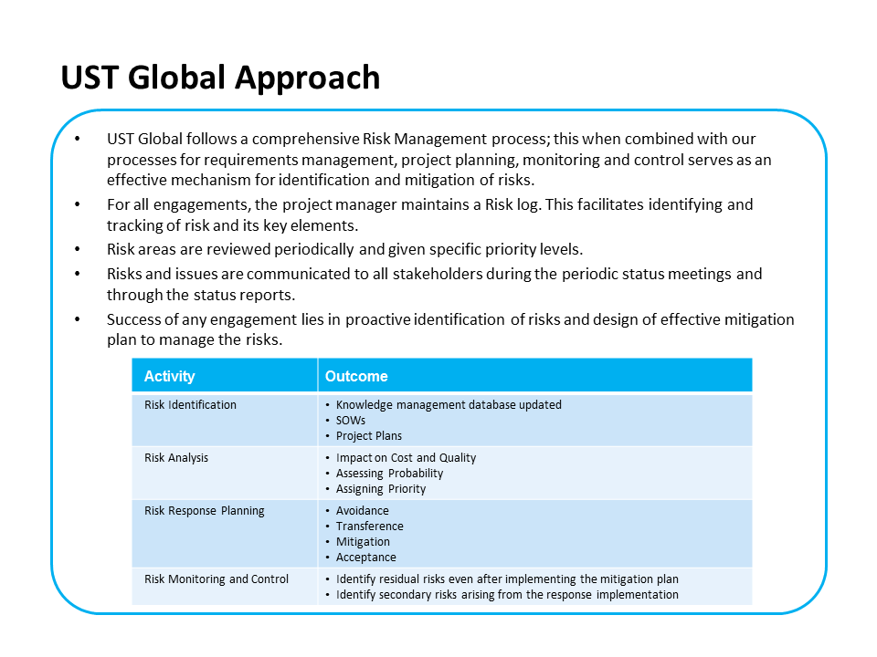

Figure 1.4.3.1-9: UST Global’s Comprehensive Risk Management Approach.

UST Global will make the results of the risk assessment available to the City of LA throughout the contract term. The risk mitigation plans will be discussed as needed in the weekly and monthly project review meetings, and dependencies on client or third party resources will be assigned, and status tracked to completion. Our risk mitigation process includes the following activities as shown in *Figure 1.4.3.1-10.*

| Activity | Outcome |
| --- | --- |
| Risk Identification | * Knowledge management database updated * SOWs * Project Plans |
| Risk Analysis | * Impact on Cost and Quality * Assessing Probability * Assigning Priority |
| Risk Response Planning | * Avoidance * Transference * Mitigation * Acceptance |
| Risk Monitoring and Control | * Identify residual risks even after implementing the mitigation plan * Identify secondary risks arising from the response implementation |

Figure 1.4.3.1-10: Risk Mitigation Process.

The following table (*Figure 1.4.3.1.11*) provides the list of risks anticipated by UST Global and its mitigation plans.

| Risk | Mitigation Plan |
| --- | --- |
| Network connectivity | We will provide a Business Continuity Plan, acceptable to the City of LA that outlines tactics to ensure that consultants maintain the required level of connectivity to applications.   * Trouble Ticket Process (BMC Service Desk) tailored to alert senior management of unplanned downtime * City of LA to be notified in case of issues and resolution in accordance with the escalation process   Execute back-up/fail-over strategies to maintain the required level of connectivity to meet SLA requirements. |
| Consultant performance and competence | UST Global and the City of LA will **mutually agree to the performance and skill requirements** for each role assigned for the project.   * If a resource has not satisfactorily corrected performance issues, we will replace the resource with a trained shadow team member with equivalent/ better skill sets and will cover the transition costs. * If a resource has not demonstrated the required competencies, UST Global will submit a competency development plan acceptable to the client based on the role/skill required. We will cover competency development costs. |
| Knowledge Retention | * If documentation is inadequate/non-existent to support transition, UST Global will work with the City to establish an acceptable baseline. The transition timeline or resource load may require change controls to cover these gaps. * We will establish a knowledge repository, organized by business area and application, that includes training manuals, system documentation, IT standards, release notes, etc. |
| Employee Attrition | * As an organization, UST Global maintains a talent pool which helps on-boarding of resources in cases of attrition. * We have a comprehensive framework to manage the attrition risk. This has been highlighted below. |
| SME and third party availability | Execution of transition plan and ongoing support may require the access of in-house staff and third party vendors. Where third party vendors are unavailable, the following mitigation will be followed:   * UST Global will prepare a schedule, with lead time as agreed, for SME and third parties at the start of the project * We will invoke the escalation process with client, with recommendations for resolution or alternate strategies * UST Global will submit change controls for timeline or scope changes as required * We will adjust consultant support staffing load to compensate for team availability |

Figure 1.4.3.1-11: Risk Mitigation Process.

Risk Mitigation Strategies against Attrition

UST Global runs one of the lowest attrition rates in the industry at less than 12% globally. Our strong focus on employee quality of life, generous stock option grants, and our focus on tier-2 Indian locations have kept our business very attractive to employees. Despite our low attrition rates, we still strive to provide our clients with complete insulation from any unforeseen staff departures. We employ the following methods on behalf of our clients to manage attrition risk:

* **Staff Buffer**: UST Global will maintain a pool of offsite shadow staff in order to minimize any potential impacts from attrition.
* **Client University**: UST Global will establish a domain-specific Client University to gather business and technical information relevant to the client. This tool is used to rapidly ramp up new team members and document all the client systems and processes.
* **Cross Training**: UST Global will ensure that each application has more than one resource capable of providing support such that any staffing challenges can be addressed by our team.
* **Staff Rotation**: UST Global works to provide our staff with opportunities for promotion, onsite/offsite rotation, and a combination of development and support work in each client account. This encourages staff to remain with an account for the long term.
* **Bench Strength**: Bench strength is a fundamental component of our business model. The forecasting models employed by UST Global stretch beyond accounts, domains, and near-term time horizons. We execute global resource management practices to support a staffing model up to two years in the future.

Some of the other attributes of our attrition management include:

Compensation is linked to performance. Market surveys are done regularly to ensure that compensation remains competitive in the industry. Performance based incentives and perks are part of compensation

* A safe and world class work environment is provided to all employees. Recreation facilities are also a standard feature of our work environment
* An active ‘Attrition-Risk-Alert-System’ is in place to identify the talent at-risk and also to pro-actively address flight-risk
* Exit Interview data is collected and the information is used to remove pain points if any.

**Risk Mitigation Strategies for Cost Management**

UST Global brings in Project Management expertise in line with industry standards, which enables us to optimize utilization of resources, and avoid operational and financial leakages. Following are the key aspects of our Cost Management Plan:

* Proactive Risk Mitigation: Using our Risk Management Framework, UST Global will identify any Change Management scenarios that will impact the Cost. Under exceptional circumstances (for example- inclusion of additional requirements), this will follow the Change Management protocol as mutually agreed upon, before additional work is taken upon.
* On Time Delivery: One of the reasons for increase in costs is- delay in Project Execution. Team UST will ensure adherence to the implementation timeframe, and create a mitigation plan to address unforeseen circumstances.
* Team UST has put a robust partnership in place, which will ensure streamlined operations and no impact of additional operational costs on the City of LA.

#### Deployment Strategy (RFP 3.1.4.3.2)

Overview

The BuildLA is a critical website with integration to various applications. The deployment strategy is targeted to ensure the repeatable and consistent delivery of each release. The complexity increases with the various applications, content/artifacts/documents, and various configurations needing to be in sync. The risks are defused by using an automated deployment approach for BuildLA.

The BuildLA will provide a high availability site to be leveraged by the various users of the system. The deployment infrastructures will be planned with no single point of failure. The deployment process will additionally ensure that the site is available during the release of the site. Our deployment strategy is shown in *Figure 1.4.3.2-1*.

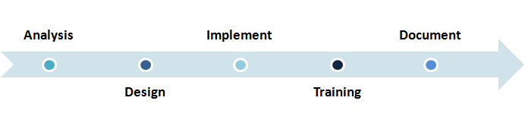

Figure 1.4.3.2-1: Deployment Strategy.

Deployment Approach

To start we will conduct a detailed analysis to determine the preferred deployment configuration. Starting with the ideal configuration, which uses the most functional and best-performing deployment architecture for the set of applications, we evaluate each feature against BuildLA's needs. We will be considering different configuration alternatives and repeat the evaluation for each configuration and funnel down to the most suited deployment architect for BuildLA’s requirements.

Next for the deployment we will leverage a quarterly release cycle to ensure smooth and consistent deployment of new features. This approach enforces discipline in introducing fixes, gives predictability, and allows more regular releasing. Additionally this approach enables the thorough testing (functional, security, performance etc.) of enhancements. Additionally, detailed planning can forecast efficiently the roadmap and provide various IT planning options to business leaders around resource availability for release delivery.

After the finalization of the approach we validate scope, objectives, and the critical success factors for the deployment. Subsequently we repeat all appropriate tasks for the deployment and verify the results. This gives us the opportunity to update the approach if required. Finally we review and approve deployment plan and associated tasks.

Now we move to the actual deployment. We start by reviewing and reconcile current system operations. We will also review organization and system procedures and mark any changes based on the current release. We will then promote the deployment to production simultaneously updating current operations, procedures, and system release and deployment notes. The team in parallel monitors and provides transition support.

All the knowledge acquired will need to transition to the teams working onsite. We establish training requirements for all personnel and finalize training schedules. The crux of the activity is to establish the right training needed for the right personnel, and prepare appropriate materials for each training session. This ensures the correct people and information is leveraged to enable people to perform their tasks efficiently. To ensure quality we capture training feedback and we leverage the feedback loop to ensure continuous improvements in training.

Finally the documentation has to be updated. We create/update a “run book” for system administrators. In this step we add expected exceptions, rollback scenarios (partial/full) and ensure the administrators have a good handle in performing required steps in any situation.

Process and Impact

The process is targeted to achieve a continuous delivery leveraging build, automated testing and deployment automation. Feedback is at the core of the process improvements. The essential idea is to have shorter feedback cycles to provide a continuously improving process. As per the lean philosophy, the impetus is to optimize globally and not locally. This enables a lean and optimized deployment pipeline which ensures continuous improvements.

We choose a list of primary metrics (cycle time from check-in to release) as well a set of secondary metrics (number of defects, build failures/day) which enable a 360 degree view of the deployment process. By tracking the metrics and postulating the decisions based on the metrics allows us to systematically improvement of the deployment process. Applying the theory of constrains we arrive at global bottlenecks and the highest value is derived on the effort expended in improvements.

The visualizations of the information captured is another critical aspect of achieving continuous improvements. We ensure the data is available in different levels of summarization based on each individual group of users. For example management needs a single health metric for the deployment process; the leads will need improvements or areas of concern demonstrated in a single graphic; and developers will need details. This enables a strong contribution from each group as the access to required information is simplified. Our sample metrics used for feedback is shown *in Figure 1.4.3.2-2*.

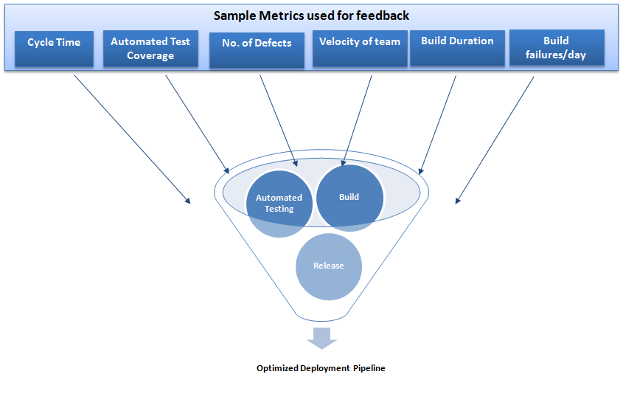

Figure 1.4.3.2-2: Deployment Approach with Sample Metrics.

Impact on Documents

The following process management document will have sections based on the deployment strategy employed.

Release Plan

The release plan will have activities for a controlled deployment or rollout in case of contingencies, and will have information on the various environments including:

* Conversion information
* Product installation information
* Distribution details
* Data migration
* Integration information on applications in the systems

Production Readiness

The production readiness plan describes the preparation required for the BuildLA application to operate in the production environment. We will specify any features that need modification to adapt to the product, and identify the steps necessary to assist the user in preparing for this new product.

Communication Plan

We will develop a plan to communicate with all interested parties regarding BuildLA, including stakeholders, sponsors, users, and developers. This planning ensures that everyone who needs to be informed about deployment activities and results receives needed information in a timely manner.

Contingency Plan

This includes planning the steps to be executed when we decide to rollback deployment of a particular release. We will develop a business resumption plan and a comprehensive statement of action.

Training Plan

Our training plan will outline our training timeline and describe the approach, activities, and tasks necessary at each point in the deployment.

Portal Deployment

The deployment process consists of a multitude of interrelated activities with a network of transitions between them. The deployment strategy leverages best practices and proactive risk mitigation to enable smooth transitions from the development environment to the production environment. The deployment strategy outlines the scope, approach, and execution planned for the deployment of the BuildLA portal implementation. The strategy includes, where relevant, information about system support; issue tracking; escalation processes; communication mechanisms; and roles and responsibilities before, during, and after deployment.

Portal deployment is inherently a complex process for a large enterprise deployment as is the case for BuildLA. There are multiple components (ear, war, portlets, etc.), artifacts (themes, skins, content, documents, etc.) and configurations (portal server, portlet etc.) to manage across the portal. Thus, it is very important to keep the Build and Deployment Strategy very clear and tight and automate all the tasks so that they are efficient and repeatable. Consequently, the portal deployment plays a major part in the successful implementation of the portal.

Portal Deployment Strategy

The BuildLA “Solution Release” is the portal site development that meets all business requirements and consists of all the types of elements mentioned below. We will classify these elements into the following categories:

* Portal Configuration – Portlet application configuration and settings, access control data, themes and skins, portal content tree, URL mappings, etc.
* Portal Artifacts – Portlet code, JEE artifacts, servlet & portlet filters, etc.
* Extension Artifacts – Portal search and search collections, web content management, document repository, documents, flows, roles, collaboration components, etc.

The Solution Release will be moved through the various environments (development, test, quality assurance, stage, and production). To manage a smooth transition across environments and releases, the deployment activities need to be fully automated. The automation will reduce the risk as well as ensure no gaps in the different environments. As the artifacts to be managed are variant, we need to leverage tools that are most adapt at this task. There are multitudes of tools both from IBM (XMLAccess, Release Builder, Site Management, etc.) and open source (Ant, Jython/JACL, etc.), which provide the umbrella of capabilities to fully automate the deployment activities.

The tools provide the capabilities for the initial configuration of the environment as well as enable incremental deployments to support a sequence of incremental feature releases. In times of contingency, the tools have the capability to roll back to a more stable previous version of the solution release. The process used for the deployment strategy will be the stepping stone for a continuous release environment as shown in *Figure 1.4.3.2-3*.

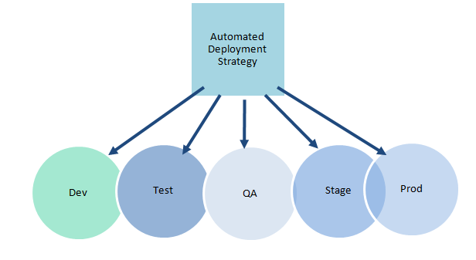

Figure 1.4.3.2-3- Automated Deployment Strategy.

#### Knowledge Transfer and Training Plan (RFP 3.1.4.3.3)

Team UST has the required knowledge and experience in working with our clients to deliver successful user training and knowledge transfer programs. We have based our pricing assumptions on training 10 City technology staff for Knowledge Transfer and 14 City trainers (Train-the-Trainers). We design specific training programs that suit the audience of the particular engagement and ensure that it is effectively rolled out to the client's end users and technical support teams. We will design and develop a specific training and knowledge transfer approach that meets with BuildLA’s requirements, both prior to the implementation stage, when we will work with the user community during the design process, and after implementation of the application. UST Global will perform the following activities as part of this approach:

* **Perform** **Training Need Analysis** – Team UST will carry out an analysis based on different aspects including user skill levels, technology, number of users, and other aspects. We will evaluate and finalize the training plans based on the analysis.
* **Knowledge Transfer and Training** **plan** – Based on the training analysis performed, Team UST will create a defined knowledge transfer plan for the City of LA’s Application Support technical team and a customized training plan for the City’s end users. UST Global will also leverage its partners in this engagement − IBM, Infor, Avolve, Excelerate and TruePoint Solutions − to create our training curriculum and plan. The training plan will be developed in partnership with the City of LA’s stakeholders and we will obtain sign-off from the City management team.
* **Documentation** – Team UST will create adequate documents during all the phases of this engagement including functional and technical specifications, training manuals, source code, release notes, and other required documentation. These documents will be utilized for the knowledge transfer sessions.
* **Platforms** – We will offer various kinds of knowledge transfer and training platforms to the City of LA users based of the needs analysis and training plan. This includes classroom training, workshops, online trainings and computer based training (CBTs).

**Knowledge Transfer**

Knowledge transfer is the key to providing a smooth BuildLA Solution transition from Team UST to the City of Los Angeles. Our strategy includes the following elements:

* **Identification** of the City’s Application Support team that will have ongoing responsibility for BuildLA
* **Designing** a knowledge transfer mechanism
* **Executing** the transition plan
  + Document the new work, business, and technical environments
  + Collect artifacts related to Business Process maps, Configurations, Interfaces, processes, and existing reusable artifacts
  + Document IT standards, processes and practices, and technical components
  + Collect and review UAT test cases and System test cases
  + Conduct knowledge transfer sessions.
  + Review documentation and knowledge transition sessions with the City’s Application Support team
  + Catalog knowledge collected artifacts in a knowledge management system
  + Create the System Appreciation Document that describes BuildLA’s functional features, architecture and design
* **Documenting** activities in a Knowledge Transfer work log
* Knowledge Transfer **Playback** Sessions with the City’s Application Support team – sometime referred to as reverse shadowing
* Knowledge Transfer **Assessment** and Scoring –continually monitor, evaluate and update
* Ensuring that the City’s users **utilize** the knowledge transferred
* **Revising** and updating the System Appreciation Document as required
* **Finalizing** the System Appreciation Document

Our transition strategy and approach is aligned with the Build LA Solution Wave based rollout plan. It includes the following transition models:

* **Initial Knowledge Transition and Service Model** – Initial set up to prepare to support Wave 1 user base.
* **Continuous and Incremental Transition Service Model** - Transitions required to cover additional user base and services scope for the remainder Waves 2 through 4.

**Benefits to the City of Los Angeles**

Team UST’s Knowledge Transfer program provides a variety of benefits to the City of LA.

1. By ensuring that the City has a well-trained Application Support team, this approach provides minimal business impact during transition, no impact on stability and performance of business-as-usual services during transition and minimal dependency on the Application Support team during Waves 2 through 4 Transitions.
2. Team UST has an active corporate social responsibility program that is designed to improve the communities in which we do business. Earlier this year we launched Step IT Up America, a Science, Technology, Engineering and Mathematics (STEM) initiative in Los Angeles to train and hire minority women. As part of this program, over 1000 women in Atlanta, Chicago, Detroit, Philadelphia and now Los Angeles participate in a 90 day IT training program followed by a technology job. We will hire 10 graduates from the Step It Up America Los Angeles program to support the BuildLA implementation.

**End-User Training**

UST Global has a unique, well established and customizable training program that caters to client requirements. We will design customized domain training to allow City users to maximize the functionality and effectiveness of the BuildLA solution, and will incorporate existing training programs from our partners to deliver our systematic training program.

Training Evaluation Techniques

Our team believes that before any system is presented to the City of LA’s user groups, the users must be provided comprehensive hands-on training, which will ensure better understanding, acceptance, and usage. The proposed training will cover both the business and technical training requirements identified in the RFP. Our development team will create self-help videos and user guides for each of the services provided as part of the BuildLA solution. These documents and self-help videos will be used as training materials that can be refreshed as needed for the trainees.

Each training package includes a structured training evaluation process. UST Global adopts two types of evaluations depending on the type of training.

1. Technical training will be evaluated by well-experienced technical staff using sample case studies.
2. Business/user training will be evaluated by the domain competency team.

UST Global’s domain competency assessment program helps the team to evaluate the competency of our team members on a regular basis to make sure that progressive domain expertise is being developed within the team. Domain competency assessment is categorized into five different levels based on the complexity of assessments with Level 1 being the entry level and Level 5 being the Expert level. Level 1 domain certification is the minimum eligibility criteria for any personnel resources to work in any project (*Figure 1.4.3.3-1*).

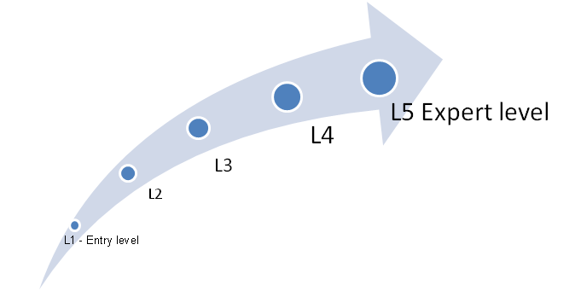

Figure 1.4.3.3-1: Domain Competency Progressive Development.

One of the key aspects of our UST Global training methodology is to ensure the involvement of the City of LA’s users from the initial phase of the project, and to conduct training on each release. Participants are actively involved by way of interactive discussions, various business scenarios, case studies, and one-to-one class room evaluation. Trainees are providing ratings through hands on exercises and online quizzes.

Selection of Training Process – Rationale

In developing the selection process for the City staff training, UST Global has assumed total ownership and responsibility for all training related planning and execution activities. Considering the extensive training requirements, our dedicated Training Lead, Nicole Thorne, will strategize the training approach for a comprehensive training curriculum supported by quality documentation, and will be responsible for effective delivery to the City of LA users. Nicole has over 11 years’ experience in land development and permitting solution training, specifically with the Infor/Avolve solutions we are proposing. She has designed, developed, and delivered user training and best practices for building, planning, and workflow implementations across the United States, including Boston, Phoenix, Albany, Las, Vegas, Riverside, Indianapolis, Chicago, and Tallahassee.

UST Global performs a Training Need Analysis and as part of our training module selection process, the UST Global Project Manager, UST Global Training Manager, program managers from technical partners, the City of LA Project Manager and service owners will work closely to identify training needs, type of training, mode of delivery, schedule, required documentation, and training pre-requisites.

Web based training using tools such as WebEx or Live Meeting will be scheduled wherever appropriate in order to bring down costs associated with travel and facilities. The instructor-led hands on training will be provided by our Training Lead with assistance from one or more UST Global staff to ensure appropriate level of help, guidance, and support during training.

Innovative Training Techniques

UST Global believes the success of a project depends on the way in which the team and the client understand the client’s new business processes. We have a number of training methods that incorporate learning about our client’s business through incorporating a fun-filled work environment, where the trainees learn the business thru fun and games. These include:

* Business Carpet- An interactive game that helps in imparting knowledge to resources, and effective and quick way to learn process workflows
* Business board game – Another interactive board game that helps in understanding business processes and smoothens induction of new joiners
* Client university- SharePoint based Knowledge Repository as discussed earlier in Section 1.4.3.3

*Figure 1.4.3.3-2* below, depicts a sample Business carpet game developed for one of our retail clients.

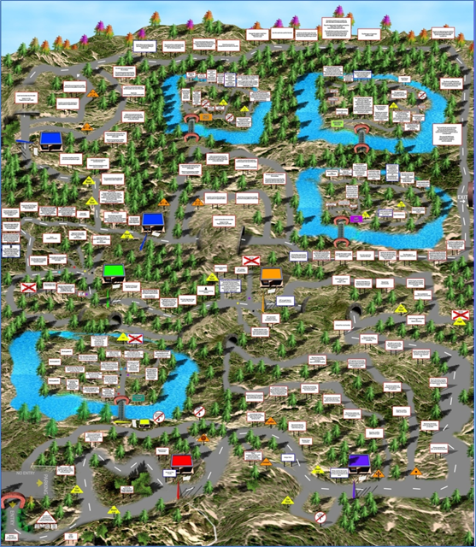

Figure 1.4.3.3-2: Sample Retail Business Flow Carpet Game for One of our Retail Clients.

#### Requirements Development, System Design, Development, and Testing (RFP 3.1.4.3.4)

UST Global provides Application Development, Maintenance (ADM) and Support services for mission critical systems for our Government and Fortune 1000 customers. ADM is our core competency and is substantiated through the fact that more than 35% of our revenue comes from it. We have carried out numerous projects across different industries on these platforms. Our proficiency spans across Mainframe technologies such as COBOL, CICS, DB2, IMS, JCL, Natural, IDMS etc. and the Web based technologies such as Microsoft technologies, Java and other open source technologies, and custom packaged tools.

UST Global, with its capabilities in application development, has formulated structured methodologies in defining and delivering our services. Our methodology also enables service improvement for reduced costs of development and business transformation through structured business centric innovations. Our methodology provides organizations the ability to transform application management from being an order taker to a strategic partner that invests in the organization to become an ongoing value enabler. ABUILD®, UST Global’s proprietary methodology for Application Development (AD) is based on best practices from industry process standards including CMMi, ISO, and ITIL as well as our experience with developing applications for Global 1000 clients across the globe. Our methodology follows a risk mitigated and phased approach to define, plan, transition, and deliver services while continuously improving the applications.

Implementation Lifecycle

UST Global has customized its ABUILD® - Iterative delivery methodology for the design, development and implementation of the BuildLA Portal in an agile development model. This will result in early prototypes that can be reviewed by the City for system functionality. The table below depicts the various phases and deliverables for our Implementation approach.

*Figure 1.4.3.4-1* depicts our ABUILD® Methodology and alignment with the implementation approach.

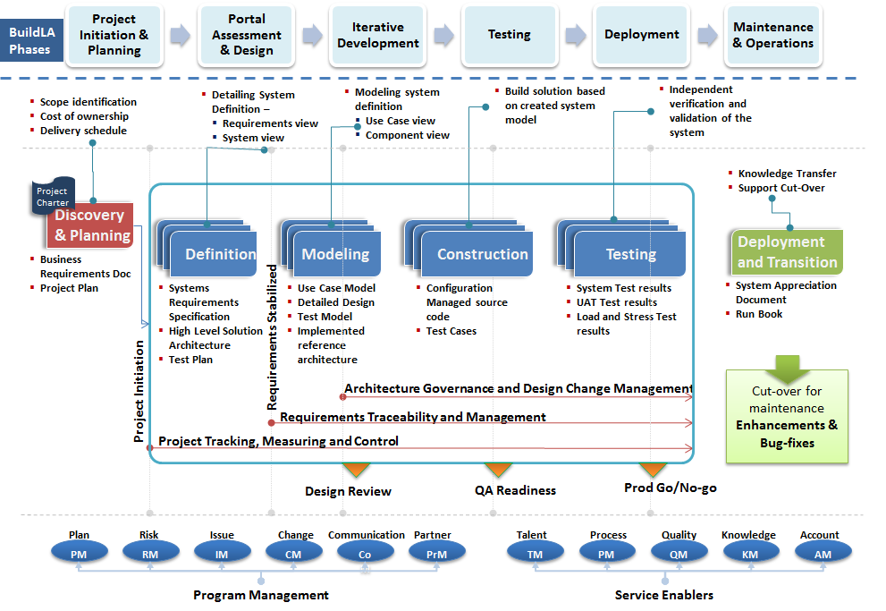

Figure 1.4.3.4-1: ABUILD® Framework and Mapping to BuildLA Phases.

**Methodology for Providing Project Deliverables**

Our methodology and approach for providing project deliverables is shown in *Figure 1.4.3.4-2* and is described in the following section.

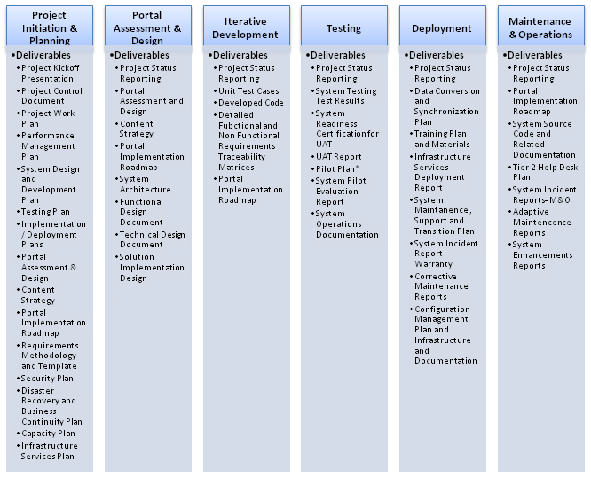

Figure 1.4.3.4-2: Our Methodology for Providing Project Deliverables.

Project Initiation and Planning

This phase lays the foundation for the quality of service delivered through a well-defined solution articulation. UST Global’s team will work with the City of LA’s SMEs to finalize the business requirements, project objectives and goals in detail. UST Global will use using robust visualization and collaborative engineering tool, i-Rise etc. for the Requirement Gathering Activity. This phase also includes creating roles and responsibility chart, task oriented project plan, communication and risk management plan, etc.

The list of deliverables, as required by the City of LA is shown in the table above. The Project Control Document Deliverable will include the following: Roles and Responsibilities Plan, Scope Management Plan, Cost Management Plan, Schedule Management Plan, Communication Management Plan, Quality Management Plan, Risk Management Plan, Change Management Plan and Performance Management Plan. The following are the key sub-tasks as described in the RFP - Scope of Work:

* Project initiation and kick-off
* Project Management Planning
* SDLC Methodology Planning
* Requirements Development

Portal Assessment & Design

We will create a detailed solution model of the system in this phase after multiple reviews. This will refine and expand the preliminary design to the extent that the model is sufficient to begin implementation and addresses the business needs unambiguously. We will obtain the sign off from the City of LA for the design document and also create a detailed project plan for the engagement. Following will be the key sub tasks of this phase:

* Portal Design
* Content Strategy
* Portal Implementation Roadmap
* System Design

Iterative Development-

This is major phase of the project life cycle. The primary focus of this phase is to ensure that unit-testable code is available for each of the features/use cases/system specification required for the business. This builds off the detailed solution model for this engagement. Figure 1.4.3.4-3 illustrates the phases involved in iterative development.

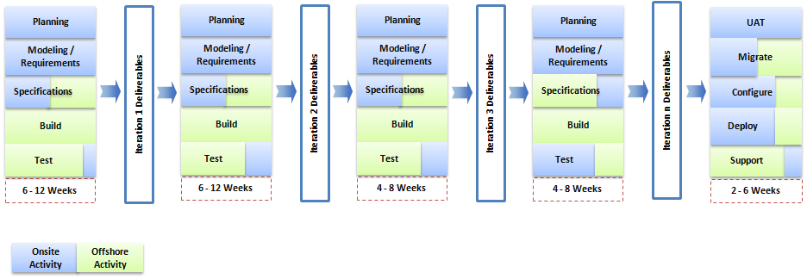

Figure 1.4.3.4-3: Phases Involved in Iteration.

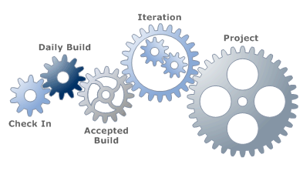

The iterative time boxed development approach focuses on delivering high value business requirements early and often, and mitigating risk by providing short, time boxed development iterations resulting in demonstrable product increment at the end of each development cycle. During every iteration, the system is presented to the City of LA stakeholders who will review and provide contextual feedback.

The following sections highlight some of the best practices that our teams employ in this engagement:

Testing

The primary objective of this phase is to validate that the application addresses the business requirements and meets the acceptance criteria as stated by the City of LA. Regression testing will be carried out at all phases to ensure the system functionality on any functional edits, and the extent of testing will depend on the overall regression efforts. UST Global processes promote significant amount of automation to reduce human error and improve productivity. Testing to ensure non-functional and performance requirements is also delivered as required. During the Testing phase, periodic reviews will be conducted with City of LA stakeholders.

As per the RFP requirements, the following are the key subtasks for the Testing phase: System testing; Unit testing; Sub-system Integration Testing; System Qualification testing; and Regression testing. UST Global will also define the process and mechanism for completing a readiness certificate; support the Pilot testing, and providing on-site support during UAT. Please see Figure 1.4.3.4-3-1 for resources required by application and phase.

|  |  |  |  |  |  |  |  |  |  |  |  |  |  |  |  |  |  |  |
| --- | --- | --- | --- | --- | --- | --- | --- | --- | --- | --- | --- | --- | --- | --- | --- | --- | --- | --- |
| **Role** | **IBM** (IOC, WebSphere Portal, IIB) | | | | | | **Avolve** (ProjectDox) | | | | | | **Infor** (CDR, IPS, Ming.le) | | | | | |
|  | **System Testing** | **Sub-System integration Testing** | **System Qualification Testing** | **Regression Testing** | **UAT** | **Pilot Testing** | **System Testing** | **Sub-System integration Testing** | **System Qualification Testing** | **Regression Testing** | **UAT** | **Pilot Testing** | **System Testing** | **Sub-System integration Testing** | **System Qualification Testing** | **Regression Testing** | **UAT** | **Pilot**  **Testing** | |
| **Test Manager** | 25% | 25% | 25% | 25% | 25% | 25% | 25% | 25% | 25% | 25% | 25% | 25% | 50% | 50% | 50% | 50% | 50% | 50% | |
| **Senior Test Architect** | 20% | 20% | 20% | 40% | 20% | 20% | 20% | 20% | 20% | 40% | 20% | 20% | 60% | 60% | 60% | 60% | 60% | 40% | |
| **Senior Test Analyst** | 100% | 100% | 100% | 100% | 100% | 100% | 100% | 100% | 100% | 100% | 100% | 100% | 100% | 100% | 100% | 100% | 100% | 100% | |
| **Tester** | 100% | 100% | 100% | 100% | 100% | 100% | 100% | 100% | 100% | 100% | 100% | 100% | 100% | 100% | 100% | 100% | 100% | 100% | |
| **Test Specialist** | 20% | 20% | 20% | 40% | 20% | 20% | 20% | 20% | 20% | 40% | 20% | 20% | 60% | 60% | 60% | 60% | 60% | 40% | |

UST recommends having three test environments. Environment #1 is for System testing, Subsystem Integration testing, and Qualification and Regression testing, Environment #2 is for User Acceptance testing (UAT), and Environment #3 is for Pilot testing. This will ensure that all three products are tested in three different environments to target a near Zero Defect in production.

Figure 1.4.3.4-3-1: Matrix of Testing Resources Required by Phase and Application.

Deployment

UST Global’s AD methodology includes a well-defined Transition-Out phase to the maintenance team or to the City of LA team once the application is deployed and delivered. In this phase, UST Global hands over details around the application – in terms of configuration, installation, open issues, test results, and codebase to the team that will manage the application post roll-out.

Maintenance & Operations

Team UST adopts a well-defined and mature application support and maintenance process through effective capture of the product runtime environment and customers’ business activity. The approach reflects Team UST’s commitment to creating world-class, technology-driven solutions that help customers increase their productivity. It further focuses on long-term functionality, lower total cost of ownership, stability, and preventive maintenance. The approach leverages Team UST’s robust service delivery mechanisms and proactive approaches to software maintenance. It reflects our broader level strategy of forging partnerships, alliances, and joint ventures for building competencies in key solution areas. Further details are included in *Section* *1.4.4.2*, Maintenance & Operations and Support.

**Best Practices of Our Implementation Approach**

Continuous Integration

Continuous Integration is a software development practice where members of our team integrate their work frequently. Usually each person, both onsite and offsite, integrates at least weekly - often leading to multiple integrations per month. Each integration is verified by an automated build (including test), to detect integration errors as quickly as possible. We have found that this approach leads to significant reduction in integration problems.

Shared Global Codebase

A single, shared l code repository is used by all developers. The single stream of development greatly decreases the difficulty of integrating between multiple locations. UST Global leverages configuration management tools that provide the capability to share code across locations in a seamless manner.

Incremental Design

UST Global team will endeavor to take a "simple is best" approach to designing this system. Systems will be designed to take into account only those requirements that are currently under development and not waste inordinate amount of time accounting for every possible design decision that may be made in the future. This is to focus on creating the most elegant simple design possible that satisfies known requirements, rather than focusing on designing for requirements that may or may not produce significant business benefit. The system is designed incrementally as more is learned and existing design elements and the design and code evolve as the project progresses, resulting in the simplest code possible to solve high priority business problems.

Coding Standards & Reusable Frameworks Adoption

In order to effectively provide an environment in which developers can quickly adapt and understand the work of other team members, an adherence to coding standards is vitally important. UST Global adheres strongly to coding standards and framework adoption. These are documented and teams receive training at the onset of every project.

Benefits of our Model

UST Global’s ABUILD® Iterative delivery capability is client focused that helps the City of LA in attaining more benefits in terms of quality and accuracy. Built on the principles of Agile, our framework incorporates regulations for:

* Permitting measured visibility into the current state of delivery
* Automating continuous integration of user needs with reduced wastage of effort
* Making the teams efficient that are not yet “self-organized” in their delivery
* Ensuring maximum value is delivered to the customer at any point in time
* Documenting the essentials
* Providing quick feedback for change with frequent communication and periodic reviews

Implementation Timeframe

The proposed engagement timelines for the portal implementation is illustrated in *Figure 1.4.3.4-4*.

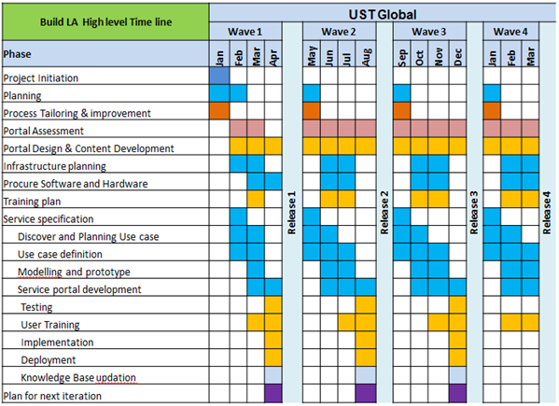

Figure 1.4.3.4-4: Implementation Timeframe.

Master Solution Blueprint

Team UST’s PWM solution will be built using modern data processing technologies, methodologies, paradigms and platforms. It will implement open, pluggable, contract based, and service-based architectures that will be divided into layers and tiers to address concerns such as scalability, capacity, availability, durability, performance, manageability, and extensibility. The solution utilizes well-known products and services to ensure reliability and sustainability as illustrated in *Figure 1.4.3.4-5*.

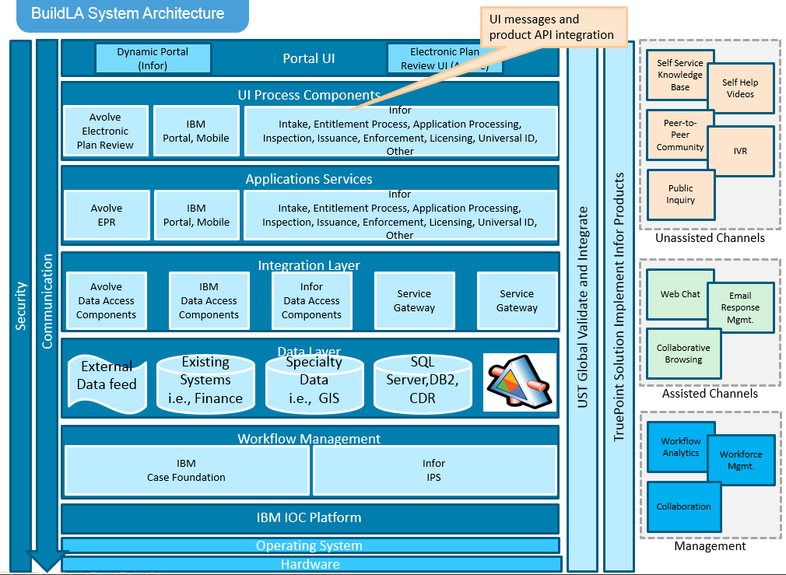

Figure 1.4.3.4-5: Proposed System Architecture.

The following are the key components that will be used in this solution.

Our core solution is built on IBM’s Intelligent Operations Center (IOC) platform, which is the foundation for IBM’s “Smarter Cities” solutions. It provides an extensible platform for cross domain growth as well as a number of out of the box capabilities including key performance indicator monitoring, team and agency collaboration tools, workflow automation and operational and executive dashboards. Additionally, the IOC includes data integration capabilities that allow the processing and management of diverse datasets including those from Infor’s permitting data and city infrastructure data. The workflow management will be performed using IBM Case Foundation and Infor’s IPS. The IBM Integration Bus (IIB) will be used as the message broker.

The base portal will be built on IBM WebSphere and contains sub portals including Infor’s Dynamic Portal and Avolve Software’s Electronic Plan Review.

* The UI Process Components have Infor Dynamic Portal, Avolve Electronic Plan Review, and custom UI components.
* The application layer contains Avolve Electronic Plan Review, IBM Portal Server side, and Infor IPS.
* The integration layer will utilize IBM IIB message broker to integrate/interact with external systems and databases.
* Our BuildLA solution will interface with finance, payment, document management, document imaging, and reporting systems. It will also expose interfaces to Universal ID and departmental local ID for universal ID as well.
* The GIS and GPS data will be integrated with the existing ZIMAS and NavigateLA databases. Transactional data will be stored in the DB2 and SQL Server Databases. Per the City’s requirement for a fully-hosted and fully managed solution, all components of the BuildLA solution are hosted in a technical environment separate from the City’s existing infrastructure. There is no need for ZIMAS or NavigateLA to co-exist in the same technical environment as the components of the BuildLA solution. In conformance to the City’s requirement for a fully-hosted and fully managed solution, all components of the BuildLA solution will be hosted in a technical environment which is separate from the City’s existing infrastructure. The BuildLA technical environment will be connected seamlessly and securely to the City’s internal technical environment through the use of redundant, reliable, secure, high-speed virtual private network (VPN) connections.
* In architecting our solution for the City of Los Angeles, we have given careful attention to the implications and potential impacts of connecting the two separate technical environments together, including the need to ensure high availability and reliability, high performance, and strong security for the interconnects. High availability and reliability considerations are addressed through the use of multiple redundant VPN links which eliminate single points of failure and mitigate risks and impact associated with network downtime. Availability, reliability, and operability are further enhanced through the use of automated monitoring and alerting infrastructure, allowing early detection and rapid correction of potential issues before they become problems. Security considerations are addressed through the use of strong encryption for all network traffic over the VPN links between the two technical environments. Performance considerations are addressed through the use of redundant high speed 1Gbps network connections, allowing data to move between the two environments literally at the speed of light, with very high bandwidth and minimal latency.
* In addressing the above needs and potential impacts, our solution leverages Virtual Private Networking technology to soften the lines between the two technical environments, enabling direct trusted communication between BuildLA components and City components (including NavigateLA and ZIMAS) just as if they were both on the same physical network while at the same time providing unparalleled network performance, security, and reliability.
* The unassisted channel and assisted channel services and management services will be developed as autonomous services and repurposed and configured for required contexts.

The BuildLA solution will utilize a federated security framework to control access for citizens, vendors and city employees, Access will be role based. For instance, citizens will be able to research (e.g. requirements for building permits) anonymously but will be required to register and login when submitting a permit.

Software Process Architecture

Team UST’s BuildLA solution will be based on typical process architecture. As indicated in *Figure 1.4.3.4-6* below there are five elements in the software process: Users, Delivery Channels, Core Business Services, Data & Information and Enabling Technologies.

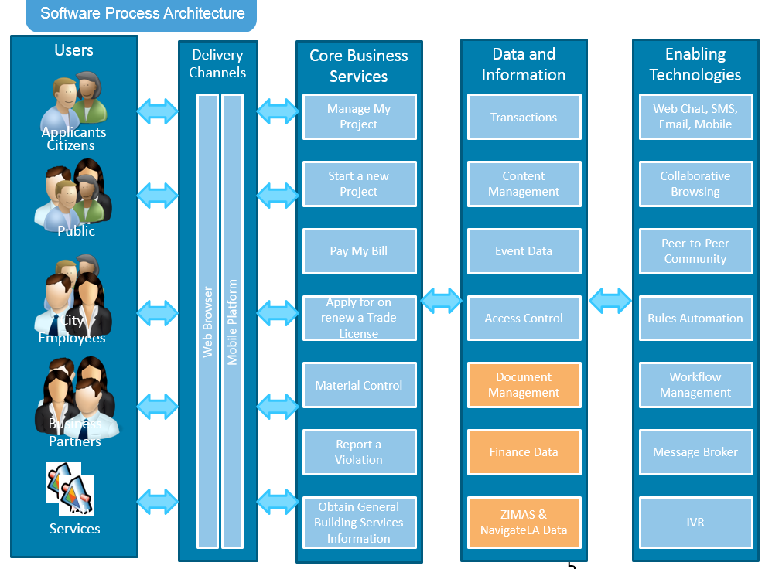

Figure 1.4.3.4-6: Software Process Architecture.

At a high level, a request is triggered by a user:

* Applicants may research how to apply for a permit and then file the actual permit application.
* Public users may conduct research, submit comments before a public hearing or file a complaint but do not file an application.
* City employees configure, manage and operate the system and will be the most active users. They may include Planners, Planning Services Staff, City Service Manager, City Supervisor, Plan Checkers, and many other employee categories.
* Business partners provide services utilized by the City. They may post the upcoming events and services that they provide. For example, Licensed Fabricators may provide notifications of upcoming fabrication projects in the city.

Users communicate with the system via Delivery Channels such as web browsers and mobile platforms. Additional delivery channels can be accommodated in the future in a cost effective manner and without having to rewrite the whole system.

The delivery channels communicate with the core business services which are where the most intensive processing occurs. They may trigger rules validations, workflows, service orchestrations and coordination may take place. As a result, enabling technology services, such as Message Broker and alert notifications may also be triggered.

The core business services interact with the data and information layer to retrieve and manage information and data.

Enabling technology services such as web chat, email management, and collaborative browsing are support services. While they don’t directly participate in the transactional processing, they facilitate and enable their successful execution.

Configuration Methodology and Approach

Our configuration management methodology is based on industry best practices that are technology and platform agnostic. It consists of a set of principles and disciplines that can be successfully applied in any environment. This methodology and approach works well with configuration management industry leaders such as, IBM Rational ClearQuest, Microsoft Team Foundation Server, Serena Dimensions CM and many more.

Our configuration methodology and approach is built to achieve the following set of objectives:

* Create a standardized build and deploy process
* Reduce process variability
* Define an end-to-end view of the Delivery process and stages from Development to QA to Production, with common standard and process across all areas
* Establish organizational structure which follows documented processes and procedures
* Collect and maintain a comprehensive model of all configuration elements and dependencies
* Create a more predictable software development and release cycle
* Increase productivity by streamlining the assembly process, and facilitating unit and integration testing within sub-environments through enhanced test data management
* Support segmentation of the application workflows to isolate change and allow testing without being dependent on the entire workflow
* Enforce single-source configuration setup and maintenance for all development activity based on the validated production baselines and pending code-line branches

Our Enterprise Configuration Model is shown in *Figure 1.4.3.4-*7.

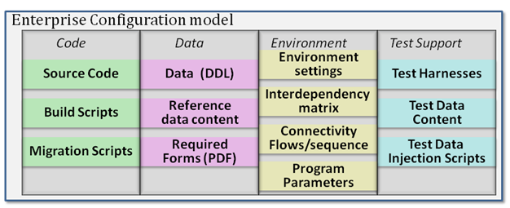

Figure 1.4.3.4-7: Enterprise Configuration Model.

Our approach is based on the following well-known principles, which are carried out as policies and procedures to establish baselines and used in the change management process. They consist of both hardware and software configuration items:

* CM Planning and Management: A formal document that contain plans to guide the Configuration Management program and includes items such as: People, responsibility, and resources; training requirements; administrative guidelines. It also contains procedure definitions and tools; baseline processes; configuration control and configuration status accounting; naming standards; audits and accountability, as well as subcontractor and vendor management requirements.
* Configuration Identification (CI): Setting and maintaining baselines, they contain the system architecture, components, and any developments at any point in time. It is the baseline by which changes to any part of configuration item are identified, documented, and tracked through the full SDLC till sunset of the configuration item. It is used as the definitive current basis for the configuration status accounting (CSA).
* Configuration Control: The evaluation of all change requests, change proposals, and their approval/disapproval. It controls changes to the system's design, hardware, firmware, software, and documentation.
* Configuration Status Accounting: The process of persisting and reporting configuration item description, e.g., hardware, software, etc., and all changes from the baseline during design and production. When problems are detected, the verification of baseline configuration and approved changes can be quickly validated.
* Configuration Verification and Audit: it is an independent review of hardware and software to assess compliance with the preset performance requirements, standards, and product baselines. Configuration audit validates the system configuration documentation to ensure its compliance with the functional and physical performance characteristics.

Testing Approach

UST Global will leverage its proprietary testing methodology TRUST® best practices in this engagement, as appropriate, to maximize the effectiveness and efficiency of the team. The following methodology will be followed at all levels of testing. Please refer section 1.4.3.4 for the details.

Levels of Testing

* Requirements/Static Testing.
* Unit Testing
* System Testing
* System Integration Testing
* System Qualification Testing
  + Functional
  + Non Functional
* User Acceptance Testing
* Pilot Testing

At UST Global we believe that Testing is the critical element of the software development life cycle. Following a well-defined comprehensive testing methodology for all development and enhancement activities undertaken is crucial to the success of all our projects. For this engagement UST Global leverages its proprietary testing methodology, TRUST®, that enable us to deliver software solutions of the highest quality, on time, every time and within budgets.

Based in CMMI principles, TRUST® methodology is tailored to each client’s unique circumstance we work with our clients first using their preferences and not imposing our methods unless requested. Our method is based on 3 cornerstones:

* Requirements Process Management
* Testing Process Management
* Configuration Process Management

For a full-fledged TRUST® implementation, there are 5 phases as illustrated in Figure 1.4.3.4-8.

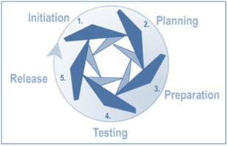

Figure 1.4.3.4-8: Five Phases of TRUST Methodology.

The following diagram describes the five phases in the TRUST® methodology (Figure 1.4.3.4-9).

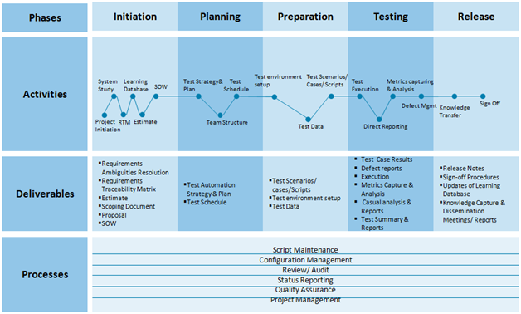

Figure 1.4.3.4-9: Activities, Deliverables, and Processes for the Five Phases of Trust Methodology

We work to ensure the success of this engagement by collecting critical information and making associated planning recommendations. Following are some of the key activities performed to ensure that the City’s testing needs are met.

* Collecting the materials for product familiarization and functionality walk-through (demo, mock-ups, user training)
* Requirements collection and review (for completeness, consistency, correctness, ambiguity, testability, etc.)
* Establish Quality Requirements and Goals in the context of project constraints and business needs
* Define the scope and approach for each type of testing to be performed, along with associated effort requirements
* Determine the need and extent for automated testing vs. manual testing
* Identify and evaluate the skills and resources needed
* Outline the needs of the test environment(s)
* Determine what type of tools and testing utilities will be needed
* Assist in staffing/recruiting/hiring and training of test resources

Requirements /Static Testing Approach

‘Requirements Testing’ is UST Global’s unique solution that addresses the dual problems of incomplete requirements analysis and inadequate test coverage. It provides feedback to business analysts and development teams that help them ascertain when requirements analysis is complete. It is a bidirectional testing discipline − Construction of the model helps analysts expose gaps, inconsistencies, and ambiguous requirements before software design is complete and coding begins. Next, the model is used to generate tests with mathematical rigor unmatched by any other discipline. Every business path is identified and sensitized to identify the fewest number of tests that maximize functional coverage of requirements. A Requirements Traceability Matrix will be provided and will track requirements from the Contract through the On-going Support Phase as required and specified in RFP Section 3.2 Scope of Work.

*Figure 1.4.3.4-10* displays the maturity level of static testing and baseline of requirements.

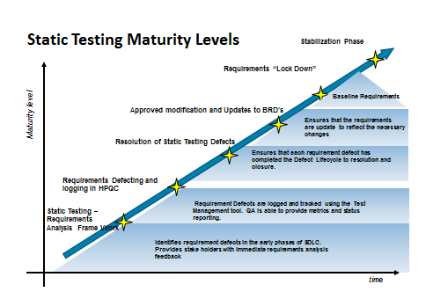

Figure 1.4.3.4-10: Maturity Level of Static Testing.

The requirements’ defects are managed the same way as application defects but in this case they are logged to the business analysts instead of the development team.

Functional Testing Approach

The objective of functional testing in this engagement is to ensure that all the requirements are satisfied and the application is ready to be deployed. Functional testing can be defined as developing and executing tests that rely primarily on direct human interaction throughout the entire test case, especially in terms of evaluating correctness and ascertaining test status (pass, fail, warn, etc.)

At UST Global, we adopt unique strategies for carrying out functional testing services. Our test plan for functional testing specifies strategies to be followed like Graphical User Interface (GUI) Testing, sanity testing, link testing, boundary value analysis, integration testing, security testing, recovery testing, and acceptance testing.

Test cases are developed according to user’s specified and implied needs. While planning the test environment, it is ensured to simulate the production environment as closely as possible. For services like integration testing all the interfaces identified are defined during the design phase. For system testing, we ensure that the test plan covers all aspects of the system to be tested, as per the acceptance criteria agreed in the Requirement Specification (RS) with the client. It is specific that the test completion criteria are appropriately defined. The following are included under functional testing:

* Functional Testing
* Graphical User Interface (GUI) Testing
* Security Testing
* Integration Testing
* Disaster and Recovery Testing
* User Acceptance Testing

System Qualification Test Approach

System qualification tests will be performed to determine if the system is fit for customer use. This approach covers various tests in an environment that will simulate production environment and is designed to capture the quality of the project when. It can be broadly classified into:

* Non-functional Tests
* Functional Tests

Non-functional Tests test the nonfunctional requirements of the project and involve performance testing to determine the system’s performance on a load higher (125%) than the stipulated load. The following approach will be taken for performance testing:

Performance Testing Approach

UST Global has tremendous experience providing end-to-end Performance testing services to our elite clientele of Fortune 1000 organizations. Our expertise covers all facets of performance related testing, including Load, Stress, Failover, Scalability, and High Availability Tests. We leverage our robust performance test processes, built around repeatability, consistent high quality delivery, complete coverage, and strong feedback mechanisms to provide the highest satisfaction to our clients while delivering best of breed solutions.

*Figure 1.4.3.4-11* depicts our Performance testing approach at a high-level.

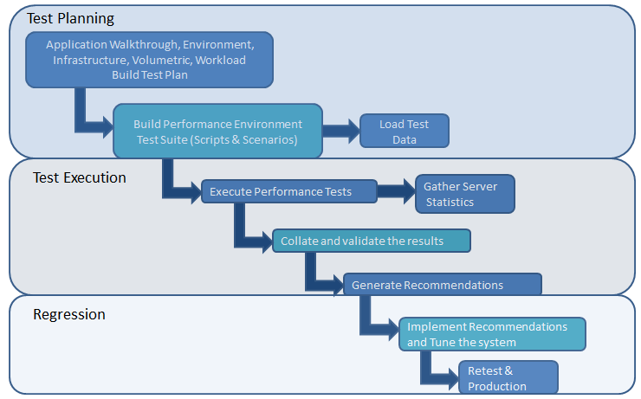

Figure 1.4.3.4-11: High level Performance Testing Approach.

In multi-tier system architecture it is imperative to have systems’ responsiveness to end user interactions thoroughly analyzed and appropriately tuned, to ensure acceptable levels of user satisfaction. We measure/analyze parameters such as transaction response time, throughput, and resource utilization for number of user sessions, CPU, and memory utilization of database and application server and accordingly provide analysis report and recommendations. We also monitor production system resource utilization and cross check them against the system limitations.

Our Load test services are accompanied with monitoring routines for active and inactive connections, analyzing any Database (DB) connection leaks. In addition to general Load Testing and Performance Benchmarking, we also carry out other value-added performance engineering services such as Reliability Testing and Availability Testing.

We recommend setting up a testing environment more closely to the production environment as it yields the best results. It is important that the performance test environment include all of the relevant components to test all aspects of the system, including integration and third-party components. We will leverage our best practices to ensure the performance test environment requirements are identified and documented before the Performance testing.

Reliability Testing Approach

UST Global will also perform Reliability Testing where the application is continuously monitored over a longer duration under specific numbers of concurrent user load. The test is designed to check the reliability of the application and hardware under specified user loads for longer period of time.

Reliability testing will be one of the performance testing goals and will be included in the performance test approach.

End to End Testing Approach

The following section outlines stages involved in our end to end testing approach as shown in *Figure 1.4.2.4-12*.

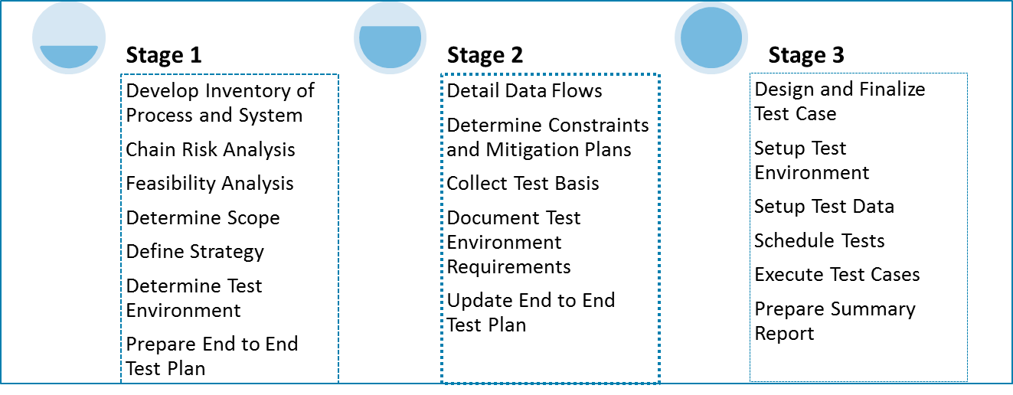

Figure 1.4.3.4-12: End-to-end Testing Approach.

User Acceptance Test

The image below depicts out our User Acceptance Testing (UAT) strategy. We follow a four phase approach − Planning, Test Design, Test Execution and Test Closure as illustrated in Figure 1.4.3.4-13.

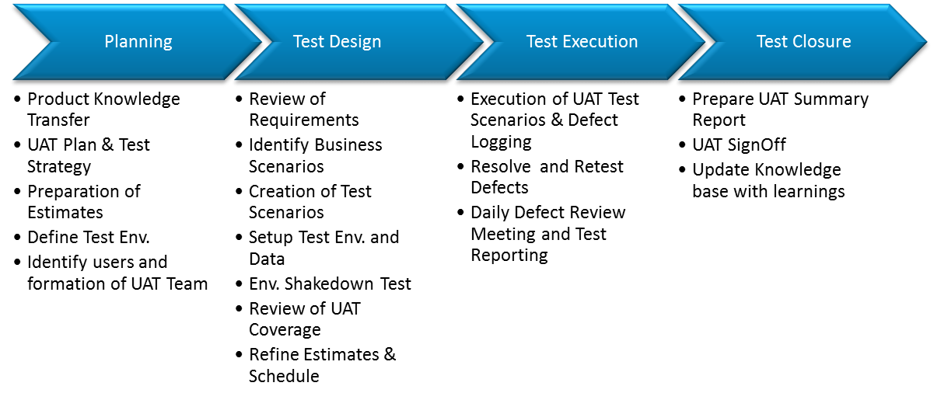

Figure 1.4.3.4-13: User Acceptance Testing Phases.

Pilot Testing

*Figure 1.4.3.4-14* depicts our Pilot testing approach. Like our other frameworks, we follow a four phased approach for pilot testing. Our Pilot testing approach can be rendered across the pilot sites identified. The Pilot testing will be carried out simultaneously or in parallel across the sites which is more efficient. The Pilot testing will be performed in each of the Waves prior to deployment of each phase of the project.

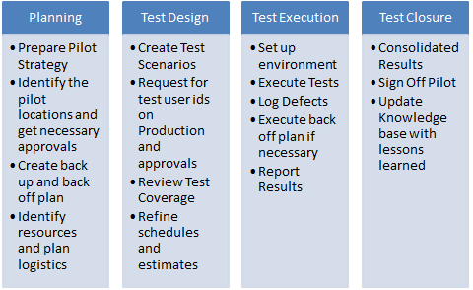

Figure 1.4.3.4-14: Pilot Testing Phases.

#### Quality Management (RFP 3.1.4.3.5)

UST Global exercises high diligence in the delivery of high quality services while maintaining control of its operational costs. This, in turn, allows us to provide cost-effective services to clients while maintaining a high quality of service. Our approach to quality is shown in *Figure 1.4.3.5-1*.

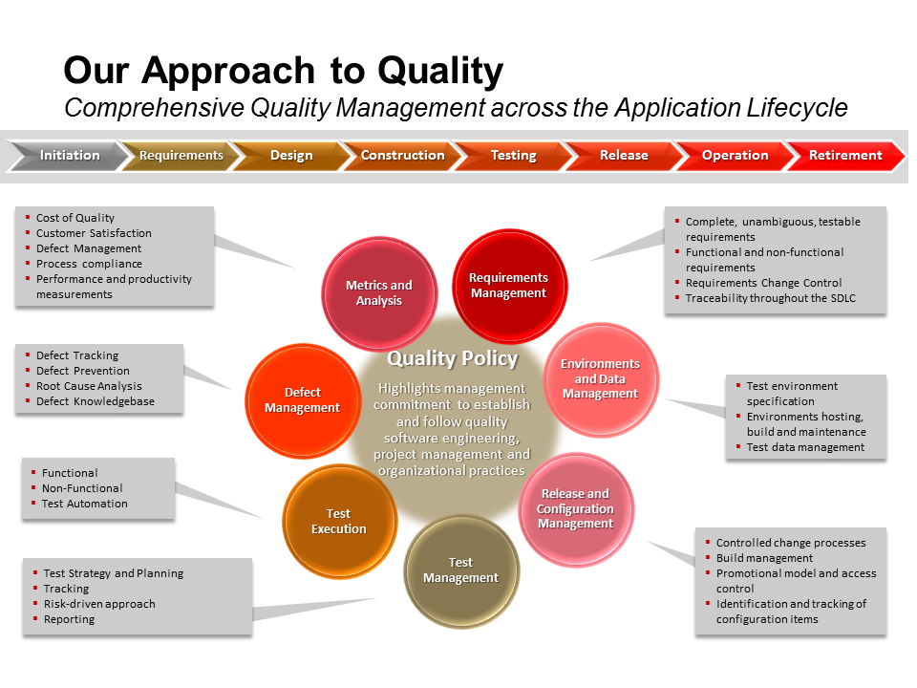

Figure 1.4.3.5-1: The UST Global’s Comprehensive Approach to Quality Management.

A few of the measures adopted by UST Global for this purpose are listed below.

* Institutionalization of mature software engineering processes based on the SEI-CMMI leads to predictable and repeatable performance in projects
* A formal defect prevention process that minimizes the possibility of common defects from being injected into the software
* Dedicated Corporate Quality Office group that oversees delivery across all Business Units and has the specific charter of monitoring and streamlining operations for efficiency while maintaining effectiveness
* Automated tools and processes for time tracking and Project Management facilitate metrics-based management and cost control

All projects in UST Global are governed, audited and assured for quality and process compliance through our SQA and PMO groups, which are a part of the Corporate Quality Office. This team ensures consistent, predictable, high quality delivery execution resulting in increased business value to our clients.

We employ our standard multi-level review mechanisms as outlined in *Figure 1.4.3.5-2* for quality assurance.

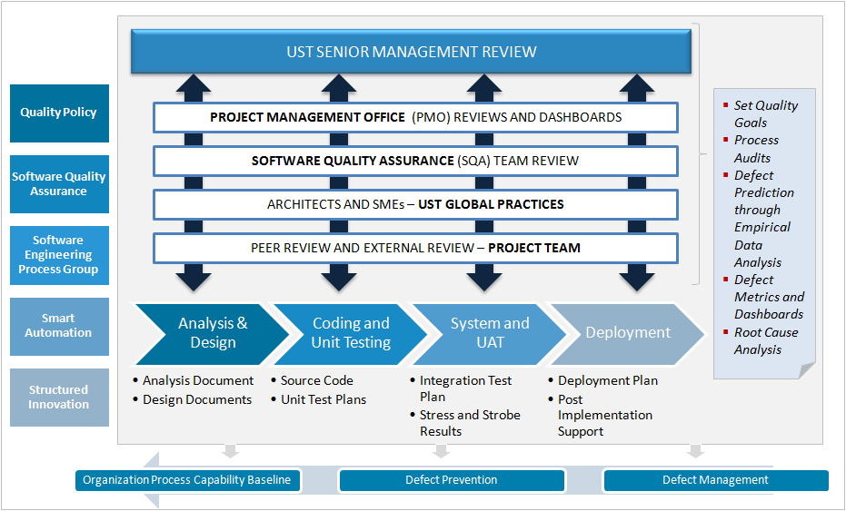

Figure 1.4.3.5-2: Our Quality Assurance Multiple Level Review Mechanism Ensures Consistent, Predictable, High Quality Delivery Execution.

The Center of Excellence (COE) is a key tenet to our approach and is the enabler to maintaining strong centralized control, managing issues, risks and facilitating distributed project execution. The COE also act as the quality control body to confirm that documents, code, designs, and other requirements meet the City of LA’s expectations and standards.

Processes are defined for quality check and various levels of reviews and audits are conducted to ensure that the processes are followed judiciously. Each project will have a Formal Project Review, Internal Quality Audit, Support Process Review and Software Quality Assurance Review, as per the Delivery Review and Audit Process.

Configuration Management Audit and Defect Prevention Audit of projects are planned as per the Configuration Management Process of the organization. We use the same process with defect prevention and causal analysis activities.

Quality Control Plan

UST Global proposes the following audits for implementation of the BuildLA project to ensure quality and process compliance and to ensure that all work products as required adhere to the Master Services Agreement.

* Quarterly CM Audit by the CM Audit Panel
* Baseline audit by the Configuration Controller (CC) after final release
* Biweekly PM Review
* Quarterly Audit by the PMO
* Periodic reviews by Delivery Excellence team and ISMS team
* Quarterly Formal Project Review by the Account Manager

All audits and reviews planned in the project will be tracked in the program schedule.

**Quality Metrics**

The following are the technical quality metrics proposed for this engagement (*Figure 1.4.3.5-3*).

| Metric | Unit | Remarks |
| --- | --- | --- |
| Effort Variation | % |  |
| Schedule Variation | % |  |
| Productivity – Test Design | Test cases per hour |  |
| Productivity Test Execution | Test cases per hour |  |
| Test Coverage | % | Test coverage will be calculated on % of requirements |
| Defect Detection Effectiveness | % |  |
| Defect Acceptance ratio | % |  |
| Defect Distribution | % | Calculated Phase wise |
| Review Effectiveness  Requirements | Number | Review Effectiveness = # of Requirement defects found during Requirements Review / Total Number of Requirements Defects Detected |
| Review Effectiveness  Design | Number | Review Effectiveness = # of Design defects found during Design Review / Total Number of Design Defects Detected |
| Review Effectiveness  Coding | Number | Review Effectiveness = # of defects found during the Code Review / Total Number of Coding Defects Detected |
| Productivity  Test Case Development | No Per Hour |  |
| Productivity  Test Execution | No Per Hour |  |
| Average Resolution Time | Average Resolution Time | Average Resolution Time = (Sum of Resolution Times for all defects) / (Number of defects) |
| Post Release Defect Density | Number | Number of Defects Report by customer / Size Delivered |

Figure 1.4.3.5-3: Quality Metrics for BuildLA.

These results will be compared with the current status for each metric.

**Performance Metrics**

Team UST will develop a baseline for comparison, and proposes using the following metrics to measure the effectiveness and performance of the BuildLA solution:

* 45% of Permits will be issued online after 12 months
* 18% of fee Payments taken online
* 40% of Inspections scheduled online
* Average of 4 minutes to Process Permit Application
* 40% Reduction in Plan Review Time

#### Production Support and Transition (RFP 3.1.4.3.6)

UST Global follows a two phased approach to provide support during the Production environment for this engagement.

* **Knowledge Transfer & Transition**: In this phase UST Global’s support team will study and analyze the City of LA’s business and technical environment and gain application and infrastructure specific experience
* **Steady State**: UST Global’s support team will provide production support and enhancement services related to the applications and infrastructure

The following section describes the activities performed in these phases.

Knowledge Transfer & Transition

In order to rapidly and effectively transfer the application support activities to BuildLA support team, we will follow our standard application transition approach, AMUST During Knowledge Transfer our support team will work closely with UST Global’s development team to understand the business and technical aspects of BuildLA application. The support team will leverage the knowledge repository created by the development for the training related artifacts and documents. We will also leverage our development team to provide “on the job training” to the production support team and thereby reducing the transition and KT timelines. UST Global will perform an application ‘baseline’ during the Knowledge Transfer and Transition phase. At the completion of the scheduled transition period, UST Global and the City of LA will jointly agree that the Steady State Acceptance Criteria. We will perform a customized version of our approach for the City of LA including the following phases:

**Preparation**

During this phase we will setup infrastructure and communications for the entire production support team. Additionally, we will also provide a plan for IT governance to manage our activities and our relationship with the City of LA team.

**Knowledge Transfer**

In this phase we will analyze study and document the BuildLA portal application environment. The focus of our efforts will be to expand our understanding beyond what was captured during our initial development phase.

* **The System Appreciation Document (SAD)** will be created by UST Global’s Production Support Team providing all the details of the current services. This may include current support model service support and delivery, legal constraints/contracts, and knowledge transfer recommendations of those services developed by UST Global. The SAD document will be the basis for all project-tracking and reporting during the lifecycle of the project as specified in Attachment 5 Section 3.2.3 of the RFP as shown in *Figure 1.4.3.6-1*.

| Recurring Deliverables | Project Status Reporting |
| --- | --- |
| * Recurring | * Project Status Reporting |
| * Task 1 | * Project Initiation and Planning |
| * Task 2 | * Portal Assessment and Design |
| * Task 3 | * Requirements Development |
| * Task 4 | * System Design |
| * Task 5 | * System Development |
| * Task 6 | * Testing |
| * Task 7 | * Deployment |
| * Task 8 | * Maintenance and Operations |
| * Task 9 | * Project Completion |
| * Task 10 | * Optional Extension Maintenance and Operations Period (if desired) |

Figure 1.4.3.6-1: Recurring Deliverables and Project Status Reporting.

* This SAD document should be reviewed by the BuildLA support team and signed off by the Service Owners and UST production support team.

**Transition**

UST Global will perform “Shadow” and “Reverse Shadow” to ensure smooth knowledge sharing during this phase and this will be monitored by our Transition/Deployment Lead.

* Train the resources on the topics covered in the SAD regarding the applications functionality and architecture.
* Efficient Application Support & Trouble Shooting
  + Historical tickets review
  + Tickets resolution approach and trouble shooting
  + Providing application/server accesses.
  + Provide Handholding in resolving sample tickets
  + Briefing of known issues existing and probable issues that the application support resource may face
  + Review stage where the trainees will be resolving the tickets and the Primary SME from BuildLA will be observing and evaluating the methodology and approach followed by the trainee
  + Customer information and contacts
  + Vendor contacts & Licensing
  + Support Model & Approach
  + Service Level Agreements
  + Best practices followed
* Ensure update of the SAD with all the additional information gathered during the knowledge transition period.

Steady State

UST Global will finalize the Steady State Acceptance Criteria at the end of transition phase. In order to manage the Steady State environment, we will gather and baseline the following metrics:

* Issues logged per week
* Resolution time per issue
* Interface / batch runtimes and error rates
* Total support time required for each application in production
* And resource distribution per application for support activities

During Steady State, UST Global will provide application support and enhancements for the BuildLA application. We will be performing the following activities as illustrated in *Figure 1.4.3.6-2*.

| Activities | Deliverables |
| --- | --- |
| * Ongoing support and enhancement * Resolve support tickets and the services * Monitoring and maintenance support for BuildLA systems on a daily basis based on the knowledge transfer phase * Acknowledge the tickets and respond as per the SLA defined * Providing solutions and fixing the issues * Track all the changes at the time of support; by documenting * Meeting the defined SLA also tracking service requests for service levels, escalations, and metrics * Documenting resolutions provided to the issues to create a knowledge base * Providing the incident report (root casual analysis report) for the most critical issues within two days * Escalating issues for any help required from client to find a solution * Creating/maintaining the production support work log * Perform user training if required * Perform preventative and perfective maintenance * Develop documentation * Conduct regular status meetings | * SLA-driven support model * Resolved support tickets * Updated and documented application changes * Ticket tracker * Resolution tracker * Metrics report * Root Cause Analysis * Change Impact Analysis * Migration Status notification * Documentation – System, User, Operations * Reports * Relevant schedule and plans * Test Documentation * Process Management Deliverables * Change reports * Successfully deployed fixes * User training sessions and documentation * Change reports and release notes |

Figure 1.4.3.6-2: Steady State Activities and Deliverables.

UST Global will revisit the staffing levels in consultation with the City of LA team, if required.

#### Appendix E.4 – Exceptions or Additions to Scope of Work (RFP Appendix E.4)

UST Global has no issues, exceptions, or additions to the Scope of Work.

### Hosting, Operational Maintenance and Support Approach (RFP 3.1.4.4)

#### Hosting Approach (RFP 3.1.4.4.1)

UST Global has contracted with SoftLayer, an IBM Company, for the provision of professional managed infrastructure hosting services. Founded in Dallas in 2005, SoftLayer is the infrastructure provider of choice for companies building for Internet Scale. SoftLayer is one of the world’s largest infrastructure-as-a-service companies, built on a secure, private network comprised of over 120,000 physical nodes spanning 13 data centers in the United States and abroad, linked together with 2,000 Gbps of connectivity between data centers.

**Key Advantages**

* Redundant, Best-in-Class Infrastructure: All SoftLayer data centers maintain multiple power feeds, fiber links, dedicated generators, and battery backup. They are built from industry-leading hardware and equipment, ensuring the highest level of performance, reliability, and interoperability.
* Geographic Diversity: SoftLayer provides fully-featured data centers with wide geographic diversity, ideal for maintaining system and data redundancy, as well as for placing systems in the optimal physical location for traffic volume and speeds.
* On-Demand, Virtual Data Center: Through IPMI 2.0 server technologies, secure and remote out-of-band management, and proprietary automated solutions, SoftLayer provides a highly scalable, on-demand, virtual data center experience.

Team UST’s BuildLA solution will be hosted within SoftLayer's United States –based data centers. **Our hosting vendor’s data centers comply with the System Capacity & Performance Hosting requirements as well as Redundancy & Business Continuity requirements in Appendix C.2.**

SoftLayer provides its clients with a wide array of options, with the ability to provision bare metal / dedicated servers which give options ranging from entry-level single processor servers to quad proc, hex-core, and even GPU-powered workhorses. They're all deployed in real time via SoftLayer’s portal or API.

With SoftLayer automated platform, servers are deployed in about two hours so they can be put to work quickly. SoftLayer’s on-demand deployment also includes additional services (firewalls, load balancers, etc.) either as part of the initial order or whenever it is needed to add them.

As operations grow and change, so do infrastructure needs. All of SoftLayer’s services are provided on month-to-month contracts, so you only pay for what you need, as long as you need, and can scale or upgrade your environment without having to renegotiate or terminate a long-term commitment.

**Flex Images™ Server Deployment System** - With Flex Images, SoftLayer’s next-generation image capture and deployment technology, you can capture images from cloud or dedicated servers, store them in a single image library, and then deploy them on either kind of system. So you can manage dedicated servers with capabilities that have historically only been available with virtual infrastructure—like the ability to quickly clone and reload servers—or easily migrate between server types.

**High-speed and Advanced Global Network** – Its global network (13 data centers and 16 network points of presence) features more than 2,000G of connectivity. It is built from best-in-class networking infrastructure, hardware, and software. It also has exceptional bandwidth and connectivity for the highest speed and reliability.

**Full Remote Management and Control** –SoftLayer’s unique network architecture provides total access to manage environment without exposure to external threats. So you can use SoftLayer's industry-leading Customer Portal, open API, and SoftLayer Mobile apps to fully manage your dedicated server from home, work, or on-the-go. You have command of more than 200 automated backend services and activities, including core functions like server reboots, OS reload, load balancing, and more.

**Comprehensive Server Security** - Our comprehensive security strategy maximizes your server's uptime, protects your private information, and reduces business risk. We ensure your data's safety with certified operational procedures, a wide range of software and hardware security solutions, and strategic partnerships with key security companies.

**24/7 Support** - If you have a hosting, server, or account issue, we have a dedicated support team and trained, certified engineers on site 24/7 resolve it quickly. You also have complete access to comprehensive online resources (KnowledgeLayer Information Center, FAQs, and Forums) for help troubleshooting.

Today, SoftLayer has a very rich portfolio of Bolt On capabilities. Over time, you can expect IBM to add even more services.

**Storage:** Complete your solution with the right storage for your application. Choose from multiple technologies, including Object Storage, iSCSI, and FTP/NAS for your ideal level of scalability, availability and redundancy.

**Network:** Customize your network configuration and services for your unique traffic, security and performance profile with port speed and bandwidth upgrades, load balancing, and beyond.

**Software:** Deploy industry-leading OSs, control panels, hypervisors and more. All software provisioned using its developer’s best practice guidelines to ensure maximum stability and uptime.

**Monitoring**: Take control of your availability and performance with one-stop monitoring and reporting (including current and historical data) of every facet of your environment, including network connectivity and system statuses.

**Security**: Select from a range of security options to establish multiple, overlapping tiers of security to shield your systems against physical and electronic threats. Multi-level security enables your environment’s total protection.

**Additional:** Special services bring additional value to your SoftLayer environment, including a leading Email Delivery Service, Message Queue Service, Digital Transcoding, and the opportunity to customize your solution by hosting a Customer-Owned-Device in our data centers. More details have been provided here: <http://www.SoftLayer.com/services/>

SoftLayer Portal provides detailed views into assets/services ordered by clients as well as direct email communications to account focal points upon order/cancel of services. The client can obtain real time status of the assets supporting its business via the portal. SoftLayer does not disclose the details of its underlying system componentry supporting the client systems. The management system, data center and underlying hardware are managed to a security policy and subject to a yearly SOC 2 audit performed by an external body. SoftLayer performs asset management including inventory scanning and online management via its management system which contains configuration mgmt. for the underling system.

SoftLayer provides the capability to provision virtualized, bare metal and private cloud compute instances containing popular open source and commercial enterprise software. Details regarding SoftLayer provided software images are available at http://www.SoftLayer.com/services/software/ SoftLayer generally performs refresh, additions to the catalog with each significant refresh (major, minor release). Details vary by vendor. SoftLayer also provides the capability to import your own images.

SoftLayer’s certified engineering and support team provides a tailor-made support proactive management plan including backup with disaster recovery options, database administration, monitoring and security services.

SoftLayer provides agents to connect to SoftLayer managed IT Monitoring system as well as to support backup and antivirus services. In addition, SoftLayer offers multiple levels of outboard monitoring and service health checks that include alert generation/email alerts. Monitoring agents include Nimsoft. Backup agents include EVault and Idera. Antivirus agents include McAfee.

SoftLayer provides monthly OS patching for SoftLayer Managed OS. Patching policy is customer specific and by prior agreement, part of Managed Services conversation. Technology is OS vendor provided tooling. Notification and agreement with customer are customer specific and by prior agreement, part of the Managed Services conversation with customer. You can find details here: <http://www.SoftLayer.com/managed/security>

SoftLayer Managed OS service model is available. An overview is available here: <http://www.SoftLayer.com/managed/>

SoftLayer partners with McAfee to offer Anti-Virus and Anti-Spyware services:

* McAfee VirusScan for Windows (anti-virus, anti-spyware, firewall, and intrusion prevention).
* McAfee Total Protection for Secure Business for Windows and Linux (Advanced antivirus, anti-malware, host intrusion prevention, device control, host-based firewall, encryption, and more, plus McAfee ePolicy Orchestrator - McAfee ePO - single-console management to automates workflow, policy deployment, updates, maintenance, and reporting across all of the technologies that protect your endpoints).

You can find more details here: <http://www.SoftLayer.com/services/security/mcafeeAntiVirus>.

For vendor managed OS, SoftLayer is managing the McAfee software.

**Availability Management Approach**

The approach taken toward IT Availability Management within the proposed BuildLA solution is per Industry best practices as depicted below, further enabled by monitoring tools and capabilities provided through hosting via SoftLayer. The following (Figures 1.4.4.1-1 and 1.4.4.1-2) are the calculations used for specifying availability within the overall solution:

**Availability Calculations**

|  |  |  |
| --- | --- | --- |
| Availability % | = | Actual Availability/Agreed Availability * 100% |
| Actual Availability | = | Size of measurement interval – Downtime |
| Downtime | = | Time to repair |
|  | or | Service restoration time – detection time |

Figure 1.4.4.1.-1: Availability Calculations.

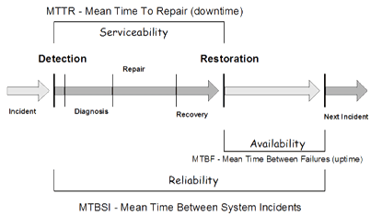

Figure 1.4.4.1-2: Availability Calculations.

Service monitoring information within the BuildLA solution is collected, aggregated, and correlated from a variety of low-level sources including:

* Load Balancer Analytics and alerts
* Database performance metrics
* Real-time web analytics and alerts
* Operating platform analytics
* Hardware SNMP messages
* System and component log messages (aggregated)
* System and infrastructure logs, analytics, and alerts
* Direct problem reporting
* Message Queue depth
* Network throughput/latency monitoring
* OS-level performance counters
* Synthetic transactions

Maximizing uptime and availability requires a monitoring strategy that’s responsive and proactive. SoftLayer Managed Hosting provides monitoring that goes beyond simply responding to alerts or errors—delivering reports and analyses that help customers avoid issues in the first place.

Monitoring with SoftLayer’s re-imagined Managed Hosting gives customers access to the full and robust set of reports available on SoftLayer’s automation platform as well as an assigned team of engineers. Customers’ assigned team is the first line of defense for alerts, leveraging best practices and years of industry expertise to design a detailed monitoring plan and escalation process. SoftLayer analyzes the reports and trending data in order to give the customer the best recommendations for mitigating potential issues and help maintain total visibility and control of the environment.

Real-time event & alert information is aggregated and presented to operations and service management personnel via CA Nimsoft, an enterprise monitoring platform which can show Service Level Objectives and Agreements as well as detailed health and performance dashboards at the system, service, or component level, tailored to a variety of audiences ranging from technicians to executives.

CA Nimsoft provides customized, integrated application management, service management, package management, application server management, and customizable monitoring/reporting dashboards (*Figure 1.4.4.1-*3).

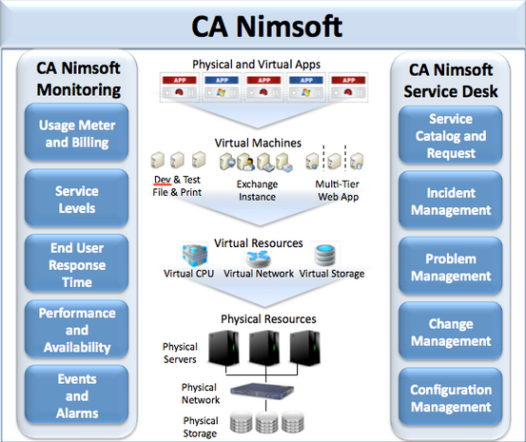

Figure 1.4.4.1-3: Real-time Event and Alert Information through CA Nimsoft.

**Proposed Incident/Problem Severity Levels and Response Time**

The following are proposed ranges of severity levels and commensurate response times related to performance issues, incidents, and loss of service (*Figure 1.4.4.1-*4).

|  |  |
| --- | --- |
| Problem Severity | Initial Response Time |
| [Level 1](http://med.stanford.edu/irt/servers/sla/response.html#level1)  (during normal business hours) | Respond within 30 minutes of notification 95% of the time. |
| [Level 1](http://med.stanford.edu/irt/servers/sla/response.html#level1)  (off hours) | Respond within 1 hour of notification 90% of the time |
| [Level 2](http://med.stanford.edu/irt/servers/sla/response.html#level2)  (during normal business hours) | Respond within 4 hours of notification 90 % of the time |
| [Level 3](http://med.stanford.edu/irt/servers/sla/response.html#level3)  (during normal business hours) | Respond within 1 working day of notification 90% of the time |
| [Level 4](http://med.stanford.edu/irt/servers/sla/response.html#level4)  (during normal business hours) | Respond to client within 3 working days of notification 90% of the time |

Figure 1.4.4.1-4: Proposed Incident/Problem Severity Levels and Response Time.

*Note: UST Global understands that the City of Los Angeles’ normal business hours are Monday – Friday from 6:00am to 8:00pm.

**Severity Level 1:**  
**Major Impact** – defined as a problem that causes complete loss of service to the production environment and work cannot reasonably continue.  Workarounds to provide the same functionality are not possible and cannot be found in time to minimize the impact to the City.  The problem has one or more of the following characteristics:

* A large number of users cannot access the system.
* Critical functionality is not available.  The application cannot continue because a vital feature is inoperable, data cannot be secured, backed up, etc.

**Severity Level 2:**  
**Significant Impact**– this classification applies when processing can proceed but performance is significantly reduced and/or operation of the system is considered severely limited.  No workaround is available, however operation can continue in a restricted fashion.  The problem has one or more of the following characteristics:

* Internal software error, causing the system to fail, but restart or recovery is possible.
* Severely degraded performance.
* Some important functionality is unavailable, yet the system can continue to operate in a restricted fashion.

**Severity Level 3:**  
**Minor Impact** – a problem that causes minimal loss of service. The impact of the problem is minor or an inconvenience, such as a manual bypass to restore product functionality.  The problem has one or more of the following characteristics:

* A software error for which there is an acceptable workaround.
* Minimal performance degradation.
* Software error requiring manual editing of configuration or script files around a problem.

**Severity Level 4:**  
**No Business Impact** – a problem that causes no loss of service and in no way impedes use of the system. The impact of the problem has one or more of the following characteristics:

* A software enhancement for which there is an acceptable workaround.
* Documentation error.

SoftLayer Security Services

Simply building a fence between infrastructure, environment and malicious activity isn’t a guarantee of safety. True security leverages proven methodologies for safeguarding an environment (and the physical facilities that host it) from the ground up and constantly updating those measures as the threat landscape changes.

SoftLayer has a multi-level approach for shielding customers against physical and electronic threats, with comprehensive practices and a range of options for Physical and Operational, Network, System, Application and Data Security. SoftLayer Managed Hosting assesses customer needs and collaborates with the customer to create the optimal security strategy for locking down your environment while providing flexibility for peak performance.

SoftLayer’s security procedures utilize industry best practices from sources including The Center for Internet Security (CIS), Microsoft, and Red Hat and more.

All SoftLayer data center facilities are SOC 2 certified.

**Features**

* SOC 2 Compliant
* 24/7 physical security of data centers and Network Operations Center monitoring
* Integrated server hardening
* Regular full-system virus scanning and systems patching
* Regular security profile review and recommendations

SecurityLayer Services

IT infrastructure requires multiple, overlapping tiers of security for its total protection. This is the driving principle of SoftLayer’s multi-level security strategy for shielding against physical and electronic threats—SecurityLayer® Services.

Through certified operational procedures and practices, a comprehensive range of software and hardware security solutions, and strategic partnerships with industry-leading companies, SoftLayer helps maximize uptime, protect private information and mitigate business risk.

Citrix Netscaler

Citrix NetScaler VPX is a Web application delivery appliance that makes applications five times better by accelerating performance, ensuring that applications are always available and protected and substantially lowering costs. Citrix NetScaler application delivery products are easily selected by determining the edition providing functional needs and the appropriate hardware platform to fulfill performance needs.

DS Protection and Assessment

Through partnerships with both hardware and software vendors, SoftLayer offers a complete array of intrusion protection and assessment options at both the network and host level.

Standard Hardware Firewalls

Add Standard Hardware Firewalls to give individual servers an additional layer of server security. Our firewalls are provisioned on demand without service interruptions and fully managed through the customer portal—you have complete control of your systems’ protection settings.

Dedicated Hardware Firewalls

With SoftLayer Dedicated Hardware Firewalls you can protect one, multiple or even all servers that share the same VLAN for the highest assurance of uptime. A High Availability option is also available, providing continuous protection in the event your primary firewall experiences hardware failure (available as new order only; cannot be upgraded or downgraded). SoftLayer firewalls are provisioned on demand without service interruptions and fully managed through the customer portal—customers have complete control of their systems' protection settings.

Fortigate® Security Appliance

FortiGate 300 series security appliances provide high performance and enterprise-class firewall protection. Customers also get direct access to FortiGate's native management tools, extending complete, granular control over advanced firewall and security features.

Anti-Virus and Anti-Spyware Protection

McAfee® security products add an additional layer of security. Anti-Virus protection can be added at no additional charge, or McAfee Total Protection is available for protection against Viruses and Spyware.

SSL Certificates

The Symantec and GeoTrust brands are backed by a dedication to excellence in customer support. Every SSL Certificate from a Symantec-owned company is signed with a reliable and ubiquitous root so customers don't have to worry that they will end up with Web site visitors not protected by their SSL Certificate because there is a problem with the underlying SSL root.

Two-factor Authentication

Add even more protection to a SoftLayer Customer Portal login with external, two-factor authentication. The extra layer of security shields the account from unverified access to ensure that servers, data, and account are always safe. Symantec Validation and ID Protection provide a dynamic security code that can be used in addition to a user name and password for safe and secure account access. PhoneFactor provides out-of-band authentication via phone call, SMS message, and mobile apps.

PCI Compliance with McAfee

Easily meet the requirements of Visa and MasterCard’s Payment Card Industry (PCI) Data Security Standard and complete compliance requirements rapidly and confidently with this accurate, easy-to-use online service. SoftLayer and McAfee have arranged for all SoftLayer customers to have a FREE PCI compliance account for as long as their server remains at SoftLayer.

Options to Monitor Uptime

Maximizing uptime and availability requires a monitoring strategy that’s responsive and proactive. SoftLayer Managed Hosting provides monitoring that goes beyond simply responding to alerts or errors—delivering reports and analyses that help customers avoid issues in the first place.

Physical and Data Security Practices

SoftLayer has a multi-level approach for shielding customers against physical and electronic threats, with comprehensive practices and a range of options for Physical and Operational, Network, System, Application and Data Security. SoftLayer Managed Hosting assesses customer needs and collaborates with the customer to create the optimal security strategy for locking down their environment while providing flexibility for peak performance. SoftLayer’s security procedures utilize industry best practices from sources including The Center for Internet Security (CIS), Microsoft, and Red Hat and more. All SoftLayer data center facilities are SOC 2 certified.

Storage and Backup Services

SoftLayer’s comprehensive selection of storage and backup services provides multiple technologies, allowing customers to select the ideal level of security, reliability, and flexibility for their environment and applications. Every type of data does not have to be backed up the same way. Some type of data may be backed-up multiple times a day, while for others, once a week might be enough. Our recommended schedule and strategy includes:

* Full Backups: Weekly, all file systems and databases
* Incremental Backups: Daily, all file systems and databases
* Offsite Storage: via snapshot transfer for iSCSI volumes, including volumes used for storing non-snapshotted NAS backups and database backups, retention near-online for 1-3 months, periodic restore/verify at least monthly

iSCSI Storage, Replication and Snapshots

iSCSI Storage allows mounting remote, enterprise-grade, SAN storage disks as though they were attached locally. It is scalable, easily provisioned, and outperforms internal disks, providing a low-cost alternative to traditional fiber-channel storage solutions. Replications of iSCSI volumes can be sent to another SoftLayer data center for painless disaster recovery. Point-in-time snapshots of iSCSI volumes can be scheduled, stored locally or remotely, and later accessed for data recovery or current data comparison.

FTP/NAS Storage

File Transfer Protocol (FTP) and Network Attached Storage (NAS) provide fast, reliable and cost-effective storage for maximum data retention and storage.

EVault Backup

* Simple Windows- or web-based graphical user interface to initiate all backups and restores, and to configure all backup and automation options.
* Administrators can set backups to follow an hourly, daily, weekly or custom schedule, and to target full systems, specific directories or even individual files.
* Individual software agents are available that enable EVault to target more specific data in Exchange, SQLServer, SharePoint, MSClusters and Oracle servers.

Idera Server Backup

Provides high-performance disk-to-disk server backup featuring a central management and data repository. Protects data at block level, and unique disk blocks on the server are stored only once across all recovery points, increasing storage efficiency.

* Reduces backup windows from hours to minutes
* Bare Metal Restore and Disaster Recovery
* Easy-to-use, Web-based interface
* Multi-platform support for physical and virtual servers
* Maximum data protection for MySQL databases

Redundancy Strategy

Team UST provides several options for redundancy:

* E-vault Backup – a web-based graphical user interface to initiate all backups and restores, and to configure all backup and automation options. Administrators can set backups to follow an hourly, daily, weekly or custom schedule, and to target full systems, specific directories or even individual files .Individual software agents are available that enable EVault to target more specific data in Exchange, SQLServer, SharePoint, MSClusters and Oracle servers.
* Idera Server Backup –provides high-performance disk-to-disk server backup featuring a central management and data repository. Idera Server Backup is a Bare Metal Restore and Disaster Recovery system, which supports multi-platform support for physical and virtual servers.

**Options to Monitor Uptime**

SoftLayer provides different levels of monitoring. This encompasses right from a simple host ping service, to a full featured monitoring service up to Databases and Application Servers.

* We can provide standard monitoring services based on proprietary monitoring software, IPMI 2.0, and SNMP data collection. More details here: http://www.SoftLayer.com/services/monitoring
* We can provide monitoring services based on Nimsoft tools. More details here: http://www.SoftLayer.com/services/monitoring/nimsoft

In the near future, IBM is expected to propose monitoring services based on IBM tools

**Physical and Data Security Practices**

SoftLayer security and controls points are described within the SSAE16-SOC2 report which is available to clients upon request.

SoftLayer Portal provides detailed views into assets/services ordered by clients as well as direct email communications to account focal points upon order/cancel of services. Clients can obtain real time status of the assets supporting its business via the portal. SoftLayer does not disclose the details of its underlying system componentry supporting the client systems. The management system, data center and underlying hardware are managed to a security policy and subject to a yearly SOC 2 audit performed by an external body. SoftLayer performs asset management including inventory scanning and online management via its management system which contains configuration mgmt. for the underling system.

SoftLayer maintains audit records and also includes multiple levels of physical security including badge access, closed circuit video surveillance, and 24x7 guard staff.

SoftLayer is SOC2 type 2 compliant for its 13 data centers across the US, as well as Singapore and The Netherlands. SoftLayer is also PCI DSS certified.

**Redundancy Strategy – Geographic Dispersal**

SoftLayer maintains geographically dispersed instances of its control portal which allows operations to continue in event of failure of the primary site. In addition to Data centers containing compute, local storage, etc. - SoftLayer facilities are connected via high speed network capability, backup/restore and global load balancing, which allow clients to quickly and cost effectively achieve disaster recovery and relocation of assets to a data center that is not affected. The SoftLayer DR and BC plans are outlined in our SOC2 report and are audited annually. DR plans are executed and audited annually. SoftLayer SLAs are online at http://www.SoftLayer.com/about/legal/standard-msa

**Incident Identification and Resolution**

SoftLayer is a highly automated platform. So, human touch points are expected to be as minimal as possible. Expected human touch points are:

* SoftLayer technical and sales support staff, through call, tickets, chat or email (SoftLayer support model diagram is here http://www.SoftLayer.com/support/)
* SoftLayer Technical Account Manager monthly review, escalations on incidents, and as needed for resourced under SoftLayer Managed Services

The Escalation process is to go through the Technical Account Manager. The incident management process, including incident communication and escalation procedures, is based on industry best practices and follows a customized ITIL-based process model. The incident management process, including incident communication and escalation procedures, is based on industry best practices and follows a customized ITIL-based process model (*Figure 1.4.4.1-5*):

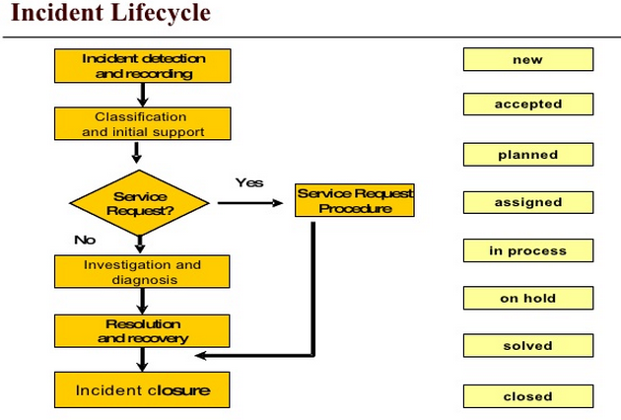

Figure 1.4.4.1-5: Incident Life Cycle

**SoftLayer Monitoring Services**

**Features**

* 24/7 support from certified support and engineering team
* Regularly-scheduled alerts reports
* Incident analysis and proactive management
* Regular reviews with your SoftLayer Technical Account Manager (TAM)

Maximizing uptime and availability requires a monitoring strategy that’s responsive and proactive. SoftLayer Managed Hosting provides monitoring that goes beyond simply responding to alerts or errors—delivering reports and analyses that help customers avoid issues in the first place.

Monitoring with SoftLayer’s re-imagined Managed Hosting gives customers access to the full and robust set of reports available on SoftLayer’s automation platform as well as an assigned team of engineers. Customers’ assigned team is the first line of defense for alerts, leveraging best practices and years of industry expertise to design a detailed monitoring plan and escalation process. SoftLayer analyzes the reports and trending data in order to give the customer the best recommendations for mitigating potential issues and help maintain total visibility and control of the environment (*Figure 1.4.1.1-6*).

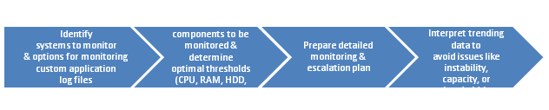

Figure 1.4.4.1-6: Soft layer Monitoring Services.

Disaster Recovery

Downtime isn't just inconvenient, it's expensive. Combine SoftLayer services to design comprehensive failover, disaster recovery and high availability strategies for keeping your mission critical applications running, maintaining data accessibility and ensuring business continuity. Global load balancing, geographically diverse DNS routing and hot swap backups can mitigate the risk of downtime in the event of even the most catastrophic system failures. Replication, snapshots and network storage help eliminate single points of failure and provide a restoration path for mission-critical data.

Replication, snapshots, and network storage help eliminate single points of failure and provide a restoration path for mission-critical data (*Figures 1.4.4.1-7 and 1.4.4.1-8*).

**Basic 2-site Disaster Recovery**

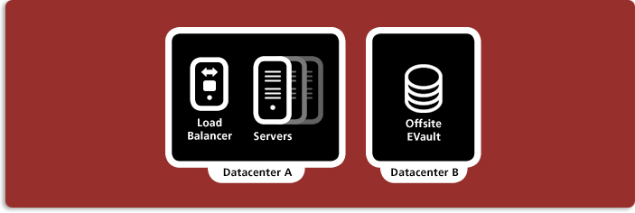

Figure 1.4.4.1-7: Disaster Recovery.

**Advanced 2-site Active/Active Highly Available processing + 3rd site for offline Disaster Recovery**

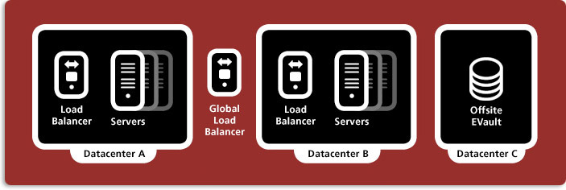

Figure 1.4.4.1-8: Disaster Recovery.

Applications Management Approach

CA Nimsoft will be used to provide customized application management, integrated application management, service management, package management, application and server management. In addition, it will also provide customizable monitoring/reporting dashboards (*Figure 1.4.4.1-9*).

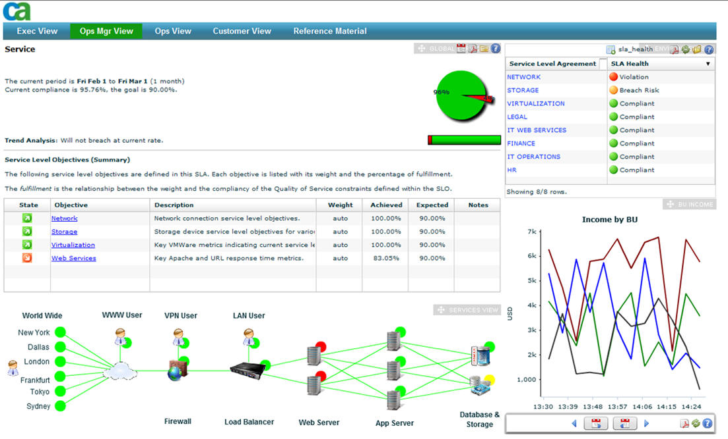

Figure 1.4.4.1-9: Application Management Approach.

Upgrade and Point Release Process

SoftLayer generally performs refresh, additions to the catalog with each significant refresh (major, minor release). Details vary by vendor. SoftLayer also provides the capability to import your own images.

All system upgrades are maintained to a minimum level of N (-)2. This means any time the systems will be upgraded to the minimum level of latest 2 versions released in the market. Patches and vulnerability fixes are evaluated and ranked as per its risk rating of critical, high, medium and low. Patches are released to production only after it is tested in the development/staging environment. Patching is usually carried out during out of office hours.

To ensure the stability of the runtime environment, the software is unit, Integration, QA, UAT tested and ported to the staging area before it is introduced into the production environment. Every new service pack and release of third party tools is tested prior to deploying them in the production environment.

Change Management, Upgrade and Patch Management Policies

All assets are maintained in a version control system and updated under a change management process.

SoftLayer regularly performs scans of the componentry supporting the management system as well as the perimeter network for access to clients subscribed compute resources. SoftLayer remediates any vulnerability encountered. A support and incident response exists to notify client of items that require their attention/assistance or that are suspected of a breech. SoftLayer does not share its logs with individual clients. Information required to allow the client to understand a potential exposure or that is needed for client to assist in a remediation will be shared with the client without disclosing information for other clients.

Moreover, a Nessus® Vulnerability Assessment scan of provisioned instances can be scheduled at no charge via the SoftLayer portal. Remediation of any issues in user subscribed resources is the responsibility of the user.

Identity Management and Help Desk Procedures

Incidents can be reported to SoftLayer via our Customer Portal, web chat, our mobile application, phone call or via APIs. Users’ access to created tickets can be controlled through the Customer portal.

SoftLayer Help Desk tickets can be integrated with any tool using SoftLayer APIs. Mode details about this API here: http://sldn.SoftLayer.com/reference/services/SoftLayer_Ticket.

Approach to Exporting Data

Many third party vendor tools, such as Microsoft SSIS for SQL Server, provide export functionality with the requested formats out of the box.

Intrusion Detection and Prevention

SoftLayer offers a wide variety of IaaS resources supporting customer managed access services: http://www.SoftLayer.com/services/security

**Procedures for Installing Security Patches**

As previously mentioned, patches and vulnerability fixes are evaluated and ranked as per its risk rating of critical, high, medium and low. Patches are released to production only after they are tested in development/Staging environment. Patching is usually carried out during out of office hours.

Enforcing Access Controls

SoftLayer provides fine grain access permissions in the portal as well a built-in VPN service. Access to customer provisioned VMs can be controlled via the portal interface and VPN. In addition, clients may choose to make use of OS level security within the VM. Or you may implement any user based authentication method relying on our IaaS components.

Customer can configure permissions in portal as well as rules/acls in specific subscribed resources such as firewalls and load balancers. Changes are self-service and immediate. Clients are welcome to govern changes via their existing change management process and systems using the SoftLayer self service capability when permission has been granted.

SoftLayer self-service portal and API layer focuses on efficient access to order/provision, configure and cancel IaaS resources. A granular access control/permission system exists which allows the client account administrator to restrict access for users per client policy. All functions resident in the SoftLayer portal are available via secure API which facilitate the integration with existing change management and approval and workflow systems. Optional managed services including change/problem management configured to client specifications can be included as extended services.

**Confidential City Data will be Hosted Internally**

BuildLA data will be stored securely and isolated away from any other kind of data, in separate databases on separate server instances, utilizing separate logical storage volumes dedicated to BuildLA. Industry wide, best practices, such as, data encryption during flight and at rest, will be used to ensure that any other potential risks are mitigated. The access to this information is strictly on need to know basis.

SoftLayer does not access client data. The SoftLayer platform provides the capabilities and facilities to allow clients to implement data handling policies according to their standards.

Customers can install and manage their own key management for customer subscribed IaaS resources. SoftLayer allows this to be handled in client space so as to insure that data is encrypted prior to submission to the IaaS.

Encryption of data at rest is under control of the client. Best practice for IaaS Clients is to encrypt data (file system encryption with client managed keys, etc.) prior to transmission to the IaaS storage. SoftLayer provides capabilities that allow clients to manage their data securely.

**Preventing Unauthorized Releases of City Data**

SoftLayer makes use of multiple layers of network security including stateful firewalls. In addition, SoftLayer IaaS provides support for clients to provision shared or dedicated firewalls and load balancers as well as fortinet application security appliances allowing for the construction of secure multitier topologies.

SoftLayer event logs are always active and protected from unauthorized access. Significant events (including login attempts, privilege escalations) are logged and analyzed. SoftLayer platform does not have access to client data.

SoftLayer security logs are not externalized for client use. Appropriate information is collected in SoftLayer platform logs that allow for analysis, identification and audit of the platform.

SoftLayer regularly monitors and analyzes security logs generated from platform componentry for irregular suspicious activities. Logged alerts are handled in a timely manner - and, if applicable information is communicated to the client via the standard incident response and support mechanisms.

A support and incident response system exists to communicate any activity to clients regarding the SoftLayer infrastructure. If SoftLayer detects malicious network activity, it will null route the traffic and work with the client to remediate the activity. If not remediated in 24 hours SoftLayer maintains the capability to take the target IP address offline. SoftLayer provides the capability for clients to provision and configure network and application level firewalls. The logs from these devices that protect the subscribed resources are available to the client.

Virus Protection

SoftLayer partners with McAfee to offer Anti-Virus and Anti-Spyware services:

* McAfee Total Protection for Secure Business for Windows and Linux provides Advanced antivirus, anti-malware, host intrusion prevention, device control, host-based firewall, and encryption.
* McAfee ePolicy Orchestrator – provides a single-console management to automate workflow, policy deployment, updates, maintenance, and reporting across all of the technologies that protect the endpoints.
* SoftLayer monitors advisories for suppliers to insure that the SoftLayer platform maintains an appropriate security posture. SoftLayer insures that client resources are isolated within their own network zones, etc. so as error, viruses may not be propagated between clients. Client are responsible for monitoring advisories and applying updates for subscribed resources (servers, OS, etc.). Note: SoftLayer provides access to Linux and Windows update (patch) servers which allows clients to easily apply security patches upon the schedule they desire.

Network Design

SoftLayer provide a unique triple network architecture which allows public internet, private network, and a secure management network connectivity to all compute resources. Internet access to VMs can be controlled by SoftLayer provided firewalls and facilities which are provided by SoftLayer platform and under complete customer control. In addition SoftLayer support the following private connectivity options: For administrative and low/medium volume access - SoftLayer supports a VPN service that is accessible by secure VPN Client as well as the ability to configure connectivity to the SoftLayer private network from client via (a) PPTP (b) IPSEC (c) SSL. SoftLayer also has a robust set of network capability and agreement with carriers and peering partners. SoftLayer is able to establish a cross connect capability from its peering partners to the SoftLayer network allowing clients to extend their MPLS and private connectivity to include SoftLayer data centers.

SoftLayer offers flexible network bandwidth options. By default all servers are configured with metered bandwidth which allows for a specific amount of inbound/outbound traffic to be sent/received per month. Additional bandwidth can be purchased in increments. Overage charges apply to metered bandwidth. It is also possible to purchase allotments up unmetered bandwidth. Unmetered bandwidth is purchased according to a transfer rate - with unlimited use of the purchased bandwidth. Detailed reports are available in the customer portal to monitor your bandwidth usage so as to be able manage your charges. All changes to the account and purchases occur through the portal. Information about network options can be found at http://www.SoftLayer.com/services/network.

Accessing BuildLA City-Located Clients

Within the City of LA network – all employees that access the BuildLA system will be authenticated and will be allowed access only to authorized assets. City of LA employees accessing BuildLA from outside the City of LA network will use either a VPN or Extranet depending upon the City of LA’s access policy:

Procedures for Bug Fixes

Our standardized defect management process is shown in *Figure 1.4.4.1-10*.

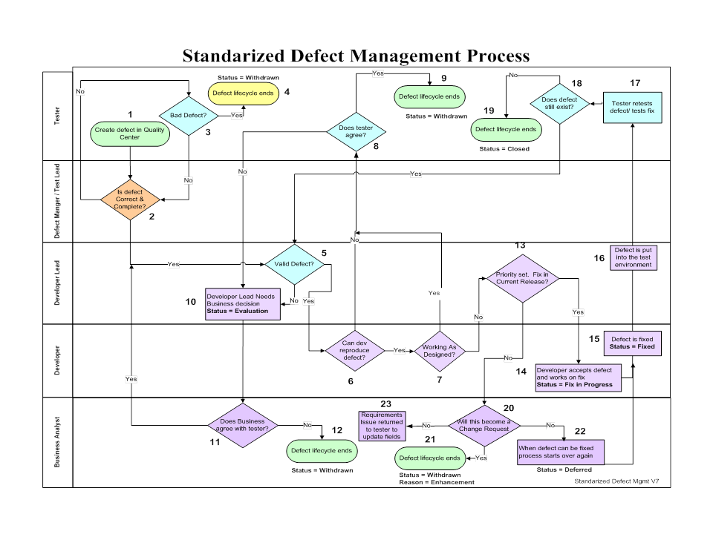

Figure 1.4.4.1-10: Defect Management Process.

Defect responsibility by task and responsible team is shown in *Figure 1.4.4.1-11*.

| Task | Task Name | Responsible Team | Description |
| --- | --- | --- | --- |
| 1 | Create Defect In QC | Tester Team | * Defect is discovered * Tester reproduces * Tester verifies defect is not a duplicate * Tester creates a new defect and the status is “Submitted” and assigned to the Defect Manager/ Test Lead for review. |
| 2 | Is defect correct and complete? | Defect Manager / Test Lead | * Does summary line say WHAT the problem is? * Does the description area contain all information? * Do selections make sense? * If defect is incomplete the defect is returned to the tester and assigned to the tester for modification. * By updating with complete information, Tester assign back to the Defect Manager / Test Lead to assign to Development Lead |
| 3 | Bad Defect | Tester Team | * Tester updates the defect with the information from Defect Manager/Test Lead and Status need to be changed to “Withdrawn” by the Tester/Test Lead. * Defect lifecycle ends |
| 4 | Defect is withdrawn | Tester Team | * Tester determines the defect should have not been written. * Status need to be changed to “Withdrawn” by the Tester/Test Lead with appropriate information in “Reason Withdrawn” * Defect lifecycle ends |
| 5 | Valid Defect? | Development Lead | * Developer Lead determines if this is something that the development team should fix * Developer Lead assigns the defect to the developer on the team who will be making the fix |
| 6 | Can Development reproduce defect? | Developer | * Developer tries to reproduce the problem * If the Developer cannot reproduce the problem the status is changed to “Returned” and assigned to the tester who created the defect * The “Defect Owner Group” is changed to the testing team who created the defect |
| 7 | Working as designed? | Developer | * If the developer can reproduce the problem and determines function is working as designed, the status is changed to “Returned” and assigned to the tester who created the defect * The “Defect Owner Group” is changed to the testing team |
| 8 | Does Tester Agree? | Tester Team | * Tester cannot reproduce or agrees it’s working as designed |
| 9 | Defect is withdrawn | Tester Team | * The Tester changes the status to “Withdrawn” for the appropriate information in “Reason Withdrawn” * Defect lifecycle ends |
| 10 | Developer Lead Needs Business decision | Developer Lead | * If the Tester can reproduce the problem or if they disagree that the defect is working as designed, the tester will discuss with the Developer * If the Tester and Developer disagree the issue is escalated to the Developer Lead * If the Developer Lead agrees with the Tester, Defect is assigned to the correct Defect Owner Group and Developer * If the Developer Lead determines Business Analyst input is required * The status is changed to “Evaluation” * The Developer Lead changes the “Defect Owner Group” to the appropriate Business Team and assigns the defect to a business analyst |
| 11 | Does Business agree with the tester? | Business Analyst | * If the Business Analyst agrees the defect is valid, the “Defect Owner Group” is changed to the development team and the defect is reassigned to the Developer Lead. The process then starts over again for the development team |
| 12 | Defect is Withdrawn | Business Analyst | * If the Business Analyst agrees the defect should be withdrawn * The Business Analyst changes the status to “Returned” and assigns to the Tester who the created the defect so that the defect can be withdrawn * Defect lifecycle ends |
| 13 | Priority set. Fix in current release? | Business Analyst | * Appropriate person determines priority and if the defect will be fixed in this release always by Business |
| 14 | Developer accepts defect and works on fix | Developer | * Developer changes the status to “Fix in Progress” and start working on the fix |
| 15 | Defect is fixed | Developer | * When the fix is completed the Developer changes the status to “Fixed” * When the status changed to “Fixed” the developer notes the root cause of the defect and selects the appropriate Planned Closing Version so the tester knows when to retest. * The Defect Owner Group is changed to match the Detected By Group and the defect is assigned to the tester |
| 16 | Tester retests defect/tests fix | Tester Team | * Tester will retest the fixed defects |
| 17 | Does defect still exist? | Tester Team | * If the defect still exists the status is changed to “Re-Open”. * The “Defect Owner Group” is changed to the Development team and the defect is assigned to the developer |
| 18 | Defect is Closed | Tester Team | * If the defect does not still exist, status is changed to “Closed” * Defect lifecycle ends |
| 19 | Will this become a change request | Business Analyst | * If the defect will not be fixed in the current release the status is changed to “Evaluation” by Development lead * The defect is reassigned to the Business Analyst * The Business Analyst determines this is really an enhancement and needs a change request. * Business Analyst creates a change request and notes the Defect Number in the Quality Center along with all comments. * Business analyst changes the status to “Returned” and reassigns to the tester who created the defect. * Defect Owner group is changed to the test team. * Tester withdraws the defect for reason “Enhancement” * Defect lifecycle ends |
| 20 | Defect is withdrawn | Business Analyst | * The Business Analyst changes the status to “Withdrawn” with appropriate reason. * Defect lifecycle ends |
| 21 | When defect can be fixed process starts over again | Business Analyst | * If the defect does NOT get a change request but is going to be fixed in a later release, the Business Analyst changes the status to “Deferred.” * When the defect will be addressed again, the defect is re-opened and the process starts over again. |
| 22 | Requirements Issue returned to tester to update fields | Business Analyst | * Business Analyst returns to the tester if it’s determined the requirements need clarification * Tester will then change the appropriate fields to identify it as a requirements defect |

Figure 1.4.4.1-11: Bug Fixing Responsibility.

Defect Severity Definitions

Defect severity definitions are shown in *Figure 1.4.4.1-12*.

|  |  |  |
| --- | --- | --- |
| Severity | | Definition |
| 1-Critical | * Severity 1 Defect (No Workaround) * Complete or critical loss of entire application or entire component resulting in User unable to complete the intended operation impacting business objective; blocking defect; remaining tests in that suite cannot be executed * Environment down * Corrupted database impacting all components * Respective functionality is not working * Complete loss of access to an enterprise application |
| 2 - High | * Severity 2 Defect (Workaround is available) * Partial loss of an entire or major portion of an application or component. * Partial or major loss examples are: situations where some components or functions are unavailable, but a workaround can be used to maintain business processes * Partial loss of access to an enterprise application * Data is received but is incorrect * The problem is extremely common and recurring or occurs in a critical non-business area |
| 3 - Medium | * Severity 3 Defect (Lower impact - Workaround is available) * Situation that impacts the system or application performance for a limited number of customers * Defects that do not have a large business impact * Cosmetic errors that cause User confusion but do not impact using the system |
| 4 - Low | * Severity 4 Defect * Situations with no impact to business functions * Partial loss of functionality affecting a single workstation or device * Minor cosmetic errors that cause frustration |

Figure1.4.4.1-12: Defect Severity Definition.

Roles and Rights for Defect Status Changes

The roles and rights for defect status changes are shown in *Figure 1.4.4.1-13*.

| Module | Rights | Tester | Test Lead | Developer | Developer Lead | Business Analyst | Defect Manager |
| --- | --- | --- | --- | --- | --- | --- | --- |
| Status  Changes | New (Create a Defect) | X | X |  |  |  |  |
| > New to Open |  |  |  | **X** |  | **X** |
| > New to Withdrawn |  | **X** |  |  |  | **X** |
| Open (Open a defect initially) |  |  |  |  |  | **X** |
| > Open to Returned (Sent to Tester) |  |  | **X** | **X** |  | **X** |
| > Open to Fix in Progress |  |  | **X** | **X** |  | **X** |
| > Open to Evaluate |  |  |  | **X** |  | **X** |
| Returned |  |  |  |  |  |  |
| > Returned to Withdrawn | **X** | **X** |  |  |  | **X** |
| >Returned to Open | **X** | **X** |  |  |  | **X** |
| Fix in Progress |  |  |  |  |  |  |
| >Fix in Progress to Fixed |  |  | **X** | **X** |  | **X** |
| >Fix in Progress to Returned |  |  |  | **X** |  | **X** |
| Evaluate |  |  |  |  |  |  |
| Evaluate to Returned |  |  |  | **X** | **X** | **X** |
| >Evaluate to Deferred |  |  |  | **X** | **X** | **X** |
| Fixed |  |  |  |  |  |  |
| >Fixed to Closed | **X** | **X** |  |  |  | **X** |
| >Fixed to Re-Open | **X** | **X** |  |  |  | **X** |
| Re-Open |  |  |  |  |  |  |
| >Re-Open to Returned (Sent to Tester) |  |  | **X** | **X** |  | **X** |
| >Re-Open to Fix in Progress |  |  | **X** | **X** |  | **X** |
| >Re-Open to Evaluate |  |  |  | **X** |  | **X** |
| Deferred |  |  |  |  |  |  |
| >Deferred to Re-Open |  |  |  | **X** | **X** | **X** |

Figure 1.4.4.1-13: Defects Status Changes- Roles and Rights.

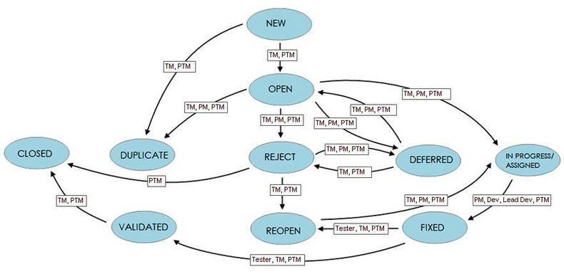

Figure 1.4.4.1-14: Process for Opening and Closing Defects.

In creating a new defect, the status is non-editable and automatically set to ‘new’. After submitting the defect TM/TL can move defect from **New to Open** or **New to Duplicate or New to Rejected/Withdrawn.** The defect process is shown above in *Figure 1.4.4.1-14*. The state/status and conditions are shown in *Figure 1.4.4.1-15*.

| State/Status | User Group | Field Value | Conditions |
| --- | --- | --- | --- |
| New | TM, TL | Open, Duplicate, Rejected | If Duplicate, “Associated Defect” is a required field |
| Open | TM, PM, TL | Rejected, Duplicate, Deferred, In Progress/Assigned | If Duplicate, “Associated Defect” is a required field  If Reject, explanation should be added to additional information tab. |
| In Progress/Assigned | PM, Developer, Development Lead | Fixed | Resolution required to be entered |
| Fixed | Tester, TM, TL | Validated, Re-open | Root Cause Required to be entered if Validated |
| Validated | TM, TL | Closed |  |
| Deferred | PM, TM | Open, Reject |  |
| Reopen | TM, PM,TL | In Progress/Assigned |  |
| Reject | TM, PTM | Reopen, Deferred |  |

Figure 1.4.4.1-15: State/Status of Defects by User Group, Field Value, and Conditions.

If the decision is made to fix the rejected defects, the user can select the “Reopen” status and in case if they want to defer it to the upcoming release, they can select “Deferred” status. This allows for real defects that are mistakenly rejected to be reopened. Our quality control defect screen is shown in *Figure 1.4.4.1-16.*

QC Defect Page

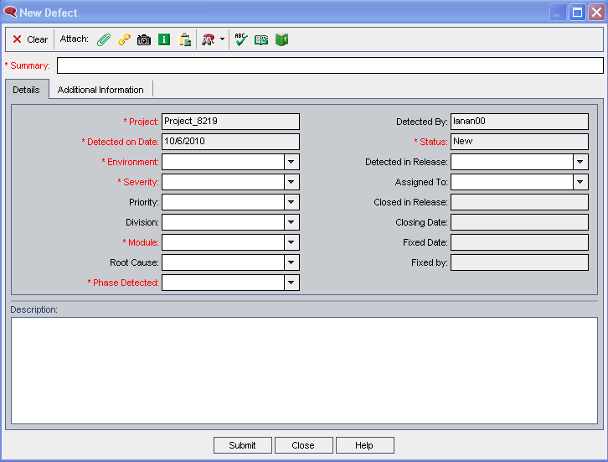

Figure 1.4.4.1-16: QC Defect Page.

Test Metrics

UST Global will capture the test metrics shown in *Figure 1.4.4.1-17* on a weekly basis and this will be the basis for assessing the quality of our processes. The Quality Center will be a major contributor for many of these metrics as the defects will be logged and tracked through QC tool. The Test Manager will do a weekly review of the Testing process. The main highlights of the review will include:

* Ensure adherence to Test Plans
* Peer review of test plans, test cases and test data for completeness
* Evaluation to test results
* Analysis of Test Metrics to evaluate robustness of product quality
* Root cause analysis of variations and corrective actions with stakeholders
* Implementation of corrective actions planned/taken to mitigate deviations

| # | Metric | Definition | Calculation | Unit | Frequency of Updates |
| --- | --- | --- | --- | --- | --- |
| 1. | Estimation Accuracy | Ratio of estimated effort to the actual effort | = (Estimated Effort)/(Actual Effort) x 100 | % | Upon completion of each milestone or monthly, whichever is crossed first |
| 2. | Schedule Variation | Difference between planned and actual durations of the project, expressed as a percentage of actual duration | = ((Actual Duration) - (Planned Duration)) / (Planned Duration) x 100 | % | Upon completion of each milestone or monthly, whichever is crossed first |
| 3. | Productivity - Test Case Development | Number of Test Cases developed per person hour of effort | = (Number of Test Cases Developed)/(Effort for Test Case Development) | /hr | Weekly |
| 4. | Productivity - Test Execution | Number of Test Cases executed per person hour of effort | = (Number of Test Cases Executed)/(Effort for Test Case Execution) | /hr | Weekly |
| 5. | Test Coverage | Percentage of requirements that are covered in test execution | = (Number of Requirements Covered in Test Execution)/ (Number of Requirements in Approved Requirements Spec) * 100 | % | Weekly |
| 6. | Defect Density | Number of Defects reported and accepted per unit size of the software | = (Number of Defects Reported and Accepted by Review and Test Teams)/ (Size of Software Reviewed or Tested) | /FP, /KLOC* | Weekly |
| 7. | Defect Detection Effectiveness (DDE) | Percentage of the total number of Defects reported for the application that are reported prior to delivery | = (Number of Defects Reported prior to delivery and Accepted) / (Number of Defects Reported prior to delivery and Accepted + Number of Defects Reported after delivery and Accepted) x 100 | % | Weekly |
| 8. | Defect Acceptance Ratio (DAR) | Percentage of Defects reported that are accepted as valid | = (Number of Defects Accepted as Valid) / (Number of Defects Reported by Test Team) | % | Weekly |
| **\***FP – Function Points, KLOC – Kilo Lines of Code | | | | | |

Figure 1.4.4.1-17: Testing Metrics.

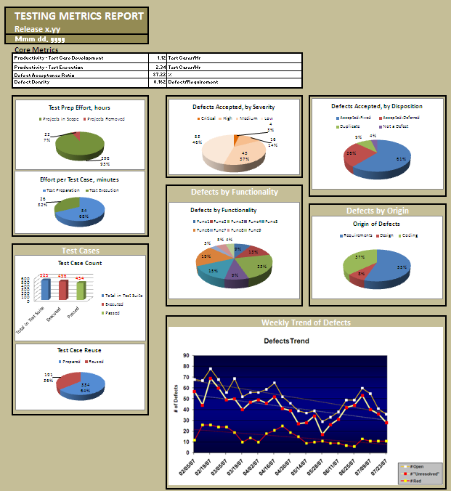

Figure 1.4.4.1-18: Sample Dashboard.

A sample dashboard of our testing metrics is shown is *Figure 1.4.4.1-18*.

Sample Test Report

A sample test report is shown in *Figure 1.4.4.1-19*.

| Category | Metrics | Description | Purpose | Formula | Periodicity |
| --- | --- | --- | --- | --- | --- |
| Product/ Application | Defect Severity | Severity of the defect indicates the potential business impact of the end user. | To measure the quality of the product |  | Phase-wise |
|  | Defect Injection Rate | Number of Defects that are injected into the system for 100 hours of development effort spent. | To measure and improve development efficiency | Phase-wise Defects / Development Effort in that phase | Phase-wise |
|  | Defect Detection Efficiency | The percentage of defects detected during review and testing to the total defects. | To measure and improve regression efficiency | (Review/Test Defects)/Total Defects | Phase-wise/Project Closure |
|  | Defects Category | An attribute of the defect in relation to the quality attributes of the product. Quality attributes of a product include functionality, usability, documentation, performance & installation. | Provide insight into the different quality attributes of the product. |  | Phase-wise |
|  | Defect Cause Category | Pareto Analysis - Causes can be Coding standard violation, code inconsistent with the specs, logic error in the code, improper unit/integration testing etc., | Identifying the more frequently occurring repetitive causes (20:80 ratio) to identify and improve the specific phases in SDLC |  | Project Closure |
|  | Defect Seepage ratio | The percentage of defects detected in subsequent phase and injected in a particular previous phase | Defect Prevention initiative |  | Phase-wise |
|  | Defect Removal Efficiency | People’s effort to remove defects efficiently | Measure the regression efficiency | Number of defect removed in Phase/Hrs. of effort expended in phase | Phase-wise |
|  | Defect Density | Density of the defect with respect to the size (LOC or Functional Points) | To measure the quality of the product | (No. of valid Defects)/Size | Project Closure |
|  | Defect Trend | Functional-wise/Component level vs. Release-wise/Phase-wise Charts | To measure the product stability |  | Phase-wise |
| Project | Test Planning performance | Planned value related to the actual value. Shows well how estimation was done. | Test planning estimation efficiency | Ratio of the actual effort spent to the planned effort | Project Closure |
|  | Test Effort Percentage | In overall project effort calculate the test effort | Gives the level of investment in testing. | Overall test effort / Total project effort | Project Closure |
|  | Test case Construction % & effort | Total number of test cases constructed and its effort | 1.To measure the % progress 2.To measure the productivity | 1. Ratio of the total number of test cases to the total number of test cases constructed  2. Total Test case constructed / construction effort. | Phase-wise |
|  | Test case Execution % & Effort | Total number of test cases executed and its effort | 1.To measure the % progress 2.To measure the productivity | 1. Ratio of the total number of test cases to the total number of test cases executed . 2. Total Test case executed / execution effort. | Phase-wise |
|  | Test Effectiveness | Test Effectiveness ratio | To measure and improve the execution efficiency | # of Test Defects found - Preshipment / (# of defects found - Preshipment + # of defects found - Postshipment) | Project Closure |
|  | Cost of Quality | Total Quality cost | Identifying the cost on the specifics (reviews, testing planning etc.) to reduce/justify. | Cost of Quality is calculated as Er*k + Et*k +Ep*k Er = Effort spent on Reviews (excluding codewalk-through ) Et = Effort spent on Testing Ep = Effort spent on replanning  where k = cost per man-hour | Project Closure |
|  | Schedule Variance | Variances in the scheduled plan. Root Cause - Attrition, Mobility, Resource, Requirement Changes, Defects | Measure the schedule slippages and its root cause | 100*(Actual elapsed time - Estimated time)/Estimated time | Phase-wise |
|  | Effort Variance | Variances in the estimated effort. Root Cause - Attrition, Mobility, Resource, Requirement Changes, Defects | Measure the effort slippages and its root cause | 100*(Actual man-hours Expended - Estimated man-hours)/Estimated man-hours | Phase-wise |
| Process | Defects in different phases | An attribute of the defect indicating in which phase the defects should have been found | Defect Prevention initiative |  | Phase-wise |
|  | Residual Defect Density | Defects that may have been unresolved in the system testing phase. | To achieve the defect level that is acceptable to the client/sponsors |  | Project Closure |
|  | Bad Fix Ratio | Indicates the effectiveness of the defect resolution process | To measure and improve defect fixing efficiency | Ratio of the total number of bad fixes to the total number of resolved defects. | Phase-wise |
|  | Bad Test Ratio | Indicates the effectiveness of the testing process | To measure and improve Testing efficiency in understanding the requirement | Ratio of the total number of bad defects to the total number of defects found. | Phase-wise |
|  | Backlog Develop-ment | # of defects that are yet to be resolved by the Development team | To measure the resolution turn around |  | Phase-wise |
|  | Backlog Testing | # of defects that are yet to be retested by the test team | To measure the regression turn around |  | Phase-wise |
|  | Scope Changes | # of changes to the test scope | To measure the stability/Volatility | Ratio of # of changed items in the test scope to the total number of items. | Project Closure |

Figure1.4.4.1-19: Sample Test Report and Metrics.

**SoftLayer Infrastructure**

SoftLayer's infrastructure is standardized, modular, and fully integrated, which allows applications to be deployed in an architecture designed precisely for specific business needs, with infrastructure control built in. In SoftLayer, administrators can drill down to the server, the rack, the network board, the serial numbers, everything down to the encryption level on the drive, offering unparalleled transparency and granular control over configuration, delivering special benefit to SoftLayer customers.

Web applications (especially online and browser-based application services) require a significant amount of flexibility to accommodate ever-changing user demand. SoftLayer’s infrastructure provides customizable, highly scalable solutions ideal for meeting today’s needs without compromising cost efficiency or expansion speed. Linear stacks of Web, application and database servers can be added on the fly to precisely meet demand whenever more resources are needed (*Figure 1.4.4.1-20)*.

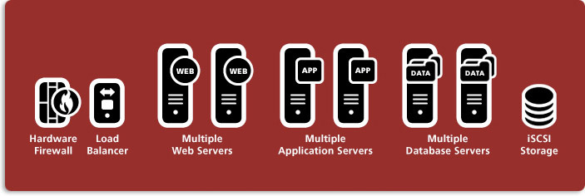

Figure 1.4.4.1-20: Soft Layer Architecture.

SoftLayer provides a wide array of options with the ability to provision bare metal / dedicated servers ranging from single processor servers to quad-core, hex-core, and even octal core workhorses which are deployed in real time via SoftLayer's portal or API. SoftLayer's Infrastructure Management System (IMS) is an API layer that today offers 2,200 documented methods across 180 discrete services. SoftLayer provides these services within a structure which has currently been deployed for many other customers and is capable of meeting or exceeding the project requirements defined in the BuildLA RFP.

Whether deploying a footprint of cloud computing instances for a Web tier, or distributing workloads over high-performance physical clusters for data infrastructure, SoftLayer's infrastructure allows seamless connection to both virtual and "bare metal" servers, along with on-demand SAN and NAS storage. SoftLayer also provides infrastructure protection with options from a choice of a broad suite of firewalls and information security solutions including the ability to configure entire private clouds online, with end-to-end provisioning being completed in as few as two hours. In addition to infrastructure, SoftLayer also provides a high-performance content delivery network optimized for fast content delivery. Features are shown in *Figures 1.4.4.1-21 and 1.4.4.1-22*.

**Standard SoftLayer Features**

|  |  |
| --- | --- |
| **Network** | **Web Portal, API, & Mobile Apps** |
| * 100Mbps Public & Private Ports * Private VLAN via Public & Private Network * Geographically Redundant DNS * Server-to-server Connectivity * IPv4 & IPv6 Addresses | * Accounting and Billing Information * Automated OS Reloads * Hardware Identification * Advanced System Reporting * Public & Private Bandwidth Graphs * Remote Reboot & Console Access * Uplink Port Speed Control * User Management |
| **Support** | Utilities |
| * 24/7 Online and Phone Support * 24/7 Data Center Staffing * Trouble Ticketing System * Advanced Resolution System | * Infrastructure Support Servers * Rescue Kernel * DNS Resolvers * PassMark BurnIn Test Certification * Nimsoft Monitoring * Email Delivery Service |

Figure 1.4.4.1-21: Features for Web Portal, API & Mobile Apps.

| Services | SoftLayer Dedicated Servers | CloudLayer Cloud Servers |
| --- | --- | --- |
| Provisioning | 2 to 4 Hours | 5 to 15 Minutes |
| Remote Management | Full Physical Control – IPMI | Full Virtual Control - OS Level |
| Hardware Refresh | Regular hardware updates | N/A |
| Reboot | Power Strip / IPMI / OS | Instance Reboot / OS |
| Storage | Local / NAS / iSCSI / Cloud | Local / NAS / SAN / Cloud |
| Configuration | Hardware Fully Customizable | Standard Configurations Build Your Own Cloud Server |
| Redundancy | User-Defined (ex. RAID) | SAN Hardware Failover |
| Backup | EVault® | EVault® |
| Image Management | Flex Image | Flex Image |
| Private Network | All Servers & Instances | All Servers & Instances |
| Location | AMS / DAL / HOU / SEA / SJC / SNG / WDC | AMS / DAL / SEA / SJC / SNG / WDC |
| KVM over IP | Thru Web Browser | Launched from Portal |
| Monitoring | Standard | Enhanced (CPU / RAM) |
| Network Reports | Public / Private Bandwidth Graphs | Public / Private Bandwidth Graphs |
| Security | 24/7 physical security, protection against power outages and guaranteed uptime | 24/7 physical security, protection against power outages and guaranteed uptime |
| Other Services | IP Management (On-the-Fly) | IP Management (On-the-Fly) |
| Add Firewalls (On-the-Fly) | Add Firewalls (On-the-Fly) |
| Add Load Balancers (On-the-Fly) | Add Load Balancers (On-the-Fly) |
| Add Load Balancers (On-the-Fly) | Add Load Balancers (On-the-Fly) |

Figure1.4.4.1-22: Comparison of SoftLayer and CloudLayer Servers and Services.

**SoftLayer Data Center Facilities & Specifications**

SoftLayer facilities are shown in *Figures 1.4.4.1-23 and 1.4.4.1-24.*

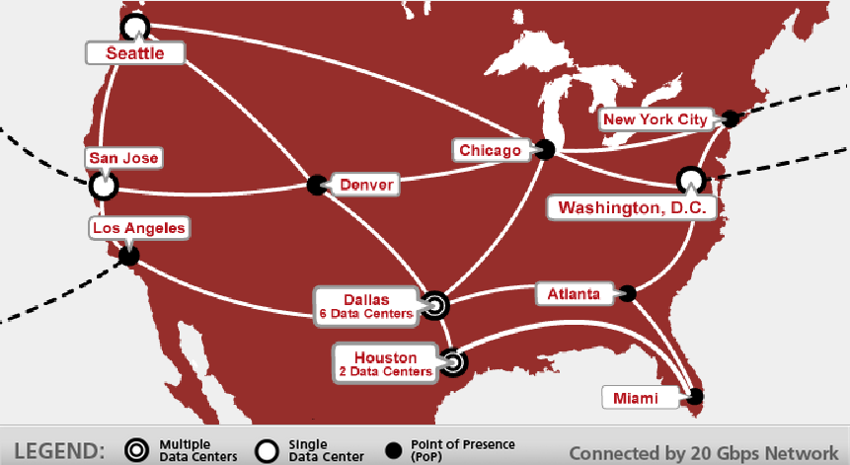

Figure 1.4.4.1-23: Soft Layer Facilities.

|  |  |  |
| --- | --- | --- |
| SoftLayer Facilities (United States) | | |
| Dallas | 104,500+ | Servers |
| Seattle | 10,000+ | Servers |
| Washington | 16,000+ | Servers |
| Houston | 25,000+ | Servers |
| San Jose | 12,000+ | Servers |

Figure 1.4.4.1-24: Soft Layer Facilities.

This is an example of one of our Dallas Data Center sites’ attributes, which is typical for all our vendor’s data centers:

Dallas Data Center: DAL01

|  |
| --- |
| * Capacity: more than 40,000 dedicated servers * 6000 amps 480v Input Power * 6 x 750Kva UPS Battery Backup Units * 3 x 2000Kw Diesel Generator with On-site Fuel Storage * Redundant Liebert 30-ton HVAC Units * Pre-Action Dry Pipe Fire Suppression * Proximity Security Badge Access * Digital Security Video Surveillance |

The SoftLayer Data Center Architecture (simplified) is shown in *Figure 1.4.4.1-25.*

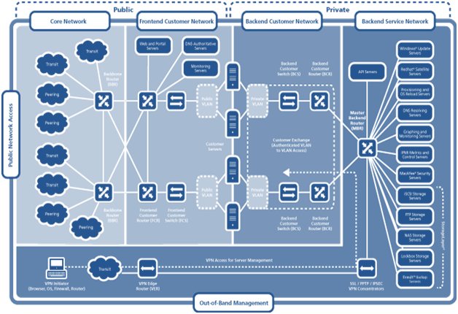

Figure 1.4.4.1-25: Soft Layer Data Center Architecture.

All SoftLayer data centers are built upon SoftLayer’s unique pod design concept, making them functionally independent with distinct and redundant resources, and fully integrated through SoftLayer’s revolutionary network architecture. You can have direct control over your system in any SoftLayer data center and full access to all of SoftLayer’s back-end services—all fully automated and on demand.

Each data center facility features one or more pods, each built to the same specifications with best-in-class methodologies to support up to 5,000 servers. Leveraging this standardization across all geographic locations, we optimize key data center performance variables including: space, power, network, personnel, and internal infrastructure.

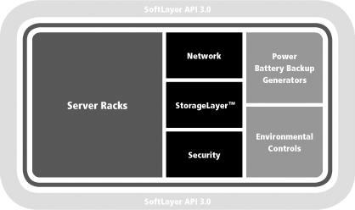

Figure 1.4.4.1-6: Server Racks.

**SoftLayer Rack Architecture**

At the core of the SoftLayer platform —and the heart of the SoftLayer data centers—are the server racks themselves (*Figure 1.4.4.1-26*).

From dedicated to cloud servers, everything starts with a physical machine. To integrate each machine into SoftLayer’s revolutionary network architecture and automated management system, a unique approach to rack architecture is employed (*Figure 1.4.4.1-27*).

Every rack has been built out with the same, standardized methodology; to streamline deployment, minimize error and increase the speed of resolution should any event require hands-on technician support.

Each server comes with triple network ports, for segregated Public Network, Private Network and Management Network access. 40Gbps of connectivity to the rack—20Gbps to the Private Network, 20Gbps to the Public Network—provides exceptional and consistent network performance for every system.

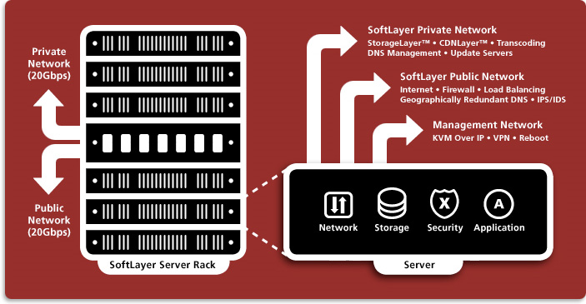

Figure 1.4.4.1-27: Rack Architecture.

**SoftLayer Virtualization**

Enterprise IT needs a high level of scalability without compromising stability, cost, or efficiency. SoftLayer provides the technology and services needed for employing virtualization within a dedicated environment to create a private solution that optimizes technology resources and costs and achieves unprecedented utilization rates.

SoftLayer’s proprietary architecture and automated platform provides uncommon advantages as well as the proven level of performance and reliability required for enterprise-class virtualization. Virtual machines running on a SoftLayer dedicated server seamlessly integrate with the rest of the IT environment, including dedicated servers and CloudLayer®Computing instances, all managed through the same Customer Portal and API.

**SoftLayer Network**

The SoftLayer network provides all customers with over 2,000 Gbps of connectivity between data centers and 17 points of presence (PoPs). SoftLayer has enabled dozens of 10Gbps network connections across our locations that are provided by leading global network providers, and include multiple public peering links to dozens of additional Internet access networks.

SoftLayer's geographically diverse PoPs provide seamless, direct, private and high speed access to our backbone network, bringing connectivity closer to the end user. Customers may choose the SoftLayer PoP location closest to their office or end users. High-speed metro-WAN services and cross connects from providers including Equinix and Telx are also available. SoftLayer’s network is built from best-in-class networking infrastructure, hardware, and software with exceptional bandwidth and connectivity for the highest speed and reliability.

SoftLayer seamlessly integrates three distinct and redundant gigabit network architectures—public, private, and data center-to-data center—into the industry's first network-within-a-network topology. This design provides its customers maximum accessibility, security and control for their IT infrastructure.

**Private Network**

SoftLayer invented the private network for the hosting industry in order to provide an unparalleled advantage in security, accessibility, and bandwidth efficiency. Administrators can access servers via VPN over carriers that are not connected to our public network. This totally segregates public and private traffic, making it impossible for external parties to access server functionality and allowing administrators to securely transfer data and manage servers without sacrificing public bandwidth to their sites (*Figure 1.4.4.1-28*).

|  |  |
| --- | --- |
| **SoftLayer Public Network Features** | SoftLayer Private Network Features |
| * Free Inbound Bandwidth * Multiple Internet Backbone Connections * Cisco Systems 10G Network * Cisco Guard DDOS Protection * Arbor Peakflow Traffic Analysis * Arbor Atlas Global Traffic Analyzer * Automated IP Routing and Management * Individual Secure Private VLAN per Customer * Add Servers to Existing VLANs On-the-Fly * Add Services to Existing Servers On-the-Fly * Gigabit Speeds from Server to Internet * Supports Dedicated, VDS, Grid Technologies * Geographically Redundant DNS * Native IPv6 Ready | * Secure Out-of-Band Management via VPN * Free Server to Server Cross Connects * Free Bandwidth for Uploads / Downloads * Individual Secure Private VLANs per Customer * Access to Private OS Update Servers * Access to Private Local DNS Resolvers * Access to OS Reload and OS Change Servers * Access to SoftLayer Software Repository * Access to Centralized NAS / Backup * Access to McAfee Security Update Server * Gigabit Speeds from Server to Server * Secure Customer to Customer Cross Connects |

Figure1.4.4.1-28: SoftLayer Public and Private Network Features.

SoftLayer deploys CiscoTM 6500 and 3750X switches throughout the data center. Every upstream network port is multiple 10G and every rack is terminated with 40G of connectivity. This includes two 10G connections to the public Internet and two 10G connections to our private network.

Port Speed Options

Each server comes standard with 100Mbps Public and Private network ports. For servers with high bandwidth or Private network utilization we offer speeds up to 10Gbps. For redundant network connectivity SoftLayer offers dual uplink configurations that feature redundancy on both the public and private network ports (four uplinks total per server) on compatible servers, eliminating single points of failure.

Bandwidth

Multiple Public Network bandwidth options, including both metered or unmetered, are available for each server. This allows for custom configurations to suit individual server requirements.

IPv4 Addresses

Each SoftLayer server comes with 1 primary IPv4 address standard. Additional IPv4 addresses are available in quantities of 1, 2, 4, 8, 16, or 32.. Global IPv4 IP addresses are available as single /32 addresses.

IPv6 Addresses

SoftLayer has provided native IPv6 support since December 2008. SoftLayer does not have to worry about tunneling to carry IPv6 over IPv4 networks, which in turn means that its networks are not limited by the diminishing pool of IPv4 addresses. In addition, its support personnel are IPv6 savvy today.

Each SoftLayer server optionally comes with 1 primary IPv6 address. Additional IPv6 addresses are available in /64 blocks. Global IPv6 IP addresses are available as /64 blocks.

Additional Information

SoftLayer offers three main types of IP addresses:

* **Static IP Addresses**: Route directly to a specific IP or resource on the SoftLayer network.
* **Portable IP Blocks**: IP blocks that can be routed to multiple resources within a single VLAN—physical or virtual.
* **Global IP Addresses**: IPs that can be pointed at any CloudLayer Computing Instance or dedicated server in any SoftLayer data center around the world, allowing workloads to transition between resources without having the IP lifecycle tied to a specific server or VLAN.

Local Load Balancing

SoftLayer Local Load Balancing utilizes industry-standard techniques including round-robin, lowest latency, least connections, shortest response and IP persistence to balance traffic among 2 or more servers. It can be activated and configured in real-time, with servers added to or removed from the balancing pool on-demand with little or no downtime.

In addition, Local Load Balancing with Secure Socket Layer (SSL) offloading streamlines performance, improves scalability and manageability and reduces the number of SSL certificates required by processing and securely decrypting incoming traffic at the load balancer instead of at each individual server.

Global Load Balancing

SoftLayer Global Load Balancing offers geography based, round-robin weighted round-robin, and failover load balancing across and between all SoftLayer facilities. By using an Anycast DNS system, the global load balancer is capable of providing highly redundant DNS resolution to clients as well as directing clients to the optimal data center site relative to location. It can be instantly activated and configured, with servers added to or removed from the balancing pool on-demand with little or no downtime.

Gateway Appliance

Protect your cloud infrastructure and optimize its performance with a gateway appliance: a dedicated server preinstalled with Vyatta Network OS for x86 servers (subscription edition). Create virtual routers, virtual firewalls, and virtual VPN devices and manage them through user-defined parameters.

Citrix Netscaler

Citrix NetScaler makes applications five times better by accelerating performance, ensuring application availability and protection and substantially lowering operational costs. Customers can choose the best Citrix NetScaler edition that meets their application requirements, and deploy it on the right dedicated system for their performance needs.

Private Network VPN

Private network connectivity allows for true out-of-band management through a distinct stand-alone third party carrier over our SSL, PPTP or IPSEC VPN gateway.

Virtual Racks

Through SoftLayer’s unique data center and network architecture, SoftLayer lets enterprises practicably connect physically separated servers even between our geographically diverse datacenters into virtual racks for optimized performance and integrated performance and management.

SoftLayer Automation & Control

Every facet of SoftLayer’s operations—dedicated servers, power strips, firewalls, load balancers, update servers, and even the accounting system—is integrated into SoftLayer’s proprietary management system.

That means SoftLayer can automate the deployment and management of everything and then extend access and control of it directly to customers, through the easy-to-use Customer Portal and fully-featured API.

Key Advantages

* On-demand deployment of dedicated infrastructure
* Full control of every service via Customer Portal and API
* Truly integrated environments with single management system
* Flexibility to deliver every service with any physical server

Customers get direct access to more than 2,200 documented methods across 180 discrete services, executed without any human intermediation, including core functions like server reboots, OS reload, load balancing, and more.

**SoftLayer API**

SoftLayer's open Application Programming Interface (API) 3.0 provides system-to-system access with more than 2,200 documented methods across 180 discrete services (also available through our Customer Portal). Directly integrating with the SoftLayer infrastructure eliminates layers of management systems and radically simplifies operations (*Figure 1.4.4.1-29*).

API 3.0 supports the use of both SOAP and XML-RPC interfaces and as an open, standards-based platform, can fully integrate with any third-party or custom application. It can securely connect any system regardless of device or location—even mobile devices such as a RIM Blackberry or Apple iPhone—via the SoftLayer private network.

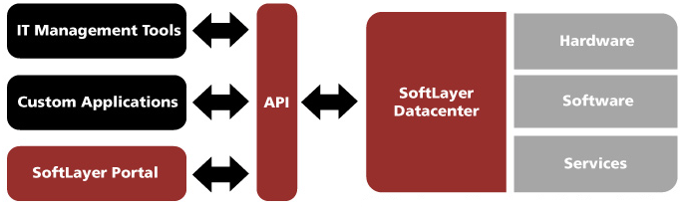

Figure 1.4.4.1-29: Soft Layer API.

SoftLayer Developer Network

SoftLayer allows accessing and managing server(s) anytime, from anywhere, with the administrator’s choice of management software, remotely performing operations such as soft and hard reboots, OS installs and upgrades that normally require expensive human intervention. SoftLayer’s approach combines turning control over to the customer, along with providing numerous online tutorials, and a customer support system complete with helpful staff. SoftLayer is committed to making the server hosting and management process as transparent, easy and painless for its customers as possible.

Server Image Capturing and Deployment

Flex Images are SoftLayer's next-generation server image capturing and deployment system, providing customers the freedom to choose, change, and grow their infrastructure to best suit their application's needs and erase the line between physical and virtual.

With Flex Images, customers can capture images from cloud or dedicated servers, store them in a single image library, and then deploy them on either kind of system.

The advantages are huge. Capabilities that have historically only been available with virtual infrastructure—the ability to quickly clone and reload servers—now available with dedicated servers. SoftLayer’s automated system adapts any image on the fly, so customers can deploy it on any platform or system they choose, enabling simple, seamless migration between physical and virtual environments. And it’s available in SoftLayer’s data centers around the world connected by SoftLayer’s peerless private network (*Figure 1.4.4.1-30*).

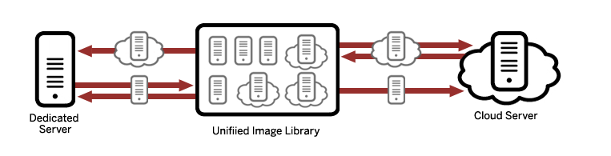

Figure 1.4.4.1-30: Soft Layer Deployment.

SoftLayer Mobile App

The SoftLayer Mobile app keeps customers connected and in control of their SoftLayer services. A full range of management functions puts infrastructure right at your fingertips, anytime and anywhere (*Figure 1.4.4.1-31*).

Functionality includes:

* Tickets: Need help but not in the office? Quickly create a new ticket for a support request or examine existing support tickets and check their status.
* Servers: View performance details and control basic functions your SoftLayer Dedicated Servers and CloudLayer Computing Instances. Easily turn a server off or on, ping the server to test its network availability, or reboot.
* Bandwidth – Monitor the bandwidth usage of your SoftLayer Dedicated Servers, CloudLayer Computing Instance, and Virtual Dedicated Racks.

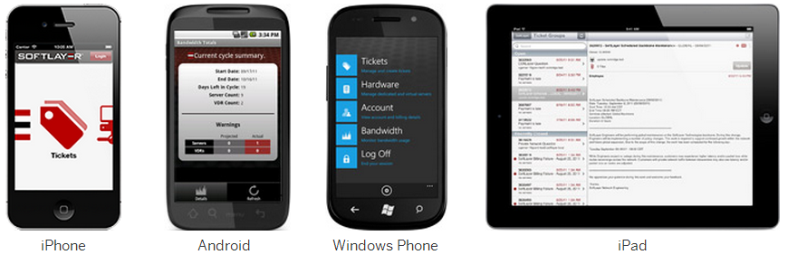

Figure 1.4.4.1-31: Soft Layer Mobile Platform.

SoftLayer Customer Portal

(Administrative UI)The SoftLayer® Customer Portal is an easy-to-use Web interface for remotely managing SoftLayer services and accounts. The Portal provides complete access to more than 200 backend actions, giving control over everything in the SoftLayer environment, including the ability to:

* View performance details and control all functions of SoftLayer dedicated servers and CloudLayer Computing Instances, easily turn a server off or on, view bandwidth graphs, ping servers to test network availability, reboot, and much more.
* Manage accounts, set up billing information, change monthly billing methods, reset passwords, or add new users to accounts.
* Deploy servers, firewalls, new backup solutions, and anything else you’d like to add to your environment on demand.
* Get support in real time by chatting with the SoftLayer support team, submit support tickets, and view valuable technical tutorials and information.

Key Advantages

* **Total User Control:** The Customer Portal gives direct access to SoftLayer infrastructure, providing total system and connectivity access and control that complement direct server management tools.
* **Higher Efficiency for IT Operations:** The Customer Portal reduces the need for human intervention inside the data center, simplifying and accelerating system management and reducing total cost of operations.
* **Secure, Flexible Access:** The Customer Portal provides complete and secure access via SSL Web-based administration over the Internet using any common Web browser.
* **Convenient Technical Resources:** The Customer Portal puts technical resources at your fingertips, with extensive Adobe® Flash® tutorials for software packages.

#### Maintenance & Operations and Support (RFP 3.1.4.4.2)

Team UST adopts a well-defined and mature application support and maintenance process through effective capture of the product runtime environment and customers’ business activity. The approach reflects Team UST’s commitment to creating world-class, technology-driven solutions that help customers increase their productivity. It further focuses on long-term functionality, lower total cost of ownership, stability, and preventive maintenance. The approach leverages Team UST’s robust service delivery mechanisms and proactive approaches to software maintenance. It reflects our broader level strategy of forging partnerships, alliances, and joint ventures for building competencies. *Figure 1.4.4.2-1* below depicts our ITIL based service delivery for maintenance & operations and support key components.

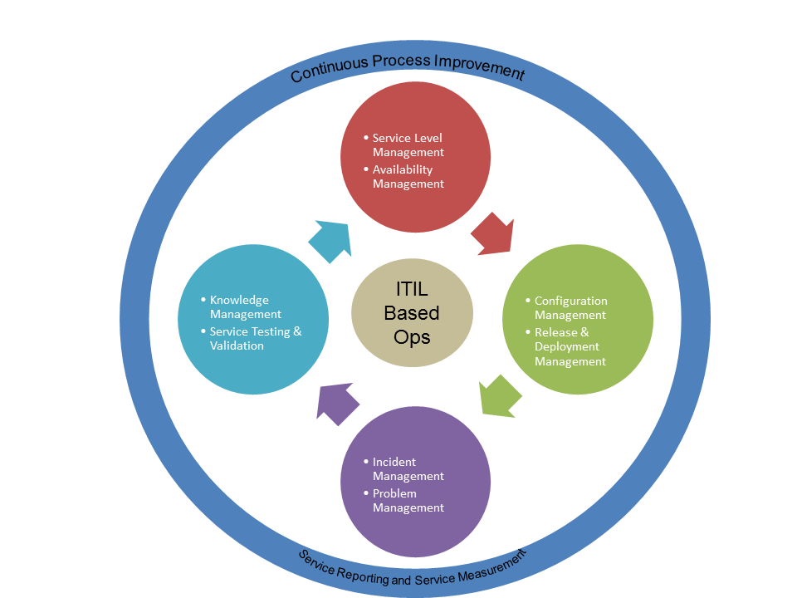

Figure 1.4.4.2-1: O&M Process

The IT Service Management process framework is a comprehensive repository for addressing the process needs of the entire Service management life cycle. This has unique workflows for Incident Management, Problem Management, Change Management and Release Management, ensuring standardization and repeatability. Team UST leverages on its Knowledge Management System to store Known Error Databases and Problem Resolution Databases and make it a central repository for all the application knowledge accumulated as part of delivering Production management services to the client.

The Service Support aspect of ITIL entails the creation of a service desk function that provides a single contact point to the customer. The Service desk function mainly focuses on Incident Management, Problem Management, and Change and Release management. Overall, there is a need to maintain Configuration management.

Application Support and Maintenance (ASM) projects are typically driven through service management framework of ITIL. *Figure 1.4.*4.2-2 below illustrates various stages of ASM projects, including Incident Management, Problem Management, Change Management, Release management and Configuration Management as per the ITIL standards.

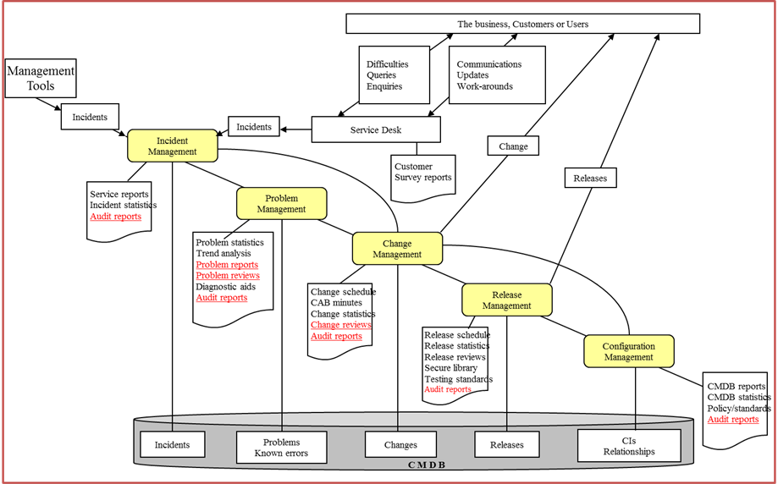

Figure 1.4.4.2-2: Various Stages of ASM.

**Performance and Availability of BuildLA Servers and Applications**

Monitoring, notification, and failure responses provide a higher level of assurance and protection. Team UST offers a variety of monitoring services—including proprietary monitoring software, IPMI 2.0, and SNMP data collection—to watch BuildLA servers and applications.

Monitoring

Each server comes standard with host ping monitoring and IPMI statistics. For those requiring more detailed monitoring, services running on the server can be monitored as well.

Notification

Notification services include an automated email and support ticket generation for host ping or service failures.

Response

Response options include both automated and human response choices. Automated reboot from monitoring allows for an automatic reboot of the server should a monitoring alert occur. The NOC monitoring option includes engineers actively monitoring your server to provide immediate response and personalized notification of an alert or failure.

*Figure 1.4.4.2-*3 represents a high level view of our performance and monitoring work plan for BuildLA servers and applications.

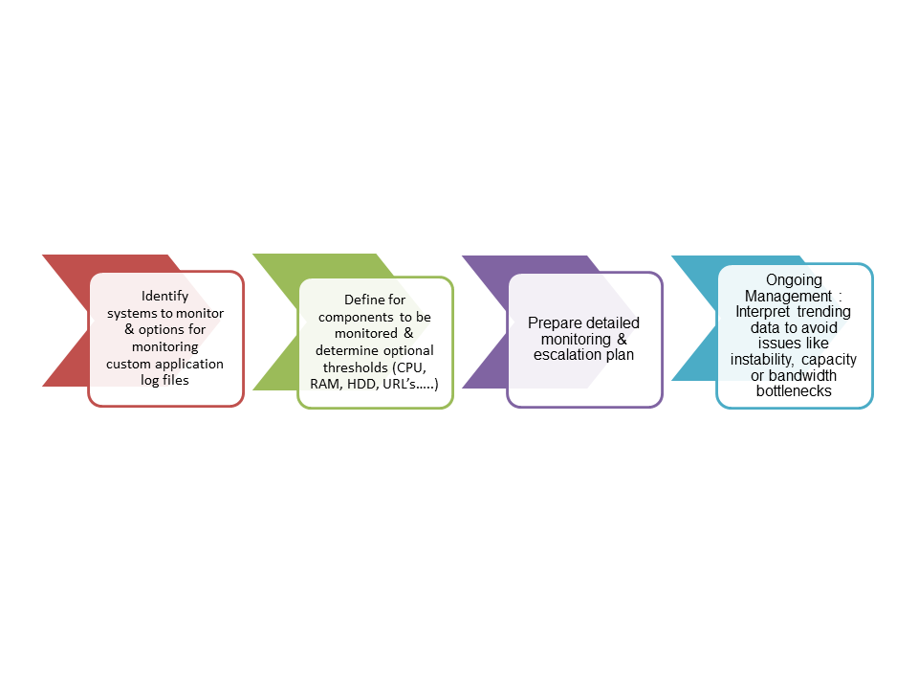

Figure 1.4.4.2-3: Performance and Monitoring Plan.

Sample screenshots of our performance and monitoring solution are provided below in *Figure 1.4.4.2-4*.

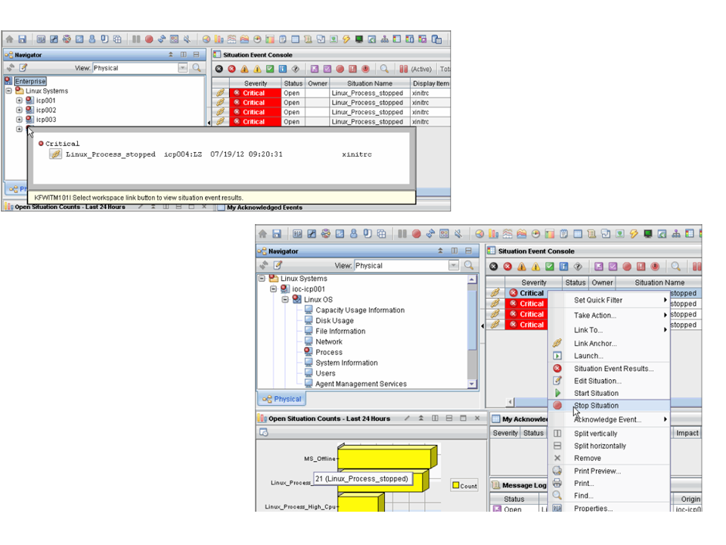

Figure 1.4.4.2-4: Sample Screen Shots.

System and User Administration

The Maintenance & Operations Support Team supports the system and its end users as an integral part of the information system’s day-to-day operations. The Operations or System Administration Manual defines tasks, activities, and responsible parties for these daily activities and must be updated as changes occur. By monitoring the system continuously, the Maintenance Team ensures that the production environment is fully functional and performs as specified. Critical support tasks and activities include:

* Guarantee of required system availability
* Implementation of non-emergency requests during scheduled outages
* Ensuring the documentation in the operating procedures of all processes, manual and automated
* Performance of routine backup and recovery procedures
* Performance of physical security functions by ensuring all system staff and end users have the proper clearances and access privileges
* Asset utilization and Capacity planning
* Diagnostics and Debugging
* Ensuring concurrency and testing of contingency planning for disaster recovery
* Ensuring periodic training on current and new processes for end users
* Ensuring monitoring and meeting of service level objectives while taking remedial actions for any deficiencies
* Monitoring of performance measurements, statistics, and system logs, including monitoring and tuning network traffic

The system log, the Operations Manual, journals, and other logs are invaluable in emergencies and should be kept in a central repository with other operational documentation.

The Support Project Manager reviews the Trouble Ticket Reports, which document problems with the system through an automated system. The reports typically include:

* Date and time
* Issue reporter
* Problem description
* Apparent cause
* Assigned developer
* Resolution
* Test results

Other information may be included and depends on the reporting system. The reporting system should permit an audit of the entire process from problem identification to problem resolution and case closure.

Database Management

Instance Management: Team UST will create documentation and maintain to provide the logical description and physical implementation of the databases within the environment.

Database Standards: Team UST will setup databases and configure in conformance to City of LA database standards and operating processes. A comprehensive set of data standards will be detailed in the Database Management Standards document and the operating processes documents.

Access Privileges

Team UST will closely monitor access privileges and in accordance with policies and standards defined in the City of LA’s Information Security policies. Overarching policies include the following requirements:

* Formal administration process that requires manager level authorization for all users to the database and supporting utilities will be defined.
* Sensitive database utilities (e.g., load utilities) will be restricted to personnel responsible for the maintenance of the databases.
* Establish Database Security administration procedures for:
  + Documented authorization for database access capabilities including input and verification of security related maintenance.
  + Requirement to retain access request forms for not less than 2 years.
  + Periodic review and monitoring of user access capabilities.

Security

Security policies and standards must be in accordance with policies and standards defined in the City of LA Information Security policies.

Changes & Modifications

Team UST DBA will maintain the database using the following procedures:

* Allocating sufficient system storage for the application database
* Adding, altering, and deleting users, roles, and privileges
* Periodically defragmenting and compacting the database for more efficient operation
* Upgrading database software and associated applications, as necessary
* Providing routine backup of the database
* Maintaining an approved list of valid values for data consistency
* Maintaining redundancy control to ensure that each data record is unique and consistent with conventions
* Performance and Tuning
* Recovery

Release Management & Testing

The basic steps that constitute a Release Management Process are shown in *Figure 1.4.4.2-5*. The movement of a Release from left to right depicts process through various environments. It also shows how the change requests on the application are raised for enhancements and how they are released to production with focus on quality and configuration management.

As part of Team UST the roles involved are:

* Release Manager: serves as a liaison between varying business units to promote smooth and timely delivery of software products or updates.
* Configuration Controller: “holds the keys” to production systems/applications and takes responsibility for their implementations.
* Maintenance engineer: help troubleshoot problems with an application (although not typically at a code level).
* UAT Coordinator: utilized to coordinate disparate projects, teams and components.

Some of the challenges facing a software release manager include the management of:

* Software defects
* Issues
* Risks
* Software change requests
* New development requests (additional features and functions)
* Deployment and packaging
* New development tasks

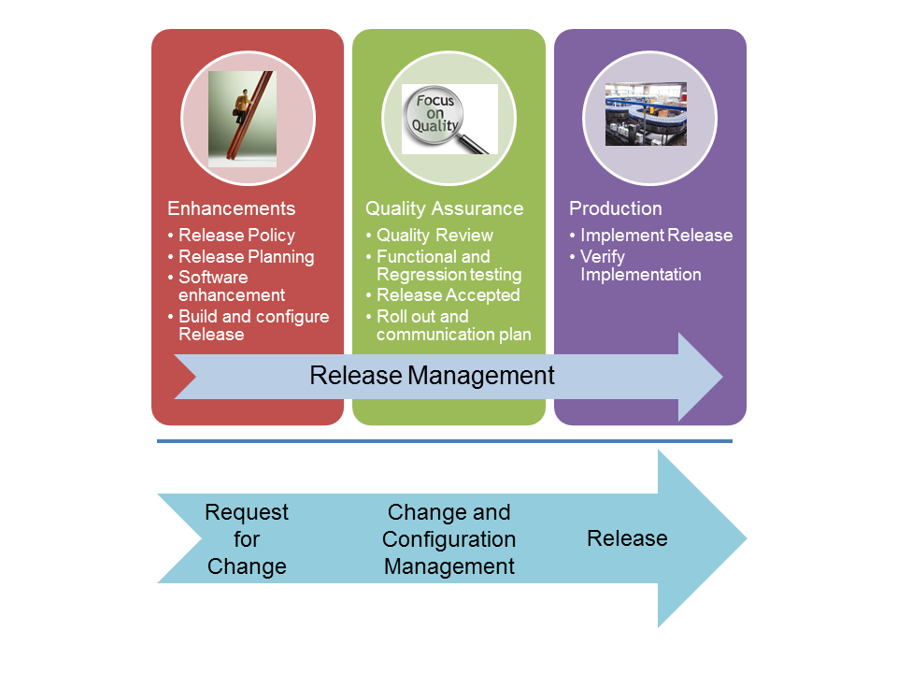

Figure 1.4.4.2-5: Release Management Process.

**Roles, Staff Structure and Rates**

All our support staff will report to the Support Project Manager. Staff roles and rates are shown in *Figure 1.4.4.2-6.*

| Roles | Rates |
| --- | --- |
| Support Project Manager | $150 / hour |
| Maintenance Engineers | $120 / hour |
| Configuration Controller | $120 / hour |
| Release Manager | $90 / hour |
| UAT Coordinator | $100 / hour |
| SQA | $120 / hour |
| Knowledge Transition Coordinator | $70 / hour |
| DBA | $100 / hour |

Figure 1.4.4.2-6: Support Staff Roles and Rates.

Training Service

UST Global performs a TNA (Training Need Analysis) and as part of our training module selection process, the UST Global Project Manager, UST Global Training Manager, program managers from technical partners, the City of LA Project Manager and service owners will work closely to identify training needs, type of training, mode of delivery, schedule, required documentation, and training pre-requisites.

Web based training using tools such as WebEx or Live Meeting will be scheduled wherever appropriate in order to bring down costs associated with travel and facilities. The instructor-led hands on training will be provided by our Training Lead with assistance from one or more UST Global staff to ensure appropriate level of help, guidance, and support during training.

Incident and Problem Management

The objective of the Incident Management and Problem Management is to provide a straightforward and workable process for handling all types of service inhibiting situations with minimum effort. Though, they both share the goal of maximizing end user satisfaction with multi-tiered Support and overall solution usage, they have quite different immediate objectives. While Incident Management aims at restoring normal service operation as quickly as possible and minimizing the adverse impact on business operations, Problem Management focuses at minimizing the adverse impact of Incidents and Problems on the business that are caused by errors within the IT Infrastructure, and to prevent the recurrence of incidents related to these errors. *Figure 1.4.4.*2*-7* shows the timeline relationship between Incident and Problem Management flow:

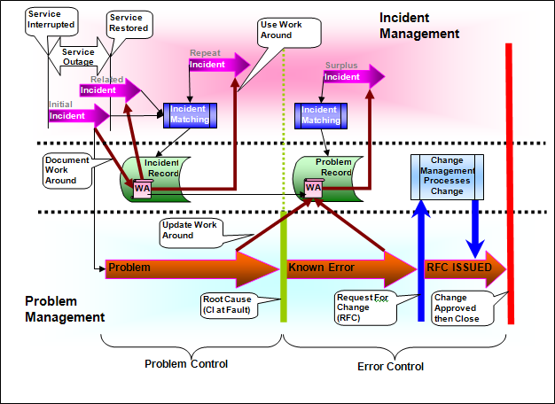

Figure 1.4.4.2-7: Incident and Problem Management Flow.

The following activities are central to the Incident Management process and consequently a key indicator to its success:

Interface Management

The key objective of the interface management process is to assure the proper functioning of a system composed of many interfacing sub-systems. Ineffective interface management is frequently accountable for the failure of large applications that are client facing. Interface reliability is particularly important with projects involving stringent web facing, safety and security requirements.

As part of our ESB implementation Team UST will leverage its Error-Handling Framework (EHF) and Logging Framework to track any failures in integrations interfacing with sub-systems. The interfaces that will be built can be monitored and administered by maintenance engineers by leveraging the dashboard that provides the status of each. The business-critical real time interfaces will be monitored programmatically to ensure that they are available meeting business needs.

Disaster Recovery

Disaster Recovery strategies should be developed for Information technology (IT) systems, applications and data. Priorities for IT recovery should be consistent with the priorities for recovery of business functions and processes that were developed during the business impact analysis. Maintenance team resources as part of support team will ensure support time-sensitive business functions and processes are properly functioning when systems, applications and data are switched to DR site. The recovery time for an IT resource should match the recovery time objective for the business function or process that depends on the IT resource.

Team UST BuildLA business applications cannot tolerate any downtime. They utilize data centers capable of handling all data processing needs, which run in parallel with data mirrored or synchronized.

Maintenance and Operations RACI Matrix

The City’s defined roles and responsibilities have been incorporated into our Maintenance and Operations RACI matrix. In any instance in which there may be a conflict within the Team UST proposal response, the RACI matrix as shown in Figure 1.4.4.2-7-1 will prevail.

|  |
| --- |
| **RACI Key** |
| The following definitions apply to this Maintenance and Operations RACI Matrix:  Responsible (R) - Primary responsibility for the role and responsibility  Approve (A) - Signoff / approval of the role and responsibility  Consult (C) - Be consulted, provide expertise, information or perspective during the role and responsibility.  Inform (I) - Be informed during and upon completion of the role and responsibility |

| Sec  No. | | Item  No. | | Service Description Roles and Responsibilities | | Team UST Support Team  Team | BuildLA Support Team  Team |
| --- | --- | --- | --- | --- | --- | --- | --- |
| I | | **BUSINESS PROCESS DEVELOPMENT** | | | |  |  |
| 1 | | Process Design & Revisions | | **I** | **R** |
| 2 | | Design Authority | | **I** | **R** |
| 3 | | Change Control | | **R** | **C** |
| 4 | | Template Management | | **R** | **I** |
|  | | | | | |  |  |
| II **ENTERPRISE SYSTEMS MANAGEMENT**  **Enterprise Systems Management** | | | | | |  |  |
|  |  |
|  | | 1 | | Align IT strategy with business strategy | | **C** | **R** |
| 2 | | Define IT mission, vision | | **I** | **R** |
| 3 | | Assign priorities to major requests for information systems | | **C** | **R** |
| 4 | | Produce long range systems plan | | **C** | **R** |
| 5 | | Conduct IT Steering Committee Meetings | | **C** | **R** |
| 6 | | Determine hardware platform/strategy | | **R** | **C** |
| 7 | | Perform annual technology audit | | **C** | **R** |
| 8 | | Assess requests for major configuration changes to application components | | **R** | **A** |
| 9 | | Assess new application release impact on the Architecture | | **R** | **A** |
| 10 | | Define annual discretionary/non-discretionary spending plans | | **C** | **R** |
|  | | | | | |  |  |
| III **SERVICE MANAGEMENT**  **Application Service Management** | | | | | |  |  |
|  |  |
|  | | 1 | | Receive business requests, monitor and report progress to business | | **R** | **A** |
| 2 | | Prioritize and approve major project or service requests | | **C** | **R** |
| 3 | | Approve requests requiring application configuration changes | | **C** | **R** |
| 4 | | Maintain prioritization of project or major service requests | | **C** | **R** |
| 5 | | Provide application service level reporting | | **R** |  |
| 6 | | Power user team meetings | |  |  |
|  | | a. | Schedule and lead end user meetings | **C** | **R** |
|  | | b. | Attend end user meetings | **C** | **R** |
| 7 | | Develop and document application service levels | |  |  |
|  | | a. | Develop and document service levels for application and database | **R** | **A** |
|  | | b. | Develop and document service levels for dependent components - Operating System, Disk, Network, etc. | **C** | **R** |
| 8 | | Application Quality Management | |  |  |
|  | | a. | Assess and document stakeholder expectations | **C** | **R** |
|  | | b. | Perform quality management reviews and communicate to stakeholders | **C** | **R** |
|  | | c. | Monitor progress against quality plan action items | **C** | **R** |
| **Help Desk Support Services** | | | | | |  |  |
|  | | 9 | | User Support (Level 0/1) | | **C** | **R** |
|  | | a. | Answer User "how-to" questions | **C** | **R** |
|  | | b. | Deliver end-user refresher training | **C** | **R** |
|  | | c. | Log incidents with the help desk or directly into the incident management tool (if no help desk) | **C** | **R** |
|  | | d. | Capture and log enhancement requests | **C** | **R** |
|  | | 10 | | Help Desk (Level 1) | |  |  |
|  | | e. | Trouble shoot, manage, track & report problems users experience with application and in-scope supporting components | **C** | **R** |
|  | | e1 | Perform initial triage in order to troubleshoot, manage, track & report problems users experience with the application and in-scope application components | **C** | **R** |
|  | | e2 | Forward to Level 2 support to manage, track & report problems users experience with the application and in- scope application components | **C** | **R** |
| 11 | | Provide problem escalation, review and reporting | |  |  |
|  | | a. | Maintain Level 1 problem escalation procedures | **C** | **R** |
|  | | b. | Maintain Level 2 application support escalation procedures | **R** | **C** |
|  | | c. | Maintain Level 2 infrastructure support escalation procedures | **C** | **R** |
| **Change Control** | | | | | |  |  |
|  | | 12 | | Overall accountability for system change management activities | | **R** | **A** |
| 13 | | Define Application change control requirements | | **R** | **A** |
| 14 | | Document and maintain change execution procedures | | **R** | **A** |
| 15 | | Application Environment Coordination and Planning | |  |  |
|  | | a. | Plan and implement release strategy | **R** | **A** |
|  | | b. | Define Project and/or Release schedules | **R** | **A** |
|  | | c. | Serve as communication point for application environment events | **R** | **C** |
|  | | d. | Represent application events in appropriate Change Control Review Board setting | **R** | **C** |
|  | | e. | Comply with all application change control and notification processes | **R** | **C** |
|  | | f. | Release migration | **R** | **A** |
|  | | g. | Identify release business contingency plan | **R** | **A** |
| 16 | | Control system changes and activities | |  |  |
|  | | a. | Overall accountability for system change control | **R** | **A** |
|  | | b. | Perform application and in-scope application/database break/fix unit testing | **R** | **C** |
|  | | c. | Perform hardware or operating system break/fix unit testing | **R** | **C** |
|  | | d. | Perform application and in-scope components/database break/fix regression prior to migration of production changes |  |  |
|  | | d1 | Perform application and in-scope components regression testing | **R** | **C** |
|  | | d2 | Test and accept application and in-scope component changes and approve into Production | **R** | **A** |
|  | | e | Conduct user acceptance test of application changes prior to introduction to Production |  |  |
|  | | e1 | Support liaisons and business Super Users with user acceptance test of application changes prior to introduction to Production | **R** | **C** |
|  | | e2 | Conduct user acceptance test of application changes prior to introduction to Production | **C** | **R** |
|  | | f. | Change Control Review Board |  |  |
|  | | f1 | Provide application and in-scope components input for changes required to environment | **R** | **C** |
|  | | f2 | Provide infrastructure input for changes required to environment | **R** | **C** |
|  | | f3 | Coordinate and provide business approval for changes that are ready to promote to production | **C** | **R** |
|  | | f4 | Manage Change Control Board process and approvals | **C** | **R** |
|  | | f5 | Provide integration between application and all other hosted environments | **R** | **C** |
|  | | g. | Process change requests | **R** | **A** |
|  | | h. | Provide notification of change warnings and errors | **R** | **C** |
|  | | i | Clean up environment within application and in-scope components (temporary programs, stale corrections, repairs, etc.) | **R** | **C** |
|  | | j. | Clean up application and in-scope component environments within operating system | **R** | **I** |
|  | | k. | Execute Operating System level commands & service programs to support application changes and other application functions | **R** | **A,C** |
|  | | l. | Execute processes (imports) | **R** | **A** |
|  | | m. | Execute application transaction processes (table copies, etc.) | **R** | **A** |
|  | | n. | Address technical change problems | **R** | **A** |
|  | |  | | o. | Address functional change problems | **R** | **C** |
|  | | p. | Document change activities | **R** | **A,C** |
|  | | q. | Perform Operating System maintenance activities. | **R** | **A,C** |
|  | | r. | Perform Vendor database maintenance activities. | **R** | **A,C** |
| 17 | | Coordinate and document change schedule - Release Management | |  |  |
|  | | a. | Coordinate and document release schedule for the application and in-scope components | **R** | **A,C** |
|  | | b. | Coordinate and document change schedule for Operating System maintenance | **R** | **A,C** |
|  | | c. | Coordinate and document change schedule for Vendor database maintenance: | **R** | **A,C** |
|  | | d. | Coordinate & document change scheduled for the application and other in-scope components | **R** | **A,C** |
|  | | e. | Coordinate and document batch job schedule changes | **R** | **A,C** |
| 18 | | Implement standard procedures and methods for change | |  |  |
|  | | a. | Implement standard procedures for the application and other in-scope components | **R** | **A,C** |
|  | | b. | Implement standard procedures for Operating System maintenance | **R** | **C** |
|  | | c. | Implement standard procedures for database maintenance | **R** | **C** |
|  | | d. | Implement standard procedures for batch job maintenance | **R** | **C** |
|  | | e. | Implement procedure for batch job schedule changes | **R** | **C** |
| 19 | | Report status of scheduled changes | |  |  |
|  | | a. | Report status of scheduled change requests | **R** | **C** |
|  | | b. | Report status of scheduled Operating System level commands & service programs used to support the application functions | **R** | **I** |
|  | | c. | Report status of Operating System maintenance | **R** | **I** |
|  | | d. | Report status of database maintenance | **R** | **I** |
|  | | e. | Report status of the application commands/functions executed | **R** | **I** |
|  | | f. | Report status of batch job schedule changes | **R** | **A,C** |
| 20 | | Assess impact of change | |  |  |
|  | | a. | Assess impact of the application production changes, prior to and after implementation | **R** | **C** |
|  | | b. | Assess impact of Operating System changes prior to and after implementation | **R** | **C** |
|  | | c. | Assess impact of database changes prior to and after implementation | **R** | **C** |
|  | | d. | Access impact of the application commands/functions executed | **R** | **C** |
|  | | e. | Access impact for batch job schedule changes | **R** | **C** |
| 21 | | Customer Services | |  |  |
|  | | a. | User Satisfaction Management | **C** | **R** |
|  | | b. | Customer Issue resolution | **R** | **C** |
|  | | c. | SLA reporting |  |  |
|  | | c1 | Infrastructure | **R** | **C** |
|  | | c2 | Applications | **R** | **C** |
| 22 | | Continuous Improvement | |  |  |
|  | | a. | Cross-Supplier | **R** | **C** |
|  | | b. | Infrastructure | **R** | **C** |
|  | | c. | Applications | **R** | **C** |
|  | | d. | Help Desk - Level 1 | **C** | **R** |
|  | | e. | Help Desk - Level 2 and above | **R** | **C** |
| 23 | | Financial Management | |  |  |
|  | | a. | Budgeting | **C** | **A,R** |
|  | | b. | Reporting actuals |  |  |
|  | | b1 | Infrastructure | **R** | **A** |
|  | | b2 | Applications | **R** | **A** |
|  | | b3 | Help Desk - Level 1 | **C** | **R** |
|  | | b4 | Help Desk - Level 2 and above | **R** | **A,C** |
|  | | c. | Managing Costs | **R** | **A** |
|  | | 24 | | Service Provider Integration | |  |  |
|  | | a. | Coordinate change requests across service providers | **R** | **A,C** |
|  | | b. | Manage SWAT teams for critical incidents | **R** | **A,C** |
|  | | c. | Arbitrate incidents which fall across resolving domains | **C** | **R** |
|  | | | | | |  |  |
| IV | | **APPLICATION MANAGEMENT**  **Software Installation(and Project)** | | | |  |  |
|  |  |
|  | | 1 | | Install application components | | **R** | **C** |
| 2 | | Load pre-configured clients, templates & scripts in support of the project | | **R** | **C** |
| 3 | | Create initial project specific clients | | **R** | **C** |
| 4 | | Determine database / file system impacts | | **R** | **C** |
| 5 | | Specify OS kernel parameters required to support the application | | **R** | **C** |
| 6 | | Setup the application and appropriate database users | | **R** | **A,C** |
| 7 | | Obtain the application license keys | | **R** | **C** |
| 8 | | Configure initial application Instance Management | | **R** | **C** |
| 9 | | Install appropriate database software | | **R** | **C** |
| 10 | | Load standard database delivered or import database copy | | **R** | **C** |
| 11 | | Setup work process and operations mode definitions | | **R** | **C** |
| 12 | | Identify & configure technical settings | | **R** | **C** |
| 13 | | Install the application front-end on PC, if required | | **R** | **A,C** |
| 14 | | Perform operations readiness test on the application installation | | **R** | **A** |
| 15 | | Apply the application level security controls (initial passwords, security control parms, etc.) | | **R** | **A,C** |
|  | | **Level Two and Three Application Problem Management** | | | |  |  |
|  | | 16 | | Track and report Incidents and Problems | |  |  |
|  | | a. | Trouble shoot, manage, track & report operations problems with disk sub-system, operating system, network, etc. | **R** | **C,I** |
|  | | b. | Trouble shoot, manage, track & report operations problems that are result of database and application | **R** | **C,I** |
|  | | c. | Trouble shoot, manage, track, report the application and in-scope components technical problems | **R** | **C,I** |
|  | | d. | Trouble shoot, manage, track, report the application database problems | **R** | **C,I** |
|  | | e. | Trouble shoot, manage, track application desktop installation issues required for Vendor Support team | **R** | **C,I** |
|  | | f. | Provide user assistance / Level 2 Support functions | **R** | **C,I** |
| 17 | | Initiate problem resolution - prioritize, assign resources | | **R** | **C,I** |
| 18 | | Analyze application problem | | **R** | **C,I** |
| 19 | | Escalate problems as necessary according to procedures from SLA | | **R** | **C,I** |
| 20 | | Coordinate 3rd level application problem management for the application and in-scope components | | **R** | **C,I** |
| 21 | | Break/Fix Support | |  |  |
|  | | a. | Design, build and test application fixes | **R** | **C** |
|  | | b. | Design, build and test infrastructure fixes | **R** | **C** |
|  | | c. | Approve fixes | **I** | **R** |
|  | | d. | Unit Test fixes | **R** | **I** |
|  | | e. | String test fixes | **R** | **I** |
|  | | f. | Integration test fixes | **R** | **A,C** |
| 22 | | Coordinate migration of changes to production | | **R** | **A,C** |
| 23 | | Analyze problem trends | | **R** | **C** |
| 24 | | Overall accountability for level two application problem management | | **R** | **C** |
| 25 | | Provide application desktop configuration for application and in-scope components | | **R** | **C** |
|  | | **Minor Enhancements and Ad Hoc Requests** | | | |  |  |
|  | | 26 | | Capture and verify service request (i.e. new report, configuration change, etc.) | | **C** | **R** |
| 27 | | Maintain backlog of requests | | **R** | **C** |
| 28 | | Create Conceptual and Functional Design | | **R** | **A,C** |
| 29 | | Create Technical Design | | **R** | **A,C** |
| 30 | | Estimate effort and perform application impact assessment | | **R** | **C** |
| 31 | | Review and approve ad hoc request | | **C** | **R** |
| 32 | | Create and review application configuration change/modification plans | | **R** | **A** |
| 33 | | Conduct walk-through review of configuration change/modification | | **R** | **C** |
| 34 | | Program, compile and document configuration changes/modifications | | **R** | **C** |
| 35 | | Perform unit testing on all changes | | **R** | **I** |
| 36 | | Perform string testing | | **R** | **I** |
| 37 | | Perform integration testing | | **R** | **A,C** |
| 38 | | Perform regression testing | | **R** | **A,C** |
| 39 | | Perform user acceptance testing for all changes | | **C** | **R** |
| 40 | | Plan and manage end-user training and adoption of modifications | | **C** | **R** |
| 41 | | Deliver end-user training | | **C** | **R** |
| 42 | | Update user documentation and training materials | | **R** | **A,C** |
| 43 | | Maintain technical architecture documentation | | **R** | **A,C** |
| 44 | | Evaluate impact on applications DR plan | | **R** | **C** |
| 45 | | Evaluate impact on system capacity and performance | | **R** | **C** |
| 46 | | Deliver other (non-system) ad hoc requests | | **C** | **R** |
| **Software Patching (Kernel, Support Package, Patches)** | | | | | |  |  |
|  | | 47 | | Develop standards & procedures for support packs, patch, etc. application | | **R** | **C** |
| 48 | | Apply vendor released changes/updates to the application | | **R** | **A,C** |
| 49 | | Apply recommended application and in-scope component bug fixes (hotpacks, etc.) | | **R** | **A,C** |
| 50 | | Apply corrections supplied by the application vendor for standard application modules | | **R** | **A,C** |
|  | | | | | |  |  |
|  | | **Core System Administration Tasks**  **OS System Startup/Shutdown** | | | |  |  |
|  |  |
|  | | 51 | | Develop procedures for OS startup/shutdown | | **R** | **C** |
| 52 | | Define schedule for planned OS startup/shutdown | | **R** | **C** |
| 53 | | Notify all parties for planned/unplanned OS startup/shutdown | | **R** | **I** |
| 54 | | Execute OS startup/shutdown | | **R** | **A,C** |
| 55 | | Restart hardware/OS following fault correction | | **R** | **C** |
| 56 | | Perform Operational Readiness Test (ORT) at OS startup/shutdown | | **R** | **A,C** |
|  | | **OS Backup / Recovery** | | | |  |  |
|  | | 57 | | Test central/remote backup/restore procedures periodically | | **R** | **C** |
| 58 | | Prepare system for OS backup processes | | **R** | **C** |
| 59 | | Perform complete/incremental OS backup | | **R** | **C** |
| 60 | | Monitor OS backup processes | | **R** | **C** |
| 61 | | Verify OS backup media integrity | | **R** | **C** |
| 62 | | Notify OS backup has failed | | **R** | **C,I** |
| 63 | | Label OS backup media | | **R** | **C** |
| 64 | | Store copies of the OS backups in a vault/off-site | | **R** | **C** |
| 65 | | Maintain backup architecture (tape library, drives, etc.) | | **R** | **C** |
| 66 | | Synchronize OS backups and restores - tape rotation | | **R** | **C** |
| 67 | | Prepare system for OS restoration processes | | **R** | **C** |
| 68 | | Restore single/multiple OS objects from the backup media | | **R** | **C** |
| 69 | | Restore complete/incremental OS backup | | **R** | **C** |
| 70 | | Monitor OS restoration processes | | **R** | **C** |
| 71 | | Validate OS integrity and consistency of restored information | | **R** | **C** |
| 72 | | Notify OS restoration has been completed | | **R** | **C** |
|  | | **Application Startup and Shutdown** | | | |  |  |
|  | | 73 | | Define Application Startup/shutdown schedule | | **R** | **A,C** |
| 74 | | Define Database startup/shutdown schedule | | **R** | **A,C** |
| 75 | | Perform starting and stopping of Application and components | | **R** | **I** |
| 76 | | Perform starting and stopping of the Database | | **R** | **I** |
| 77 | | Perform stopping and restarting of batch schedule on Production | |  |  |
|  | | a. | Perform stopping and restarting of application components of the batch schedule in Production | **R** | **I** |
|  | | b. | Perform stopping and restarting of non-application tool components of the Production batch schedule | **R** | **I** |
| 78 | | Restart Application after failure | |  |  |
|  | | a. | Restart disk subsystem, O/S, network components | **R** | **I** |
|  | | b. | Restart application | **R** | **I** |
|  | | c | Restart database | **R** | **I** |
| **Database Backup/Restore Management** | | | | | |  |  |
|  | | 79 | | Prepare system for backup processes | | **R** | **C** |
| 80 | | Test central/remote application backup/restore procedures periodically | | **R** | **C** |
| 81 | | Perform complete/incremental backup | | **R** | **C** |
| 82 | | Monitor backup processes | | **R** | **C** |
| 83 | | Verify backup media integrity | | **R** | **C** |
| 84 | | Notify backup has failed | | **R** | **C** |
| 85 | | Label backup media | | **R** | **C** |
| 86 | | Store copies of the backups in a vault/off-site | | **R** | **C** |
| 87 | | Maintain backup library | | **R** | **C** |
| 88 | | Synchronize application backups and restores - tape rotation | | **R** | **C** |
| 89 | | Prepare application and database for restoration processes | | **R** | **C** |
| 90 | | Restore single/multiple objects from the application backup media | | **R** | **A,C** |
| 91 | | Restore complete/incremental application backup as required | | **R** | **A,C** |
| 92 | | Monitor restoration process | | **R** | **I** |
| 93 | | Roll forward from the archive logs after a restore (i.e., point in time recovery) | | **R** | **I** |
| 94 | | Validate integrity and consistency of restored information | |  |  |
|  | | a. | Validate integrity and consistency of restored information at Database layer | **R** | **I** |
|  | | b. | Validate integrity and consistency of restored information at application layer | **R** | **I** |
|  | | c. | Validate integrity and consistency of restored information at OS layer | **R** | **I** |
|  | | d. | Perform business level validation of integrity and consistency of restored information | **C,I** | **R** |
| 95 | | Notification to Support team and City Liaison that restoration has been completed | | **R** | **I** |
| 96 | | Define requirements for backup times and schedules | | **R** | **A,C** |
| 97 | | Create and maintain backup scripts | | **R** | **I** |
| **Database Management** | | | | | |  |  |
|  | | 98 | | Plan / implement the application database disk layout | | **R** | **I** |
| 99 | | Plan database extensions | | **R** | **I** |
| 100 | | Perform database extensions | | **R** | **I** |
| 101 | | Manage table space usage | | **R** | **I** |
| 102 | | Manage next extent sizes | | **R** | **I** |
| 103 | | Perform database profile modifications as required - tuning | | **R** | **I** |
| 104 | | Perform database reorganizations | | **R** | **I** |
| 105 | | Backup database archive logs to tape | | **R** | **I** |
| 106 | | Resolve Database problems | | **R** | **I** |
| 107 | | Perform database imports/exports | | **R** | **I** |
| 108 | | Perform database upgrades and patches | | **R** | **A,C** |
| 109 | | Creation of indexes | | **R** | **I** |
| 110 | | Assist development team in optimizing SQL statements (indexes, selects etc.) | | **R** | **I** |
| 111 | | Assess the application database capacity/utilization | | **R** | **C** |
| 112 | | Respond to alerts, investigate and resolve issues | | **R** | **C** |
|  | | 113 | | Schedule Database specific related jobs | | **R** | **C** |
|  | | 114 | | Perform DB copies and application database refreshes | | **R** | **C** |
|  | | 115 | | Analysis of database functions using vendor provided application tools | | **R** | **I** |
|  | | 116 | | Database administration using application tools | | **R** | **I** |
|  | | 117 | | Plan, manage, and coordinate Database upgrades and patches | | **R** | **A,C** |
|  | | **OS Administration** | | | |  |  |
|  | | 118 | | Install/Configure OS per the application requirements | | **R** | **I** |
|  | | 119 | | Detect / Troubleshoot OS problems / Events | | **R** | **I** |
|  | | 120 | | Work with Hardware vendor to resolve OS problems | | **R** | **I** |
|  | | 121 | | Apply patches to the OS | | **R** | **I** |
|  | | 122 | | Perform OS Upgrades | | **R** | **I** |
|  | | 123 | | Create file systems and/or logical volumes per storage policy/procedure | | **R** | **I** |
|  | | 124 | | Administer OS scheduler (UNIX CRON, etc.) | | **R** | **I** |
|  | | 125 | | Administer NFS requirements | | **R** | **I** |
|  | | 126 | | Administer output management devices (print/fax devices) | | **R** | **I** |
|  | | **Application Client Operations** | | | |  |  |
|  | | 127 | | Develop and Maintain Client/Instance Strategy approach | | **R** | **A,C** |
|  | | 128 | | Perform application-specific technical operations | | **R** | **I** |
|  | | 129 | | Perform external client removes, copies and refreshes | | **R** | **A,C** |
|  | | 130 | | Perform client exports/imports between the various application instances | | **R** | **A,C** |
|  | | 131 | | Provide service level management with feedback on system availability and operations | | **R** | **C** |
|  | | 132 | | Post client operation system messages | | **R** | **I** |
|  | | 133 | | Investigate and resolve application technical problems | | **R** | **C** |
|  | | 134 | | Maintain application technical settings | | **R** | **I** |
|  | | 135 | | Investigate and resolve functional errors (application, database tables/fields, etc.) Submit client operations requests | | **R** | **C** |
|  | | 136 | | Maintain instance/client configuration documentation | | **R** | **A,C** |
|  | | 137 | | Administer Client Copy Schedule | | **R** | **C** |
|  | | 138 | | Develop and Maintain Client/Instance Strategy approach | | **R** | **C,I** |
|  | | **Application Technical Patches and Packaged Code Updates** | | | |  |  |
|  | | 139 | | Determine overall technical patch and packaged code update approach and work plan Implementation of application-specific technical patches and packaged code updates Execute technical and functional operations to resolve application conflicts | | **R** | **C** |
|  | | 140 | | Test support package and kernel updates - application testing | | **R** | **I** |
|  | | 141 | | Test application technical patches and packaged code updates - business testing | | **R** | **I** |
|  | | 142 | | Manage, plan, coordinate support pack implementations | | **R** | **I** |
|  | | 143 | | Determine overall technical patch and packaged code update approach and work plan Implementation of application-specific technical patches and packaged code updates Execute technical and functional operations to resolve application conflicts | | **C** | **R** |
|  | | 144 | | Test support package and kernel updates - application testing | | **R** | **A,C** |
|  | | **Database Problem Management** | | | |  |  |
|  | | 145 | Analyze incident trends to determine problems | | | **R** | **I** |
|  | | 146 | Operate support Tier 3 for database support. Receive request from Tier 1 help desk / Tier 2 | | | **R** | **I** |
|  | | 147Aa | Assess request criticality, effort required and approvals required | | | **R** | **C** |
|  | | 147B | Log and categorize problem | | | **R** | **C, I** |
|  | | 148A | Coordinate request scheduling | | | **R** | **C** |
|  | | 148B | Initiate problem resolution - prioritize, assign resources | | | **R** | **C** |
|  | | 149A | Track problem resolution progress | | | **R** | **C,I** |
|  | | 149B | Escalate problems as necessary | | | **R** | **A,C** |
|  | | 150A | Determine problem resolution or work-around solution | | | **R** | **C** |
|  | | 150B | Test problem resolution | | | **R** | **C** |
|  | | 151 | Communicate resolution status - closure notification. Generate and disseminate reports from tracking database | | | **R** | **I** |
|  | | 152 | Correspond with appropriate vendors for resolution of problems | | | **R** | **I** |
|  | | **Output Management** | | | |  |  |
|  | | 153 | Define printer / fax / output management requirements | | |  |  |
|  | |  | | a. | Provide business requirements for printer / fax / output management | **C** | **R** |
|  | | b. | Define application requirements for printer / fax / output management | **R** | **C** |
|  | | c. | Define technical requirements for printer / fax / output management | **R** | **C** |
| 154 | | Configure, monitor, test and manage OS printer / fax / output management queues and spool files | | **R** | **C** |
| 155 | | Configure and test printer / fax / output management in application based on existing standards | | **R** | **C** |
| 156 | | Maintain printer / fax / output management application parameters | | **R** | **C** |
| 157 | | Manage application printer / fax / output management processes and output queues at the application layer | | **R** | **C** |
| 158 | | Investigate and resolve application related printer / fax / output management problems | | **R** | **C** |
| 159 | | Investigate and resolve infrastructure related printer / fax / output management problems | | **R** | **C** |
| 160 | | Provide output management device maintenance & service | | **R** | **C** |
| 161 | | Provide technical team with output device IP address / technical configuration | | **R** | **C** |
| 162 | | Cancel output jobs at O/S level | | **R** | **I** |
| 163 | | Configure printer / fax / output management profile parameters in the application | |  |  |
|  | | a. | Support and maintain printer / fax / output application | **R** | **C** |
|  | | b. | Support and maintain printer / fax / output integration components on the application | **R** | **C** |
|  | | c. | Support and maintain printer / fax / output integration components on the server | **R** | **C** |
|  | | d. | Support and maintain printer / fax / output integration server | **R** | **C** |
|  | | | | | |  |  |
| **Batch - Job Control and Scheduling** | | | | | |  |  |
|  | | 164 | | Define business requirements governing batch schedule | | **C** | **R** |
| 165 | | Job scheduling plan analysis and design (with changes / deletion management) | | **R** | **C** |
| 166 | | Define job dependencies | | **R** | **C** |
| 167 | | Distribute production job schedule | | **R** | **C** |
| 168 | | Define parameters and variants for production jobs | | **R** | **A,C** |
| 169 | | Job Scheduling creation and execution | |  |  |
|  | | a. | Job scheduling in application | **R** | **C** |
|  | | b. | Job definition in Production control tool | **R** | **C** |
|  | | c. | Job definition in application if control tool is native to application | **R** | **C** |
| 170 | | Identify and facilitate resolution of scheduling conflicts | | **R** | **C** |
| 171 | | Job Monitoring Configuration and Execution | |  |  |
|  | | a. | Job monitoring configuration and execution in application | **R** | **I** |
|  | | b. | Job monitoring configuration and execution in production control tool | **R** | **I** |
|  | | c. | Monitoring of failed jobs that are submitted ad-hoc by business users | **R** | **I** |
| 172 | | Assess impact of failed jobs | | **R** | **C** |
| 173 | | Notification of failed jobs | |  |  |
|  | | a. | Notification of failed jobs that are monitored with native application tools | **R** | **I** |
|  | | b. | Notification of failed jobs that are monitored with production control tool | **R** | **I** |
|  | | c. | Notification of failed jobs that are submitted ad-hoc by business users | **R** | **I** |
|  | | d. | Verify results for completion and accuracy | **R** | **I** |
| 174 | | Recover/resolve from failed jobs | | **R** | **A,C** |
| 175 | | Terminate/cancel jobs per requests or pre-defined procedures | | **R** | **C** |
| 176 | | Job rejection analysis with error notification to the users using coded procedures | | **R** | **I** |
| 177 | | Provide schedule status and escalate problems | |  |  |
|  | | a. | Provide schedule status and escalate problems for jobs monitored with native application tools | **R** | **C** |
|  | | b. | Provide schedule status and escalate problems for jobs monitored with production control tools | **R** | **C** |
|  | | c. | Terminate / cancel jobs per requests or pre-defined procedures | **R** | **C,I** |
|  | | | | | |  |  |
| **Technical Task Level Operations**  **System Performance Tuning and Management** | | | | | |  |  |
|  |  |
|  | | 178 | | Application performance and tuning | |  |  |
|  | | a. | Application performance and tuning as related to application layer code, database configuration and layout, objects and configuration | **R** | **I** |
|  | | b. | Determination and definition of performance and tuning requirements that are related to operating system configuration and layout, disk sub-system configuration and layout, or network configuration and throughput. | **R** | **I** |
|  | | c. | Implementation of performance and tuning requirements as related to operating system configuration and layout, disk sub-system configuration and layout, and network configuration and throughput | **R** | **C,I** |
| 179 | | Database layer performance and tuning | |  |  |
|  | | a. | Database performance and tuning as related to database configuration and layout, table reorganizations, index reorganizations, trigger and code tuning | **R** | **C** |
|  | | b. | Determination and definition of performance and tuning requirements that are related to operating system configuration and layout, disk sub-system configuration and layout, or network configuration and throughput. | **R** | **C** |
|  | | c. | Database performance and tuning as related to operating system configuration and layout, disk sub-system configuration and layout, and network configuration and throughput | **R** | **C** |
| 180 | | Operating System performance and tuning | |  |  |
|  | | a. | Create and distribute reports on system and network utilization, capacity, and performance | **R** | **I** |
|  | | b. | Identify/recommend potential OS tuning adjustments | **R** | **C,I** |
|  | | c. | Alter tunable OS parameters | **R** | **I** |
|  | | d. | Monitor performance adjustments for their effectiveness | **R** | **C,I** |
| 181 | | Disk subsystem performance and tuning | | **R** | **I** |
| 182 | | Network WAN and LAN performance and tuning | | **C** | **R** |
| 183 | | Application and Instance Performance and Tuning | |  |  |
|  | | a. | Identify end-user performance problems | **R** | **C,I** |
|  | | b. | Provide application performance analysis (i.e. SQL, etc.) | **R** | **I** |
|  | | c. | Determine optimal performance settings for the application parameters | **R** | **I** |
|  | | d. | Configure the application tunable parameters | **R** | **I** |
|  | | e. | Monitor systems performance adjustments for their effectiveness | **R** | **I** |
|  | | f. | Monitor application performance adjustments for their effectiveness | **R** | **I** |
|  | | g. | Manage workload balancing | **R** | **I** |
|  | | h. | Define work process environment | **R** | **I** |
|  | | i. | Implement work process environment | **R** | **I** |
|  | | j. | Support application team in resolution of application performance problems | **R** | **I** |
|  | | k. | Provide the vendor system access to perform reviews of the system performance | **R** | **I** |
|  | | l. | Analyze performance reports and provide recommendations for database changes | **R** | **I** |
|  | | m. | Analyze performance reports and provide recommendations for non-database changes | **R** | **I** |
|  | | n. | Perform application instance profile modifications, as required | **R** | **I** |
|  | | o. | Perform Database profile modifications as required | **R** | **I** |
|  | | p. | Adjust memory management services as needed (e.g. programming short dumps, core dumps, etc.) | **R** | **C,I** |
| **System Monitoring** | | | | | |  |  |
|  | | 185 | | Application monitoring | |  |  |
|  | | a. | Define application monitoring requirements - availability, performance, critical issues or faults such as database locks, massive abends, update suspension, massive application locks, extremely poor performance, database errors, etc. | **R** | **A, C** |
|  | | b. | Configure and execute application monitoring requirements in application and/or native application monitoring tool | **R** | **I** |
|  | | c. | Configure and execute application monitoring requirements in non-application tool | **R** | **I** |
| 186 | | Database monitoring | |  |  |
|  | |  | | a. | Define database monitoring requirements - availability, performance, critical issues or faults such as database locks, massive abends, extremely poor performance, database errors, etc. | **R** | **A, C** |
|  | | b. | Configure and execute database monitoring requirements in database and/or native database monitoring tool | **R** | **I** |
|  | | c. | Configure and execute database monitoring requirements in non-application tool | **R** | **I** |
| 187 | | Operating system monitoring | |  |  |
|  | | a. | Define operating system monitoring requirements - availability, performance, critical issues or faults, extremely poor performance, etc. | **R** | **A, C** |
|  | | b. | Configure and execute operating system monitoring requirements | **R** | **C** |
| 188 | | Disk sub-system monitoring | |  |  |
|  | | a. | Define disk sub-system monitoring requirements - availability, performance, critical issues or faults, extremely poor performance, etc. | **R** | **A, C** |
|  | | b. | Configure and execute disk sub-system monitoring requirements | **R** | **C** |
| 189 | | Network monitoring | |  |  |
|  | | a. | Define network monitoring requirements - availability, performance, critical issues or faults, extremely poor performance, etc. | **R** | **A, C** |
|  | | b. | Configure and execute network monitoring requirements | **C** | **R** |
| 190 | | Event detection and notification | | **R** | **C** |
| 191 | | Execute monitoring and event detection per requirements | | **R** | **C** |
| 192 | | Log events - Cat 1 - 5, etc. | | **R** | **C** |
| 193 | | Respond to events according to event notification and escalation procedures | | **R** | **C** |
| 194 | | Communicate event status through to closure | | **R** | **C** |
| **Application Connectivity to Remote Support Environments** | | | | | |  |  |
|  | | 195 | | Define and communicate connectivity requirements to remote support environments | | **R** | **A, C** |
| 196 | | Initial network connectivity and setup | | **C** | **R** |
| 197 | | Configuration of connection in application | | **R** | **C** |
| 198 | | Application remote connection enabling/disabling in the application | | **R** | **C** |
| 199 | | Application problem submission, querying and download | | **R** | **C** |
| **Capacity Planning** | | | | | |  |  |
|  | | 200 | | Determine Trends and Forecast Capacity | |  |  |
|  | | a. | Servers, peripherals, disk-subsystems, desktops and printers | **R** | **C** |
|  | | b. | LAN and WAN Infrastructure | **R** | **C** |
|  | | c. | Database | **R** | **C** |
|  | | d. | Application | **R** | **C** |
| 201 | | Manage capacity plan based on requirements (Users, New Apps, etc.) | |  |  |
|  | | a. | Gather business requirements for additional users, new applications, etc. | **C** | **R** |
|  | | b. | Provide application requirements and recommendations for application changes | **R** | **C,I** |
|  | | c. | Utilize application capacity requirements to define database modifications and issue appropriate change requests | **R** | **C,I** |
|  | | d. | Utilize application capacity requirements to define OS modifications and issue appropriate change requests | **R** | **C,I** |
|  | | e. | Utilize application capacity requirements to define disk sub-system modifications and issue appropriate change requests | **R** | **C,I** |
|  | | f. | Utilize application capacity requirements to define network modifications and issue appropriate change requests | **C** | **R** |
|  | | | | | |  |  |
|  | | **Security and Controls**  **System Data Security** | | | |  |  |
|  |  |
| 202 | | Administer security system in compliance with standards | |  |  |
|  | |  | | a. | Administer Database security practices and procedures | **R** | **C** |
|  | | b. | Administer operating system security | **R** | **C** |
|  |  | | c. | Provide application-specific security access for standard application management activities | **C** | **R** |
|  | | d. | Create new OS users as necessary | **R** | **I** |
|  | | e. | Administer firewalls | **R** | **I** |
|  | | f. | Provide OS support for annual audit | **R** | **C,I** |
|  | | g. | Provide database and Application support for annual audit | **R** | **C** |
| **Application Security Management** | | | | |  |  |
|  | 203 | | Define City security policies specific to each application | | **C** | **R** |
| 204 | | Implement City security policy in application | | **R** | **C** |
| 205 | | Setup initial passwords for user administrator and application specific delivered users | | **R** | **C** |
| 206 | | Maintain/Reset passwords | |  |  |
|  | | a. | Maintain/Reset passwords for Production | **R** | **A,C** |
|  | | b. | Maintain/Reset passwords for development and test | **R** | **C,I** |
| 207 | | Request changes to end-user security | | **C** | **R** |
| 208 | | Request changes to developer security | | **R** | **A,C** |
| 209 | | Request changes to system process security (e.g., batch processes and interfaces) | | **R** | **A,C** |
| 210 | | Create new application users | | **R** | **A,C** |
| 211 | | Identify and define specific security roles for new / modified users | | **R** | **A,C** |
| 212 | | Coordinate business approval for new / modified users | | **C** | **R** |
| 213 | | Create / Modify / Delete users based on fully approved request | |  |  |
|  | | a. | Create / Modify / Delete Production users based on fully approved request | **R** | **A,C** |
|  | | b. | Create / Modify / Delete development users based on fully approved request | **R** | **A,C** |
| 214 | | Reset Users | |  |  |
|  | | a. | Reset users for production only if users are locked due to incorrect logins | **R** | **A,C** |
|  | | b. | Reset users for production if users are locked by system manager | **R** | **A,C** |
|  | | c. | Reset users for development and test | **R** | **A,C** |
| 215 | | Maintain user roles or profiles | |  |  |
|  | | a. | Maintain user role templates | **R** | **C** |
|  | | b. | Provide requirements for new / updated / deleted user roles or profiles | **C** | **R** |
|  | | c. | Create / Modify / Delete user roles or profiles based on fully approved request | **R** | **A,C** |
| 217 | | Migrate security modifications through to Production based on change management procedures | | **R** | **A,C** |
| 218 | | Test and communicate status to user | |  |  |
|  | | a. | Test user security to verify accurate implementation | **R** | **C** |
|  | | b. | Test security changes to verify business usage functionality and communicate to users | **C** | **R** |
| 219 | | Support client audit requirements for security roles, database parameter settings, procedures, etc. | | **R** | **C** |
| **Application remote support user account administration** | | | | |  |  |
|  | 220 | | Define access privileges | | **C** | **R** |
| 221 | | Assign user accounts | | **R** | **A,C** |
| 222 | | Define procedure to provide access keys | | **R** | **A,C** |
| **Site Disaster Recovery - Provider Delivery Sites** | | | | |  |  |
|  | 223 | | Determine disaster recovery requirements based on SLAs | | **R** | **A, C** |
| 224 | | Determine key infrastructure components required to provide service | | **R** | **A, C** |
| 225 | | Determine disaster recovery strategy required to meet SLAs | | **R** | **A, C** |
| 226 | | Review disaster recovery plans with management | | **I** | **R** |
| 227 | | Develop and maintain overall disaster recovery plan | | **R** | **A, C** |
| 228 | | Coordinate disaster recovery testing | | **R** | **C** |
| 229 | | Perform disaster recovery testing | | **R** | **C** |
| 230 | | Report test results | | **R** | **A** |
| 231 | | Annual site audit | |  |  |
|  | | a. | Provide support for annual physical site audit | **I** | **R** |
|  | | b. | Conduct annual physical site audit | **I** | **R** |
|  | | | | | |  |  |
| **Development and Test System Refreshes**  **Development and Test System Refreshes** | | | | | |  |  |
|  |  |
|  | | 232 | | Accountable for planning, scheduling and managing execution of system refreshes | | **R** | **C** |
| 233 | | Plan and schedule development and test system refreshes | | **R** | **C** |
| 234 | | Database copy | |  |  |
|  | | a. | System level activities - e.g. tape restore, copy of data files | **C** | **R** |
|  | | b. | Database level activities - e.g. startup database, rename control file | **R** | **C** |
| 235 | | System ID rename | | **R** | **C,A** |
| 236 | | Application layer changes | | **R** | **C,A** |
|  | | | | | |  |  |
| **Documentation Management**  **Creation and Modification of Existing Documentation** | | | | | |  |  |
|  |  |
|  | | 237 | | Overall accountability for management of documentation | | **R** | **C** |
| 238 | | Update existing documentation as required in order to enhance or improve quality of documentation | |  |  |
|  | | a. | Update existing system documentation for the application and in-scope component functionality, as required, in  order to enhance or improve quality of documentation | **R** | **C** |
|  | | b. | Update existing application and component documentation, as required, in order to enhance or improve quality of documentation | **R** | **C** |
|  | | c. | Update existing infrastructure documentation, as required, in order to enhance or improve quality of documentation | **C** | **R** |
| 239 | | Document problem resolution in Help Desk tool | | **R** | **C** |
| 240 | | Create new documentation for enhancements | | **R** | **A,C** |
| 241 | | Create user documentation for enhancements | | **R** | **A,C** |
| 242 | | Create technical documentation for enhancements | | **R** | **A,C** |
| 243 | | Creation of documentation to address existing gaps in documentation of current application configuration and functionality | | **R** | **A,C** |
|  | | | | | |  |  |
| **End-User Training** | | | | | |  |  |
|  | | 244 | | Overall accountability for creation, modification and delivery of training to end-users | | **C** | **R** |
| 245 | | Creation and maintenance of training materials | | **C** | **R** |
| 246 | | End-user training for new employees, delta training for new functionality | | **C** | **R** |
| 247 | | Schedule training | | **C** | **R** |
| 248 | | Maintain training records | | **C** | **R** |
| 249 | | Deliver Power User training | | **R** | **C** |
| 250 | | Maintenance of training systems - hardware, software and data contents | |  |  |
|  | | a. | Hardware and infrastructure | **R** | **C** |
|  | | b. | Software | **R** | **C** |
|  | | c. | Data | **R** | **C** |
|  | | | | | |  |  |
| **Data Management** | | | | | |  |  |
|  | | 251 | | Maintenance of business data | | **C** | **R** |
|  | | | | | |  |  |

Figure1.4.4.2-7-1: Team UST Maintenance and Operations RACI Matrix.

###### Enhancements (RFP 3.1.4.4.2.1)

UST Global has well defined processes for enhancements which help customers and users enhance the functionality of applications in a well-structured and effective manner with appropriate documentation. A customized Enhancement work flow has been depicted in the image below.

Portal functionalities can be enhanced by a customer, or by a City of LA user. All enhancement requests will be routed through the Helpdesk. Helpdesk executives will capture enhancement requests in an enhancement data base and the City of LA user request will be categorized and prioritized in EnR DB (Enhancement Request DB).

All such requests will be analyzed by Business Analysts, who will create a detailed requirement specification and submit to City LA change board for approval. Once an enhancement request is approved by the Change board, it will be sent to the Development team to initiate development activities, as per the UST Global Development process mentioned in section 1.4.3.4 of this document.

Based on the enhancement request, UST Global development /enhancement team will estimate the work using standard estimation technique based on nature of enhancement and type of resource required for change. For example, we will perform function point analysis (FPA) for new functionality, page wise estimation for content development. Pricing will be in compliance with Master Pricing sheet.

Application support is also as important as development; and UST Global will form an application support team during the implementation phase itself. The support teams consist of L2 helpdesk, enhancement, Maintenance and production support. Resource loading for enhancements task will be based on many parameters, predominately the number of requests, service complexity, training requirements (if any), interface and estimation to implement the enhancement request.

Once the development is over, integration will be completed and regression testing will be carried out as per the process described in the testing methodology TRUST®(section 1.4.3.4). Upon successful completion of all testing and approval from the City of LA Business IT, completed enhancement request will be submitted to the City of LA’s Change Board for deployment approval. Once it is approved by the change board, training team will initiate user training for City of LA users and Helpdesk executives.

All the enhancement related documents, application help documents, video clips (if any) will be uploaded into knowledge base for all the stake holders, including customers of the City of LA. Software related documents like requirements, Design documents, testing documents will be uploaded into the client university knowledge base for future enhancement and portal maintenance.

*Figure 1.4.4.2-8* illustrates the process flow for a typical enhancement request.

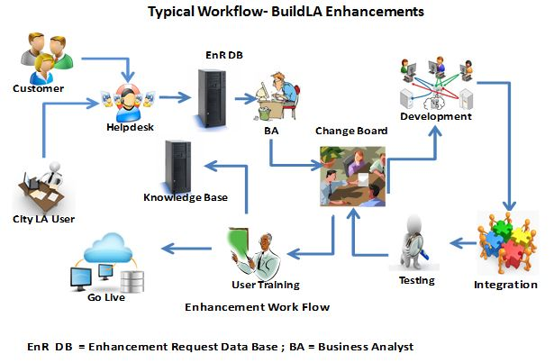

Figure1.4.4.2-8: Workflow for a Typical Enhancement Request.

Change Management Process for enhancements

UST Global has a streamlined process in place to classify enhancements activities. We categorize enhancements under two sections − enhancements to be carried out as part of the normal support process, and enhancements that have to be raised as Change Requests. Team UST will classify enhancement requests based on the magnitude of effort to be spent for these activities. In this engagement, UST Global recommends a Change Request to be raised for any enhancement request that will need more than **40 hours** for resolution. The following section outlines the proposed Change Management process for this engagement.

* Change Requests on enhancements can be initiated either by UST Global or the City of LA
* UST Global project team will assess and document the change, including a description of the change, the originator of the change, and the impact on costs and/or schedule
* UST Global’s Project Manager will submit each Change Request including the effort estimates to the City of LA POC for review and approval
* Each Change Request must be approved or rejected by the City of LA, in writing, within five (5) business days of receipt of the Change Request. If the action is not taken within this agreed upon timeframe, the Change Request will be added to the issues list for immediate resolution
* No work associated with the Change Request will begin until the Change Request is approved in writing by the City of LA. If approved, the project baseline cost, schedule, etc. will be adjusted appropriately as indicated by the executed Change Request

Please refer to Section 1.4.3.1.8 for the Change Management process that we will follow in this engagement.

UST Global will follow the same approach for configuration management, testing requirements etc., as described in Sections 1.4.3.1.7 and 1.4.3.4 for all types of enhancements activities.

###### Helpdesk (RFP 3.1.4.4.2.2)

Team UST will establish a Tier 2 – 24/7 Helpdesk for the City of LA to provide On-Call support to BuildLA users. Our support team will work in collaboration with the existing Tier1 Helpdesk run by the City of LA. Team UST can use the same tools used by the City of LA, our defect tracking tool EDT (Enterprise Defect Tracker), or any standard third party tools to manage incidents/tickets. UST Global’s L2 support engineers will utilize this tool to log and manage incidents, and escalate the tickets to various levels. All helpdesk agents will use this tool to log the tickets/incidents and support the user requests. This tool can also be used to monitor the performance of the services rendered by the support engineers and to find out the status of certain request/incidents so that tracking becomes easier. *Figure 1.4.4.2-*9 outlines the activities performed by our Helpdesk team.

| Phases | Activities |
| --- | --- |
| Investigation and Diagnosis | * Initial call intake from Tier1 Helpdesk * Assessment of the Incident details – application/infrastructure related problems * Collection and analysis of all related information, and resolution (including any Work-around) or a route to on-line support |
| Resolution and Recovery | * Resolve the Incident using the solution/work-around or, alternately, to raise an RFC (including a check for resolution) * Take recovery actions |
| Incident Closure | * The confirmation of the resolution with the Customer or originator * Update Incident details * Follow incident escalation and resolution procedures (if needed) * Close Incident |
| Incident Ownership, Monitoring, Tracking and Communication | * Monitor Incidents and problems * Escalate Incidents and problems * Inform User |

Figure 1.4.4.2-9: Phases and Activities for Helpdesk Support.

The proposed Helpdesk workflow for this engagement is shown in *Figure 1.4.4-2-10*.

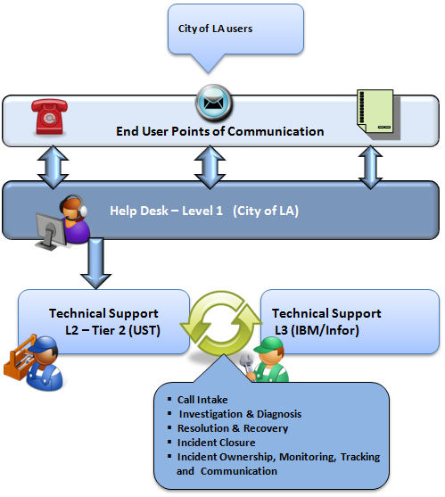

Figure1.4.4.2-10: Helpdesk Workflow Processes.

Roles and Responsibilities

*Figure 1.4.4.2-11* illustrates the roles and responsibilities of the Helpdesk team.

| City of LA (Tier 1 Helpdesk) | UST Global (Tier 2 Helpdesk) |
| --- | --- |
| * Call Intake * L1 Incident and Problem Management * Simple resolutions * Ticket Management * Infrastructure Support * User support through Secure Chat, phone, email, etc. * Server Administration | * Round the clock application and infrastructure monitoring and support * Enterprise application and infrastructure monitoring and predictive reporting * Reports & Trends Analysis with Periodic reviews * Enterprise dashboards on service health and service risks * Proactive monitoring and fault Isolation by event correlation * Problem escalations |

Figure 1.4.4.2-11: Helpdesk Roles and Responsibilities.

**Help Desk Services and Operations**

*Figure 1.4.4.2-12* depicts the workflow for a support desk including L1 and L2 (Tier 1 and Tier 2). The enterprise wide bug tracker tool will be used to keep track of each tickets or queries at every stage.

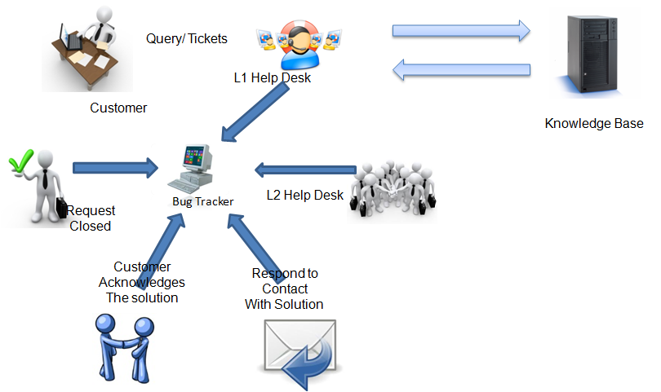

Figure1.4.4.2-12: Workflow for L2 Support Desk.

When a customer raise a ticket, the L1 (Tier 1) help desk team records the issues in the tool and assigns a ticket number for tracking. The L1 team checks the knowledge base for similar issues, if any, for a quick resolution and document those references in the tool. If the issue is very minor then L1 support team fixes the issue and updates it in the bug tracker tool. If the issue is not in L1 scope, then it will be assigned to the respective L2 support group with reference details from the knowledge base. The L1 support team will be well-equipped with the details of all L2 support group and their contact details.

As part of service implementation the service name and L2 support team POC will be communicated to the L1 Support team before the service is implemented.

The L2 support team consists of UST Global experts from infrastructure, application monitoring, and service developers, and service experts from the City of LA. The L2 support team will be competent to resolve issues within the SLA (Service Level Agreement). The L2 team will analyze each issue and decide whether it can be resolved within L2 support or if a Change Request is required to change the service. If a Change Request is needed, then the organizational level change management process will be initiated and the ticket will be closed.

The L2 support team will communicate the recommendation, problem solution, or problem escalation to the customer via email and document it in the bug tracker tool. Problem escalations will be sent to the service owner and the UST Global Project Manager for support. If the recommendation or problem solution resolved the customer issue, then acknowledgment will be recorded in the bug tracker and close the request.

**Required Staff to Support Help Desk Operations**

Resource requirements for Tier 2 support are dependent on many factors such as:

* Size of the service
* Number of service users
* Complexity of service
* Stability of service
* Number of issues reported
* Criticality of service
* Severity of issues

Based upon our analysis of BuildLA our estimation of required staff to support the Help Desk operations are:

* For three services: One L1 helpdesk executive and two L2 helpdesk engineers are required
* For 25 services: 8 L1 helpdesk executives and 16 L2 helpdesk engineers are required

As we progress, the number of resources required to support these services will also change dependent on metrics captured during the support cycle. Team UST will provide L2 helpdesk support for the same hours as the City’s Helpdesk and support hours, from 4:00 a.m. to 8:00 p.m. (PT) Monday through Friday.

**Effectiveness Measurement**

UST Global has a well proven metric to measure the effectiveness of L2 support or Tier 2 help desk. Standard metrics including response time, resolution time, and issues reopen will be used to measure effectiveness of L2 support time.

* Response time is the time taken to acknowledge the ticket or query to customer or L1 support team. Resolution will not be provided during the response time. The response time varies based on severity of issues.
* Resolution time is the time taken to resolve the issue, this is also depends on the severity of issues.
* The number of issues reopened determines the quality fix provided by L2 support team.

All these standard metric figures will be baselined after discussing with the City of LA and UST Global.

**24/7 Tier 2 Support**

Most of our Fortune 500 clients with customer facing applications demand 24/7 support. We have a mature process to handle these 24/7 support requests. UST Global provides L2 support from India as well as from the client location. We anticipate providing this same support to the City of LA.